
TASTE OF

WINE & FOOD
By Frank Mangio

Week of July 22 2018

Wine “Paradiso” – Napa Valley Part 2

Welcome to Part 2 of a 3 part wine and food dream trip adventure in the land of the world’s most triumphant wines: meeting, eating and drinking with selected world-class wineries in Napa Valley. If you missed Part 1, go to https://www.tasteofwineandfood.com.

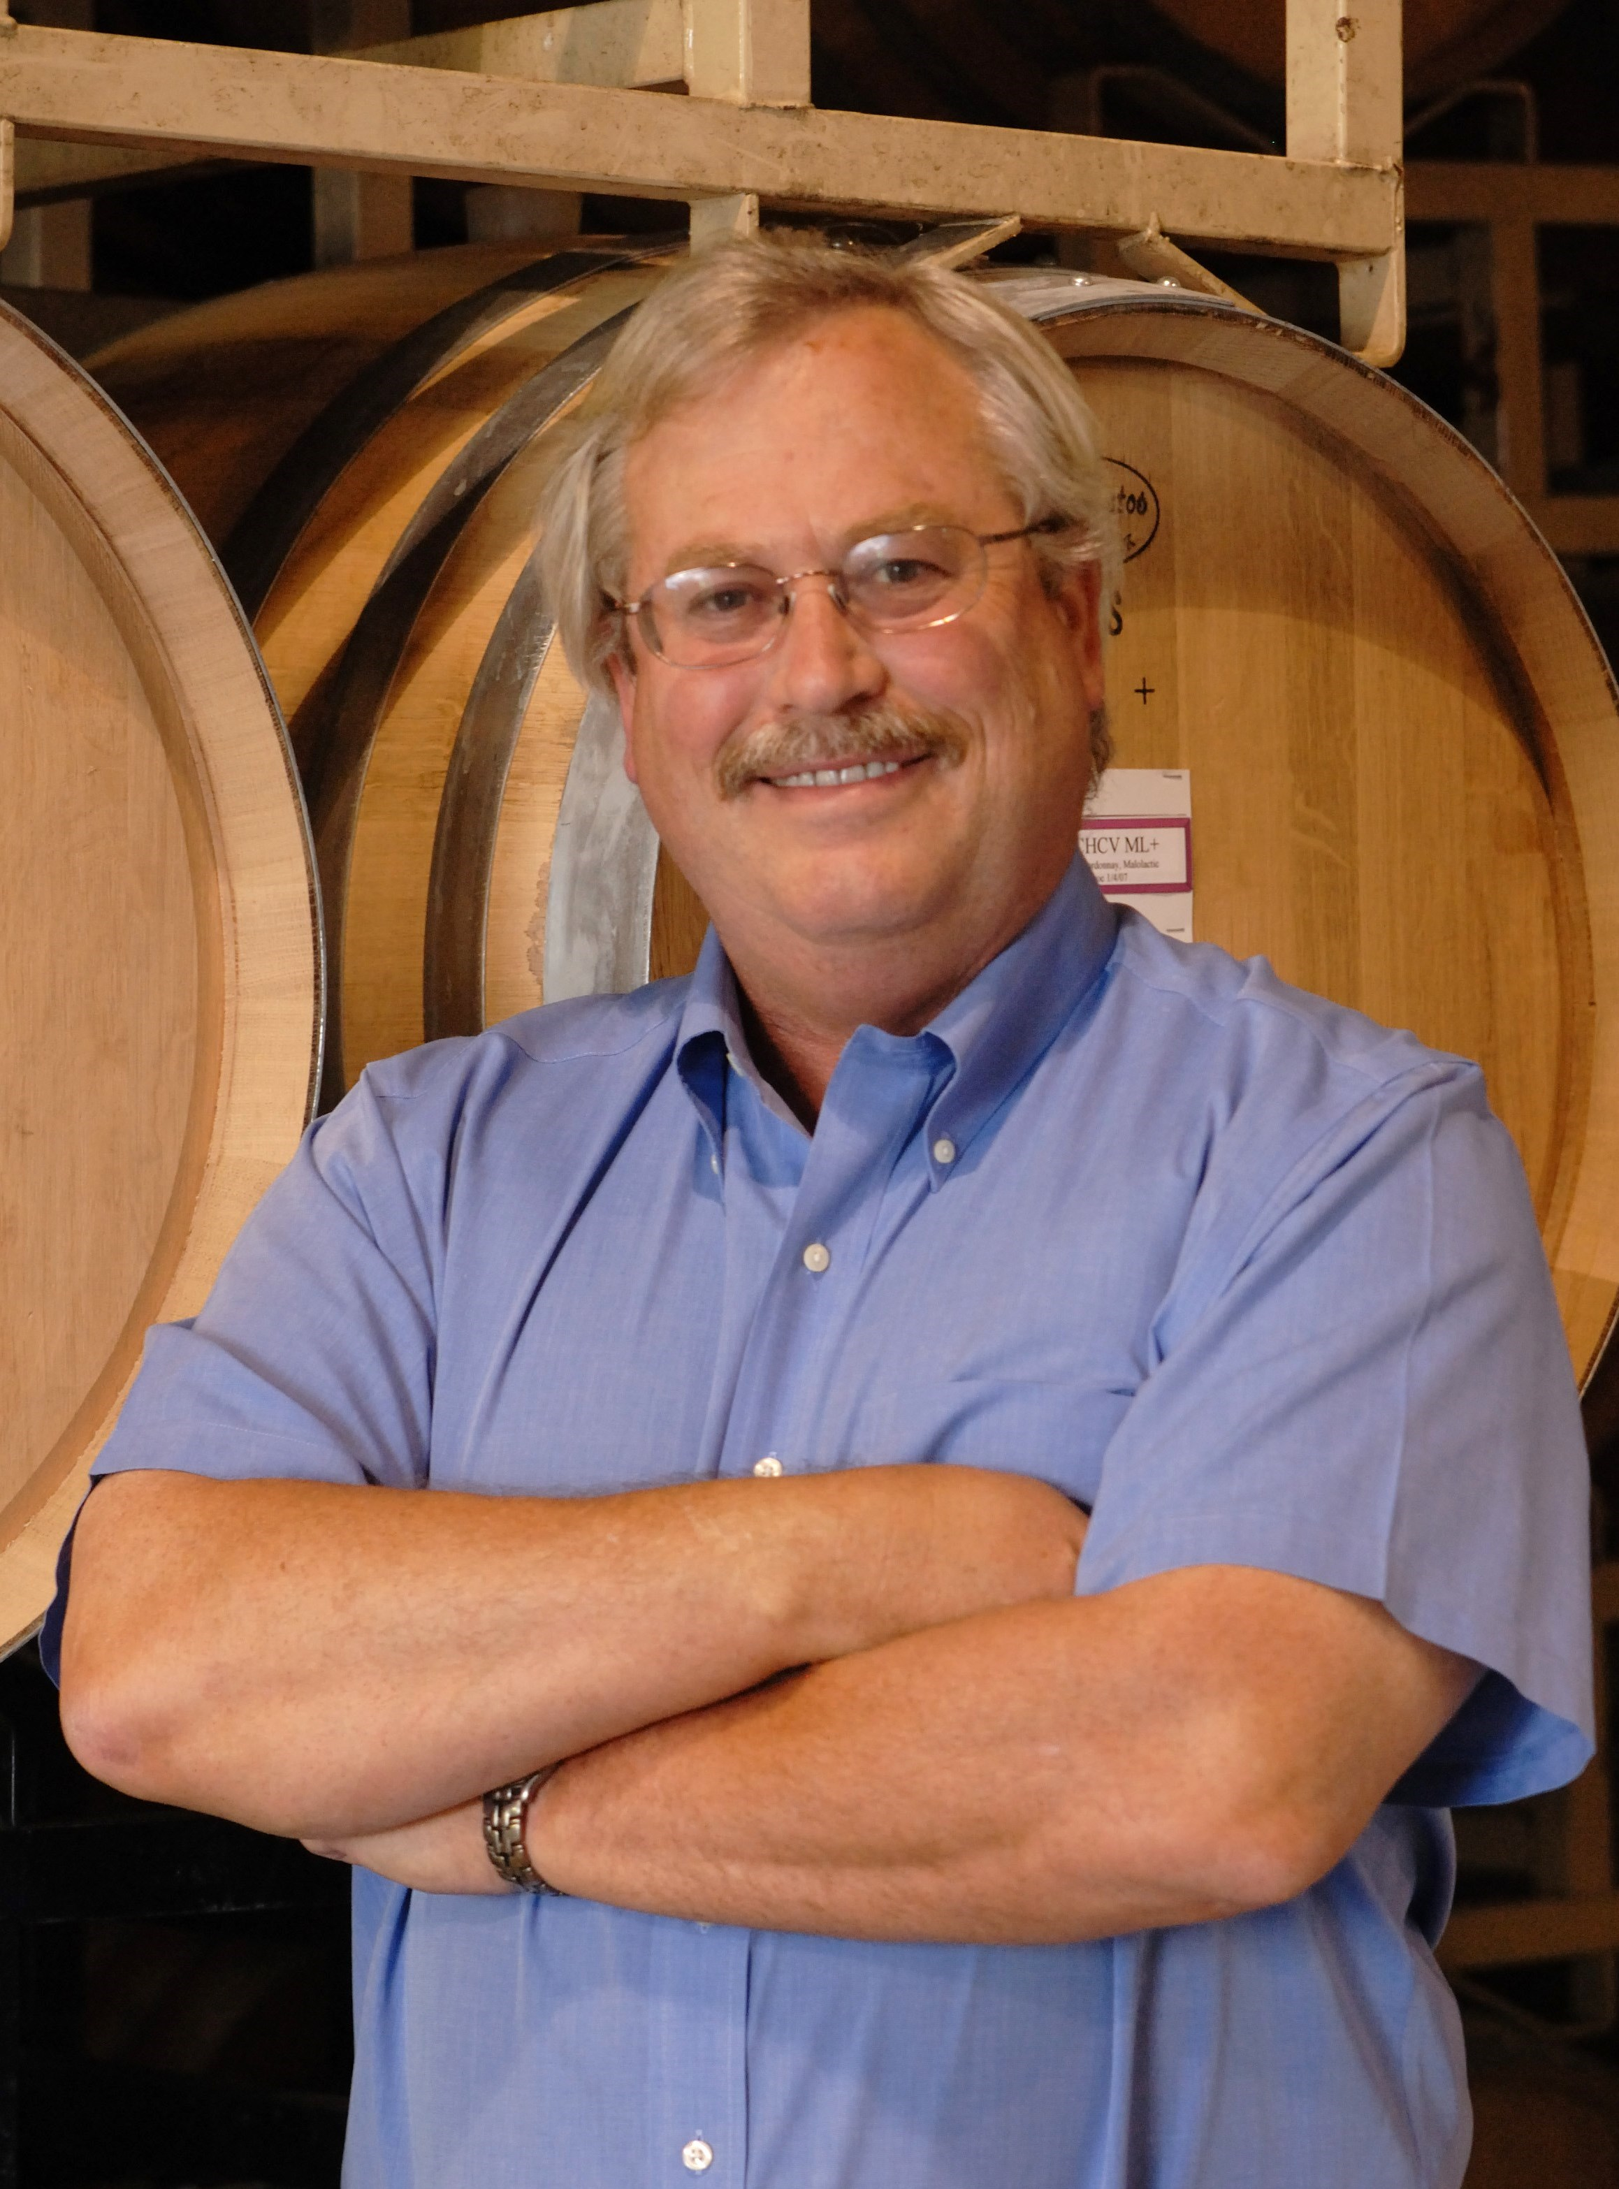
“Paradiso” is Italian for Paradise and that in itself would be all you need to know about Napa Valley. But this is a column, so I have a lot more to say about “Paradiso” and why I chose this description at this point in time.

Brooks Painter is the Director of Winemaking for both V. Satttui Winery St. Helena, and Castello Amorosa in nearby Calistoga. They are owned by the same founder and builder, Dario Sattui, a noble man with a king-sized determination to create an Italian inspired garden themed winery in V. Sattui, and a behemoth of a castle in Castello Amorosa, that is an authentic 13th century multi-leveled castle and winery.

Brooks Painter is Director of Winemaking

at both V. Sattui and Castello Amorosa, both

embodying the wine “paradiso” that is Napa Valley.

Painter has been a winemaker for over 30 years, having worked at Mondavi and Stag’s Leap. He recently received a Winemaker of the Year Award from the American Fine Wine Association. Don’t miss the Castello and its huge inventory of fine Italian style wines, but you must see V. Sattui, its artisan authentic Italian deli with over 200 cheeses and its portfolio of over 60 different wines, including the 2014 Paradiso Bordeaux Blend. ($90.)

This wine is currently all the rage in the wine trades. You need to purchase it at the winery. Better you join the wine club and be the benefactor of important discounts and special events. This is 63% Cabernet Sauvignon, 24% Merlot, 6% Malbec, 4% Cab Franc and 3% Petite Verdot. This vintage was exceptionally high quality fruit. It’s dark, ruby red and very “inky.” It was barreled 19 months in 80% new French Oak, 20% in seasoned oak. Get set for something very special!

As to Castello Amorosa, I chose the La Castellana Super Tuscan Blend. ($98.)

Great point assessment on this wine, intense with firm vibrant red and dark berry flavors. It’s a blend of Sangiovese, Merlot and Cabernet Sauvignon. For food, try lamb, sausage, grilled steak or a great pasta dish.

Next Up….CAYMUS!

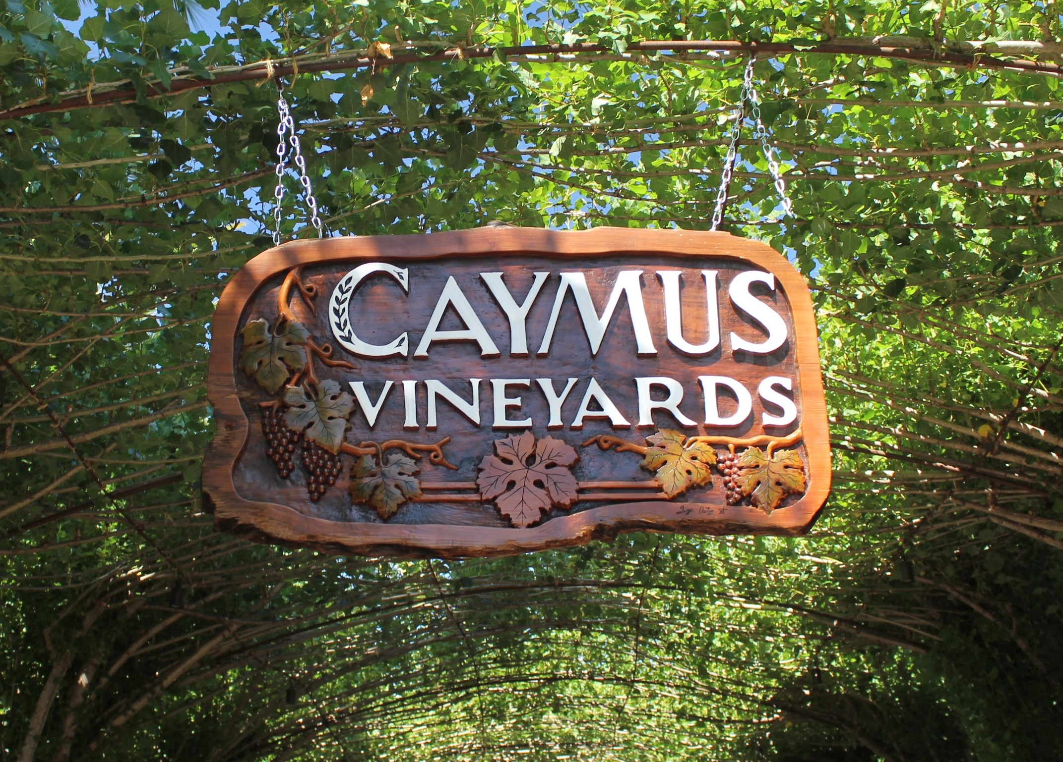
You got a glimpse of Caymus in Part 1 when we spotlighted the youngest member of the Wagner Family, Joe, who hit the jackpot with his Meiomi Pinot Noir at the age of 34. We visited Caymus in Rutherford, one of the major stars of Cabernet Sauvignon, and met Jenny who was the winemaker for the new 2015 “Plumerai” Sauvignon Blanc. This is a bright, high acid drink

Caymus Vineyards, in the Rutherford district of Napa Valley

has established itself as a high end premier Cabernet

in the Wagner Family of Wines. Several members of the

Wagner Family are involved in the making of their varietals.

with low alcohol. The thing about this bottle is it is a 1 ltr, larger than the standard .750 ltr, so it can and does get $90. A special technique knocks down the high sugar level. It’s high in mineral content and is barreled in French oak.

Of course, the signature big seller at Caymus is the 2014 Special Selection Cabernet Sauvignon. ($180.) This is a fantastic expression of Napa Valley Cabs.

It’s been Wine Spectator’s #1 wine, twice! Shockingly good! Watch for breath-taking news out of Caymus. This winery has a history of twists and turns in its upward legacy. New labels, new styles, new locations. Fascinating stuff coming down the pike from Caymus.

A Restaurant in Napa to Know & Love: BRIX

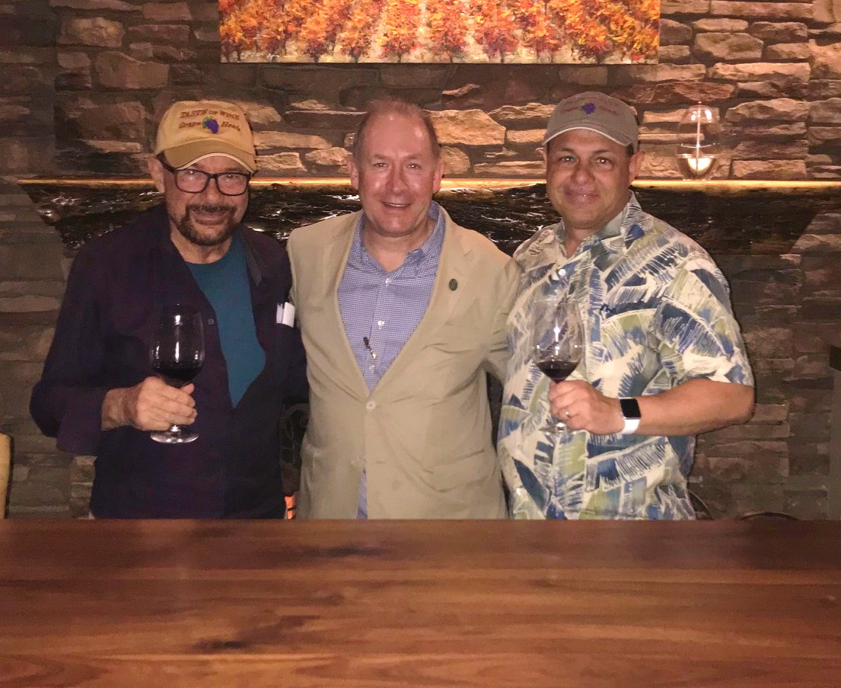
Napa Valley has long put a damper on wineries that build palatial restaurants on their properties, unlike other wine countries. I like that. If you make wine, make it great and don’t get distracted. Most of the wine has to be Napa Valley juice and no permits allowed for major sit-down eateries. Taste Of Wine & Food was excited to find BRIX on Highway 29, just north of Napa. It’s 100% committed from farm to table with raised farming beds just

Frank Mangio, Senior Editor and Rico Cassoni,

Internet and Tech Director of Taste of Wine & Food,

are to the left and right of BRIX Restaurant G.M.

Jamie Jamison.

beyond the veranda patio, including wine grape acreage. BRIX has just been awarded a high honor from Wine Spectator, the Best of the Award of Excellence, for superior breadth of selection of wines, and their presentation. G.M. Jamie Jamison favors California-centric wines with a Napa Valley accent. A Kelleher Family Sauvignon Blanc 2016 was served to compliment the favored entrée: a seasonal Halibut with red pepper polenta and grilled corn. Close behind was the Braised Shortrib with shaved asparagus, marinated mushrooms and raclette fondue.

See more at brix.com.

Wine Bytes
- It’s the 8th Anniversary celebration for North County Wine Company, Fri. and Sat. July 27 and 28 from 4 to 9:30pm. Top flight wines, plus a kickoff Champagne Saber ceremony Fri. at 5pm. $35. for a premium wine lineup! Other discount tastings on selected wines. Food sampling. Rafflle drawings. Check out northcountywinecompany.com. or call 760-653-9032.
- A Sextant wine dinner is planned for AVANT Restaurant in Rancho Bernardo Sat. Aug. 4 from 6 to 8pm. Cost is $125. per person. This is a premier winery in San Luis Obispo wine country. Call for an RSVP at 858-675-8551.
- Plan now to be at Il Fornaio in Del Mar for its month of Aug. Campania Festa Regionale dinners and wine events, from the 6th to the 19th. Check out the beautiful dinners from this south of Naples district, then call 858-755-8876 for an RSVP.

Frank Mangio is a renowned wine connoisseur certified

by Wine Spectator. He is one of the leading commentators

on the web. View his columns at tasteofwineandfood.com

Go to Recent Columns. Reach him at frank@tasteofwineandfood.com to comment or unsubscribe.

