
TASTE OF

WINE & FOOD

By Frank Mangio

Week of May 9, 2021

When it’s Cass … Let the Party Begin!

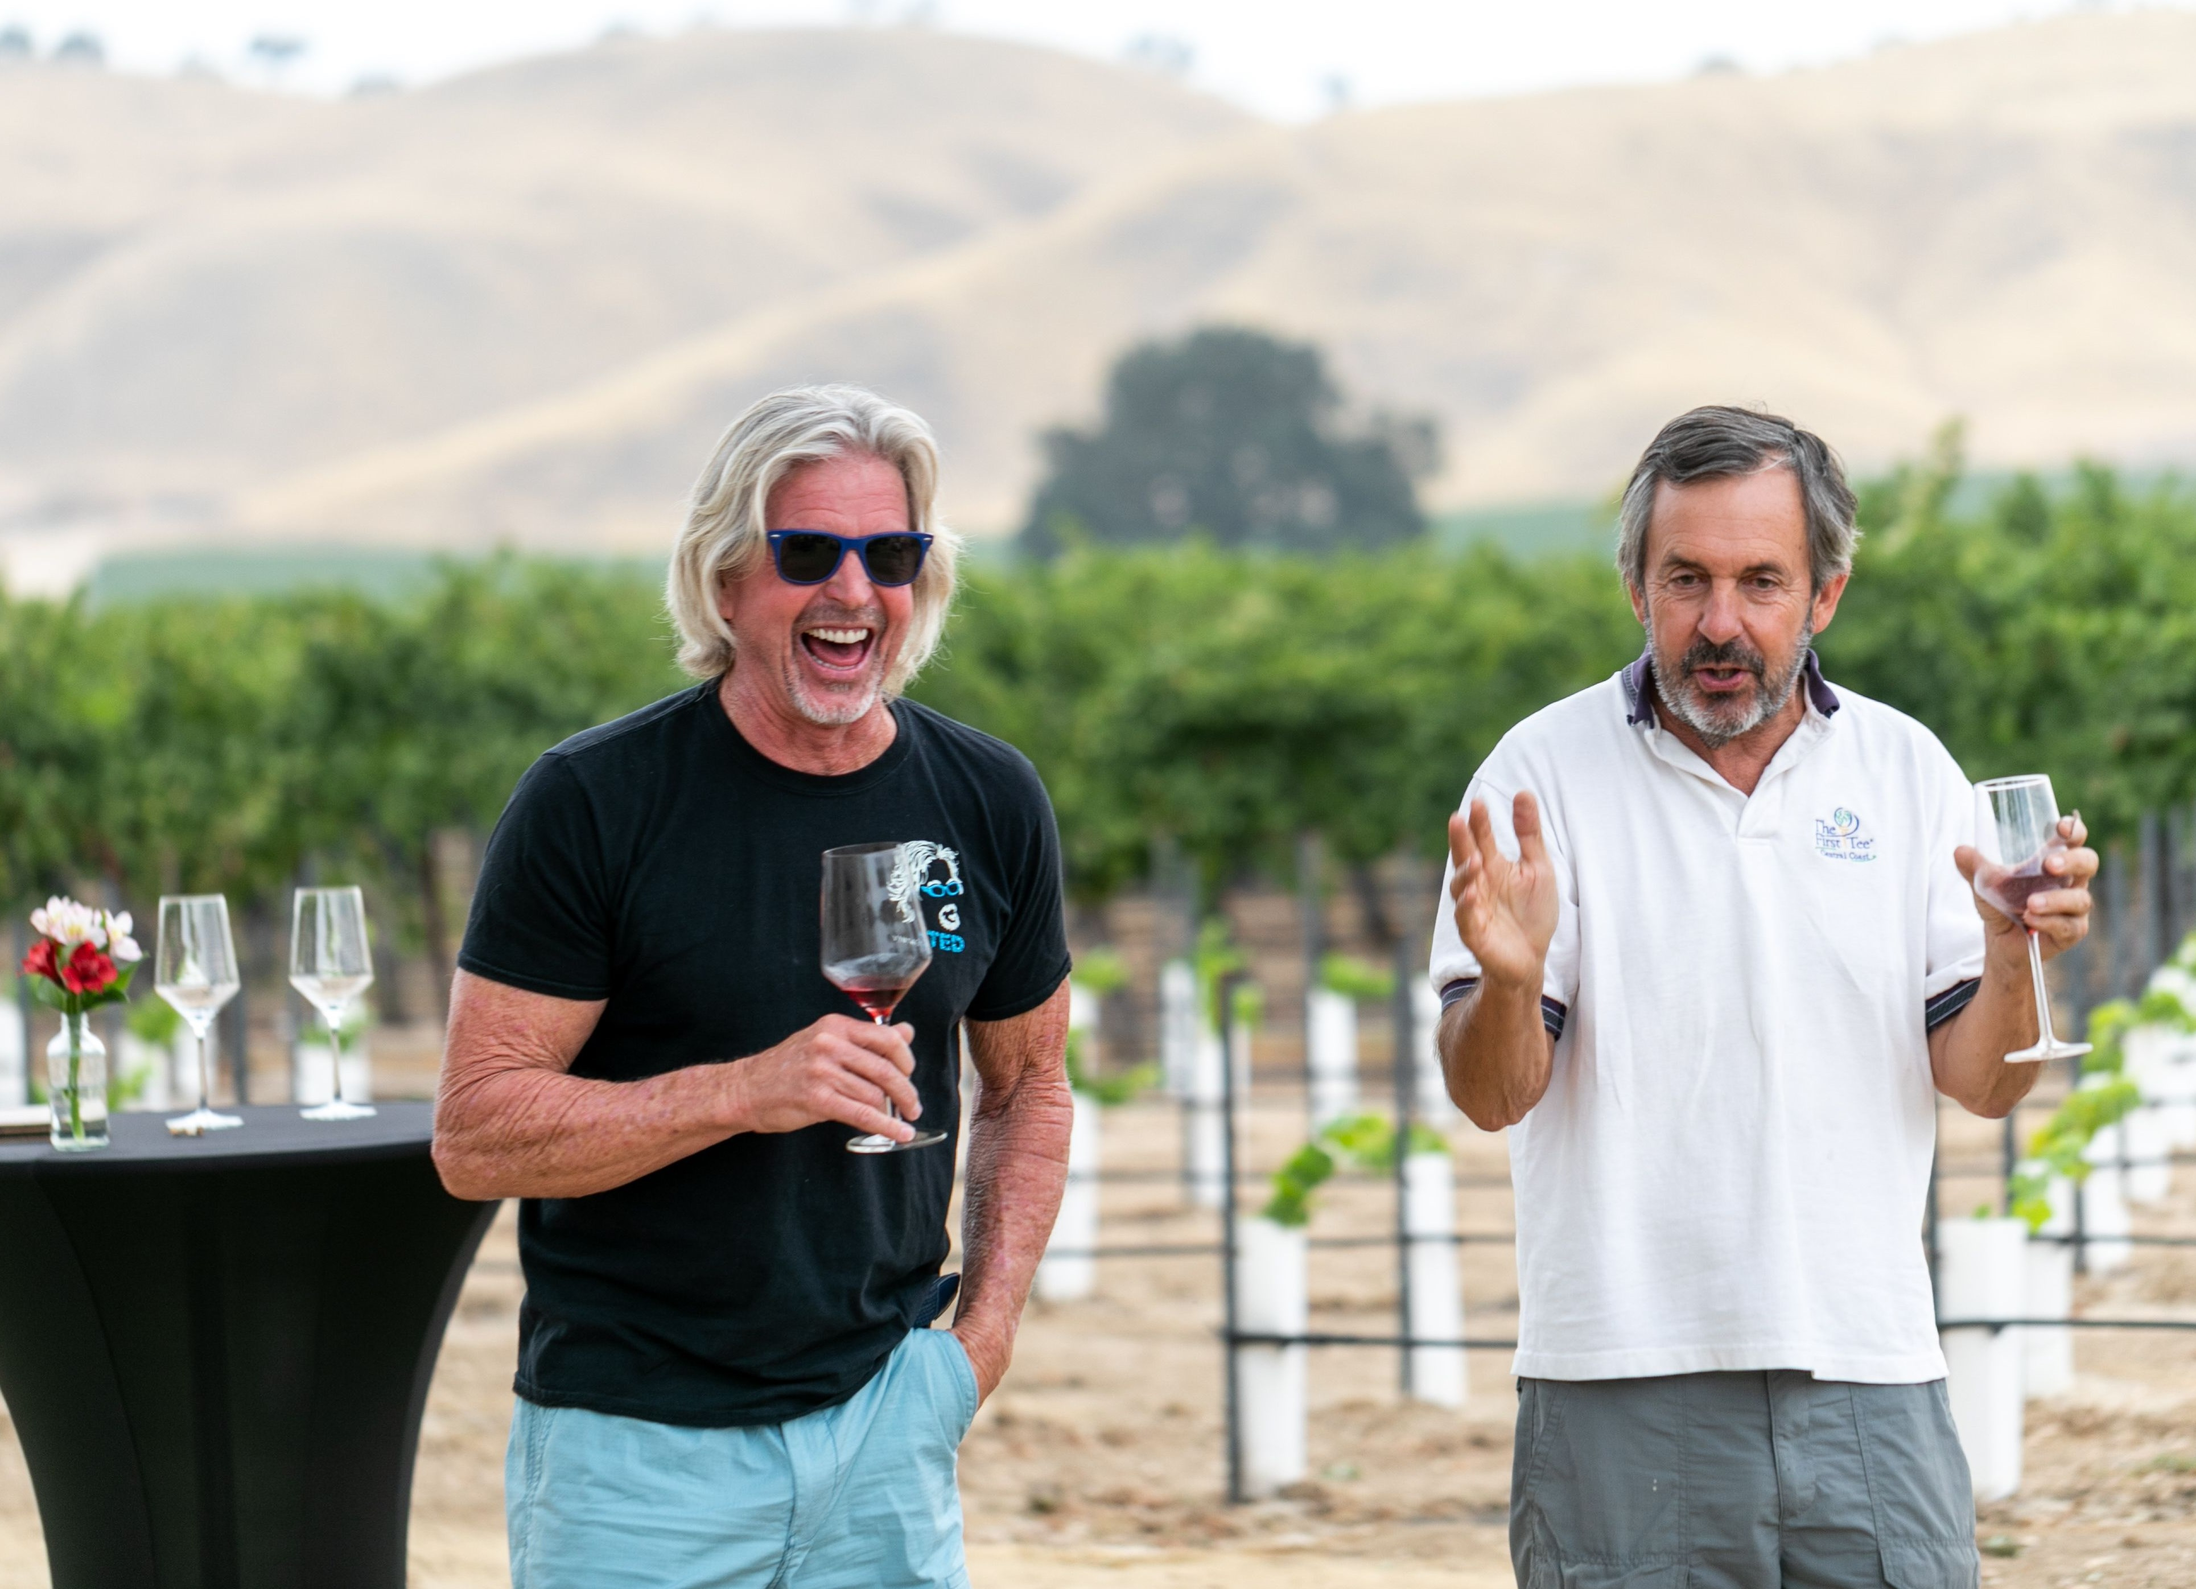

Cass Winery partners Ted Plemons and Steve Cass share a laugh at a

recent vineyard tasting party in Paso Robles, before coming to their San

Diego Wine Club Spring Pickup Party.

The most dynamic duo I know of in the wine making business is Ted Plemons and Steve Cass of Cass Vineyard and Winery in Paso Robles. These guys play off each other like Brady and Gronkowski in the last Super Bowl. It’s been that way since 2000 when builder Plemons created Steve Cass’s new home and barn on the 145 acres Cass had bought to plant 12 varieties of wine. Two years later, Cass and Plemons created their partnership, and they haven’t stopped running the most ambitious program of wine and wine related activities that I know of.

They know how to take care of their customers, especially wine club members.

Their latest road show for members was in San Diego a couple of weeks ago.

Staged in the courtyard of a new hotel in the posh Pt. Loma district, the Cass team brought all their new releases for all to taste, along with luxe food

grazing on the swank banquet tables.

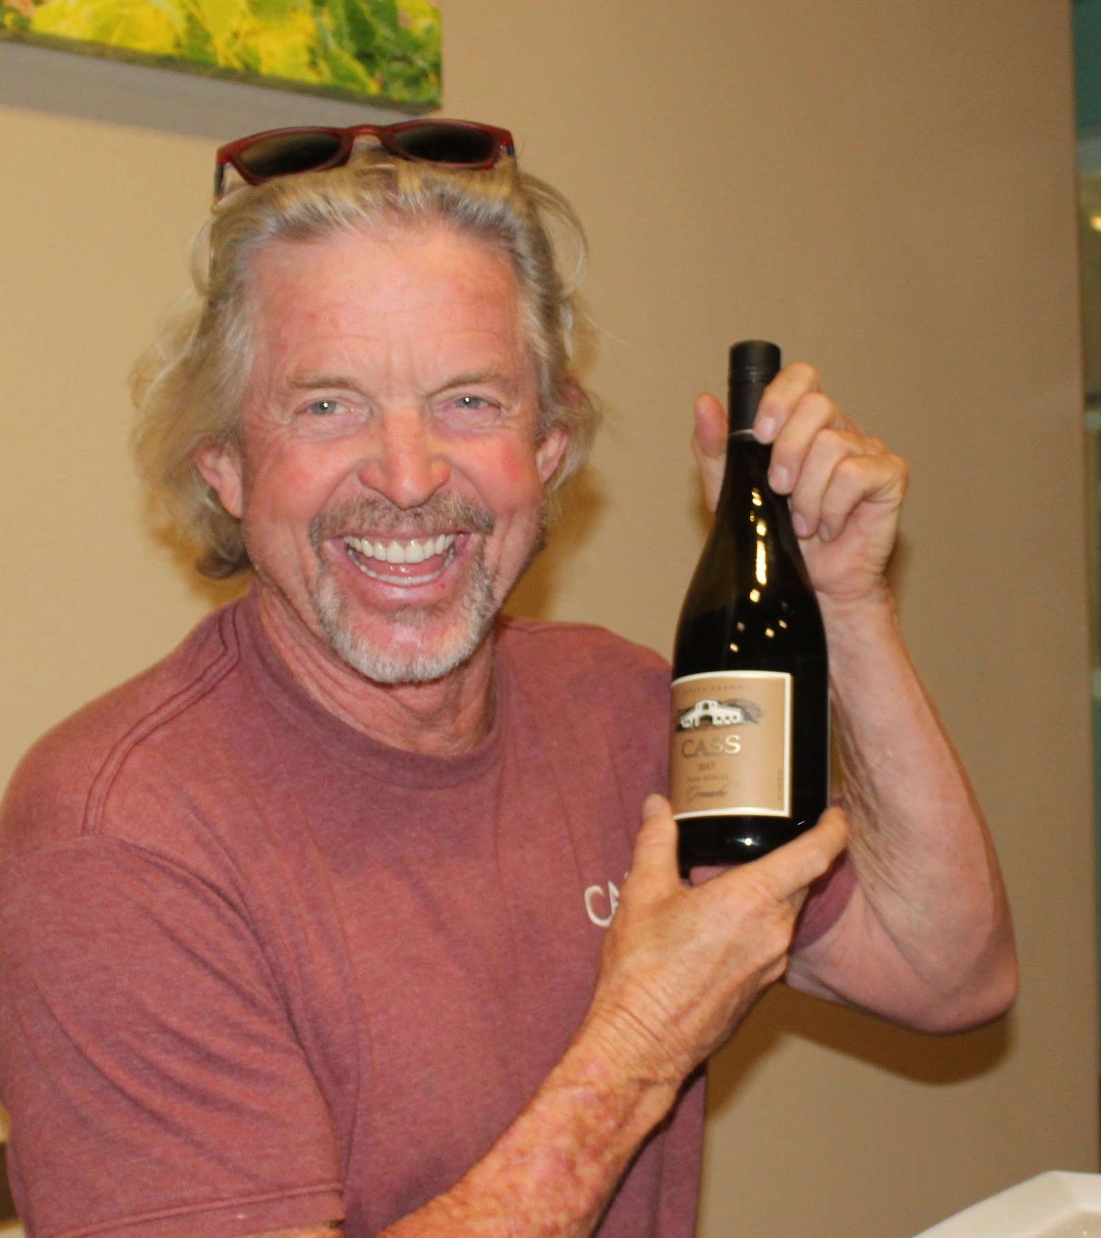
The three Cass wine clubs have a wine plan for every desire and taste. There was plenty of party time to commiserate about the wines and lots of fun and wine prizes from the dynamic duo of Cass and Plemons, including two with Ted’s name and signature on the bottle: Rockin’ Ted and Vintage Ted.

Three new Cass releases kept the guests buzzing. Once again, it was their popular French Rhone Valley Trio and big wine club favorites all estate grown: the 2020

Cass Winery partner Ted Plemons

displays the 2019 Grenache with rich

tasting fruit and a touch of licorice.

Viognier, the 2019 Mourvedre and the 2019 Grenache. These wines are captivating with exclusive flavors all their own. Aiming to preserve the intense

fruit and aromatics, this Viognier was cold-fermented and aged in 100% stainless steel, creating a bouquet of honeysuckle, apricot and Asian pear. The Mourvedre

is sheer seduction in a bottle with aromas of red fruit, mint chocolate and fresh earth, and fills the palate with pomegranate, baking spice and a velvety tannin structure. The Grenache is a favorite of mine. Light bodied yet intensely flavored, it expresses the beauty of fresh strawberries, candied cherry and hints of white pepper, paired perfect with grilled salmon, honeyed ham, Shepherd’s Pie and black bean tostados.

A couple of revolutionary concepts will keep Cass ahead of the pack and on the leading edge of Paso wineries. A modern winery retreat, the new Geneseo Inn

at Cass, is now open. This is a luxury boutique hotel like no other. Each stand-alone unit has modern appointments, upscale architectural detailing and exclusive Chef’s Estate Breakfast included. Choose to unwind with a private massage or yoga session, or ramp up your adventure by selecting one of the many Cass Camp experiences.

I am most excited with plans for a Cass elite Society of Paso Absolute, by invitation only. This is an opportunity to share your passion to learn and savor premium wines at the winery, cultivating the excellence to understand and love the elite wines to come. Paso Absolute organized travel to notable wine and food districts of the world will light up your knowledge of the source of great wines. Quarterly winemaker dinners, events and entertainment with your friends and family will add memorable moments to your membership.

For the full benefit list, visit pasoabsolute.com. For Cass winery, see casswines.com.

Wine Bytes

Adam Carruth’s Bordeaux Bash returns to Carruth Cellars in Solana Beach

Sat. May 22 and Sun. May 23 starting at Noon each day. This event celebrates

all Bordeaux varietals including Cabernet Sauvignon, Merlot, Cab Franc, Petit Verdot and Malbec. The feature you will love….you get a chance to blend your own wine to take home (with the help of a winemaker)! Taste unreleased Bordeaux wines from the barrel. Small bites food is available. As a bonus get access to “futures” (the opportunity to purchase wine before it is bottled and released) at a generous discount of up to 40%. Reserve your private time slot for up to six guests before they’re all gone. $100. for wine members, $120 for the public. Phone 858-876-7027 or visit carruthcellars.com.

Sal Ercolano’s West End Bar & Kitchen in Del Mar presents a wine dinner with Catena Zapata of Mendoza Argentina, Thurs. May 20 and Fri. May 21 at 6pm.

Catena is famous for resurrecting Malbec wine for making high altitude

rich tasting wines. A perfectly paired menu will complement the wines. $70 per person plus tax and gratuity. Call 858-259-5878 for your RSVP.

The Encinitas Craftsman Tavern is planning their first wine dinner of the year, Wed. May 26 at 6pm. This will be a Spanish wine dinner with wine expert Bryan Taylor. You’ll be enjoying Spanish Garnacha, Rioja Reserve and others. $65. each person, 30 seat max. To RSVP contact Mike at 760-452-2000.

Frank Mangio is a renowned wine connoisseur certified

by Wine Spectator. He is one of the leading commentators

on the web. View his columns at tasteofwineandfood.com.

Go to recent columns. Reach him at frank@tasteofwineandfood.com

