
TASTE OF

WINE & FOOD

By Frank Mangio

Week of April 4, 2021

Behind the Scenes: DAOU Family Estates

Senior Editor Frank Mangio and I had the pleasure of spending two days behind the scenes with Daniel Daou, Proprietor/Master Winemaker, along with others from Team DAOU Family Estates during our recent Paso Robles trip. For a wine and food journalist, it gets no better than this.

Our behind the scenes adventure included dinner at Daniel’s house, a tour of DAOU Mountain including barrel tasting, the initial testing and tasting of 2020 Soul of a Lion, the new site of PATRIMONY Estates and a tour of Gabrielle’s Vineyard. We also enjoyed dinner at Buona Tavola, covered next week.

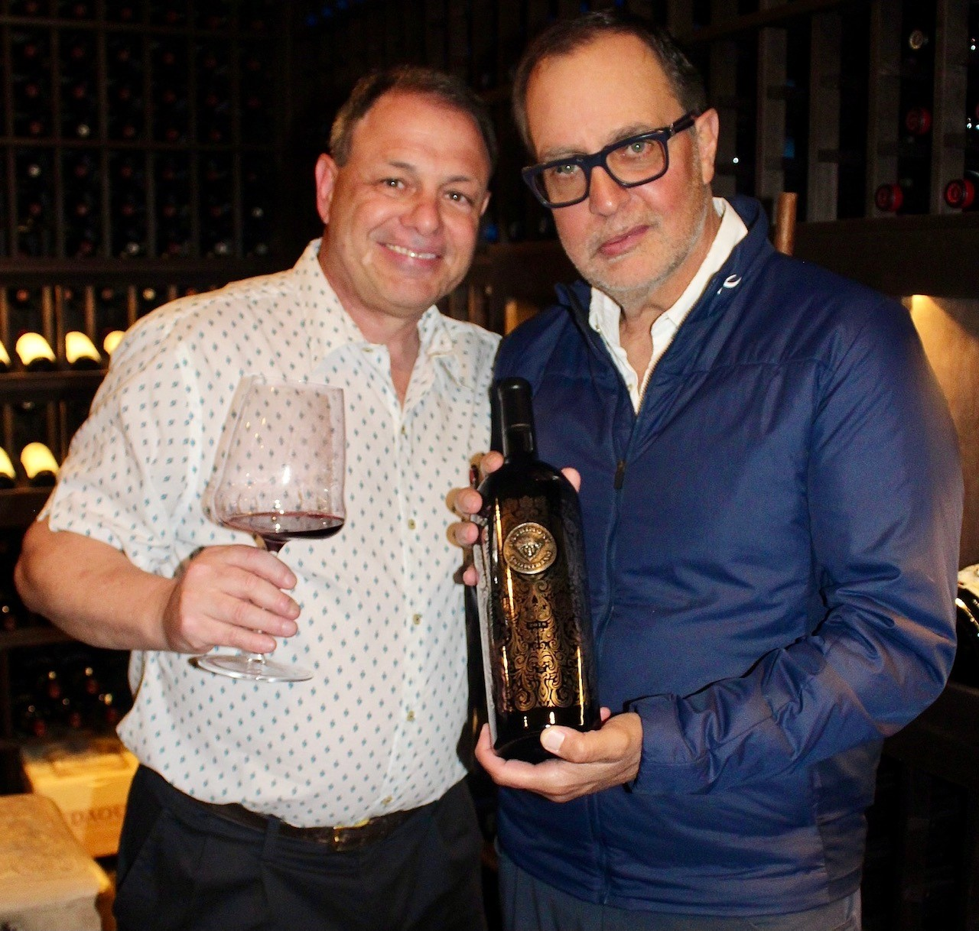
Daniel’s most impressive qualities that stood out during our candid time together were his approachability, love of family, friends and his DAOU Team, passion for wine excellence and culinary skills. We started the evening with DAOU 2019 Estate Chardonnay and then 2010 and 2011 Reserve Cab Sauv followed by 2014 Estate and 2012 Soul of a Lion Cab Sauvs - each had a story. As we were drinking the 2010 library wine, Daniel shared that he was making it while his father’s health was

(Left) TOWAF Rico Cassoni with Daniel
Daou, Proprietor/Master Winemaker, DAOU
Family Estates in Daniel’s private home cellar.

declining. It was special to share both this story and library wine with us knowing how much this vintage meant. He decided that the 2011 Soul did not meet the 4th tier phenolics required and instead skipped 2011 Soul of a Lion and bottled as the 2011 Reserve. Anyone out there with a 2011 has an amazing bottle of wine at a great cost. We continued to enjoy all the Cabs through dinner. Daniel and fiancé Sara made an authentic Lebanese dinner featuring Kafta, Lebanese Rice and Egg Plant Salad served with Labneh yogurt sauce, Hummus and Pita Bread. Later came DAOU Estate Port, Frozen Yogurt and cigars. During the pandemic, Daniel shared he enjoyed gourmet cooking. I suggested he create a Lebanese cookbook, and he said he was thinking about making one.

In between dinner and desert, Daniel took Frank and me to his home cellar adorned with Soul of a Lion, PATRIMONY and PATRIMONY Black Label Collector’s edition (1.5L magnum in a collector’s case with only 600 made, $1000). Daou shared, “Objective indicators for wine include color, sugar, alcohol and other characteristics. An example of the quality of DAOU’s 5th and highest tier PATRIMONY Estate wine is its color between 300 and 500 parts per million (ppm), in comparison to other high end Bordeaux Cabernets that are between 130 and 200 ppm.” He added, “DAOU’s Flagship Soul of a Lion is 250+ ppm as well.” Enjoying these wines showed how the phenolics come into play for exceptionally structured wine where the fruit, tannins, acidity and alcohol create perfect harmony and balance allowing long term storage.

The following day, we had a personal tour of DAOU Mountain. I asked Daniel the secret to good wine. He replied, “It is 50% fruit and 50% winemaking, but it all must start with terroir that includes both of these.” He spent 8 years searching the world for the perfect spot. Once he saw the yellow limestone-based calcareous soil of DAOU Mountain at 2,200 feet, he knew he had the soil of Bordeaux and the climate of Napa. This perfect soil also allows one to responsibly dry farm. The limestone can absorb and release moisture as necessary to ensure the fruit has sufficient water. Additionally, DAOU Mtn has fewer days over 100 degrees vs Paso, Napa and matches temperatures found in Bordeaux and Saint Helena. Other factors that add to DAOU’s prowess are 18 inch tall cordons. Cordons are the top part of the vine. Having 18 inch cordons permits canopies to grow up to 4 feet providing shade to shield grape berries from sunburn. Daou shared, “We mainly use 6 x 2 vine density where rows are planted 6 feet apart with 2 feet in between vines. This produces about 3,600 vines per acre resulting in high amounts of clusters that can be dropped so that the only fruit remaining is the same ripeness.” Frank and I learned that having out of balance ripeness requires additives to “doctor” the wine. Other factors include using only free run juice and oak staves that are weathered outside at DAOU Mtn so that the oak absorbs the terroir before construction and toasting. Additionally, the barrel room is a cut in (rock) cave and was the 1st commercial modern winery in Paso created by Dr. Hoffman, the original owner in 1965, and was restored by DAOU in 2012. By keeping temperatures low with the cave and extra insulation, DAOU can use fewer sulfites (10ppm) vs the nominal amount of 25-40 ppm that tire the wine and leads to bleaching. These differentiating factors stack up resulting in DAOU competing with Napa Valley blue chip and premium wines on the world stage.

As we were finishing up our tour of DAOU Mtn, we stepped into the DAOU chemistry lab. Workers just finished running the first set of tests for the new 2020 Soul of a Lion vintage. There was a bit of nervous energy that broke into ear to ear smiles when the Soul registered a whopping 281ppm in color with time remaining in the barrel to further deepen its inky opaque color. Frank and I were also able to try this new gem. Based on our tasting, 2020 is going to be another stellar year for Soul with nose, palate, and finish of previous Soul vintages.

Next was the other side of the mountain to see the new PATRIMONY Estates site. In a few years, guests will have 300 degree sweeping views with a tasting room connected to a 3-star restaurant and French style Chateaus via underground caves where PATRIMONY wine will be stored alongside fresh cheeses. Guest will enjoy a Bordeaux France get away in Paso Robles. Currently there are two varietals of PATRIMONY - Cab Sauv and Cab Franc. Merlot will join the lineup with a 2020 vintage and Sauvignon Blanc for a 2021 vintage. For those who have seen PATRIMONY Caves des Lions bottles, this is fruit grown at Daniel and brother/co-proprietor Georges’ home vineyards, hence the name.

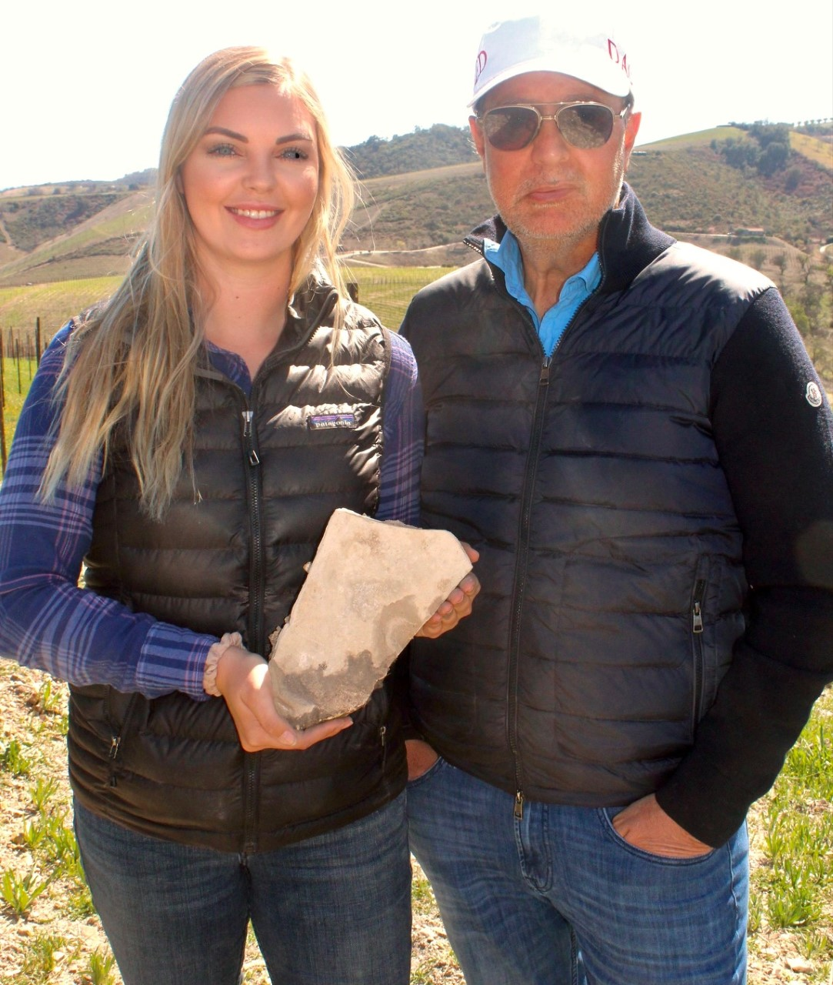
Our final stop, was Gabrielle’s Vineyard, named after daughter Anna Gabrielle Daou, a few miles from DAOU Mtn. Perhaps this was one of the best parts of our two day adventure seeing the next generation of Daou children carrying on the family trade. At 25 years old, Anna has full responsibility of her 80 acre vineyard that she was put in charge of last year. This is especially impressive in a male dominated industry. However, Anna is in good company with 54% of Team DAOU

(Left) Anna Daou holding a piece of
limestone rock with father Daniel Daou
at (Anna) Gabrielle’s Vineyard.

being females. We loaded up the Polaris with Anna driving and giving the tour. Her father, in the passenger seat, smiled and showed great pride for his daughter’s expertise in running 80 of the 700 total estate acres owned by DAOU.

Thank you Daniel, Sara, Anna and Team DAOU for a memorable tour! Be sure to visit DAOUvineyards.com and PATRIMONYestate.com.

Story by Tech Director/Writer – Rico Cassoni

Frank Mangio is a renowned wine connoisseur certified

by Wine Spectator. He is one of the leading commentators

on the web. View his columns at tasteofwineandfood.com.

Go to recent columns. Reach him at frank@tasteofwineandfood.com

