
TASTE OF

WINE & FOOD

By Frank Mangio

Week of February 7, 2021

DAOU’s PATRIMONY Estate Dream Team is Born

Every great legacy begins with a back story. Georges and Daniel Daou grew up in France after their family migrated from war torn Lebanon. While growing up in France and influenced by stimulating conversations he had with his father Joseph and brother Georges, Daniel became fascinated with wine. The Daou brothers came to San Diego to attend UCSD as engineering majors. After graduating, they created Daou Systems, a healthcare information technology company, and then sold the company after several years. Daniel’s dream of becoming a winemaker was about to come true.

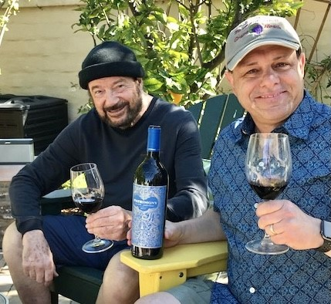
As engineers, successful business owners, and quality seekers, Georges and Daniel combed the world looking at 100’s of wine terroirs. They knew to create world class wines, they needed the best phenolics, which are organic soil compounds, and a perfect climate. When they saw what is now DAOU Mountain in the Paso Robles Adelaida District, they immediately knew the calcareous soil with some of the best phenolics in the world matching that of Bordeaux France, and the

Taste of Wine and Food Senior Editor Frank Mangio
and Tech Director/Writer Rico Cassoni savoring
2017 DAOU PATRIMONY Cabernet Sauvignon.

2,200 foot elevation creating a climate like Napa Valley’s, would be a perfect terroir to create DAOU Family Estates. These exemplary conditions and passion for perfection enabled Daniel Daou, Lead Winemaker, to create a California “first growth” Bordeaux style Cabernet Sauvignon called PATRIMONY.

Several weeks ago, I received a text from Daniel saying, “Ciao Fratello, I have earth shattering news to share with you.” Minutes later, I learned that Chris Avery, Steve Palumbo and Nicholas Holmes—all longtime veterans of Opus One and other iconic wineries would be joining PATRIMONY Estate as the global sales and marketing team lead by Chris. Also, Erik Johnson, former head sommelier at The French Laundry, would join as the PATRIMONY estate director. Taste of Wine and Food was excited to be the first to learn of this news outside of the winery. Seconds later I was sharing the epic news with Senior Editor Frank.

When the story officially broke on February 2nd, Taste of Wine and Food had an interview with Daniel Daou, Chris Avery, and Maeve Pesquera, Senior Vice President to learn more about PATRIMONY Estate. Daniel shared that PATRIMONY is more than a wine, it will be its own DAOU entity. DAOU purchased 269 acres bordering its property for the PATRIMONY Estate project. Eighty acres will be planted for PATRIMONY fruit, leaving space for a winery, French cottages, a restaurant, wine caves, and DAOU Mountain views creating a chateau masterpiece destination overseen by the new dream team.

During the interview, I asked what makes PATRIMONY different from Soul of a Lion, which is dedicated to Daniel and Georges’ father Joseph who told the boys when life gets tough, have the “Soul of a Lion.” Soul is a spectacular wine as well, with 100% estate, free run juice outselling the best of Napa Valley wines. Daniel shared, “It is all about the phenolics” and gave an example of color. “Most first growth Bordeaux wines have color at 180 parts per million (ppm). Soul of a Lion has around 300ppm, and PATRIMONY has 480+ ppm.” PATRIMONY is aged in three different barriques, including limited Tonnellerie Sylvain barrels made from 362-year-old fine-grain oak, originating from a forestry program initiated during the reign of Louis XIV; only 35 of these barrels were produced from two fallen oaks. The aging includes 30 months in barrels and an additional year in the bottle. This creates seamless integration with perfect balance in color, structure, and tannins resulting in PATRIMONY’s “Modern Antiquity” deserving to compete on the world stage.

Speaking of world stages, Pesquera mentioned, “DAOU has changed Paso Robles. People who are in and have experience in the world of wine are drawn here. A perfect example being the new dream team. PATRIMONY is another defining moment for Paso. PATRIMONY will extend what Soul of a Lion started 13 years ago as a world class luxury wine and show what Paso Robles can do.”

Avery added to the commentary, “PATRIMONY is approachable with depth. It will evolve in your glass while drinking, over the course of a few hours, a couple of days even without Coravin preservation, and in the cellar for years.” Of course, Frank and I had to put Avery’s comments to the test and opened a bottle. I have never seen color or legs so bold in a Cabernet Sauvignon. When a glass is tilted exposing the purple black color of the wine, a layer coats the side of the glass and after a few seconds deep legs formed. The nose had fruit with floral hints and some spice, sweet fruit through the palate with soft and balanced acidity, baby smooth tannins, and a long earthy finish. PATRIMONY is truly a phenomenal wine. One of the best, if not the best, that I have ever had!

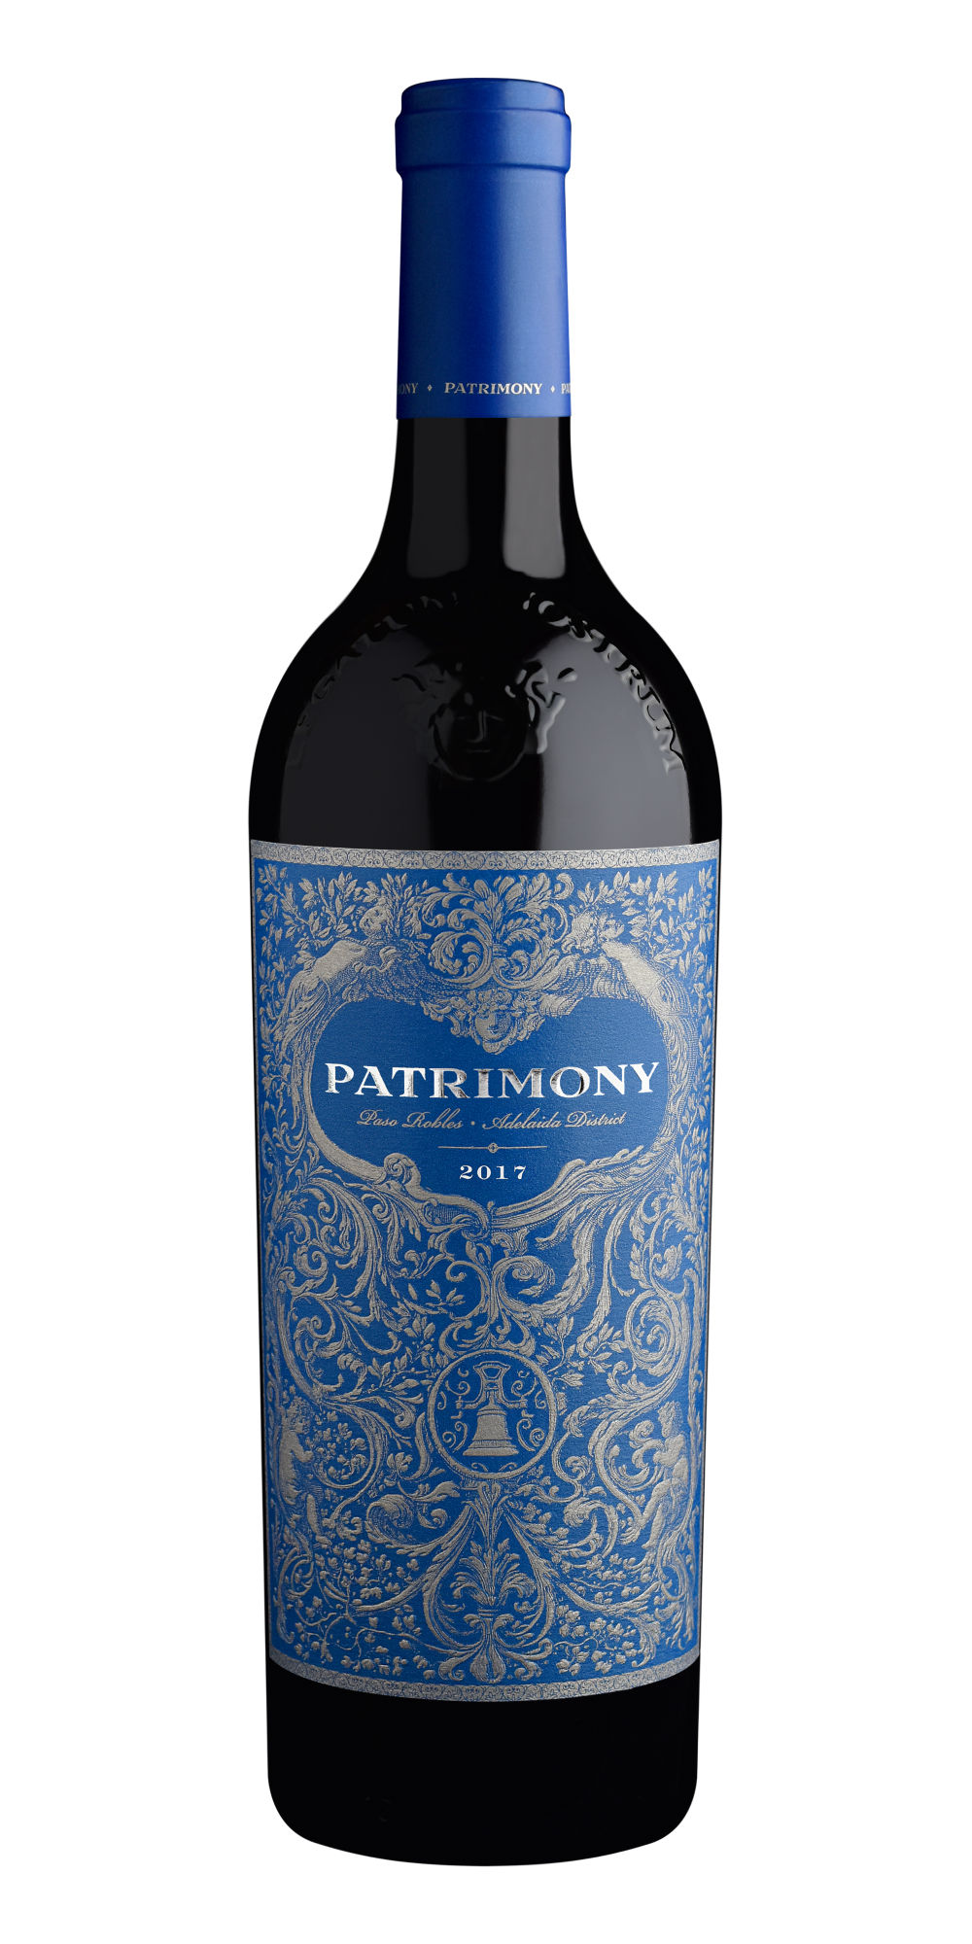
As the interview was winding down, I had one final question for Daniel, Why PATRIMONY? He said, “While Soul of a Lion is dedicated to Georges’ and my father, PATRIMONY is Georges’ and my legacy. This is what Georges and I want to leave the world and be remembered by.” Starting with the 2017 vintage, each bottle is prominently molded above the label with LEGATUM NOSTRUM meaning Our Legacy in Latin.

2017 DAOU PATRIMONY Bordeaux style
Cabernet Sauvignon with LEGATUM NOSTRUM
(Our Legacy) molded into the bottle.

I suspect some readers are thinking, where and how do I get PATRIMONY ($275). PATRIMONY will remain a small production wine, even with the 80 acre expansion. Interested patrons are encouraged to sign up for the waiting list on their website. An interesting factoid is that starting with next year’s 2018 vintage, bottles will be tagged with near field communication (NFC) tags and have certificates of authenticity. This will allow collectors to trade PATRIMONY like artwork on markets such as Sotheby’s. Details at patrimonyestate.com.

Story by Tech Director/Writer Rico Cassoni

Wine Bytes

West End Bar & Kitchen is Del Mar presents a night of royal treatment with Schramsberg Sparkling Wine Vineyards and Davies Vineyards of Napa Valley in a memorable 3 night wine dinner, Thurs. Fri. and Sat. Feb. 25, 26, and 27 at 6pm. This event is close to a sell-out so don’t delay. Cost is $95. per person plus tax and gratuity. Call 858-259-5878 to reserve your seat.

Flora Bar & Kitchen in the Carmel Valley Trader Joe’s Center is planning a DAOU wine dinner with Proprietor and Winemaker Daniel Daou, Wed. March 24 at 6pm. This 5 course dinner menu will perfectly compliment the carefully selected DAOU wines, including the world class DAOU Soul of a Lion. Call 858-461-0622 to reserve your seat. Cost is $75. per person plus tax and gratuity.

Frank Mangio is a renowned wine connoisseur certified

by Wine Spectator. He is one of the leading commentators

on the web. View his columns at tasteofwineandfood.com.

Go to recent columns. Reach him at frank@tasteofwineandfood.com

