
TASTE OF

WINE & FOOD

By Frank Mangio

Week of January 31, 2021

Wineries/Restaurants Open Again for Outdoor Tasting and Dining

With Valentines Day just a brief couple of weeks away, our needy friends in the hospitality and wine business would love to see you for a hearty glass of wine and a dinner away from home.

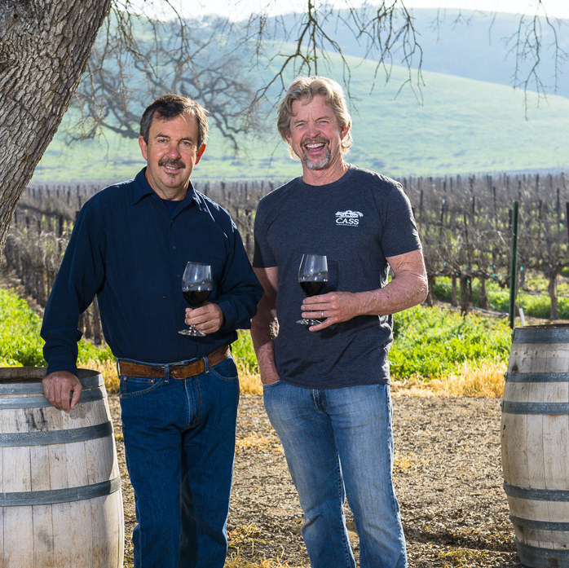
If time permits, go for a visit to Cass Vineyard and Winery in Paso Robles, and hook up with owner Steve Cass and partner Ted Plemons. They’ve officially kicked off 2021 as the year of “New Beginnings and New Hopes.” Last year with the lock-downs and restrictions, not many of their upgrades and plans got to see the light of day. But it’s a new dawn and a new day and hopes are high that serving wine and food will be approved inside as well.

Cass Vineyard and Winery in Paso Robles is operated by
Owner Steve Cass (left) and Partner Ted Plemons.

Cass Vineyard and Winery began operations back in 1999 when Steve Cass retired from the Charles Schwab brokerage business at 48 years old. Paso Robles was a favorite place to visit. That, and his love of wine, moved him to find a 145 acre pasture, perfect for a vineyard and winery. In 2002 Cass found Ted Plemons, a real estate builder, who constructed a tasting room, production barn and residence. A mutual love of Syrah reds led to other big ideas and soon Paso Robles had another progressive winery, capped recently by the newest modern winery retreat, Geneseo Inn at Cass.

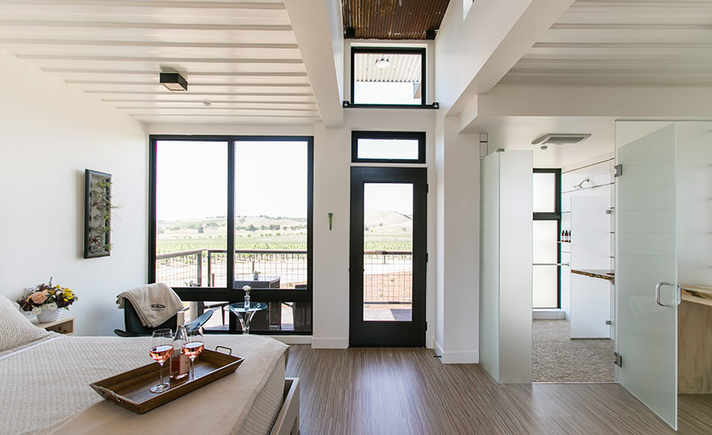
Geneseo Inn is a luxury boutique hotel nestled in the rolling hills of Cass Winery’s 145 acres of vineyard, allowing guests to “breathe in the vineyard views.” At Geneseo, you’ll enjoy ultra-modern appliances and décor, panoramic elevated vineyard views from a private bedroom deck, and an

The interior of one of 12 Geneseo Inn individual suites

with panoramic views of the 145 acre Cass Vineyard

and Winery in Paso Robles.

included daily Estate Breakfast, prepared by the executive chef. Chef gardens

are grown around the perimeter of Geneseo, making it the quintessential food, wine and lodging experience. Guests can ramp up their adventure with an optional “Cass Camp” experience in the vineyard, making it a playground of fun and learning.

Pick from horseback riding, cooking classes, E-bike rentals, archery and a “field to fork” class. Of course, this is a VIP winery with the emphasis on Rhone style

French wines, led by a 2015 Backbone Syrah, which hits double gold annually.

See more and reserve your Geneseo Inn suite at casswines.com.

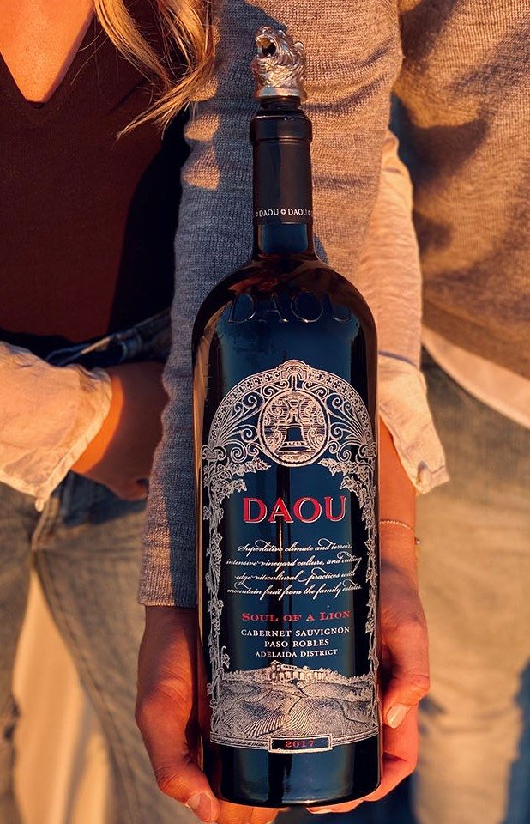
DAOU Family Estates Perfect

Valentine’s Day Gift

No matter lockdowns, pandemic and outside only,

nothing can diminish true love, Valentine’s Day and DAOU’s lovely Soul of a Lion Magnum Gift Set. This gift honors inspiring love stories of family members.

Toast your love with a “Soulmates” Gift Set that includes: a regal 2017 Magnum Soul of a Lion along with a lion head pourer-aerator in a luxury gift box.

This Bordeaux Blend wine displays richness, elegance and balance, the hallmarks of a superb growing season that allowed for extended ripening.

The 2017 DAOU Magnum Soul of a Lion

now in a Valentines Gift Set at the winery.

A deep, complex bouquet reveals notes of cassis, black currant, licorice, incense, ripe plum and vanilla. The wine has received very high marks, from 95 to 97 points, from leading wine commentators.

Cost for the DAOU Magnum Soul of a Lion Valentines gift set is $350 plus $10. flat shipping. To order yours go to daouvineyards.com.

Frank Mangio is a renowned wine connoisseur certified

by Wine Spectator. He is one of the leading commentators

on the web. View his columns at tasteofwineandfood.com.

Go to recent columns. Reach him at frank@tasteofwineandfood.com

