
TASTE OF

WINE & FOOD

By Frank Mangio

Week of December 13, 2020

Guy Fieri – A Restaurateur Hero

I suspect that many of our readers have had a chance to see one of the food industry’s most loved chefs, Guy Fieri. Perhaps some even recall his famous saying, “Welcome to Flavortown” from his Food Network’s show, “Diners Drive ins, and Dives.” A few weeks ago, I had a tweet pop up talking about how Fieri is assisting the restaurant industry. With this info in hand, I reached out to Senior Editor Frank and he said, “Rico roll with it” and so here we are.

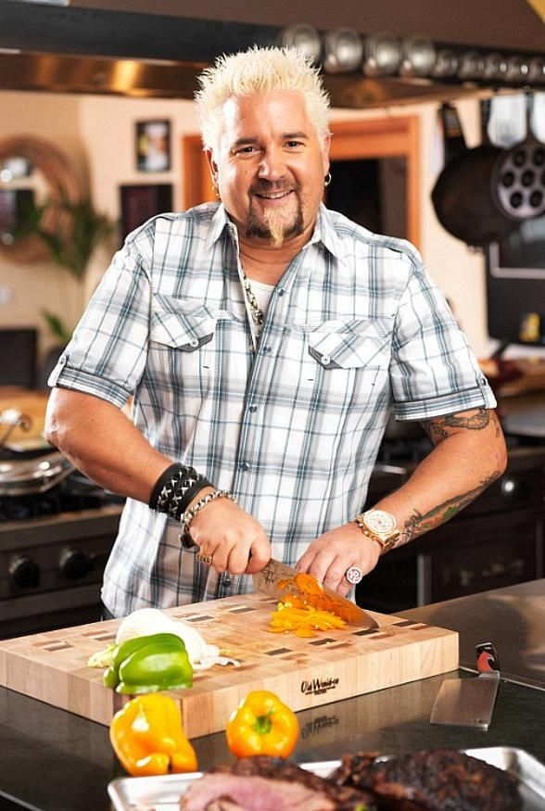
Fieri started his love affair with food at 10 years old selling soft pretzels from a bike cart that he built. Along with washing dishes for six years, Fieri earned enough “dough” to study abroad in Chantilly, France and then earn a Hospitality Management degree from the Univ of Nevada, Las Vegas (UNLV). After graduating, Guy returned home to Northern CA to open his initial dining concepts eateries.

In 2006, Fieri with his blonde dyed hair, tattoos, charm, and culinary skills won Food Network’s popular television competition show, “Next Food Network Star.” This grew his initial culinary career into becoming a worldwide restaurateur, New York Times Best Selling author, and Emmy Award

Guy Fieri famous for his Food Network’s
show Diners, Drive ins, and Dives working
in the kitchen chopping up vegetables.

winning TV host, as one of the world’s most recognizable culinary stars. He even has a Hollywood Walk of Fame star to prove it.

Seeing his restauranteur colleagues across the nation struggle with the devasting impacts of Covid, Fieri knew he had to help the restaurant industry. In March, he started the Restaurant Employee Relief Fund, raising $21.5 million for unemployed restaurant workers. Fieri’s Fund has helped over 43,000 people in the restaurant industry with $500 grants. What an amazing effort using his star power to help the battered food industry. More info at rerf.us. Bravo Guy Fieri!

When not fundraising, Fieri was busy putting together a new documentary, Restaurant Hustle 2020: All On The Line. Fieri said, “When the COVID-19 pandemic hit, the impact on the restaurant industry was immediate. Restaurant Hustle 2020: All On The Line provides a real and intimate first-hand look into the lives of four top restaurateurs navigating through it all.” Hopefully, the documentary provides awareness and additional contributions to the Restaurant Employee Fund. Check out the airing on Sunday Dec 27th, on Food Network.

Story by Tech Director/Writer Rico Cassoni
The World’s Top Ten Wines from Wine Spectator
Although we’ve been knocked around and humbled by the Coronavirus Pandemic, with devastating losses in our restaurants, bars and tasting rooms, our taste for wine excellence has never been greater, with increased higher-end wine consumption at home and an increase of 80% in on-line sales year over year. We now bring you the unveiling of the 2020 Top Ten wines from Wine Spectator, the world’s largest circulated wine publication.
The staff of WS reported that they blind-tasted over 11,000 wines this year with nearly 50% rated as 90 points or higher. The top 100 wines will be revealed in WS in their next edition, evaluated for quality, value, availability and the “wow” factor.
Truly a world class list, there are 6 countries represented in the WS Top Ten:U.S. (California 3 & Oregon 1), France (2), Italy (2), Argentina (1) and Spain (1). (All wines with their scores, prices and descriptions are sourced from Wine Spectator.)
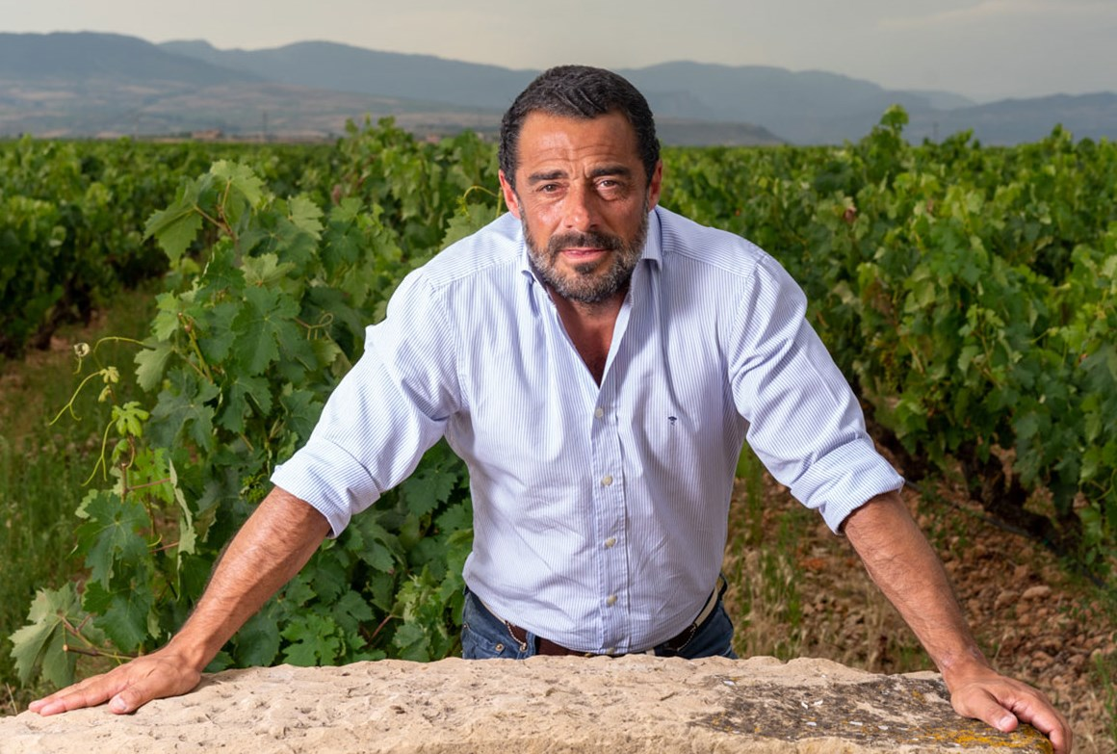
#1- Bodegas Marques de Murrieta Rioja Spain 2010. $139. Marques de Murrieta is one of the founding wineries in Rioja, Spain’s premier wine-producing region. This wine is a leader in using French techniques for greater complexity and longevity from Tempranillo, Rioja’s native red grape. This wine has matured for a decade in the wine cellar before release.
Vicente Cebrian-Sagarriga is the owner/winemaker
of Bodegas Marques de Murrieta Gran Reserva,
vintage 2010, from Rioja Spain.
2- Aubert Pinot Noir Sonoma Coast 2018. $85. Mark Aubert is a skilled master of Pinot Noir, made off the coast of western Sonoma County. His goal is to make wines with mouth-filling flavors and a low amount of tannins. Powerful and structured with mineral richness that adds to the fine-edged red fruit and savory spice flavors.
#3-San Filippo Brunello Le Lucere, Montalcino, Italy 2015. $90. San Filippo is a 25 acre vineyard on a plateau of more than 1,320 feet in elevation, aged in three sizes of barrels, then spends another 14 to 16 months in large floor to ceiling casks and a year in bottle before release. The wine shows terrific complexity.
#4-Mayacamas Cabernet Sauvignon Mt. Veeder Napa 2016. $135. Winemakers age this venerable wine 32 to 36 months in mostly neutral oak. This cab is built on acidity and minerality and represents 2 years in a row in the WS Top Ten.
#5-Domaine de la Vielle Julienne Chateauneuf-du-Pape 2016. $90. A biodynamically farmed estate with 54 acres of vines in sandy soil. The wines impart a silky elegance to the typically powerful fruit profile of Grenache.
#6-Kistler Chardonnay Russian River Valley Sonoma 2017. $90. Sandy soil produces berries that are small in size with concentrated fruit flavors backed by high natural acidity. This is perfect for long-term aging. This Chardonnay is a leader in the new California cool chards that have swept the state with purity and freshness.
#7-Massolino Barolo Serralunga d’ Alba Italy 2016. $53. Fourth generation brothers Franco and Roberto Massolino produce this muscle wine from the heart of Serralunga d’Alba, on a 100 acre estate. A blend of the native Nebbiolo grape, the wine is aged 29 months in 5,000 liter Slavonian oak casks.
#8-Bodega Piedra Negra Malbec Los Chacayes Mendoza Argentina 2015. $99. This wine is made at an elevation of 3,600 feet above sea level, rich with gravelly deposits from the nearby Andes. It’s aged 24 months in mostly new French Oak.
#9-Beaux Freres Pinot Noir Willamette Valley Oregon 2018. $95. This vineyard is planted on Ribbon Ridge, deep in the Chehalem Mountains AVA. A wine of expression, elegantly layered with raspberry, rose petal and brown baking spice.
#10-Bollinger Brut Champagne La Grande Annee Champagne France 2012. $175. The cellar master has blended the 2012 La Grande Arnee with its intense spine of acidity, with a range of flavors offered by a Pinot Noir and Chardonnay Blend, sourced from premiers and grand crus vineyards. This racy wine goes from zero to 60 right out of the gate, richly aromatic and expressive from start to lasting finish.
In the next TASTE OF WINE & FOOD, the week of December 27th, our Top Ten Tastes for 2020 will be reviewed. Don’t miss it.
Rico and I wish you a relaxing, healthy, and joyous holiday season!
Wine Bytes
Both Rico and I urge you to patronize Sal Ercolano’s West End in Del Mar and Flora in Carmel Valley for your next take out dinners. West End has free delivery up to 3 miles, every day from 4pm to 8pm. Buy $50. worth of take out food and select a bottle of wine from the menu at a 50% discount. Call 858-259-5878.
Flora is Ercolano’s Farm to Table family restaurant featuring delicious Italian specialties. Take out and delivery hours are 4 to 8pm Tues. thru Sun. Buy $50. worth of dinner and get a free pizza of your choice, up to $15. Call 858-461-0622.
Limited time on both specials.

Frank Mangio is a renowned connoisseur certified

by Wine Spectator. He is one of the leading commentators

on the web. View his columns at tasteofwineandfood.com.

Go to recent columns. Reach him at frank@tasteofwineandfood.com

