
TASTE OF

WINE & FOOD

By Frank Mangio

Week of Nov. 8, 2020

A Tale of Two Legends – Morton’s & DAOU

If you asked Senior Editor Frank and me our favorite steakhouse, Morton’s The Steakhouse, would be at the top of our lists. If asked our favorite wine, DAOU Family Estates would be at the top of our wine lists. We were instantly salivating when we saw the “A Tale of Two Legends” Morton’s The Steakhouse DAOU Wine Dinner announced. Frank and I were excited to attend the four-course 5 star dinner at the San Diego Morton’s venue overseen by General Manager Tim Reed and narrated by DAOU Family Estate, Daniel Brunner, CSW, Assistant Division Sales Manager, Southern California.

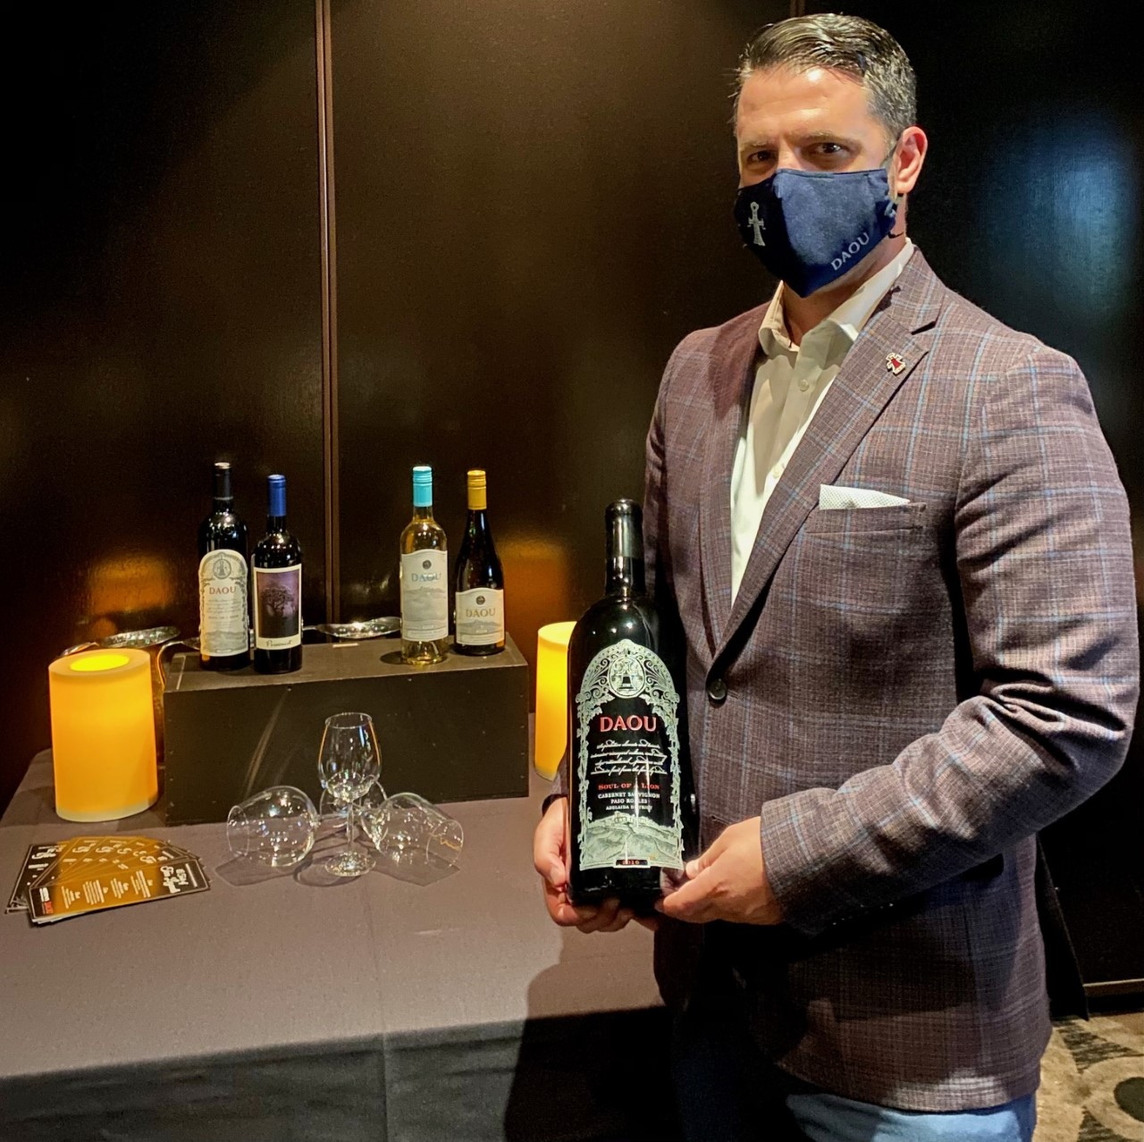
DAOU Family Estates is owned by brothers Georges and Daniel Daou. Daniel is also their winemaker. I would add that Daniel is one of the top master winemakers in the world across all varietals they produce and a Cabernet Sauvignon wizard! When I think of DAOU three items come to mind: (1) Lebanese culture and love of family (2) Quest to make the world’s best Cabernet and (3) The experience created for their customers whether at beautiful DAOU Mountain or wherever you are enjoying DAOU wine.

DAOU Family Estate, Daniel Brunner, CSW,
Assistant Division Sales Manager, Southern
CA holding a 3 liter magnum of DAOU
Estate Cabernet Sauvignon Soul of a Lion.

Let’s take a dive into each of these. The Daous immigrated to France after their home was devastated by an errant missile. Three of the four children playing outside were taken to the hospital. The most serious injured was Georges who ended up in a coma. When he awoke at the hospital, he peered into the eyes of brother Daniel creating a bond even beyond brotherly love. Georges and Daniel moved from France to attend school at UC San Diego. They used their engineering skills to create Daou Systems, an IT healthcare system that they sold. After selling the company, Daniel immediately knew the next item in his career was to buy land to become a vineyard that he dreamed of as a child growing up in France inspired by his father Joseph Daou, who loved to talk to the boys while enjoying a glass of wine. Of course, Daniel knew he could not fulfill this dream without his brother Georges. Georges and Daniel scoured the world for several years and purchased a magical spot in Paso Robles at 2200ft with rich calcareous soil infused with limestone creating some of the best wine phenolics in the world, now called DAOU Mountain. Daniel planted the first 33 acres of vines by hand in 2007. Daniel’s oldest daughter Katherine, DAOU Social Media Manager & Brand Ambassador, remembers her father being the happiest he ever was in his life sowing the new young vines.

Everything DAOU does from high density planting techniques to drop fruit ensuring all fruit is ripe at the same time, optical sorters, specialty French Rosewood Oak for their barrels, their own yeast strain that Daniel has developed, free run juice, night harvesting, etc. goes into every bottle from their Discovery label to their fifth and top tier Patrimony. Each bottle has gold foil labels, ornate corks, thick glass, and deep punts except a few varietals including Rose’ with white stenciling on the bottle. It is rare to see a wine product with so much craftsmanship, quality, and care. The third item on my list is creating unforgettable experiences. To me, this is rooted in how down to earth, kind, and approachable the Daou Family is. This flows to employees and ultimately out to their customers. I highly recommend all our readers to experience DAOU Mountain the next time you are in Paso Robles to take in the breathtaking views and ultimate wine and food experience. Details at daouvineyards.com.

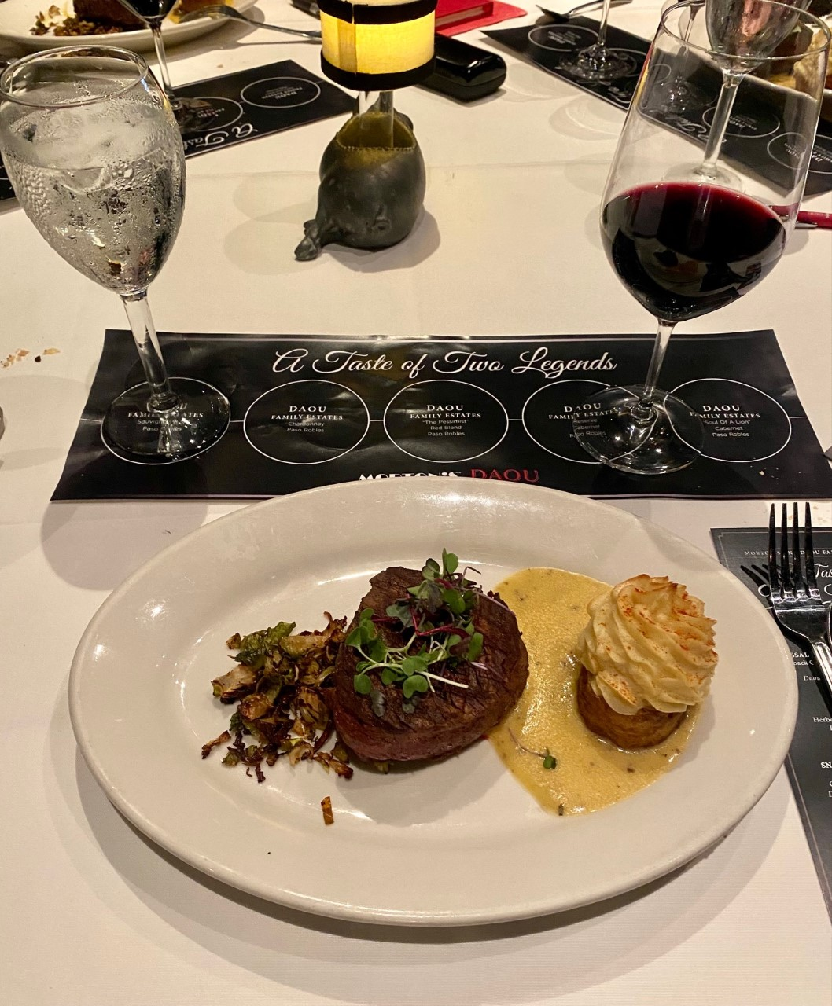
Now onto the dinner that kicked off with Morton’s Colossal Lump Crab & Avocado salad with large pieces of crab atop avocado chunks marinated in mustard dressing topped with caviar. This was paired with DAOU Sauvignon Blanc. The pineapple and lemongrass nose and apple with mango palate completed the salad. The second course featured Lobster Cargot with herbed garlic butter and crisp puff pastry. DAOU’s Chardonnay with honeysuckle and vanilla aroma and silky palate with hazelnut and toasted almonds on the finish paired nicely with garlic butter of the cargot.

Morton’s The Steakhouse Snake River
Farms Filet Mignon with Twice Baked
Potato and Crisp Brussel Sprouts paired
with DAOU Reserve Cabernet.
The main course featured flavor explosions of Morton’s famous Snake River Farms Filet Mignon perfectly custom prepared for each guest served with Twice Baked Garlic Duck Fat Potatoes and Crisp Brussel Sprouts with a DAOU double header of Pessimist and Reserve Cab. Pessimist is a Petite Sirah (62%), Zinfandel (20%), Syrah (16%), and Lagrein (2%) blend. The world class Reserve Cab includes 95+ and 92 point accolades from Robert Parker Wine Advocate and Jeb Dunnick respectively. Dinner ended with a “fireworks finale” of La Bete Noire, which in French translates to chocolate beast. This is one of the best desert “beasts” I have ever tackled paired DAOU’s Flagship Soul of a Lion dedicated to Georges and Daniel’s father Joseph Daou. Soul is a blockbuster Cab (78%) blended with 13% Cab Franc and 9% Petit Verdot for a perfect balance of aroma, palate, and the deepest color I have seen in a Cab. It is aged for 22 months in 100% new French oak. This remarkable wine has earned a 96 point Jeb Dunnick score. Thank you Tim Reed and Morton’s team and DAOU (Daniel Brunner) for a perfect wine dinner. See mortons.com.
Story by Tech Director and Writer Rico Cassoni

Wine Bytes

West End Bar & Kitchen Del Mar will present a Wine Dinner with Chateau Montelena of Napa Valley, Thurs. Nov. 19 and Fri. Nov. 20 at 6pm. Wines are from French oak barrel aging and are the result of sustainable and organic farming that promote soil health. A 5 course dinner is featured. Cost is $75.

per person plus tax and gratuity. Be sure to RSVP at 858-259-5878.

Charthouse in Cardiff has Thanksgiving Family Meals available for order. Choose from their famous slow roasted Prime Rib or traditional Turkey Dinner, both served with a starter, entrée accompaniments and desert for a family of 3 to 4. Pre-order by Nov. 20 at 3pm. Call 760-436-4044.

North County Wine Company in San Marcos has a Pinot Noir Thanksgiving

Promotion. Check out their weekly Pinot special discount price. Think cherries and raspberries with a long, luscious finish. Call 760-653-9032 for discounts.

Frank Mangio is a renowned wine connoisseur certified

by Wine Spectator. He is one of the leading commentators

on the web. View his columns at tasteofwineandfood.com.

Go to recent columns. Reach him at frank@tasteofwineandfood.com

