
TASTE OF

WINE & FOOD

By Frank Mangio

Week of Nov. 1, 2020

Nightly Live Music at Coomber Craft Wines

A few weeks ago, Frank and I had a great time revisting Coomber Craft Wines in Oceanside, which happened to be the first place we visited following Covid lockdown in June. This time we were with our travel writers Scott Hagner and Nancine Belfiore. As always it was good to catch up with Owner Skip Coomber.

Skip’s goals continue to be the same. When asked, he loves being an upstanding member in the Oceanside beach corridor and to have his guests enjoy Coomber Craft Wines as an experience in a fun and comfortable environment with food delivery from local eateries. Taking a step into the winery is like walking into Cheer’s. Skip’s connection with his guests is incredible. Each guest is always greeted with a smile and “hello how are you doing” that launches into a friendly conversation. This is one of the reasons why wine club membership has grown 50% over the pandemic from 200 to 300 members. Along with great wine!

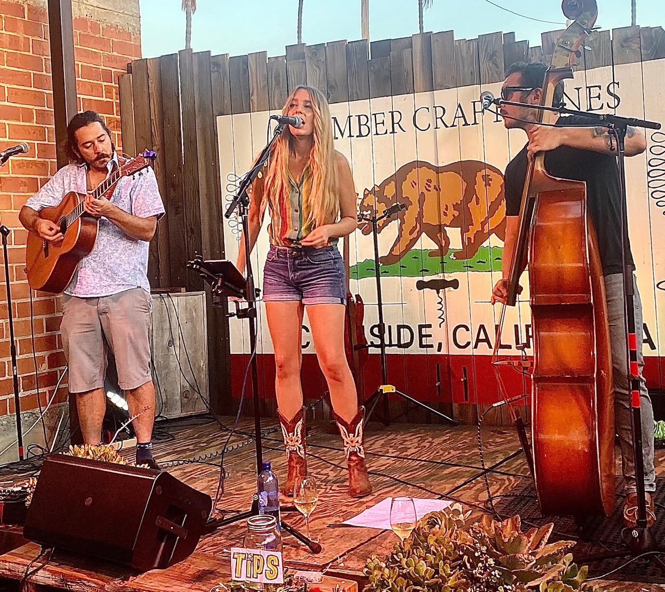
Another element of the magic at Coomber’s is the nightly live music with two sets each evening. Being a musician himself, Skip said, “He is committed to helping local artists survive the pandemic and what better way to do this than nightly live music.” This visit we were blown away by Kimmi Bitter’s pipes and chops. She prides herself on being old school with music integrity inspired by Patsy Kline and Linda Ronstadt. The set included her own music along with covers from

Kimmi Bitter performing at Oceanside’s
Coomber Craft Wines flanked by guitarist
Willis (left) and bass cellist Ben (right).

Carly Simon, Johnny Cash, The Judds, Tom Petty, Bonnie Raitt, and more. Kimmi along with guitarist Willis and bass cellist Ben typically perform on Thursday evenings. Be sure to make a reservation at (760)231-8022. Also, you can check out Kimmi at kimmibitter.com along with social media and Spotify.

It was easy to enjoy the music alongside Skip’s delicious wines which included the 2013 Signature Collection Santa Ynez, Cabernet Sauvignon ($57) and paired nicely with the Benito’s Brick Oven Classic pizza topped with pepperoni, portobello mushrooms, and onions. The Cab sported cherry and cocoa and dark fruit on the palate.

With the seasons changing, Coomber guests will continue to be able to partake in the music thanks to the new outdoor roof installed. As always, it was a delight to visit Coomber Craft Wines. This is a must do experience for wine and music lovers. Thanks Skip and The Coomber Team for another great evening and wine experience! Additional details and calendar at coomberwines.com.

Story by Tech Director/Writer Rico Cassoni

BLACK RAIL KITCHEN + BAR Thrives with Soothing Outdoor Dining
This little story begins with two successful family-driven restaurants sailing along in pre-Covid years in the same neighborhood shopping center in La Costa/Carlsbad in SoCal. Beach Plum and Tin Leaf built up a reliable “fast-casual” in and out menu business for their owners who happened to live in the neighborhood and could shop in the center.
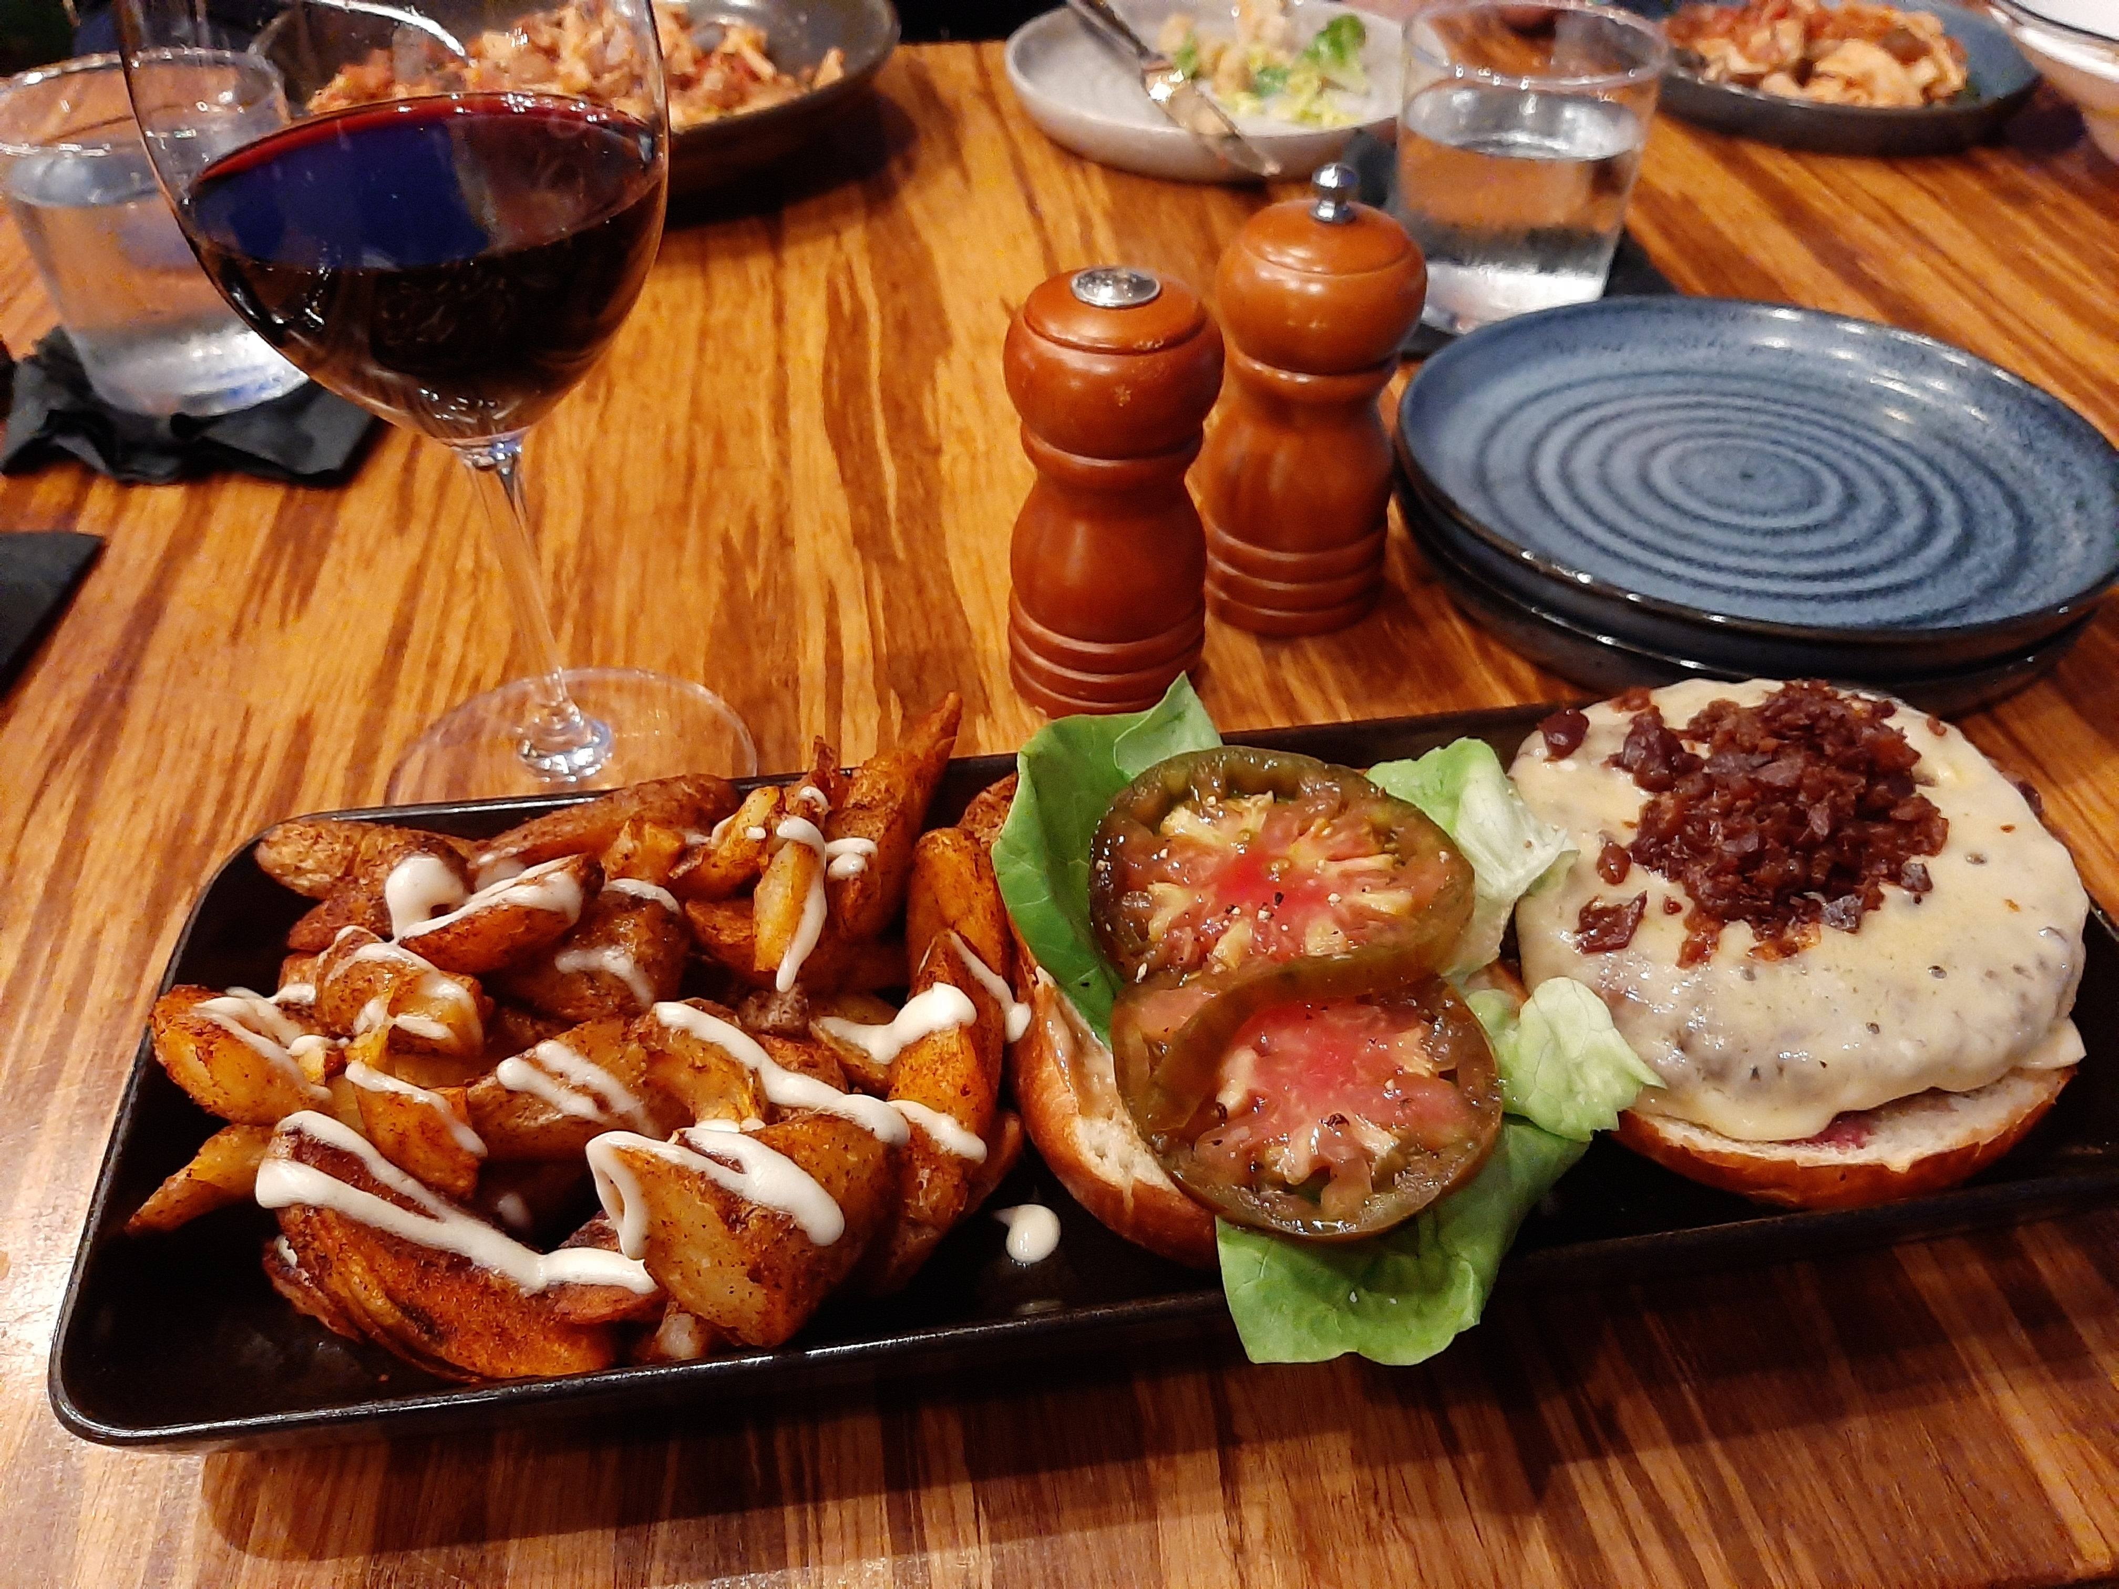
But, their passion was for “something fresh and new.”
The result was the third restaurant in the same center, Black Rail Kitchen + Bar, an upscale, beautifully appointed
dining room and bar, in an elegant indoor/outdoor setting. It’s relaxed and friendly, with food crafted by excellent chefs and caring servers.

Black Rail Kitchen + Bar, less than a year old in La Costa/Carlsbad
is serving fresh, innovative menu items in its spacey upscale patio
with a comfortable temperature-controlled environment. The custom
made Black Rail Half Pound Burger entrée is shown above.

The dining experience is now outdoors due to Covid pandemic protocol, but this wide ranging patio was well planned for comfort and care for diners and sippers. It’s attention-getting, with a dramatic fire treatment in the evening.
The menu opens with a Middle East/Italian influence, a “Mediterranean Mezze” of roasted garlic hummus, tzatziki, red pepper feta and fire-roasted pita, then swings into the sea with tuna tartare and garlic shrimp. Plenty of soups and salads add to the appetizers and sharing plates. Do you love flatbreads and housemade pastas? If so, you’re at home with Black Rail and their endless choices.
My choice for a “larger plate” was the Black Rail Half Pound burger, grilled with Prime Beef. Burger lovers dream about meeting up with this one. It was surrounded by crispy Pancetta, Havarti cheese, Bibb lettuce, tomato, black garlic
Aioli, toasted Brioche bun and crispy Fingerling potatoes. I washed it down with a red wine Zinfandel by Seghesio, from Sonoma. On occasion, live music keeps the good vibes coming. Dinner and bar hours are Tues. thru Sun. from 4 to 9pm. Happy hours are Tues. thru Fri. from 4 to 6pm. For further information, call 760-931-0020 or visit blackrailkitchen.com.

Wine Bytes

Il Fornaio in Del Mar is now open for lunch every day. Make a reservation or order food and wine to go. Your choice of indoor or outdoor dining, or curbside pickup and delivery available. Call 858-755-8876.

A Wine Tasting class is on with a renowned Sommelier at Somerset Winery

in Temecula, Sun. Nov. 29 from 10:30 to 1pm and Sun. Dec. 13 from 10:30 to 2:30pm. Cost is $85. per person for the public. It includes 7 wine samples, food samples, tour of the barrel room and other experiences. For details, call 951-365-5522.

Vigilucci’s North County Coastal Restaurant Group has a large menu of take out food, perfect for two, with the same great quality Italian food as always. Choose your location: in Leucadia call 760-634-2365, in Carlsbad call 760-434-2500 and in Carlsbad by the Sea, it’s 760-434-2580.

Frank Mangio is a renowned wine connoisseur certified

by Wine Spectator. He is one of the leading commentators

on the web. View his columns at tasteofwineandfood.com.

Go to recent columns. Reach him at frank@tasteofwineandfood.com

