
TASTE OF

WINE & FOOD

By Frank Mangio

Week of Oct. 25, 2020

Cakebread Wine Dinners Sell Out at Seasalt

Sal Ercolano hosted two sold out nights of Cakebread Cellars Wine Dinners this past week at Seasalt Seafood Bistro in Del Mar as part of his 2020 Wine Dinner series. Over a delicious 5 course dinner paired with Cakebread wine, guests learned about Cakebread’s history and wines from Young’s Market John Parker who narrated the wine dinner event.

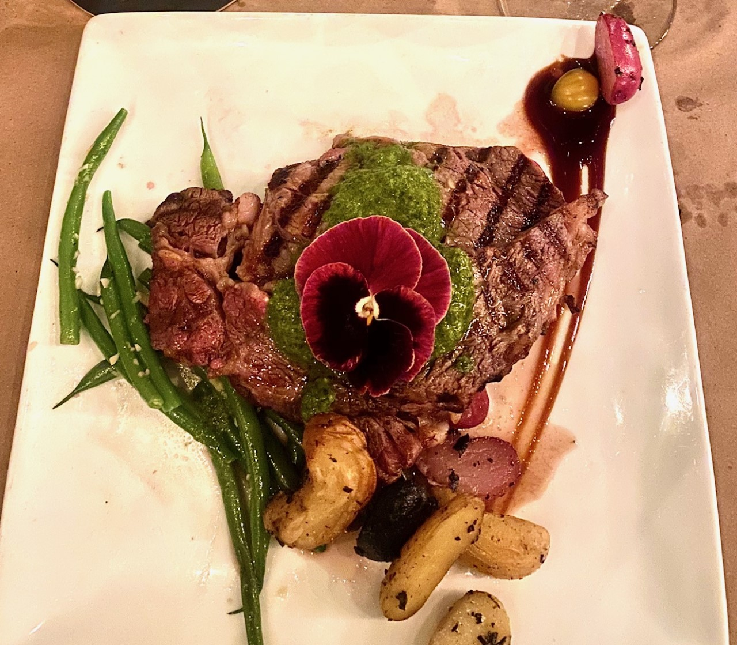
Like many wineries and vineyards, Cakebread Cellars has a unique story that guests were able to learn about over dinner. By trade Jack Cakebread was a photographer. In 1972 when doing a photo in 1972 for Nathan Chroman’s "Treasury of American Wines", Jack and Dolores Cakebread fell in love with Sturdivant Ranch in Rutherford. The Cakebreads casually offered to buy the 22 acre ranch. By the time they got home to Oakland after the photo shoot, Ribeye drizzled with chimichurri sauce, fingerling
potatoes, French beans paired with 2017 Cakebread
Cellars Napa Valley Cabernet Sauvignon.

the phone rang and the Sturdivants took them up on the offer. Cakebread celebrated their first vintage in 1974, a Chardonnay with only 157 cases sold.

Fast forward 46 years later, the Cakebreads added to their family's estate vineyard collection throughout Napa Valley and Anderson Valley with a total of 1,600 acres across 15 vineyards including 200 acres on Howell Mountain where they created Dancing Bear Ranch for their top end 95 point Robert Parker rated Cab. A total of 600 acres are currently planted across the collection.

Now onto dinner. Guests enjoyed Chef Hilario mini bites with 2019 Sauvignon Blanc with citrus notes. The 1% Semillion added a subtle minerality. The second course paired 2018 Mendocino County Pinot Noir with wafer thin Wagyu Carpaccio accented with scallions and chives. The 100% pinot featured black cherry and plum on the palate complementing the Wagyu beef. Third up was Wild Ravioli filled with short rib and garnished with wild porcini mushroom paired with 2017 Merlot (85%) with Cabernet Sauvignon (9%), Syrah (4%), and Petite Verdot (2%) accents. The 17-month 55% new French oak maturation produced blackberry and black cherry with smooth tannins and bright acidity perfectly complementing the brown gravy. The fourth course featured ribeye with chimichurri sauce, tricolor fingerling potatoes, and French beans served with the 2017 Napa Valley Cabernet Sauvignon (84%) with splashes of Merlot (9%), Petite Verdot (4%), and Cabernet Franc (4%). The blackberry, boysenberry, and cocoa on the nose with dark fruit, smooth tannins and acidity was a perfect choice to pair with the ribeye and bread pudding dessert. Both this Cab and the Pinot Noir benefit from lots harvested, fermented, and matured separately, then the components are combined and further aged. More info at cakebread.com.

Next up in the Ercolano Wine Series is Chateau Montelena Thur. 11/19 and Fri. 11/20, $75 person at West End, RSVP at 858.259.5878. The series ends with a Royal Night of Schramsberg complex handcrafted sparkling wines along with Davies Vineyards at Seasalt on Wed. 12/16 and Thur. 12/17, $95 per person. RSVP at 858.755.7100. All wine dinners start at 6:00PM.

Also, Ercolano’s new Italian Restaurant in Carmel Valley, Flora Bar & Kitchen with “Modern Farm to Table Italian Cuisine” is now open. Guests will enjoy cheeses, breads and meats from local food artisans and fresh ingredients from local sources. Details at florabarandkitchen.com.

Story by Tech Director/Writer Rico Cassoni

CASS Winery Named 2020 Winery of the Year

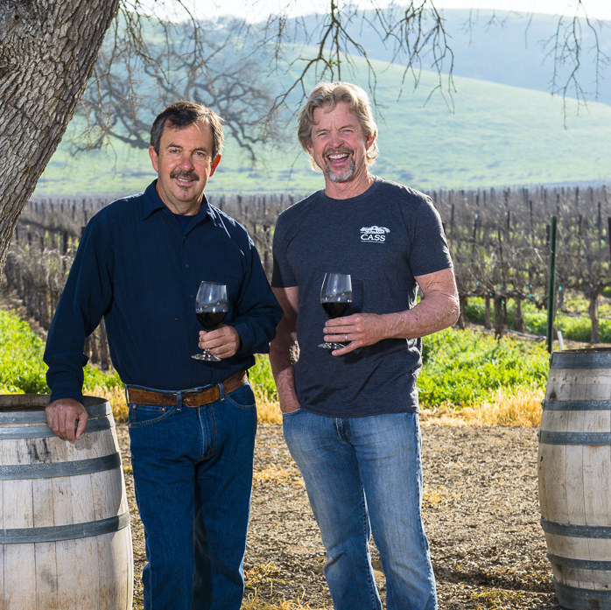
CASS Winery and Vineyard earned its 3rd Winery of the Year award by the 18th annual Central Coast Wine Competition (CCWC). Previous winners for CASS were 2015 and 2018, making it the first time a winery has won this award three times, all under the supervision of 34 year old chief wine maker Sterling Kragten.

This year’s competition included 503 wines from 86 wineries in 10 counties, from Alameda to Ventura.

Cass Winery and Vineyard of Paso Robles, with owner Steve Cass

and Partner Ted Plemons are celebrating receiving the 2020 Winery
of the year award at the 18th annual Central Coast Wine Competition.

All 18 wines submitted by Cass medaled. Specializing in Rhone Valley French wines, Cass collected 3 Best of Class, 4 double Golds, 7 Golds, and 7 Silvers that produced the point average to win the overall honor of Winery of the Year.

“It’s a big honor, there are lots of great wines in Paso Robles,” said owner Steve Cass. “I love the fact that the more obscure varietals (like Rhone reds and whites) are gathering so much attention.” Visit casswines.com.

Wine Bytes

With Halloween close at hand, North County Wine Company has the perfect

wine for the occasion. The 2018 Vampire Cabernet Sauvignon is blood red and full flavored, with lush notes of blackberry, plum, mocha and vanilla. Each bottle comes with its own vampire cape! This party wine is just $11.97 thru Halloween, Sat. the 31st. For a check on inventory call 760-653-9032.

The 8th annual Ramona Art and Wine Festival is Fri. thru Sun. Nov. 6 to 8 with wine tasting, bites, a silent auction and art and vendor exhibitors at 6 participating wineries. A gala reception will be held Fri. Oct. 30 at Hatfield Creek Winery from 5 to 7pm when commemorative art will be unveiled. For details on the Festival, see ramonaartandwinefest.net. You can also contact Elaine Lyttleton at 760-787-1102.

Frank Mangio is a renowned wine connoisseur certified

by Wine Spectator. He is one of the leading commentators

on the web. View his columns at tasteofwineandfood.com.

Go to recent columns. Reach him at frank@tasteofwineandfood.com

