
TASTE OF

WINE & FOOD

By Frank Mangio
Week of Oct. 11, 2020

Merlot’s Bounceback Complete with October

‘Merlot Month’ Celebration

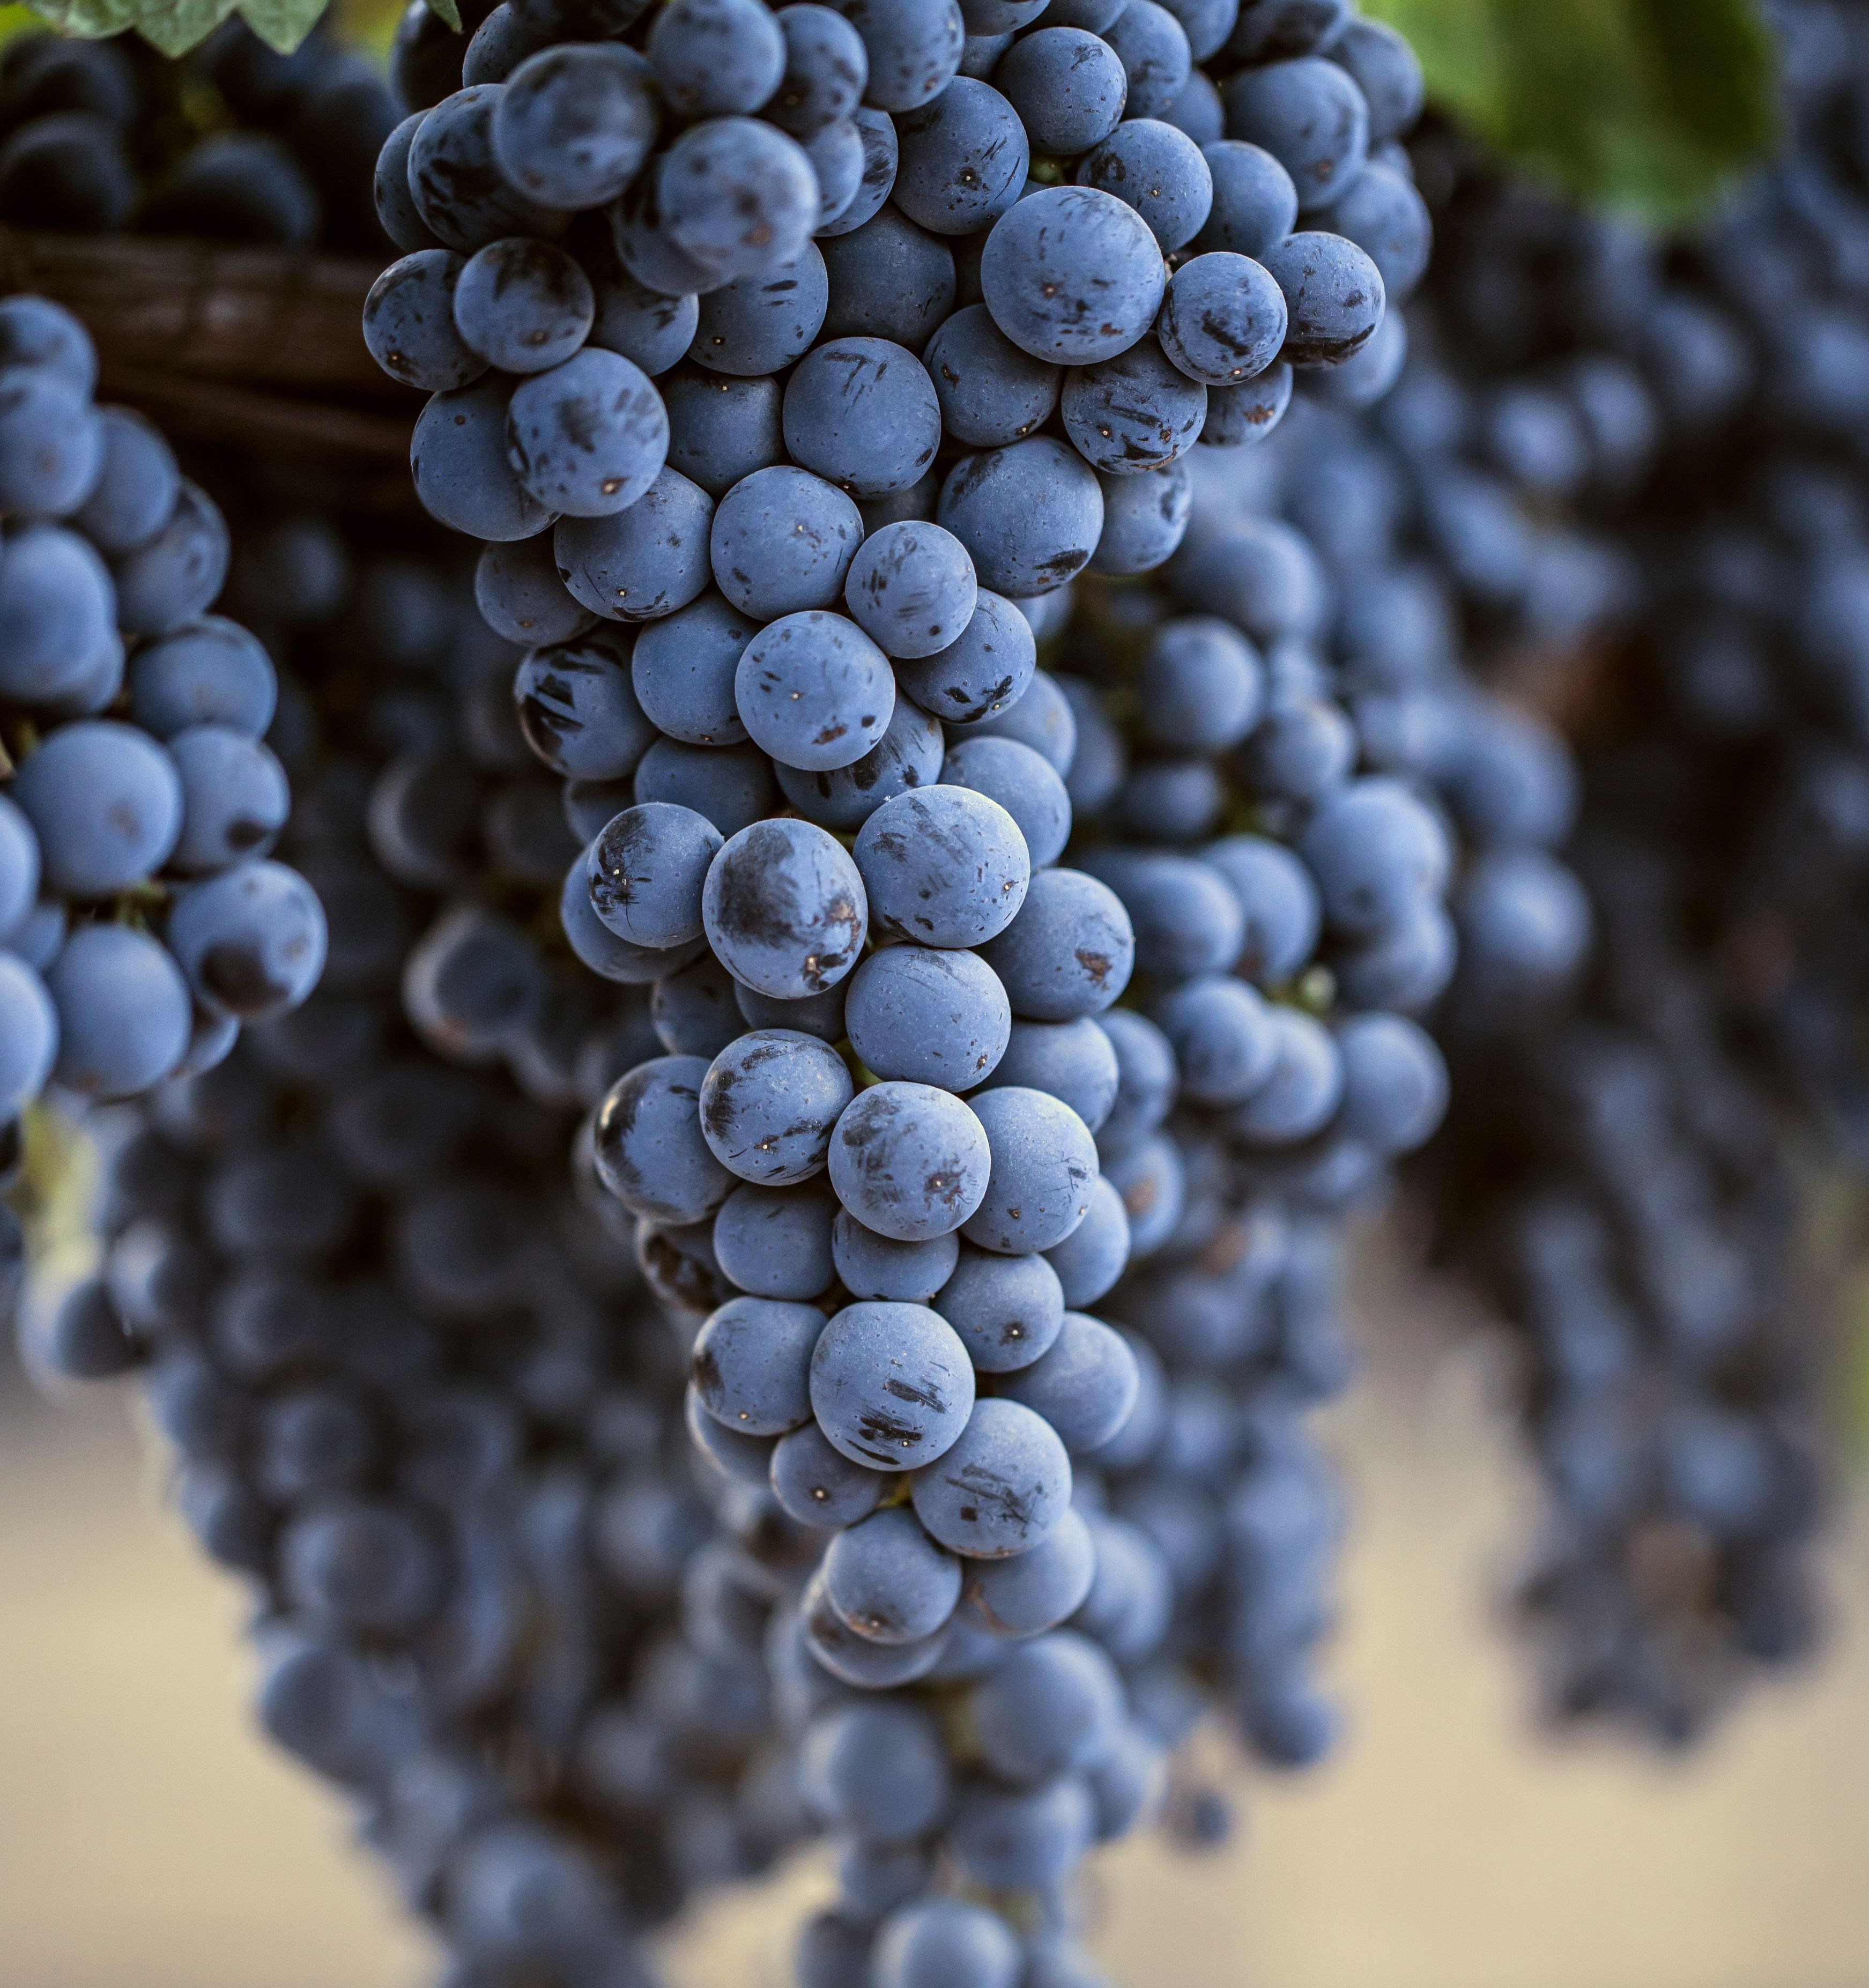
Fifteen years ago, an intoxicating wine movie comedy with little fanfare except “word of mouth,” caught fire. It was Sideways, about two frustrated sidekicks on a bachelor’s last days spent guzzling wine along the Central Coast of California. For some unknown reason, the movie savaged Merlot in both words and deeds, resulting in a stunning twenty five percent drop in sales that year. In the movie, Miles, the main character who hated Merlot, secretly owned a never-opened world-class Merlot bottle, a very expensive Right Bank Bordeaux French

The Merlot grape, shown above, has more than 720,000 acres
planted worldwide. It is reported to be the 2nd leading red
varietal after Cabernet Sauvignon.

legend named Petrus. In a fit of anger and frustration over a lost book publishing deal and a lost love, he gulps down the Petrus with a burger at a McDonalds.

At its best, Merlot is a beautiful round and supple grape. It is sometimes

characterized as the flesh on Cabernet Sauvignon’s bones. Proof of this

might be the fact that most red blends start out with Cab but make sure that the

next choice in the blend is Merlot. Some serious top-notch producers make intensely flavored, big, complex Merlots. We will review some below.

Merlot’s golden years were the pervasive Nineties. You didn’t buy a bottle of wine for a fine dinner, you bought a Merlot. That “bubble” of production

led to copycat bottles by two-bit growers peddling cheap, soft tasting bland Merlots. So “Sideways” was simply the punch-out in a wine balloon that had to burst to be eventually better. And better it got…so much so that in 2017, a Duckhorn with Merlot grapes from their Three Palms Vineyard in Napa Valley, was awarded the number one wine in the world by the most respected wine publication in the world, Wine Spectator. Spectator praised the wine as “an easy-going red of generous fruit and texture. Its subtle tannins make it perfect for early drinking that allows it to pair with a wide range of foods.”

The Renaissance of Merlot is being celebrated in October in a month-long recognition of its achievements in the wine world. The rallying cry is #MERLOTME, a global movement reaching millions of wine lovers. First, get your hands on some fantastic tasting Merlot. I have a few suggestions.

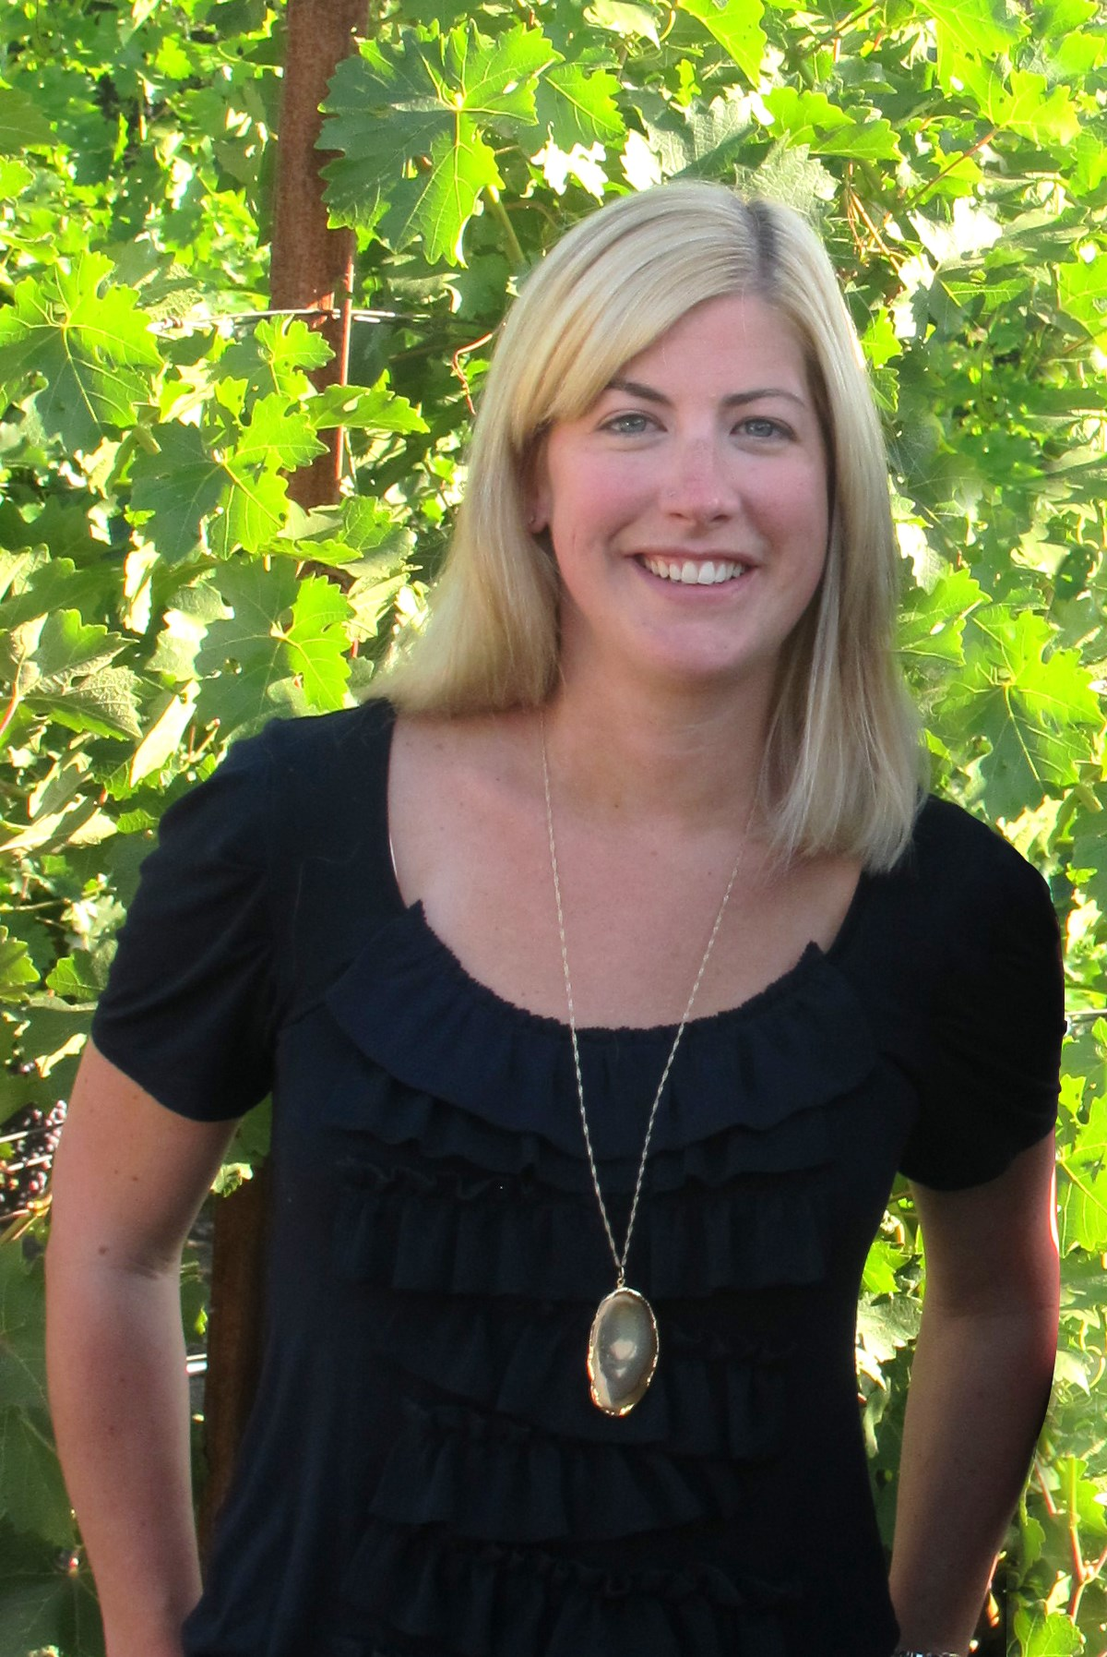
Inspired after a visit to Bordeaux, Dan Duckhorn produced the first vintage of Duckhorn Vineyards Napa Valley Merlot in 1978. A splash of Cabernet Sauvignon in the current 2017 vintage, adds notable depth and structure, as well as creative flavors of black cherry, plum and spice.($56.)

St. Supery is a Rutherford Merlot in Napa Valley and sports a rich black plum and chocolate tasting sensation for its 2016 vintage. ($50.) This was a near perfect growing season as TASTE OF WINE & FOOD has frequently enthused about. St. Supery ages its Merlot for nineteen months

Renee Ary joined Duckhorn in 2003,

and after a decade of learning its style,

was made the fourth winemaker in the

history of the vineyard.

for added layers of complexity. The wine is sustainably farmed and given optimal hang time. Sorting by cluster, then by berry, ensures a well-balanced Merlot.

Up Washington way, a stop at LeEcole No. 41 in Walla Walla is all you need to

confirm the quality of Merlot in this district. We tested the 2017 Estate grown Merlot. The winery was a school at one time, and proudly proclaims their Merlot as certified sustainable and salmon safe. The wine delivers great structure, color and balanced acidity. A beautiful Indian summer brought in plenty of sunshine for the October harvest. ($37.)

Visit MerlotMe.com for more information.

Wine Bytes

Lorimar Vineyards and Winery in Temecula is making a bid to become the

entertainment capital of that wine country with an array of dates monthly.

The live pop music group Those Guys, play Fri. Oct. 23 from 6 to 9pm.

Free admission, with food and wine for purchase.

Also, a fun Murder Mystery Dinner is on for Thurs. Oct. 29 with showtime at 7pm. It’s an experience that will leave everyone laughing. $50. per person includes admission and dinner with three choices of entrees. Go to lorimarwinery.com for all details, or call 951-694-6699.

Experience the new seasonal food and wine/spirits events at Morada, in the Inn at Rancho Santa Fe Resort & Spa. Chef Haas’ seasonal menu includes new versions of a Pan Seared Seabass and Charred Ribeye. A cocktail lab is presented

each Thurs. at 5:30pm in the Huntsman Whiskey Bar. Oct. 21st enjoy the Bourbons of Jack Daniels. Cost is $65. per person. Small bites are provided. Details at 858-756-1131.

October is National Seafood month at Charthouse along the Cardiff coast. On Mon. thru Thurs. celebrate with a 3-course sea-to-table Prix Fixe menu for $39. each. RSVP at 760-436-4044.

Frank Mangio is a renowned wine connoisseur certified

by Wine Spectator. He is one of the leading commentators

on the web. View his columns at tasteofwineandfood.com.

Go to recent columns. Reach him at frank@tasteofwineandfood.com

