
TASTE OF

WINE & FOOD

By Frank Mangio

Week of August 23, 2020

Mexican Wines with an Italian Heart

The title of this week’s column happens to be the tagline of one of Baja California’s premier vineyards and wineries in Valle Guadalupe, Villa Montefiori, overseen by owner and wine maker Paolo Paoloni. Senior Editor Frank and I had the pleasure of dining with Paoloni this week at Sal Ercolano’s West End Bar & Kitchen featuring Villa Montefiori’s wines over a 6 course wine dinner. When few restaurants are holding in person wine dinners, Ercolano, ensuring covid safety protocols are being met, is providing his customers opportunities to enjoy traditional great value wine dinners that he is famous for.

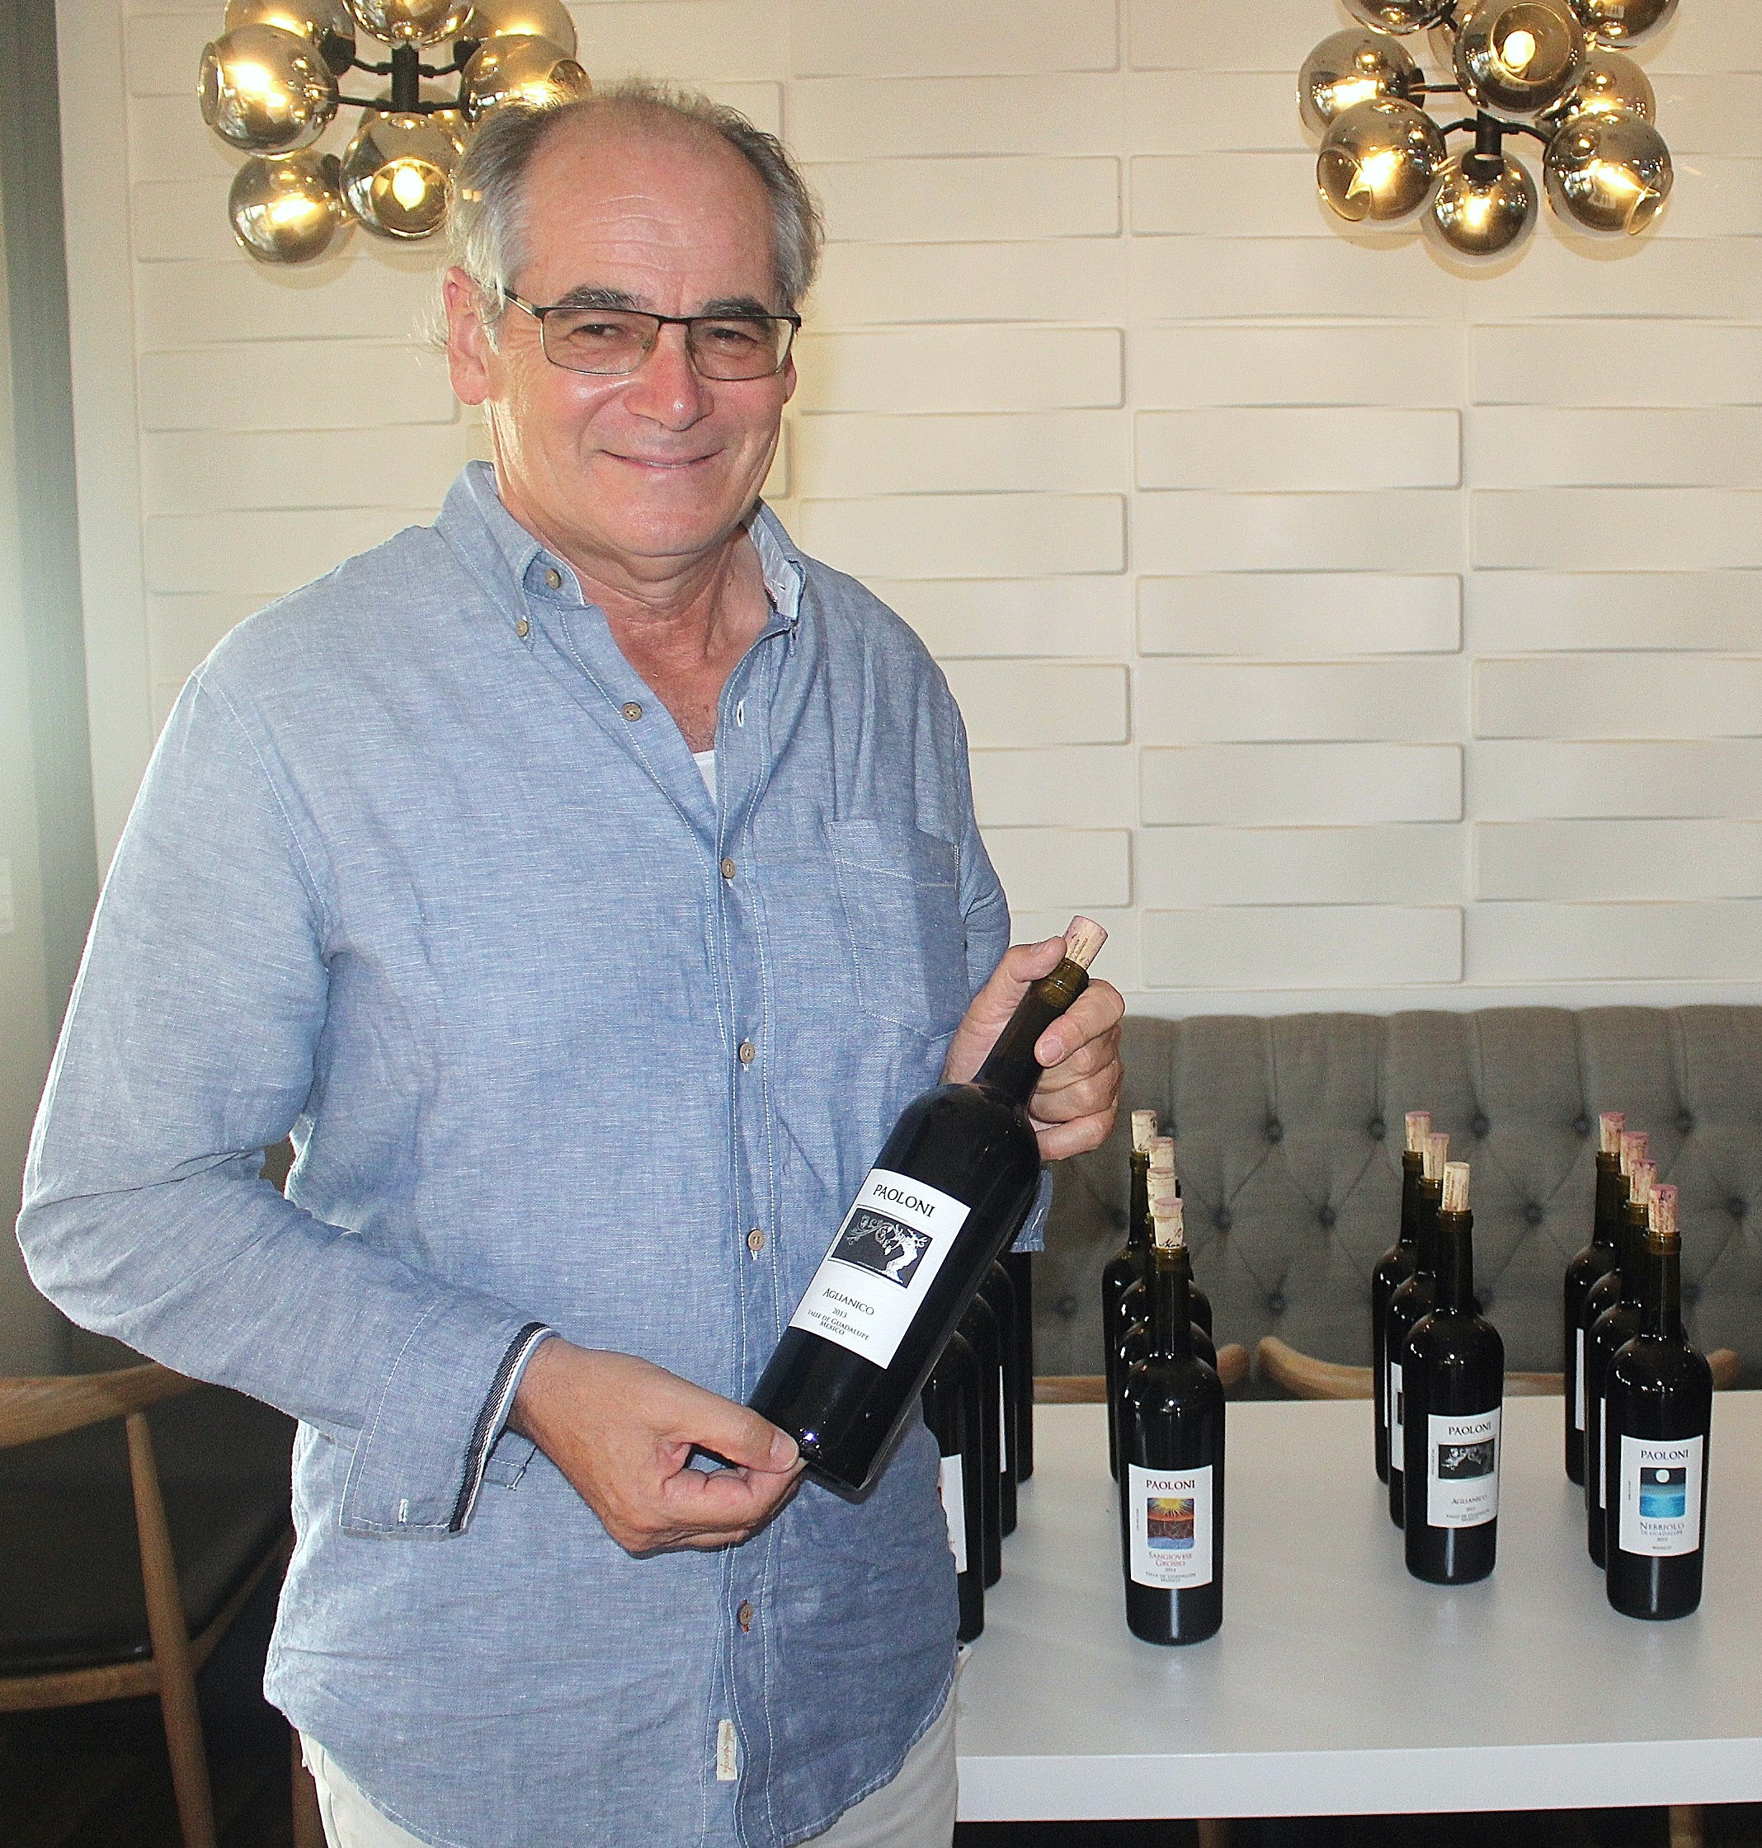
Paoloni’s family started with horses in in Le Marche, near Tuscany. In the 50s, his father Carlo Paoloni, purchased property in Chiarino Recanati where the family planted a vineyard and built a winery. His experience with viticulture as a child, shaped Paolo’s education and career where he became a Doctor of Agronomy specializing in Enology from the University of Perugia. In 1985, he emigrated to Mexico as the Director of Wine and Spirits for Mexico’s largest wine producer Valle Redondo in Aguascalientes.

Paolo Paoloni, owner and wine maker of Villa Montefiori,
one of Baja Mexico’s premier vineyards and wineries in
Valle Guadalupe holding a bottle of Aglianico wine with
the evening’s wine line up in the background. Photo by
Senior Editor Frank Mangio.

In 1997, Paoloni purchased a 38 hectare property in Toros Pintos, Valle de Guadalupe, Ensenada and founded Villa Montefiori. He planted the vineyard in 1998 with grape clones from France and Italy including Sangiovese, Montepulciano, Nebbiolo, Sangiovese Grasso, Aglianico, Chardonnay, Cabernet Sauvignon, Merlot and Shiraz. 20 hectares of the property is planted with 18 hectares native for guests to take in the scenery that includes their tasting room where Chef Surinder Veer Singh creates heavy appetizers for guests to savor. Additionally, Paoloni is building a 9 room on-property hotel for guests to enjoy that is scheduled to open in January 2021 followed by an accompanying restaurant slated for a March 2021 launch.

Dinner started with Chardonnay Paoloni and Chef Noe’s small bites. Next up was a Citrus Jeweled Ceviche featuring fresh sea bass paired with Villa Montefiori Rosato from Sangiovese fruit. The lightness of the salmon colored Rose’ was simpatico with the citrus inspired ceviche. The 3rd course was Enchilada Potosinas matched up with a Cabernet-Merlot blend followed by Asada Beef Tacos with Sangiovese Grosso Paoloni (4th course). In a side bar conversation, Paolo challenged Frank and me to a friendly blind tasting of Brunellos and Super Tuscan’s up against his Sangiovese Grosso. Paoloni’s first objective is “to have the best wines possible and not money.” We are working on a future date for the blind tasting to coincide with a one on one interview with Frank and Paolo. I am already looking forward to the blind tasting. In the same side bar, Paoloni noted,”Chemistry, sight, and especially taste of the grape’s seeds were indicators of when it is time to harvest.”

The main course featured Filet Poblano (beef tenderloin) paired with one of Villa Montefiori’s top wines, their Aglianico Paoloni. Aglianico has a long history in the wine world. The Greeks brought this grape to the south of Italy 2,500 years ago. Aglianico Paoloni is a 100% Aglianico aged in new French oak for 18 months with deep red garnet color and nose and palate of dark fruit, berries, and spice. Dinner ended with Crème Brulee paired Nebbiolo Paoloni. Great combo. Being a chocolate lover, I was thinking that the Nebbiolo would be a great complement to a chocolate-based dessert as well, possibly a decadent dark chocolate. Another great wine dinner series in the books, Sal and West End team. Bravo! More on Villa Montefiori at villamontefiori.mx.

Next up for Ercolano and West End Bar & Kitchen are 3 nights of Caymus Wine Dinners starting Wed Sept 23rd – Fri Sept 25th @6PM. At $70 per person, this is an amazingly valued 5 course elite wine dinner featuring Wagner Family wines with Caymus Napa Valley Cabernet Sauvignon and Amalfi Iron (pan seared flat iron steak) lined up as the main course. RSVP at 858-259-5878.

Story by Tech Director/Writer Rico Cassoni

Our thoughts go out to our vineyard and winery friends to the north battling historical fires. We wish you the best for you, your families and properties.

Frank and Rico
Wine Bytes
Chandler’s Restaurant, in the Cape Rey Resort, on the beachfront in Carlsbad,
is now open for Dine-in and To-go, fresh from the kitchen. Every table comes with an ocean view. Dine-in Wed. thru Sun. from 3pm to 10pm. A new dinner entrée has just been added, the Blackened Seared Ahi Tuna, served over coconut sticky rice, bok choy and cimini mushroom in a miso butter sauce. No reservation needed. For details, call 760-683-5500.

Fleming’s Prime Steakhouse & Winebar in La Jolla is ready to wine and dine you and your special someone during Al Fresco Date Night, a special menu feature for patio dining, starting at 4pm. A full dinner menu awaits with showstoppers like a 16 oz. Prime Dry-Aged Ribeye, topped with Diablo Shrimp. Call 858-535-0078 for details and an RSVP.

Jeff Venier, is the Wine Steward at Pavilions in Carmel Valley, is presenting Chardonnay Saturday, Aug. 29th. Chardonnays from around the globe can be purchased at the double discount price. For more, contact Jeff at 858-793-4661.

Frank Mangio is a renowned wine connoisseur certified

by Wine Spectator. He is one of the leading commentators

on the web. View his columns at tasteofwineandfood.com.

Go to recent columns. Reach him at frank@tasteofwineandfood.com

