
TASTE

OF

WINE
By Frank Mangio

Week of July 26, 2020

Pasta – The Ultimate Comfort Food

I’m a baseball and pasta fanatic. These two delicious pastimes came together when the Dodgers played last their first game last night in their home park in L.A. in front of 4,500 cutouts of fans who paid big bucks to have their images seated at the park. During the game, the announcer spotted all-time great Dodger Manager and leading Italian pasta eater Tommy Lasorda’s cutout and blurted out “WHERE’S THE PASTA!”
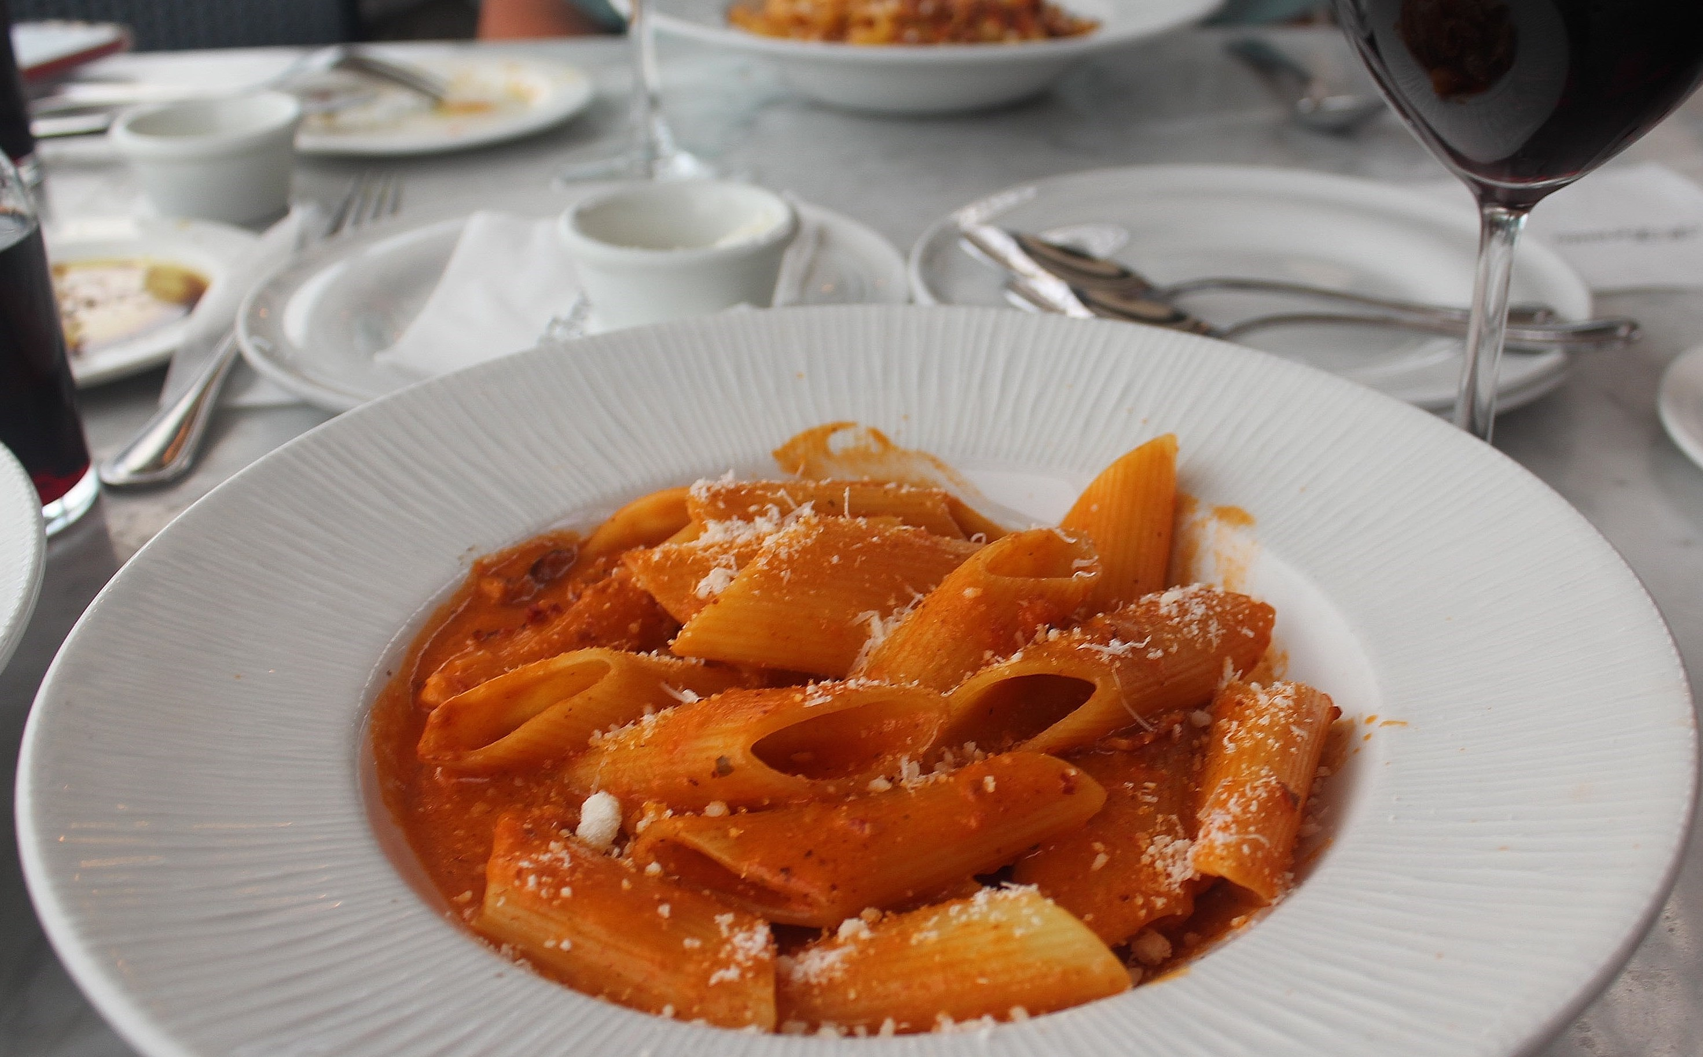

Pasta is just about everywhere, mostly in Italian restaurants.

When I was a kid and things were tough in the family, my mother, who came from southern Italy, knew exactly what to do…she cooked a week’s worth of sauce and pasta, and added meat on the first night’s dinner, chicken the next, fish the third night,

Frank’s favorite Pasta plate at the elegant, always delicious Italian Restaurant

in Del Mar, Il Fornaio, is the Pennoni alla Vodka with large ribbed tubes

to catch the full flavor of the Vodka meat sauce.

then filled in the rest of the week with maybe lentils, peas, broccoli and on and on. But the basic ingredient was always a long thin spaghetti now known as “Angel Hair” with generous amounts of tomato sauce, “extra virgin” olive oil and grated Parma cheese.

When I want to feel and taste the comfort of a freshly made pasta dinner, I make my way to Del Mar Plaza’s Il Fornaio and their home-made style menu of pasta shapes and flavors at value prices. My favorite of the current list is the Pennoni alla Vodka, sopping wet with vodka-cream-tomato sauce. Looking closer, you will love the bacon and Grana Padano Parmesan imported grated cheese, the best in all of Italy. This is a creamy, tangy, and SUPER take on Vodka Pasta, with a small cup of Vodka, and ¼ cup of olive oil, coconut milk, and a clove of garlic.

A close second for a favorite would be the three-cheese, meat sauce covered, Rigatoni Il Forno (baked Rigatoni.) Rigatoni is a large tube-shaped pasta with characteristic ridges to capture the meat sauce flavor of Southern Italy and Sicily.

It is created as a large plated layered casserole, similar to Lasagna.

There’s much more to Il Fornaio and I want to bring in our Tech Director/Writer Rico Cassoni who joined me in seeking the newest premier pasta comfort food.

In the spirit of baseball, I am taking the mound after a perfectly pitched game for the last inning with our team ahead in runs based on Frank’s great start! As Frank said, there is much more to our Il Fornaio visit. Before jumping into more pasta, I thought I would first discuss the ultra fresh Caprese Tradizionale salad we had with juicy sliced heirloom tomatoes topped with creamy mozzarella and fragrant basil leaves drizzled with extra virgin olive oil. We both started our meals with the Caprese and the 2018 Montelpulciano d’Abruzzo that paired well with the acidity in the heirloom tomatoes.

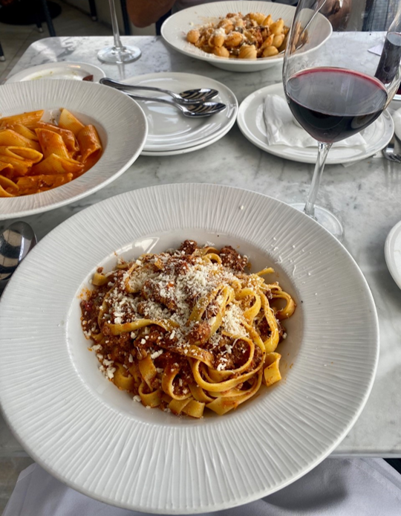
In my pasta world, my go-to is Tagliatelle. Tagliatelle pasta features long strands of thicker noodles. Many times, they are a wider noodles as well. Il Fornaio’s Tagliatelle features an egg pasta resulting in a goldish yellow color. The dish that I selected was the Tagliatelle alla Bolognese. Bolognese is a traditional dense meat ragu infused with tomatoes, garlic, onion, along with milk to create density and more tender meat. This delicacy ragu originated in Bologna, Italy. I chose the 2017 Seghesio Angela’s Table Napa Valley Zinfandel to pair the Bolognese and was glad that I did.

Rico’s favorite Pasta plate at the elegant, always delicious Italian Restaurant

in Del Mar, Il Fornaio, is the Tagliatelle alla Bolognese with thick golden
pasta noodles served with a rich, deep, and flavorful Bolagnese meat ragu.

The depth of Seghesio Zin perfectly complemented the richness, depth, and flavors of the Bolognese.

As always it was a pleasure catching up with our good friend General Manager Vittorio Homberger during our Il Fornaio visit. Homberger said, “Their biggest goal is adhering to guidelines and policies for the safety of their customers and employees during the pandemic.” For those deciding that they want to enjoy Il Fornaio, but not on property, can take advantage of one of Il Fornaio’s family feasts available via Doordash and Olo mobile apps. Currently there are three feasts being offered: (1) Full Rotisserie Chicken cut into 4 pieces (2) Four Norwegian salmon filets or (3) Two Il Fornaio pizzas. Each of these main entrees are accompanied with Cesarina salad, Penne Vodka, Roasted Yukon Potatoes, seasonal veggies, Tiramisu, and fresh baked Ciabatta bread.

Thank you Vittorio and the Il Fornaio Del Mar team for another great dining experience!

Wine Bytes

Sal Ercolano’s Seasalt in Del Mar is presenting the iconic Buena Vista Napa Valley Winery in a memorable wine dinner Thurs. July 30th and Fri. July 31st at 6pm. Buena Vista was California’s first premium winery. Cost is $70. per person plus tax and gratuity. Call 858-755-7100 for an RSVP to this 4 course masterpiece. Seasalt now has Weekend Brunch on its open patio and outdoor space every Sat. and Sun. from 10am to 2pm.

Gianni Buonomo winery in the Ocean Beach district of San Diego is open for bottle sales and is offering a super-premium lineup of award-winning wines,

including: Double Gold Medal winner 2015 Blaufrankisch, and Gold Medal winners 2015 Maestrale, 2015 Avennio and 2015 Sangiovese. For more details, call 562-458-9477.

The San Diego Zoo is planning a Food, Wine & Brew Celebration Sat. Sept. 26 from 6:30 to 10:30pm for VIP, 7:30-10:30pm for General. Cost for General is $100. and for VIP $200. More than 160 of SoCal’s best vendors with live entertainers are planned. Check for the latest info at zoofoodandwine.com.

Frank Mangio is a renowned wine connoisseur certified

by Wine Spectator. He is one of the leading commentators

on the web. View his columns at tasteofwineandfood.com.

Go to recent columns. Reach him at frank@tasteofwineandfood.com

