
TASTE OF

WINE & FOOD

By Frank Mangio

Week of July 19, 2020

Back with a Bang…West End DAOU Wine Dinner

When restaurants opened back up for dining in, we suspected that Sal Ercolano, owner of both Del Mar’s Seasalt Seafood Bistro and West End Bar & Kitchen would be one of the first in San Diego to host a wine dinner. And, we were right! Frank and I were especially excited when Ercolano announced that it was going to be a DAOU Wine Dinner. What was initially planned for 1 night dining in and 1 night virtual wine dinners, turned into three sold out dining in events. We are always amazed and impressed by our good friend Sal. Bravo Sal!
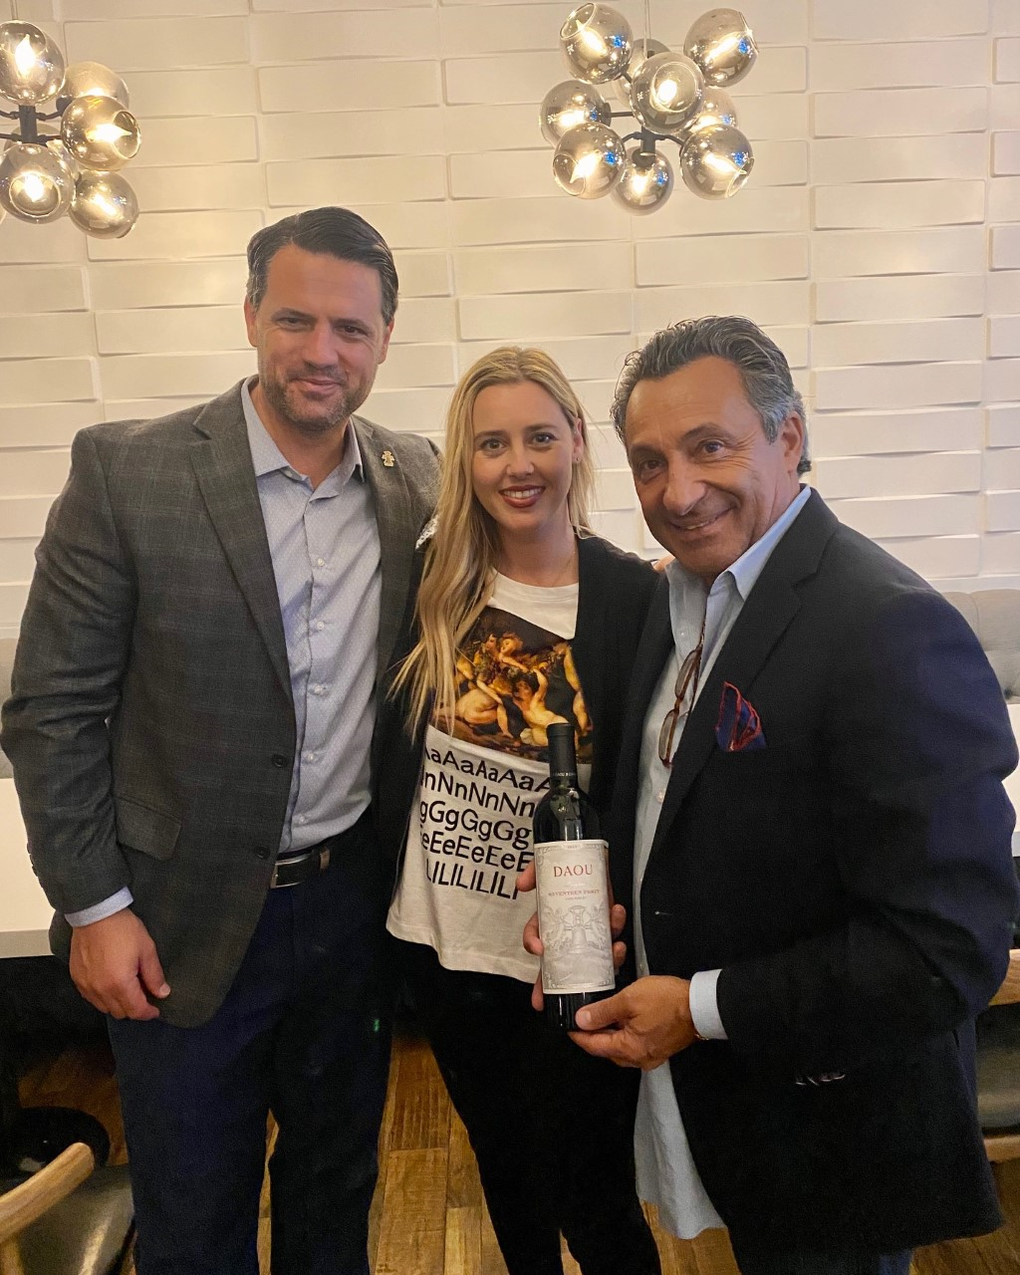

Chef Noe was at the top of his game for this 5 course dinner starting off with a Chef Platter paired with DAOU’s recently launched 2019 Discovery Rose that is topping the charts as one of this year’s best Rose’s. Next up was a crispy crab cake served atop baby arugula with a grapefruit vinaigrette complemented by the 2019 Sauvignon Blanc. The guava, kiwi, and citrus influence of the Sauv Blanc drew out the grapefruit in the dressing. The third course was a Mediterranean Lasagna with bay scallops, shrimp, crabmeat, and pink bechamel sauce served with DAOU’s 2017 Bodyguard, Petit Verdot/Petite Sirah

(Left to right) Daniel Brunner, Asst. Divisional
Sales Mgr, Southern CA., Katherine Daou, Social Media
Manager & Brand Ambassador, and Sal Ercolano
owner West End Bar&Kitchen and Seasalt Bistro.

Blend (60/40%) dedicated to DAOU brothers Daniel and Georges’ mother, Marie, who huddled over and protected the boys when their Lebanese home was subject to missile attack - a Mother’s Love! This was a KILLER course and pairing! Course Four featured Angus Short Rib Stew paired with DAOU 2017 Reserve Cabernet Sauvignon. The silky palate with hints of toasty oak along with ripe fruits and spice was harmonious with the braised short ribs. The dinner ended with chocolate pudding and 2018 Pessimist Red Blend. The smoky notes of truffle and coffee were perfect for pairing with the chocolate pudding.

Daniel Brunner, Asst. Divisional Sales Mgr., Southern CA. narrated the evening along with a kickoff from Sal and Senior Editor Frank Mangio. It was an extra special treat having Katherine Daou, Social Media Manager & Brand Ambassador at the dinner to provide commentary in addition to Brunner.

I always love hearing the DAOU story. Daniel and Georges scoured the world for the perfect terroir and settled on now DAOU Mtn with its perfect chalky, calcareous soil reminiscent of France and the climate of Napa. Everything DAOU does is marked by perfection. This includes the amazing and breathtaking views of DAOU Mtn, the attention to detail for winemaking, the quality of the French Oak, bottles, corks, and especially the care taken for farming and harvesting with optical sorters. Everything is top notch and as they say “Made in Paso Robles. French at Heart.” However, I would probably say of all things DAOU, the DAOU family and their employees are 2nd to none. All it takes is one trip to DAOU Mtn to be a believer.

Next up for Ercolano wine dinners are two nights of Buena Vista Wine Dinners at Seasalt Bistro Thu. July 30th & Fri. July 31st, both at 6:00PM. $70 per person plus tax and gratuity. Chef Hilario is creating a 5 course menu featuring slow cooked Drunken Short Ribs. All five courses will be paired with Buena Vista wines re-born under the vision of Jean-Charles Boisset. RSVP at (858) 755-7100.
Story by Tech Director/Writer Rico Cassoni.

PAON WINS “BEST OF AWARD OF EXCELLENCE” from WINE SPECTATOR
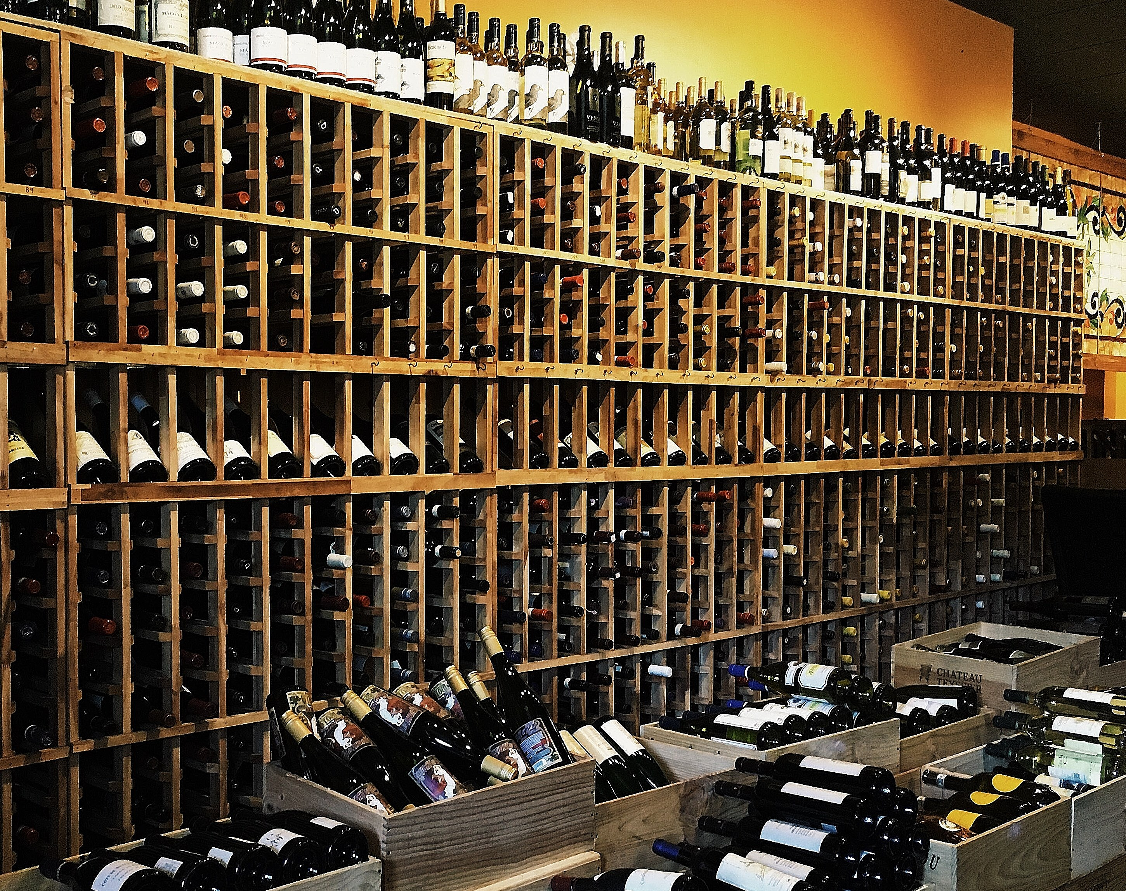
Wine Spectator, the signature publication for restaurant and wine excellence, has again honored PAON Carlsbad Village for its wine list that offers “excellent wine across winegrowing regions, along with superior presentation.”
This is the 5th year in a row that PAON, in Carlsbad North San Diego County, has come away with this distinguished award.

PAON Restaurant Wine Bar & Bistro in Carlsbad Village
displays over 500 fine wines offered in its menus and
recognized as the “Best of Award of Excellence” by Wine Spectator.
Wine Director Kate Edgecombe exclaimed “what perfect timing to announce our new Peacock Selection Wine Discount Program!” PAON, in French, means Peacock, a beautiful multicolored bird with a rainbow-like fan span.
This wine discount program covers many colorful wine regions, some available exclusive to PAON. Examples of the current list include: Caymus-Suisun Grand Turif Petite Sirah 2017, was $60 now $35. Round Pond Cabernet Sauvignon Napa Valley 2017, was $78 now $40. Niner Pinot Noir Paso Robles 2018, was $38 now $26. There is a 3 bottle minimum for purchase. Pickup in the wine bar is Wed. thru Sun. 4pm to closing. To learn more about the Peacock Selection Wine Discount Program, call 760-729-7377.
In the PAON traditional old-world covered outdoor patio, now with expanded seating in compliance with the latest protocols, the same meticulous meals are carefully prepared for the highest quality results. There is no finer certified Angus Filet Mignon beef in any restaurant than what is on the PAON menu, which includes a perfectly portioned trio of sides. The same can be said of the restaurant’s Braised Beef Short Rib, a photo and dining opportunity…looks great, tastes great!
500+ wine bottles and 30+ wines by the glass should satisfy every palate.
PAON is open for lunch Fri. thru Sun. 11:30am thru 2:30pm, with dinner daily from 4pm. Take-out and delivery are still good to go. RSVP strongly recommended by calling 760-729-7377.

Frank Mangio is a renowned wine connoisseur certified

by Wine Spectator. He is one of the leading commentators

on the web. View his columns at tasteofwineandfood.com.

Go to recent columns. Reach him at frank@tasteofwineandfood.com

