
TASTE OF WINE & FOOD

By Frank Mangio

Week of June 21, 2020

The San Marzanos are coming..Spotlight on Mangia e Bevi’s Tore Trupiano

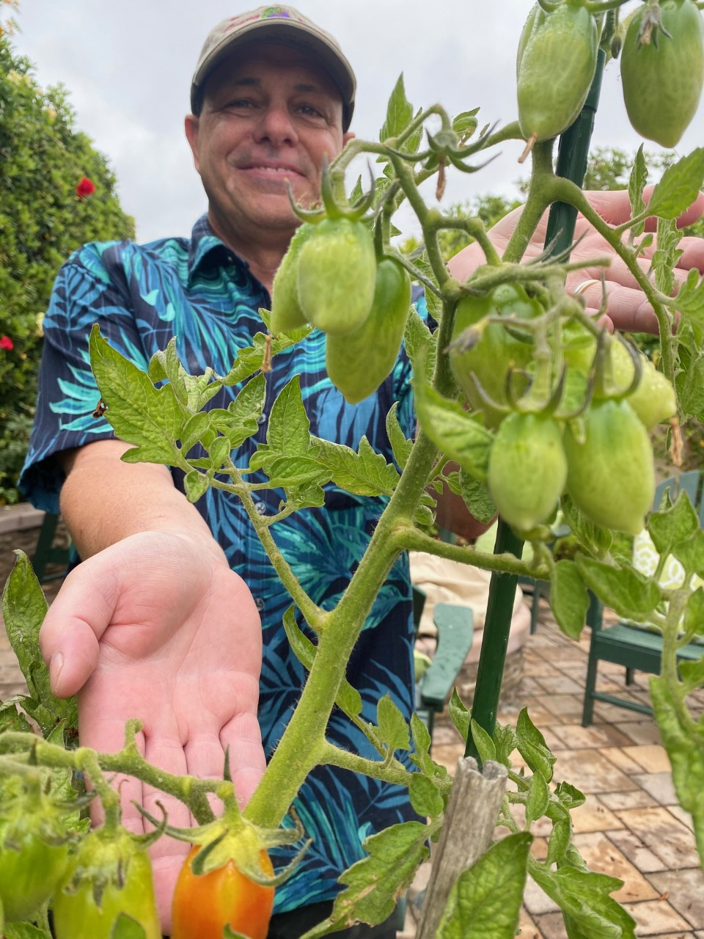
In the May 17th column, I shared with viewers the superiority of San Marzano tomatoes, especially in Italian cooking. I was hoping that there would have been a higher number of tomatoes that were ripe at the time of writing this week’s column. The warm late May/early June temperatures were a shot of lightning. However, the onset of June gloom over the past 2 weeks has slowed the growing and ripening process. Frank and I decided we would provide an update this week and share ripe San Marzanos on Neapolitan pizza on our July 5th column.

Tech Director/Writer Rico Cassoni showing
progress on San Marzano tomatoes on a
June gloom day. Photo by Mary Cassoni.

Despite Mother Nature not cooperating, the column must go on. This is when I reached out to Mangia e Bevi’s CEO and co-owner, Tore Trupiano. Trupiano, 3 Time Pizza Expo Champion and United States Pizza Team Member, along with co-owner Ann Perham and Chef Sterling Smith have been busy over the Covid pandemic serving their full menu for take-out, but more importantly serving the community via the “Great Plates Delivered” program. Each day, the Mangia e Bevi Team creates and delivers 3 meals (breakfast, lunch, and dinner) for 80 Oceanside Seniors. Set to end June 10th, the program has been extended to July 10th. Trupiano said, “The Great Plates Delivered program was some of the most rewarding I have ever done.”

Back to the San Marzanos, I asked Trupiano to share a favorite recipe featuring these sought after red beauties. He provided Rigatoni alla Norma.

Ingredients: Rigatoni 320g, Eggplant 500g, 4 tbsp extra virgin olive oil (EVOO),

2 garlic cloves, roughly chopped, fresh or canned San Marzano PDO tomatoes 850g, salt (to taste), fresh basil leaves 10g, freshly ground black pepper, Ricotta salata 200 g

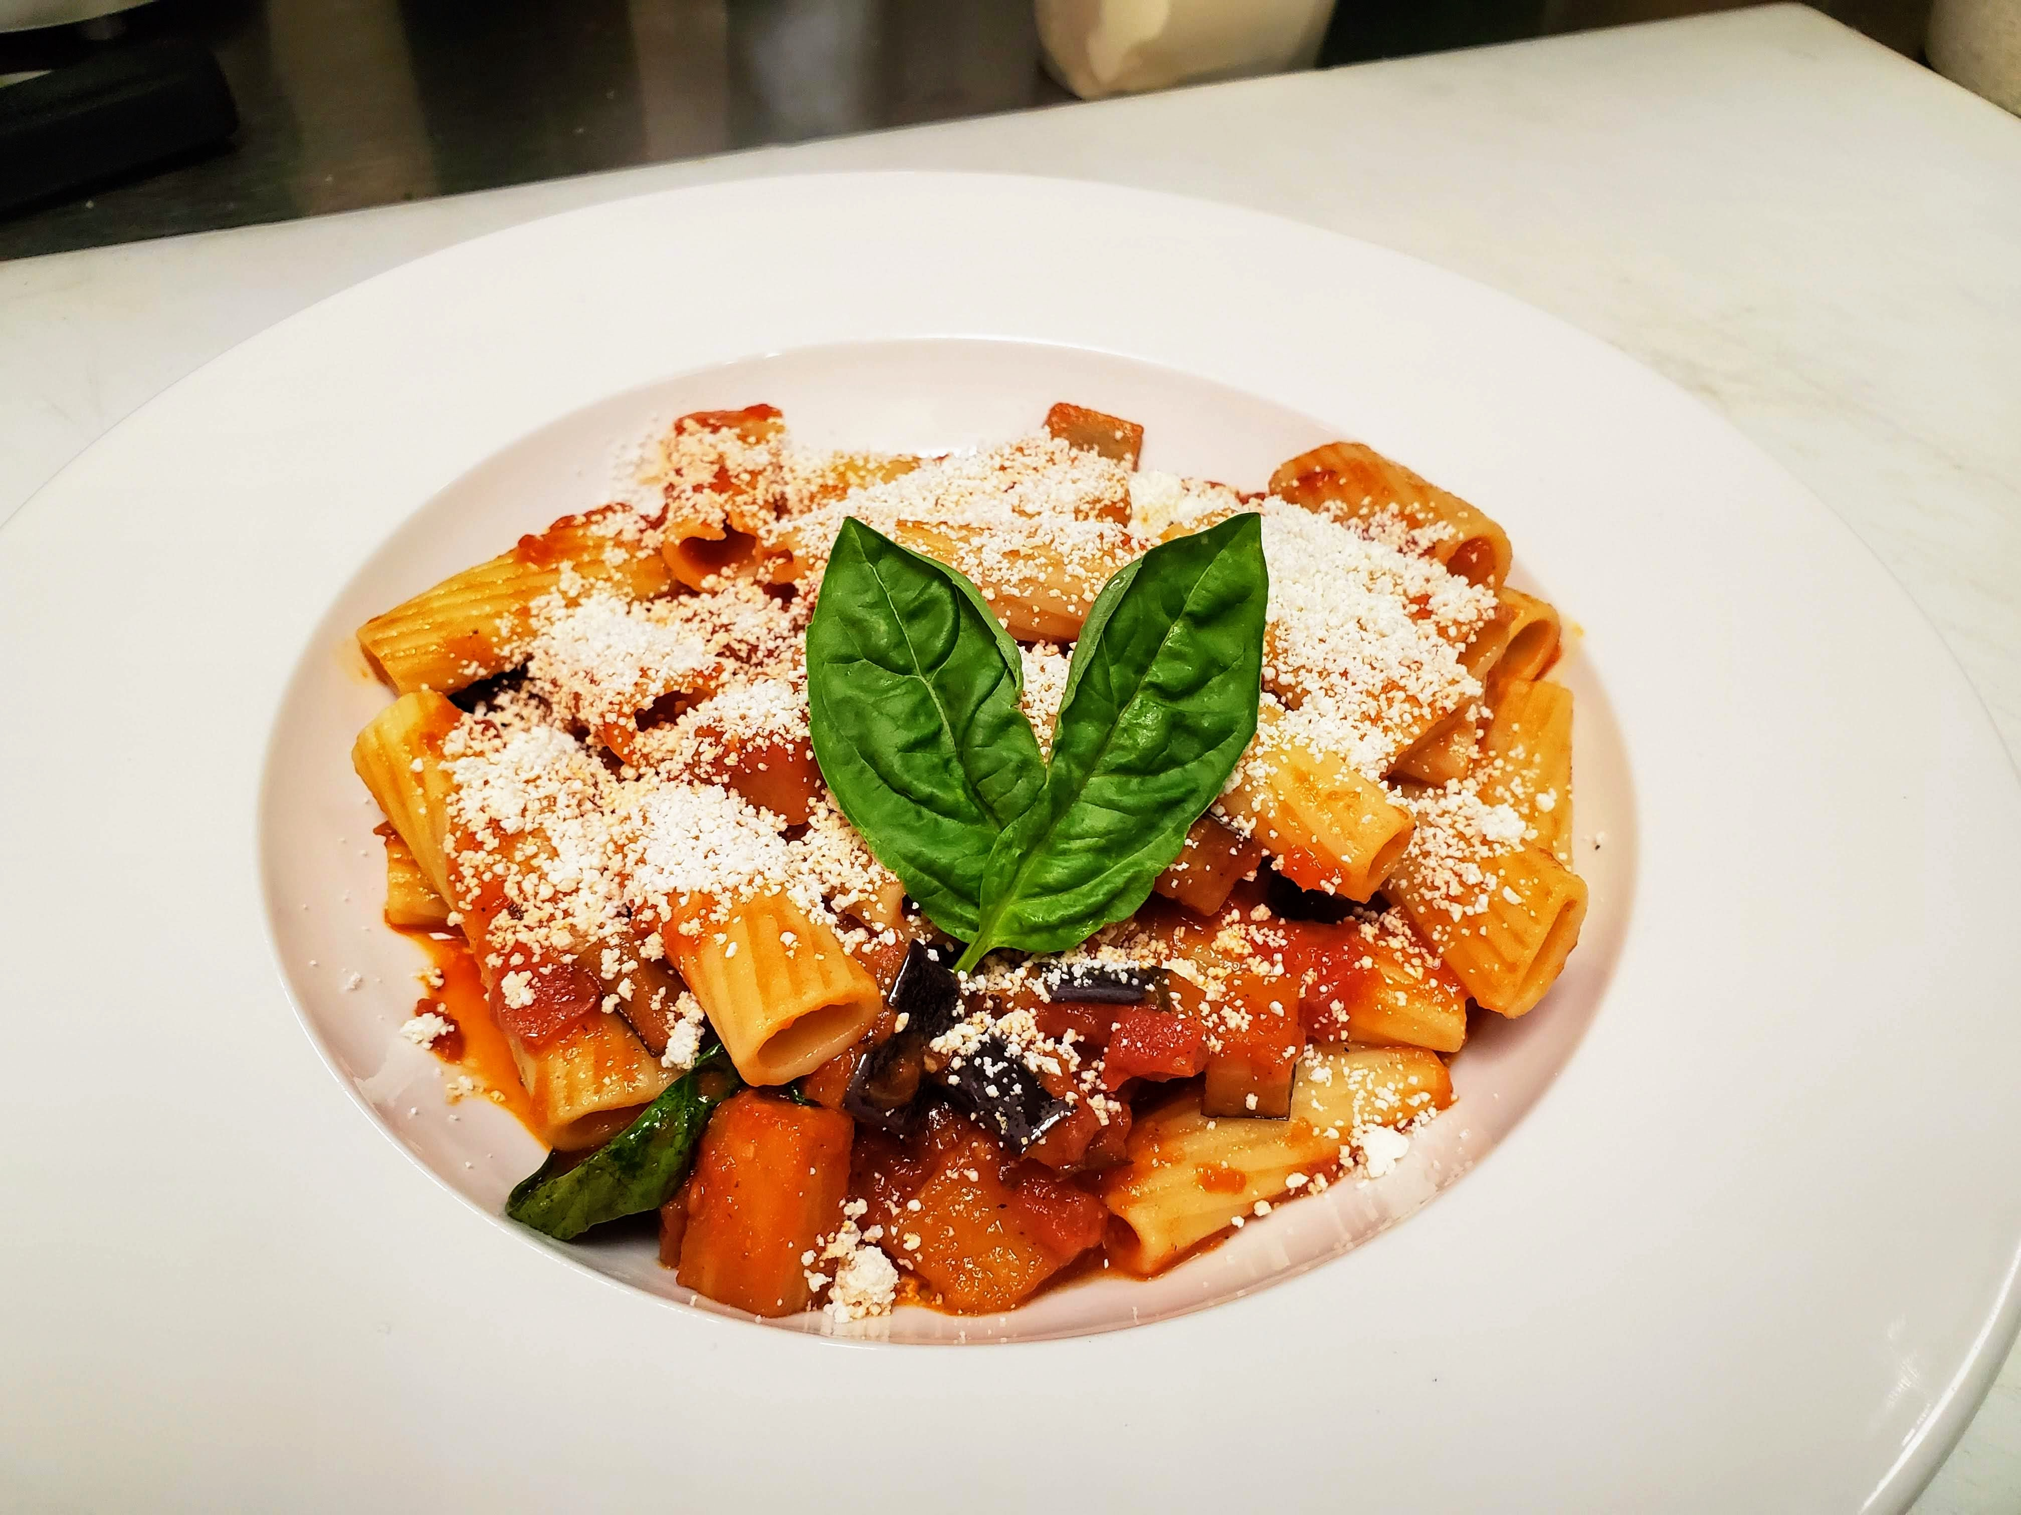
Instructions: Cut eggplant into cubes about 2 cm thick. Wash in a colander, dry, and set aside. Heat 3 tbsp EVOO in a large shallow pan and fry eggplant (in batches if necessary) until brown and almost caramelized. Transfer to a plate lined with paper to absorb the excess oil. Salt to taste. Add remaining oil and garlic to the pan and fry until garlic is soft

Mangia e Bevi Rigatoni alla Norma
made with San Marzano PDO tomatoes.

and fragrant. Add tomatoes. Cook for 10-15 minutes on medium heat until tomatoes are soft. Towards the end, mash tomatoes to create a rough sauce. Once ready, transfer to a vegetable mill placed on a bowl to obtain a juicy and smooth pulp. Return sauce to pan and cook for 10-15 more minutes or until sauce has thickened.

Boil a pot of salted water and cook pasta al dente. When pasta is almost ready, add fresh basil and eggplant into the sauce over low heat. Drain pasta and add to the pan with sauce. Mix well. Season with salt and pepper. Divide the pasta between 4 serving dishes. Grate the ricotta salata over each portion.
For those wondering when Mangia e Bevi will be open for dine-in, they anticipate outdoor dining the 2nd week of July al fresco style with 11 tables on their patio. Keep up the great work serving the Oceanside community, Tore and Mangia e Bevi Team. See mangiaoceanside.com.

Story by Tech Director/Writer Rico Cassoni.

ANTINORI – WINE ROYALTY IN TUSCANY

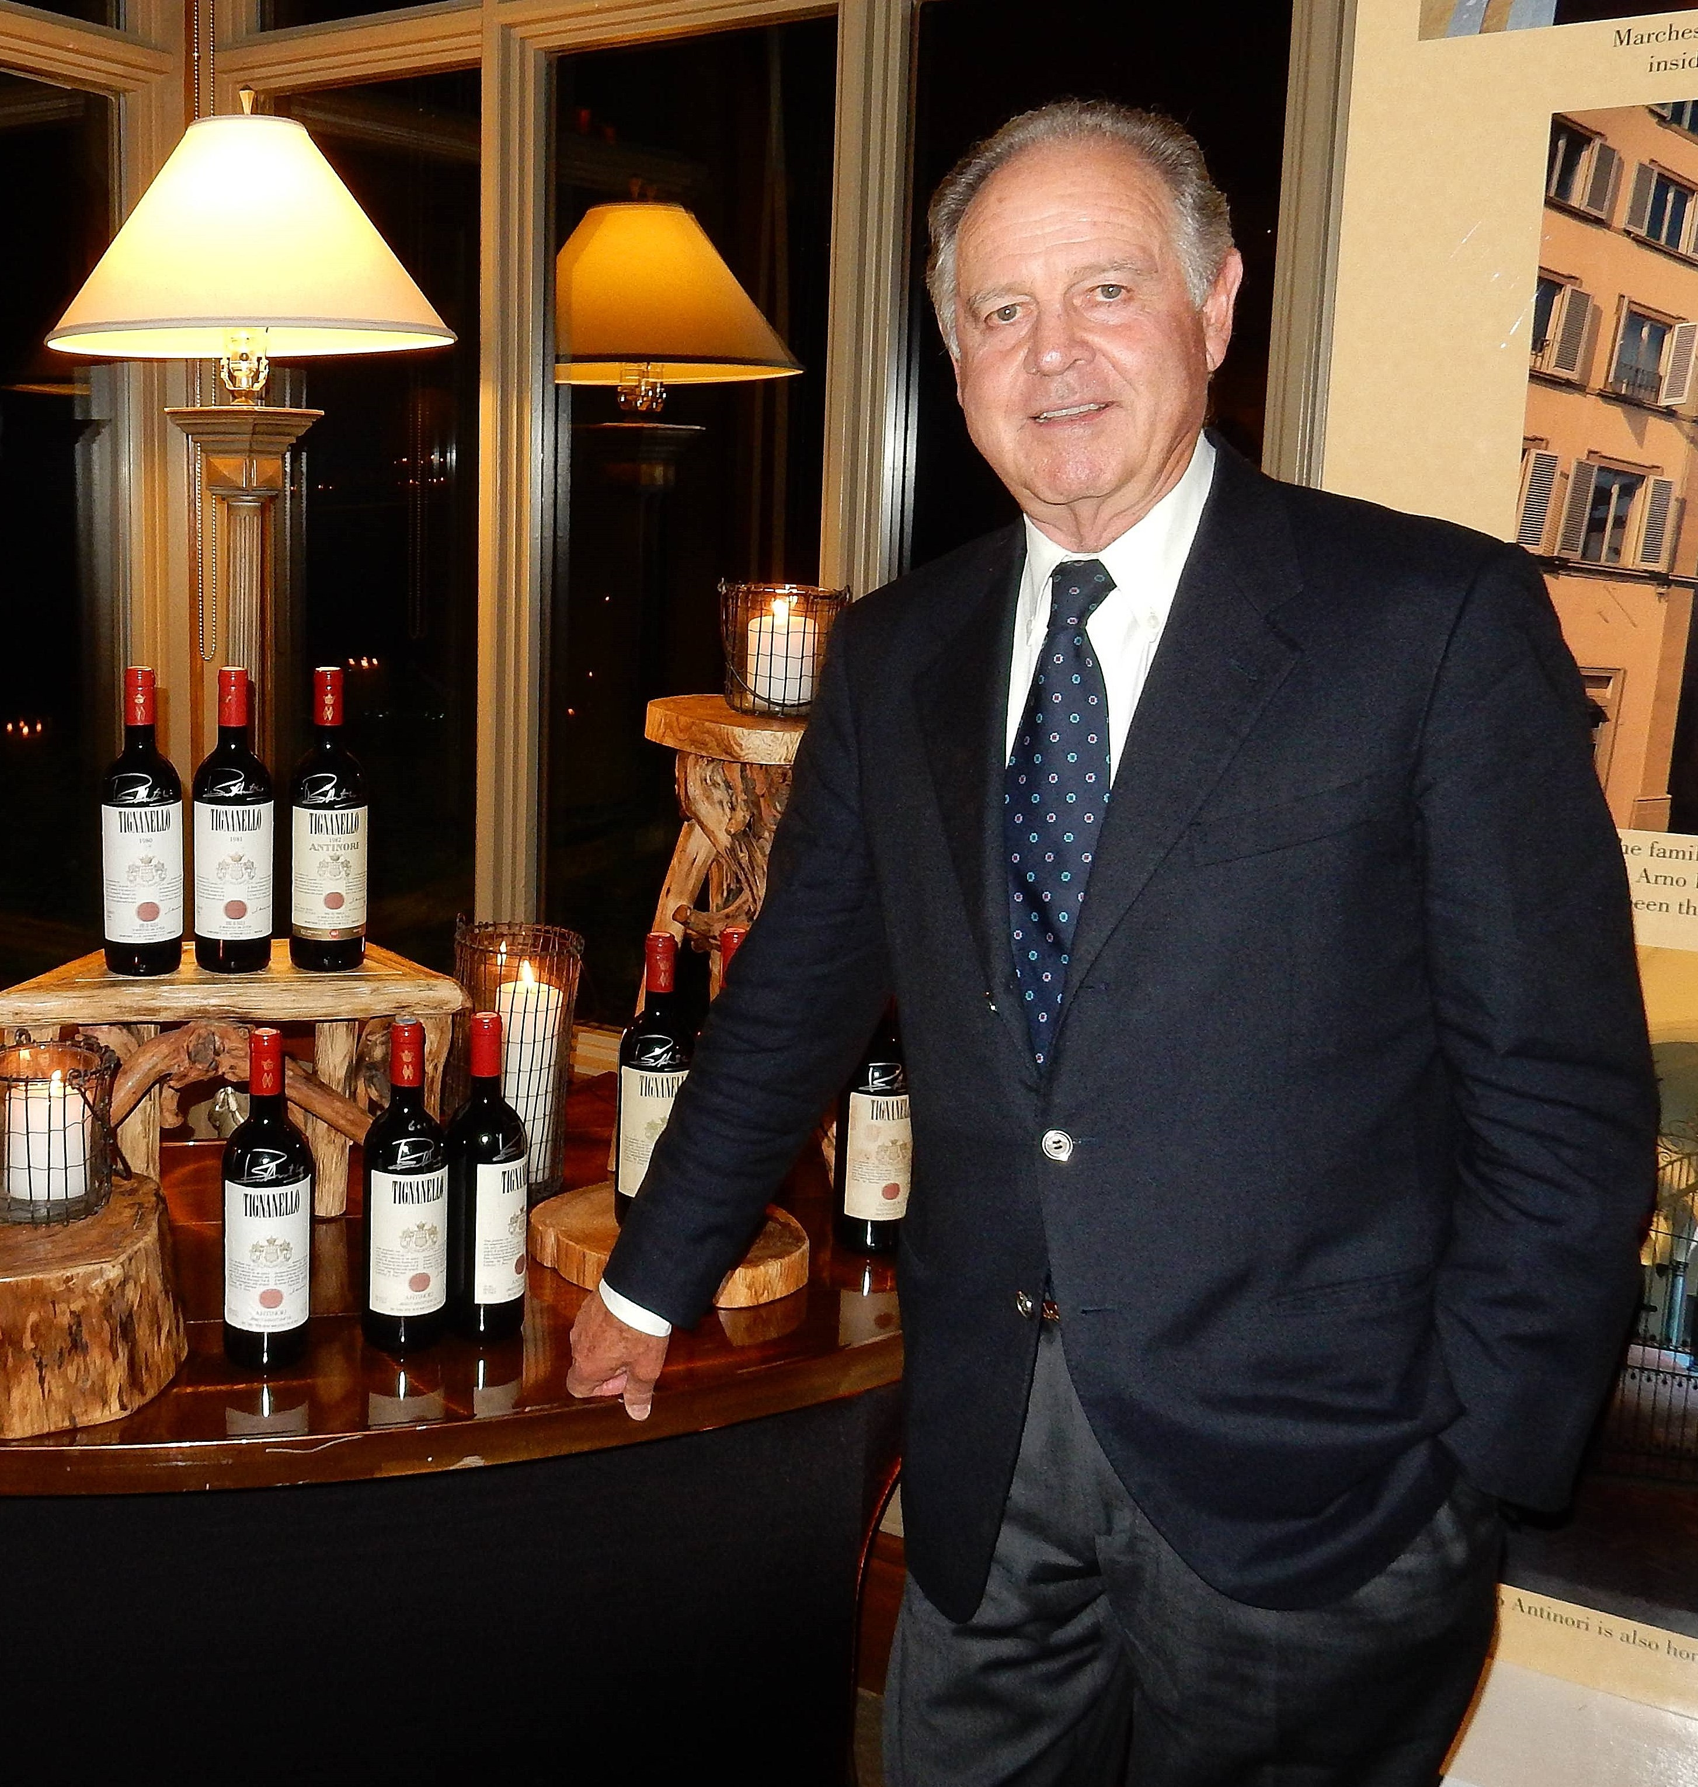
Tall, dignified, and looking every bit the part of a Florentine nobleman who operated a 600 year old winery, Piero Antinori greeted me in an online Italian wine course offered by Wine Spectator Magazine in 2004.

I concluded that this was what I needed…a certified Italian Wine Connoisseur award by this highly circulated international wine publication. What I didn’t know until it began was that it would be taught by the most honored figure in the history of winemaking in Tuscany.

Piero Antinori, the famous Florentine vintner displays
his 2016 Ruby red Tignanello, with ratings in the high 90’s
by the most esteemed critics in the world.

Marchese Piero Antinori traces his family’s Tuscan wine history to 1385. Over the centuries, the family went through periods of great wealth, partnering with the Medici family and expanding the winemaking empire south of Florence to what is now San Casciano and neighboring Tignanello.

In 1966, as a young 28 year old, Piero Antinori took the reigns from a scandalized father who was discovered making Bordeaux wine varieties and adding cheap white wine to the revered native Tuscan red wine, Sangiovese, the backbone varietal to Chianti Classico. As Antinori put it: “the Chianti that went into bottles was thin, watery and lacking in body.” He immediately began to innovate with small barreled “barriques,” stainless steel vats and the biggest revolution, the launching of Tignanello’s first vintage in 1974, from a harvest of 85% Sangiovese, 10% Cabernet Sauvignon and 5% Cabernet Franc.

I suppose Tignanello and other “Super Tuscans” of the day, Sassicaia, Guado al Tasso and Solaia, really shook up the Italian wine officials who spitefully designated this group a mediocore IGT designation.

But young progressive Tuscan winemakers had grown tired of the government-dictated rules of making fine wine which called for absolute purity of the native Sangiovese wines with long periods of barrel aging before they could be sold to an adoring public. These so-called “Super Tuscans” were exciting blends that could be harvested, aged and off to market in 2 years. Tignanello is now $134.99 in most retail establishments.

Antinori, not content with his Tuscan success and visualizing the dynamic wine market on the west coast of America, began a focused foothold in Napa Valley with investment in Atlas Peak and Stag’s Leap wineries, then Col Solare, part of the St. Michelle group of wineries in Washington. Later he ventured into Romania, Chile and Hungary.

Over the years, Piero Antinori has passed the torch of great winemaking to his three daughters, Alberia, Allegra and Alessia, the 26th generation of winemaking Antinoris. This was possibly his most challenging decision but one that has seen great returns in the success of the Antinori wine empire. Visit antinori.it/en/wines.

Wine Bytes

Sal Ercolano’s West End Kitchen & Bar in Del Mar, after 2 sellouts on his DAOU

“dine-in” wine dinners Thurs. and Sat. June 25 and 27, has a 3rd dinner for you

Fri. June 26 with great DAOU wines and a gourmet 4 course dinner. $85. pp, $150. for two. Also, West End is now offering a Seaside Brunch, available both Sat. and Sun. Seating. RSVP for either at 858-259-5878. Protocol rules apply.

The DAOU winery experience on DAOU Mtn. in Paso Robles has now re-opened. Its personalized one-on-one experience has been enhanced with guided walking experiences and the latest offering, the “French at Heart” Picnic, in a new lawn area near its Cabernet Sauvignon clonal vines. Details at daouvineyards.com.

Frank Mangio is a renowned wine connoisseur certified

by Wine Spectator. He is one of the leading commentators

on the web. View his columns at tasteofwineandfood.com.

Go to recent columns. Reach him at frank@tasteofwineandfood.com.

