
TASTE OF
WINE & FOOD

By Frank Mangio

Week of May 17, 2020

No Matter Which Vine… It’s All About Farming
When talking vines, I suspect that most of our viewers are thinking they are about to hear about Cabernet Sauvignon, Chardonnay, Sangiovese, or other familiar grapes. Surprise! This week we are throwing our viewers a curve ball in the spirit of baseball, that hopefully will be starting soon despite the Covid pandemic, with tomato vs. grape vines.
This article features the most popular and famous tomatoes found in Italian kitchens – the San Marzano. I will explain not only why San Marzano tomatoes are dominant in fine Italian cooking, but also, where they come from. Let’s start with where they come from first.

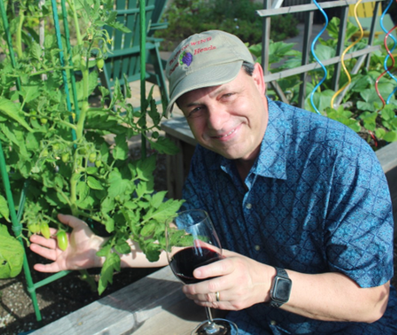
San Marzano tomatoes originate from the said named town near Naples. Folklore claims that the first seed came to Campania in 1770 as a gift from Peruvian royalty as a gift to Naples. These heirloom specialty tomatoes were first grown in volcanic soil near Mount Vesuvius. Amy Goldman one of the foremost heirloom plant conservationists in the US, calls the San Marzano, “the most important industrial tomato of the 20th century.”

Tech Director/Writer Rico Cassoni showcasing his
San Marzano buds to Senior Editor Frank Mangio
while enjoying 2016 Goldschmidt Yoeman Cabernet
Sauvignon ($75). Photo by Frank Mangio.
Compared to Roma tomatoes that were breed from San Marzanos, San Marzano tomatoes have a thicker flesh, fewer seeds, and a flavor/taste that is stronger, sweeter and less acidic making them superior to their Roma offspring and why San Marzanos are king and sought out in Italian dishes over Roma and other tomato varietals.
The good news is that for those now intrigued about growing San Marzanos you can do so from the comfort of your home as seeds are available worldwide. The one’s shown in the earlier picture were started from seed around Feb 15th. A great vendor and resource for high quality seeds is Eden Brothers (edenbrothers.com). Additionally, a new home gardening method I discovered this year was Square Food Gardening invented by the late Mel Bartholomew. His farming method focuses on dense, efficient, compact farming methodologies so that anyone with a bit of space can farm with a plot that is divided into square foot sections that are only 6 inches deep. Details at squarefootgardening.org.
Speaking of farming, one of the best virtual series I have discovered over the pandemic is Daniel Daou’s Tuesday AM Vineyard series. Daniel walks the vineyard fields with his team sharing DAOU vineyard’s above and beyond attention to detail including practices leading to superior phenalics such as less density per acre and canopy development ensuring that all fruit is ripe at the same time for perfect wines. As amazing of a winemaker that Daniel is, after listening to his vineyard tours, one could claim he is just as good as a farmer. This seems to go hand in hand as neither Frank nor I can think of a wine that we enjoy that is made by a winemaker who is not an ardent farmer. Check out Daniel’s tours on Tuesday’s at 9AM on Instagram LIVE (@daniel.j.daou).
Be on the lookout for future pictures of the San Marzano’s on homemade pizza in the mid-June timeframe! Story by Tech Director/Writer Rico Cassoni.

The Ultimate Take-Out Takes Place at Charthouse

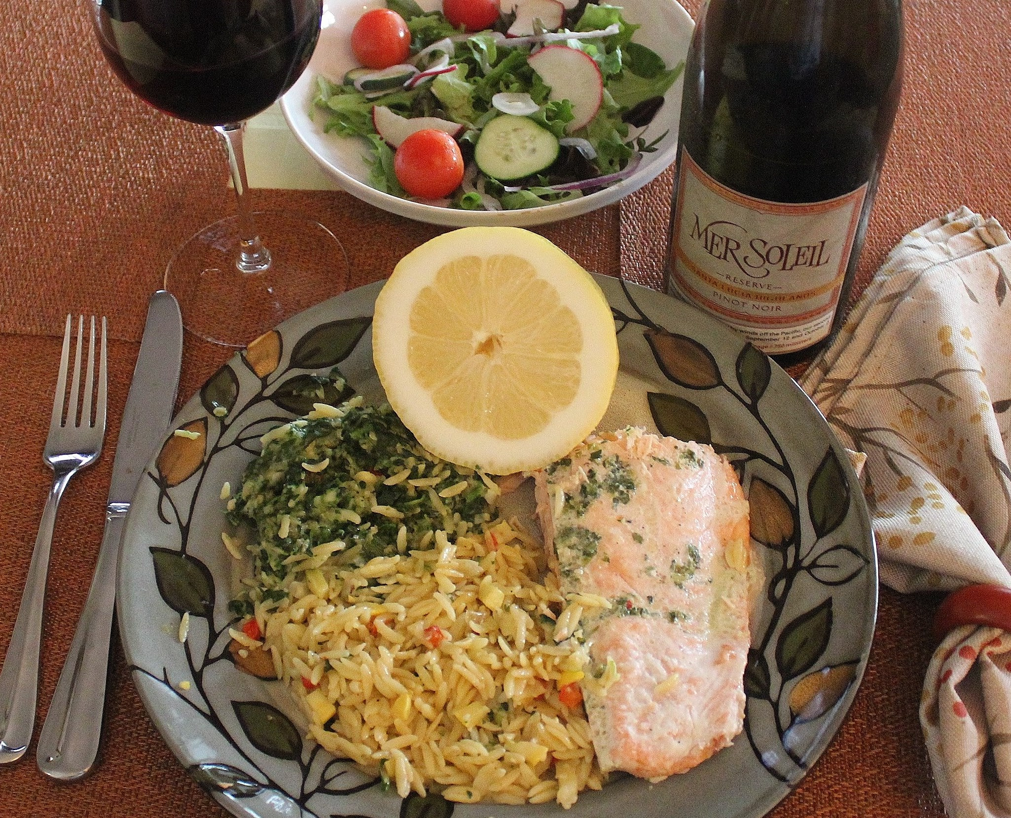
Did you ever think that a deluxe fine dining 3 course dinner for 2 would

ever be served take-out style. Well this is 2020 and strange happenings call for strong responses if business is to survive.

And so it was on Mothers Day, Charthouse, along the shores of Southern California’s Cardiff in San Diego County, pulled all the stops with its take-out dinner for two for $60.

Charthouse, a Cardiff fine dine beach restaurant in San Diego County,

went all out for Mothers Day with its 3 course crafted dinner featuring

roasted citrus herb salmon.

When I made my reservation, I had several questions that were promptly answered. Yes, the Charthouse parking lot would be cleared out and set up for

pick up only, with each guest exclusively assigned some minutes to process in and out, with the full meal carried to the guest’s vehicle by kitchen staff. Yes, all entrees and sides would be in their own sealed container designed to preserve the warmth of the food, which, with the salmon, included: a field-green salad with a separate container for the balsamic vinaigrette, parmesan asparagus, vegetable orzo and creamed spinach (optional.) Dessert was a Molten chocolate cake.

I chose a Mer Soliel Monterey Santa Lucia Highlands Pinot Noir to pair with the salmon. The dramatic weather and unique character of this hillside AVA, create ideal conditions for this red wine wonder, that enhances most all foods.

It’s made by Charlie Wagner of Caymus wine fame in Napa Valley.

Charthouse is owned by The Landry restaurant group. In San Diego, Morton’s The Steakhouse and Del Frisco’s are also owned by Landry. The charismatic leader of the Landry group from Houston is Tilnan Fertitta. His motto, right on the receipt for each purchase, is: “There are no spare customers. Thank you, come again.”

For more take-out from Charthouse, visit chart-house.com.

Wine Bytes

With more Charthouse take-out news just in, the restaurant now has a 12 Pack Wednesdays and Thursdays. 6 burger sliders with cheddar cheese plus a 6 pack

of domestic beer $22. dollars, with imported beer slightly higher. Order from 3 to 8pm at 760-436-6044.

PAON in Carlsbad has an expended take-out menu to include steaks and

dessert. Add a half-bottle of wine with your order for just $10. Details at

760-729-7377 Wed. thru Sun. from 3 to 7pm.

Craftsman restaurant in Encinitas is now open for take-out Wed. thru Sun. from 4pm to 8pm. A full menu is now available, including their famous

Buttermilk fried chicken breast with potato puree. Call in at 760-452-2000.

Hope all our viewers are staying safe and healthy!

Frank and Rico

Frank Mangio is a renowned wine connoisseur certified

by Wine Spectator. He is one of the leading commentators

on the web. View his columns at tasteofwineandfood.com.

Go to recent columns. Reach him at frank@tasteofwineandfood.com

