
TASTE OF
WINE & FOOD

By Frank Mangio

Week of May 10, 2020

The Five S’s… the Essence of Wine Tasting
Last week I got to thumbing through my earlier wine columns some years ago. The wine world has changed so much since those halcyon days when life was a little calmer, prosperous and most of the wine we reported on was Cabernet and Chardonnay.
But what hasn’t changed and what I focused on in those columns is that wine is a celebration of life and it makes sense to know how to celebrate to get the most out of it.
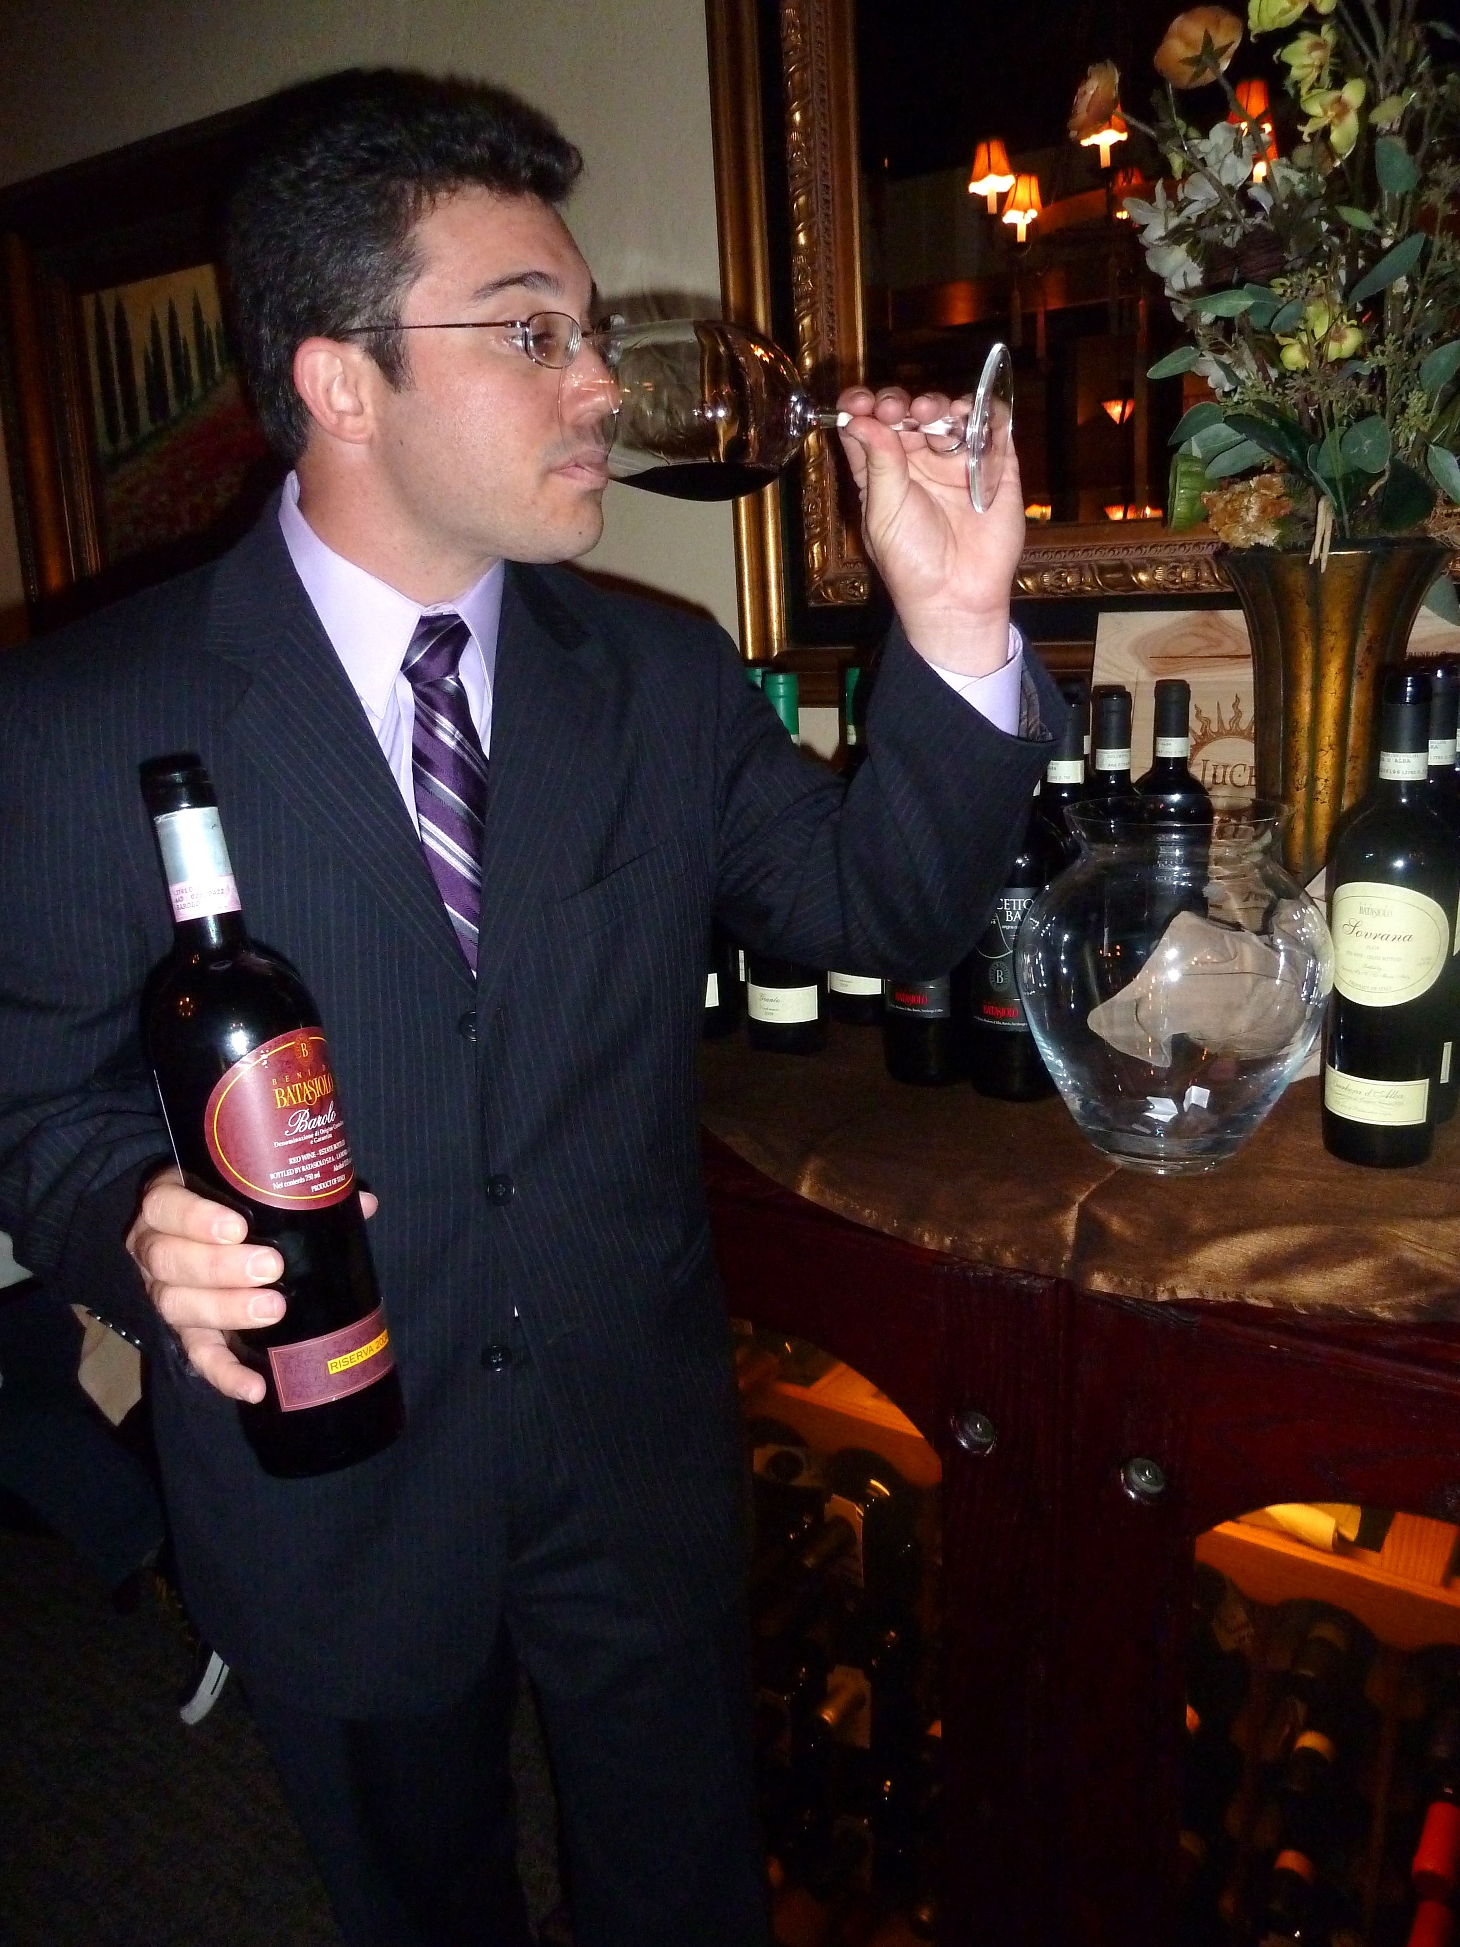

Pour about a third of a glass of your favorite red and stay with me as I take you through the basics of elevating your celebration, with a review of the five S’s.
The first thing that happens in this five part harmony in the romance of wine is the SIGHT of the wine. Wine should be poured into a clear tulip-shaped glass with a long stem to grip.

The color will vary from a deep red approaching black, in wines like Cabernet Sauvignon and Syrah, from France and California, and the Nebbiolo grape, found in Barolo and Barbaresco in Italy. The sight of brick red might be a Pinot Noir, Merlot or a Sangiovese and other lighter red colored wine.

Stefano Poggi of Batasiolo Wines in
Piedmont Italy demonstrates the smell
and grip of a wine glass.

You are also scanning for any foreign objects in the wine which would compromise the flavor. It could be cork fragments, even tiny sticks or other impurities from the crush of the grapes prior to barreling.

SWIRL – Swirling, the 2nd of the five S’s, is done to prepare the nose for this step as it aerates the wine allowing oxygen to mix with the wine to create a perfumed smell and flavor. When swirling, hold the glass firmly vertical by the stem, never by the glass to avoid warming, and briskly move it in a circular motion. “Legs,” or “tears,” may be seen running down the inside of the glass after the swirl. These result from higher levels of alcohol and sugar and hint at the wine’s power. On my trips to meet Italian wine makers in Italy, I always got a laugh out of the vigorous swirling of their wines while expressing themselves, concluding it was just a nervous habit. Not at all! They were simply seeking the maximum “bouquet,” a combination of smell and taste.

SMELL-The smell of a wine is its “bouquet.” It’s a fitting description, like the best flowers bundled up into a bouquet as a gift for a loved one. Another expression would be the “nose” of the wine. The human nose can distinguish thousands of unique smells. Wines have over 200 of their own. So get your nose down in the glass as close to the wine as possible. Take deep, short, sharp inhalations and try to detect smells such as flowers, fruit, herbs, oak, coffee and licorice. Younger reds will smell fruity, old wines will smell more earthy.

SIP-The sip or taste of the wine is indeed the most enjoyable of this five part harmony. With the smell still lingering in the nose, place the glass to your lips and take in a healthy mouthful. Work it around your mouth, but make sure it’s not so much that you have to swallow right away. Keep the wine making contact with your palate and tongue with an awareness of the flavors it presents, as well as body, and acidity which will come from the tannins in the wine, essential for maturity. The last is the finish or SAVOR. In the swallow/savor, be aware of how long the taste lasts in your mouth. Great wines have a long finish that lasts as long as a minute. It should leave a very pleasant after-taste. It is your final impression of a wine and should reflect its excellent quality and taste.

.

Simple Innovation in a Complex World

Over the last few years, we as a society have been inundated with technology. The Internet and key innovations like our smart phones are essential parts of our lives. I like to think of our phones as adult pacifiers. We don’t dare leave home without them. I am always amazed (and sometimes frightened) by machine learning and artificial intelligence baked into our phones, especially when I am getting ready in the morning and my phone tells me when I have to leave the house, where I am going, what time I have to be there, the weather, traffic along the way, and alternate routes if incidents. All of this from my 6x3x0.5 inch phone that talks to my “Dick Tracy” smart watch.

Additionally, in our new Covid world, words like Deoxyribonucleic acid (DNA), Ribonucleic acid (RNA), and epidemiology from biotechnology lab benches have become part of our regular vocabulary showing up in our daily news feeds.

This week when an email popped up in my email box with the subject line of “Cooking at home during COVID-19 (or the apocalypse) with solar ovens”, I reached out to Senior Editor Frank Mangio to pitch the idea of covering solar ovens, surely a simple concept. We had a social distance staff meeting, but close enough to enjoy a bottle of 2017 Mollydooker Two Left Feet ($30), a blend of Shiraz, Merlot and Cabernet, purchased in February from our good friends Jim and Bill Tobin, owners of North County Wine Company in San Marcos, CA. At the conclusion of our staff meeting, Frank with a grin on his face said, “Rico run with the solar oven story.” This seemed fitting with our Taste of Wine and Food mantra to Bring Smart Information to Your Table.

I love gadgets and gizmos and explored getting a solar oven a few years ago myself. When I checked out GoSun’s solar ovens, I was amazed at the technology baked into their oven. Yes, this pun was intended! Go figure, even solar ovens are advanced these days.

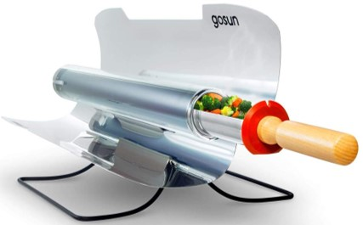
There are three models from a portable GO to middle of the road SPORT to grand FUSION. What was interesting about the FUSION version is that it could generate heat from the sun, as well as, 12 volt power sources such as car, boat, RV, or GoSun’s PowerBank batteries.

GoSun Sport solar oven pictured with
39oz. capacity cooking a meal with
steamed veggies.

Of note, both the SPORT and new GO (launching June 2020) models are Red Cross approved. With camping now opening up in California and other parts of the US, perhaps a GoSun solar oven is an option outside of the traditional Coleman green stove and propane bottles. All one has to do is unfold, load with food, point towards the sun and relax. In as little as 20 minutes, the SPORT model ($199) can bake, roast, and steam a meal for 2 persons with direct sun and reach temperatures as high as 550deg. With a 39oz cooking capacity, these are real meals. I was impressed that GoSun ovens can cook in rain, clouds, and sun. As long as you can see a shadow, one is cooking. However, your mileage will vary based on how direct the sun exposure is.

At 7lbs, the portable SPORT model is perfect for RV, camping, boating, backyard, and as an emergency response tool kit capable of boiling water, cooking food, and dare I say roasting a sunset smore. Get information including recipes at gosun.co.

Story by Tech Director, Rico Cassoni.

Hope all of our viewers are staying safe and healthy!

Frank and Rico

Frank Mangio is a renowned wine connoisseur certified

by Wine Spectator. He is one of the leading commentators

on the web. View his columns at tasteofwineandfood.com.

Go to recent columns. Reach him at frank@tasteofwineandfood.com

