
TASTE OF

WINE & FOOD

By Frank Mangio

Week of April 26, 2020

This Week’s Take-out Creations & Newly Discovered Wine Gems

During this stay at home and social distancing mentality we are enduring, you may be surprised to know that wine sales are doing very well, thank you very much. The last week of March, wine, along with other alcoholic beverages, rose 55% in the latest figures released, proving that wine especially is a needed “essential.” It’s reported that Roses’ rose 75% year over year. And, online sales were way above last year sales for all wines.


A couple of months ago, this column introduced you to a half dozen new wine rookies. It went over so well, we are encoring 6 more discoveries starting with a local winner at Orfila Winery in nearby Escondido, the 2018 Orfila Estate Lotus Viognier (Vee-own-yay) $34.

This is the most full bodied white you will taste. Its tropical fruit notes will put you squarely in the Bahamas. A healthy cream flavor enhances the wines with hints of Vanilla. Visit Orfila.com.

Justin Mund is the Winemaker/General
Manager of Orfila Winery in Escondido
for the past 10 years.

-Jeff Runquist 2018 Petite Sirah, Plymouth CA. $28. After winning “Winery of the Year” four times in competition last year, Runquist just released his 2018 Petite Sirah which should walk in the footsteps of past vintages with a parade of ripe, dark fruits. Rich flavors live in a wine which is at once soft, supple and silky. jeffrunquistwines.com

- Fifty Row 2016 Rutherford Cabernet Sauvignon, Napa Valley $85. Paul Johnson has finally done it. His Fifty Row Cab from the exquisite 2016 Napa Valley vintage, has masterful written all over it. John was the owner of Encinitas Baker and Olive when he heard the clarion call of Napa Valley making the wines he knew were in him. The 2016 stands tall, his best to date with distinctive “Rutherford dust.” Deep garnet in color with aromas of jammy blackberries and opulent dark plum. The palate is treated to voluptuous flavors of black currant, tobacco, plum and dark chocolate. fiftyrow.com.

- (Rico pick) DAOU 2019 Discovery Collection Rose, Paso Robles, CA. $22. The ornate bottle is the first indication this is a DAOU product. Any wine with DAOU on it has no shortcuts and benefit from Daniel Daou’s master winemaking skills including the Discovery Wine Collection up to their flagship Soul of a Lion. This dry Rose’ has strawberry, peach, and hints of cherry and honey on the nose and a crisp palate of nectarine, orange, strawberry, and apple. It is a perfect afternoon wine and a chameleon for many light dishes that it complements. Check out Daniel Daou LIVE each Tuesday from 9-10AM via Instagram (@daniel.j.daou) as he walks DAOU Mountain. Daouvineyards.com.

- (Rico pick) Trambusti 2018 Origo Super Tuscan Cabernet Sauvignon, Toscana, Italy $18. After digging through the freezer, I found some of last year’s San Marzano tomatoes. I figured this great value Super Tuscan would be perfect to go with some Casa Cassoni homemade pizza. And I was correct! The dark ruby color with cherry and spice on both the nose and palate along with medium tannins were a great flavor combo complementing the pizza’s sausage and mozzarella. Details at chiantitrambusti.it.
- (Rico pick) Stag’s Leap Wine Cellars 2017 ARTEMIS Cabernet Sauvignon, Napa Valley, CA, $75. Those who read last week’s column might remember that Frank and I enjoyed this wine at a recent Morton’s The Steakhouse Stag’s Leap Wine Dinner. ARTEMIS had raspberry and boysenberry on the nose along with cherry and hints of cedar wood and spice. The plum and dark chocolate palate and lingering finish was perfect with the melt in your mouth Morton’s signature Filet Mignon. Those with a larger budget might want to try FAY Cabernet Sauvignon Estate Collection ($150). This was also served at the dinner and was an exceptional treat. Details at stagsleapwinecellars.com.

This Week’s Takeout Specials

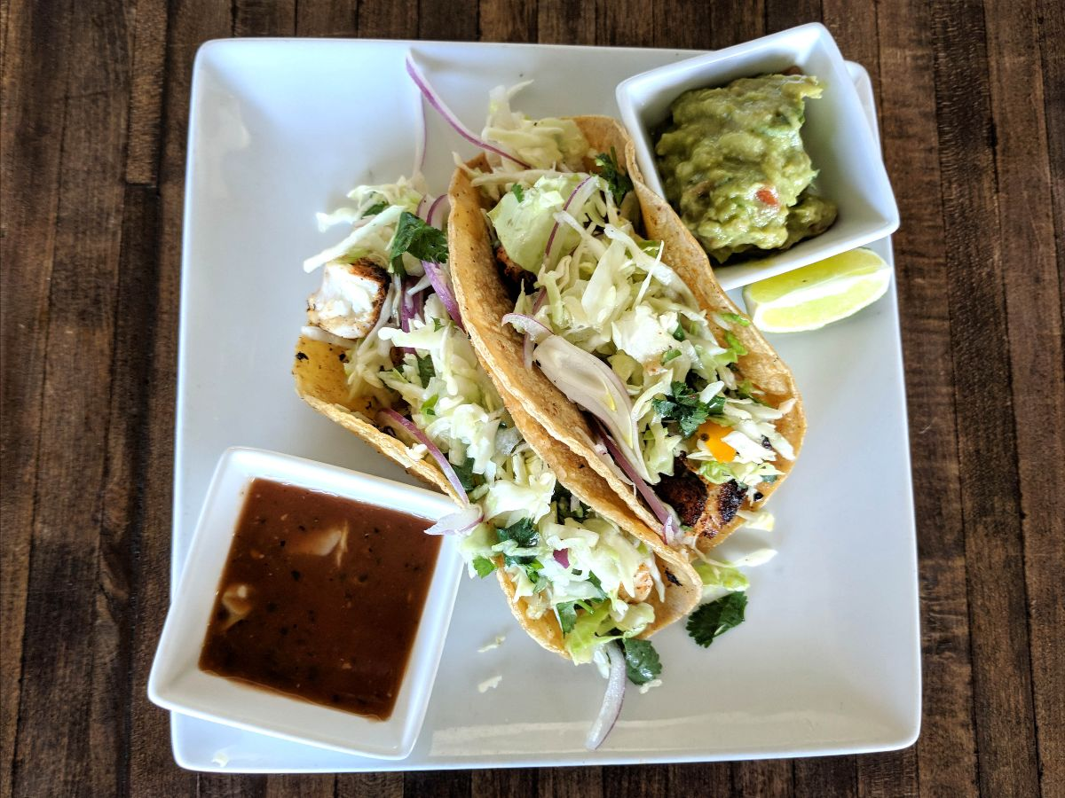
Seasalt in Del Mar, every Tuesday and Thursday, celebrates with $12. salmon or steak tacos with Spanish rice, plus a bottle of Dos Equis beer for 1cent! Call Sal at 858-755-7100. Pickup hours are 4 to 7:30.

Vigilucci’s in Carlsbad & Leucadia offer their new Family Style takeout. Family trays for limited time pricing for 6 to 8 persons can be ready

Seasalt in Del Mar features a takeout of 2 tacos every Tuesday

and Thursday. Choice of steak or salmon, along with Spanish

rice, guacamole for just $12. and 1cent Dos Equis beer.

prepared for that overdue party. For Carlsbad, call 760-434-2500 and 760-634-2365 for Leucadia.

The Landry restaurant group is going all out with the best steak and seafood for take out. Morton’s the Steakhouse, San Diego has a 3 course Steak and Lobster

menu starting at $59. and a prime burger plus fries for $13. with a half priced wine option. Call 619-696-3369 for details. Charthouse at the Beach in Cardiff

has 10 lunch items under $10., daily from 11to 4pm. From bowls and greens to hand-helds with fries, you’ll see a combination you’ll like. Call 760-436-4044 to order.

Frank Mangio is a renowned wine connoisseur certified

by Wine Spectator. He is one of the leading commentators

on the web. View his columns at tasteofwineandfood.com.

Go to recent columns. Reach him at frank@tasteofwineandfood.com

