
TASTE

OF

WINE
By Frank Mangio

Week of April 5, 2020

Napa Valley Reaches Out with its Cellar

Library Wines

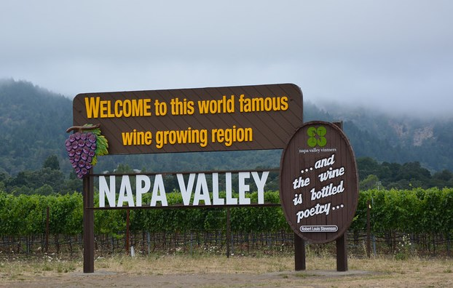
Napa Valley has just gone to its Ace of Hearts in a bold effort

to appeal to its many customers who, over the years, have traveled

to this fabled wine country and had a wine experience unlike any other.

Many wineries are offering their coveted cellar library wines at sharply discounted prices if purchased directly online or at the winery.

The Covid-19 disease knows no bounds, including the North coast of California

and its wine country greats. Napa produces 4% of all the wines in California, however accounts for 80% of its sales, an eye-popping ratio! Food & Wine Magazine reports an average price for a ton of Cabernet Sauvignon is now $8,062., about double what it was in 2007. Divide that price by 100 and you get an industry rule on the suggested retail price of a bottle of high quality Cab at the most well known wineries, a lot to lose if the Coronavirus pandemic swept through the Napa Valley. Cabernet is one of some 34 different varietals of wine grapes available in the valley with prices lower than the elite Cab. Wineries in Napa that have continuous discounts and special offerings through virtual tastings to engage and connect include: Paul Hobbs, Chateau Montelena, Inglenook, Lewis, Merryvale, Hall, Roundpond, Groth, Raymond, St Supery and Plumpjack, etc. With some, shipping is waived. Go to napavintners.com for more.

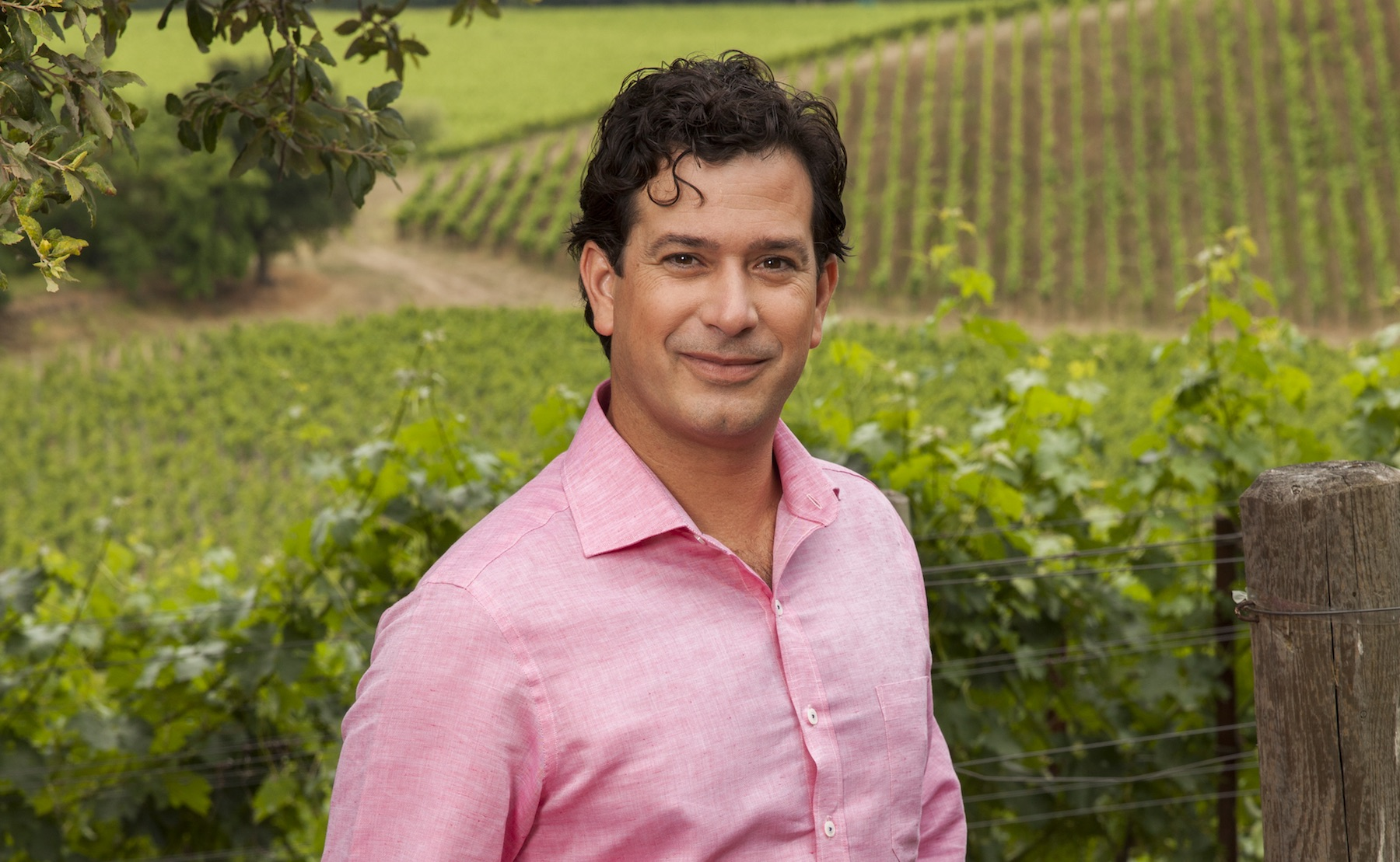
A famous name in wines, Robert Mondavi, mastered the art of Napa Valley winemaking from the 1960’s to his death in 2008. Today his son Michael, granddaughter Dina and grandson Rob Jr. operate Michael Mondavi Family Estate on Atlas Peak in Napa Valley. Rob has developed Wine Wednesday, in his stay

Rob Mondavi Jr., grandson of the late great Winemaker Robert Mondavi,

who with his father and sister operate Michael Mondavi Family

Estate in Napa Valley, developed a series of Wednesday

Instagram Live streams. Go to @MichaelMondaviFamilyEstate.

at home Instagram Live Wednesday progams that begin at 4pm. Rob said of this on-line streaming program…”we talk about wine and food, tell a few stories and occasionally have live musicians. We introduce a select group of fine wines that you can enjoy with your families in the comfort of your homes. All shoppers who purchase six or more bottles will receive a complimentary bottle of our family’s Napa Valley Olive Oil. We have concentrated on affordability so you can enjoy quality wines from Napa and Sonoma.” Some rich red wines are discounted 50% or more! Go to michaelmondavifamilyestate.com for details. On Instagram, it’s @MichaelMondaviFamilyEstate.

Rico Ups his Pizza Game with Solare LIVE

As an Italian and Tech Director/Writer for Taste of Wine and Food (TOWAF), of course, making homemade pizza is a passion of mine. While I would like to call myself an aficionado, I am probably more of a hobbyist. On my list of To-Dos, to up my pizza game, was taking the Pizza Making class at Solare Ristorante Italiano under the guidance of Brian Smerik, proprietor Randy Smerik’s son. With Randy being a previous techie, it was natural for him to start Solare LIVE via their Instagram channel to share mixologist Tommy Smerik, another one of Randy’s sons, with Petra Belliti’s knowledge in wines and drinks, Chef Fillipo’s How To Make Polenta and Homemade Pasta recipes, and Brian’s killer pizza techniques.
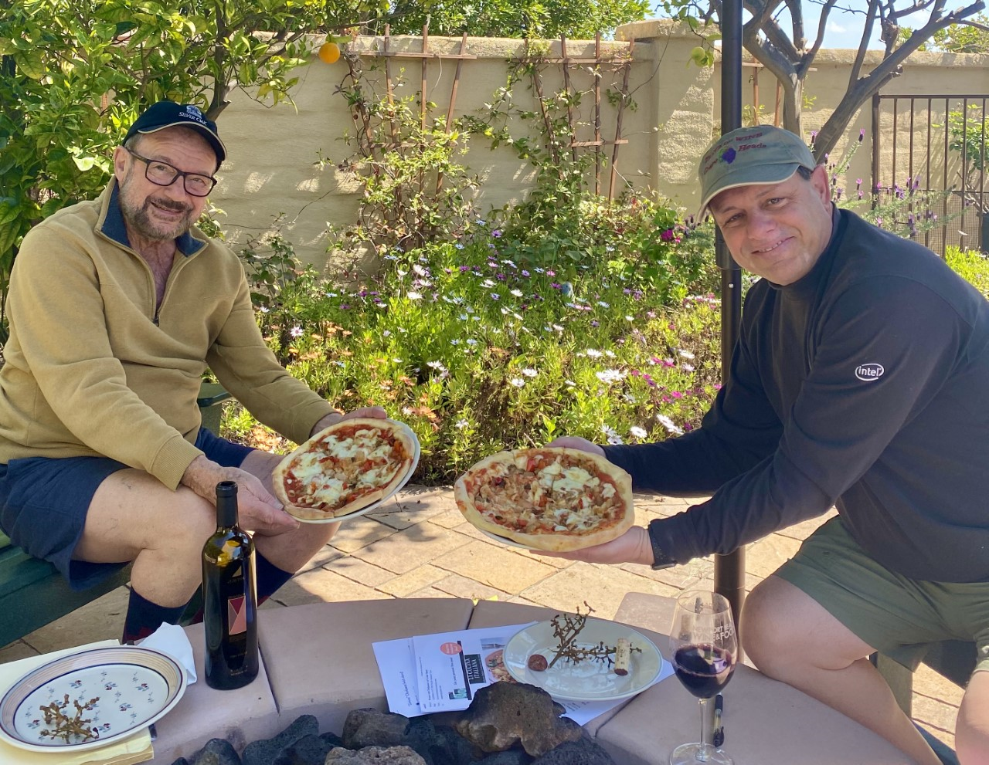

While it was not the onsite class mixing dough by hand, I have to admit I cheated with the KitchenAid mixer and dough hook, I picked up a couple of tips taking my pizza crusts to the next level. Two key tips were folding over the dough in half 4 times to not overwork the dough and using one’s finger tips to press out the dough making 3 specific areas (1) crust, (2) main area, and (3) a bullseye

(Left to Right) Taste of Wine and Food Senior Editor
Frank Mangio with Tech Director/Writer Rico Cassoni
enjoying homemade pizza and Justin Isosceles over a staff meeting

providing a reserve area to prevent a thin center. Can’t wait to take the class live after Coronavirus. Thank you Brian for the great tips! See solarelounge.com and their Instagram site @solaresandiego for upcoming LIVE events.

The good news was that I needed a volunteer to try to try my new techniques. Who would be better than my two doors down neighbor Senior Editor Frank Mangio who was kind enough to share a 2017 Justin Isosceles to savor our pizza over a staff meeting, all while maintaining social distance?

Before ending, I would like to plug a few of our North County and Paso friends:
- Orfila Winery under the leadership of General Manager and Head Winemaker Justin Mund has opened their Oceanside Tasting Room, Wed through Sun from 12 to 7PM for takeout. Check out one of the best burgers in North County by Exec Chef Luke Morganstern and say hi to Manager Dave. They also have some great bargains on their wine as well. See orfila.com.
- Speaking of pizza, Tore Trupiano, Co-Proprietor of Mangia e Bevi and world renowned pizza maker, has DIY pizza kits that customers can pick up at their Oceanside location. They are also open for take out as well. Details at mangiaoceanside.com.
- PAON in Carlsbad has reopened for bottled wine sales. Each week Wine Manager Kate Edgecombe will be featuring wine specials. They are open Wed to Sun from 3 to 7PM. Order ahead, by phone or email, to have your wines ready for pick-up at the Wine Bar or stop by to shop deals during their temporary hours. Call 760-729-7377 or email Kate@PaonCarlsbad.com.
- Be on the lookout for DAOU Vineyards new 2019 Discovery Rose’ wine that launched on April 5th the day this column launched. This is a Grenache-based rose resembling iconic French dry roses. With aromas of strawberry, peach, and watermelon along with a palate of nectarine, orange, strawberry parfait and apple, this is sure to be to another knockout DAOU wine ($22). Details at daouvineyards.com/product/2019-daou-disc-rose.

Story by Tech Director/Writer Rico Cassoni.

Hope you and yours are safe and healthy,

Frank and Rico

Frank Mangio is a renowned wine connoisseur certified

by Wine Spectator. He is one of the leading commentators

on the web. View his columns at tasteofwineandfood.com.

Go to recent columns. Reach him at frank@tasteofwineandfood.com

