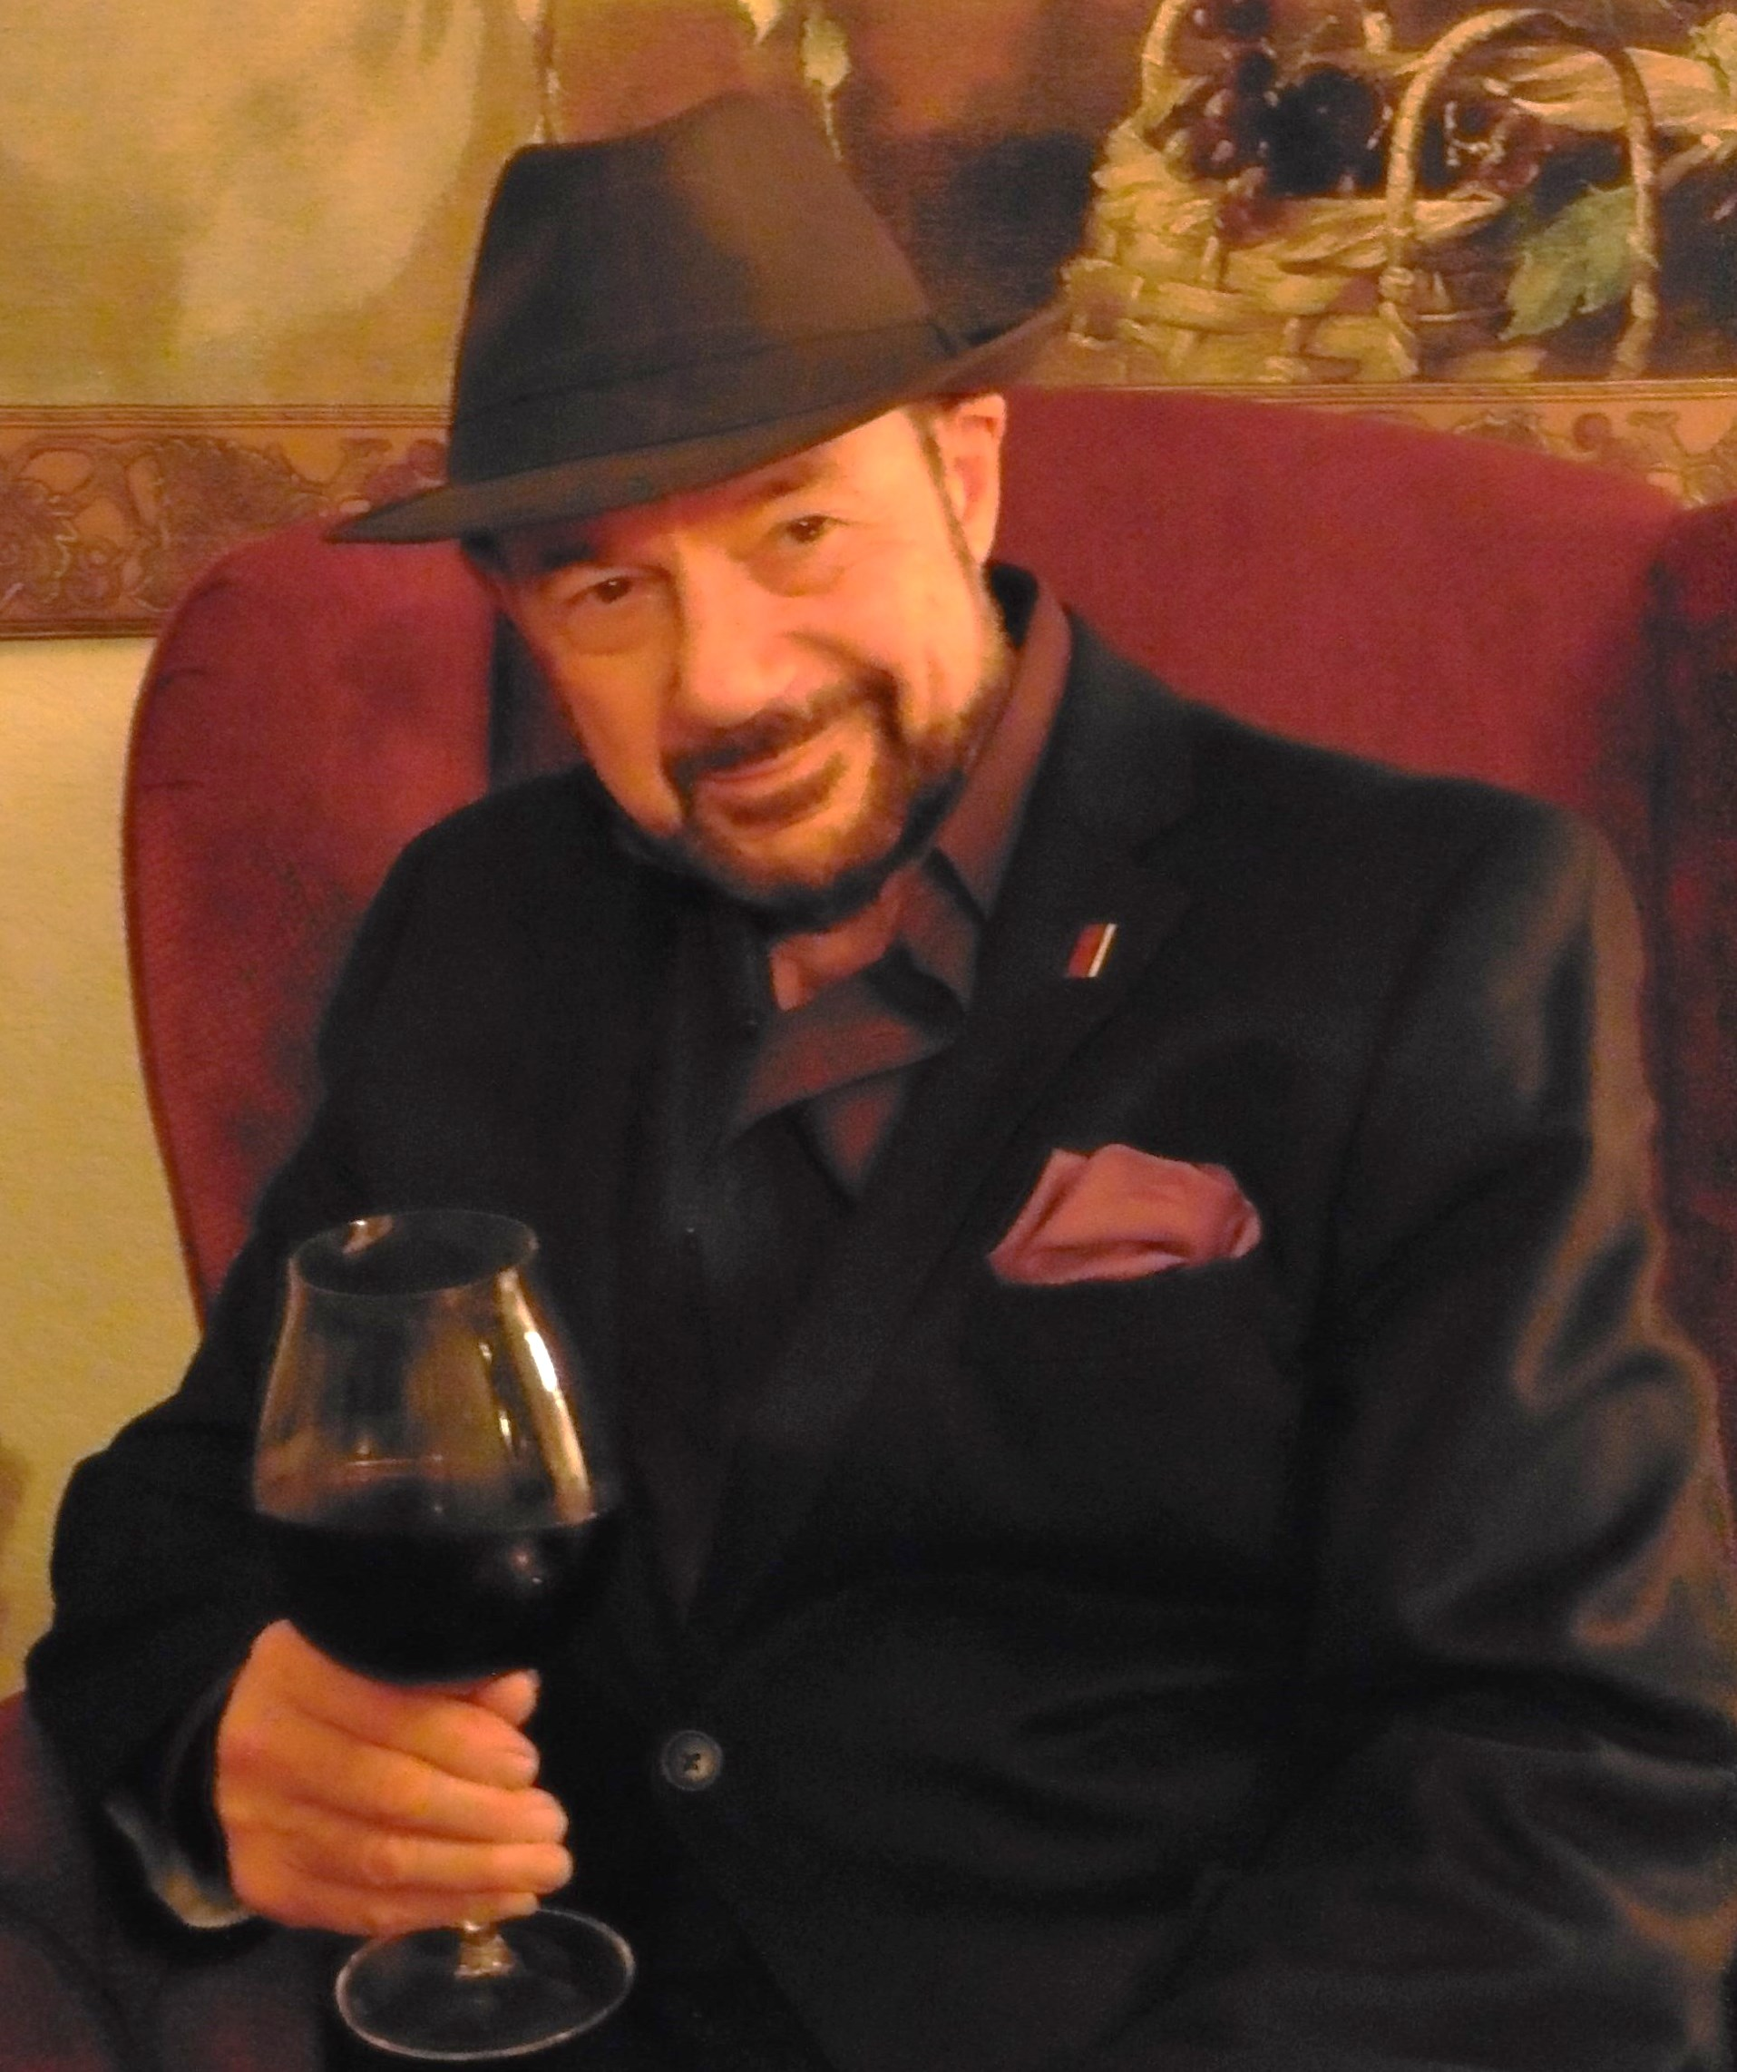TASTE

OF

WINE
By Frank Mangio

Week of March 1, 2020

Duckhorn Dazzles at Il Fornaio Del Mar
I suspect that some read the title, smiled, and thought Ah Duckhorn! Perhaps, a few others read the title and thought where did I hear Duckhorn from? For the latter, Duckhorn was Wine Spectator’s 2017 Wine of the Year with their 2014 Three Palms Vineyard Merlot that renewed interest in Merlot following its unfortunate bad rap from the movie, “Sideways.” Merlot lovers everywhere jumped for joy and rejoiced that Merlot was once again in good graces.
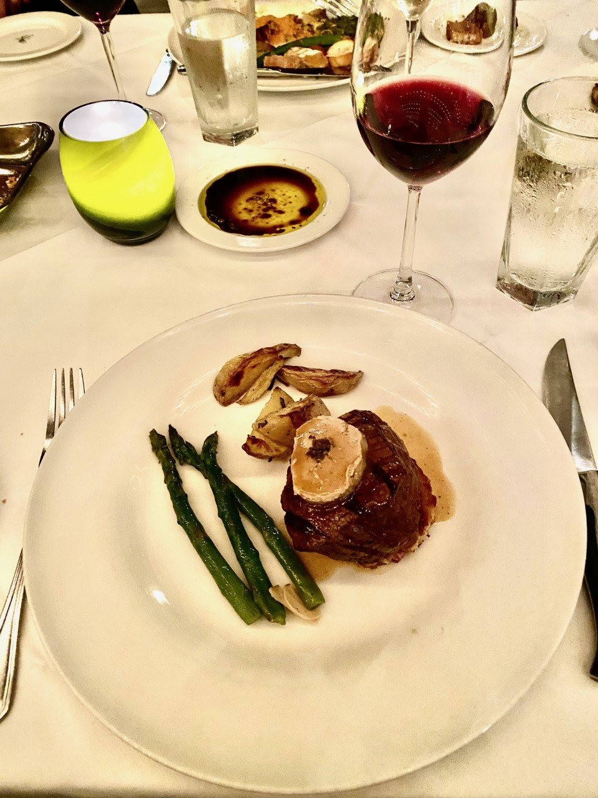
It was an extra special Duckhorn Wine Dinner hosted by Il Fornaio/Vons Pavilions with Guest Speaker Dana Epperson, Duckhorn Portfolio Migration Winemaker & VP of Winemaking, Sonoma/ Mendocino. Il Fornaio GM Vittorio Homberger, Chefs Roberto and Gianlucca, and staff created another “Over the Top” experience quoting Senior Editor Mangio. The Secondi Beef Tenderloin with goose-truffle pate with roasted potato wedges and grilled asparagus paired with 2017 Duckhorn Napa Valley Merlot and the Primo Pear Ravioli in a mascarpone sauce paired with 2017 Duckhorn Napa Valley Chardonnay were both AMAZING!
Beef tenderloin medallion topped with
goose-truffle pate in a Madeira wine sauce
paired with 2017 Duckhorn Napa Valley Merlot
Guests also enjoyed a few appetizers with 2018 Duckhorn Sauvignon Blanc and ended dinner with chocolate layer cake paired with 2016 Paraduxx Red Blend.
Epperson made the night extra special with her presentation of the Duckhorn portfolio wines. She grew up in grape country in Sonoma County and was drawn to what she saw everyday - grapes and wine. She started her career in 2007 after completing her Cal Poly Food Service degree at Edna Valley Vineyard, then worked at Artesa under Mark Beringer who would become Duckhorn’s 2nd winemaker. In 2014, she became the associate winemaker and then winemaker for Duckhorn portfolio Decoy Winery. She took a hiatus to Etude Winery to get more experience with small-lot luxury Chardonnay and Pinot Noir as its winemaker under Pinot Noir-specialist Jon Priest. She then returned to Duckhorn portfolio in 2017 as Migration’s winemaker. Her passion for wine making is obvious. When she was talking to Frank and me, her face lit up with excitement as she discussed viticulture, bottling and everything in between that encompasses winemaking.

One of the benefits that Epperson sees throughout the Duckhorn family of brands is the presence of females in a male-dominated industry. She loves having Duckhorn’s winemaker Renee Ary as a peer. Epperson commented that Duckhorn’s executive team also includes females as the SVP Chief Financial Officer (Lori Beadoin) and SVP Chief Marketing & Bus. Development Officer (Carol Reber). Perhaps all this girl power is part of Duckhorn’s secret sauce and “balance of artistry, science, and deep respect for viticulture and winemaking”, says Renee Ary. All we can say at Taste of Wine and Food is keep up the great work Duckhorn family. We love your wines! Visit duckhorn.com.

Looking for more Il Fornaio Del Mar wine dinners? Check out “100 Years of Napa Wines” Thur, Mar 26 at 6:30pm, hosted by Gillian Balance, one of only 25 female Master Sommeliers in the world, $99.99 per person. RSVP 858-755-8876. Visit www.ilfornaio.com/delmar. Story by Tech Director/Writer Rico Cassoni.

Discover New and Celebrity Wines at
Fun Bars Like PAON & NCWC
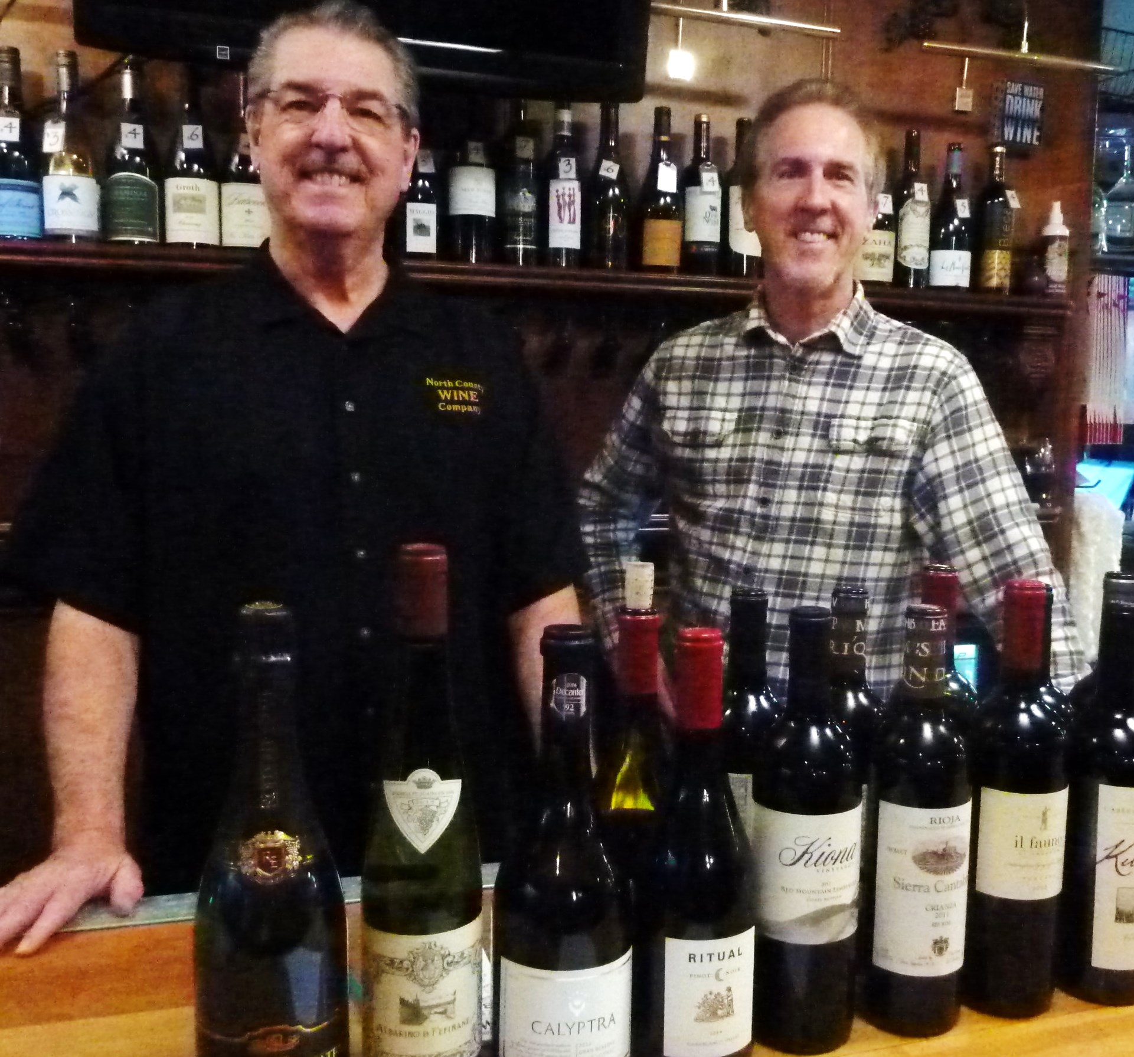Last week’s column had several tips on how to get that new wine you want to add to your “highly regarded, tastiest discovery” wine list.
I poured through my e mails from wine shops, bars and wineries, dovetailing the info, did some cork-popping and came up with some new wines I thought you should try.
Two wine bars in the San Diego area, as they usually do, caught my attention for the wines

North County Wine Company (aka NCWC) always has

more wine bottles per square foot than anybody. It’s operated

in San Marcos by Bill Tobin (left) and brother Jim Tobin.

presented in their weekly “flights,” the price to value of the list and the research that went into their presentation. Always several different wines presented weekly, for one flight price. If you ask for it, you can get a wordy history of each wine presented by Jim Tobin, a certified Sommelier, who with his brother Bill, founded NCWC (North County Wine Company) back in 2006. Bill is behind the bar, and like every good bartender knows most customers by their first name.

You should ask about their “WOW of the week. That’s how I learned about LUKE from Jim who writes their newsletters. It was my #1 wine recommendation last week. It’s a Washington red from the Columbia Valley, a Cabernet, that’s selling at NCWC for only $17.97 a bottle, a screaming steal!

There latest Top Flight on Fridays and Saturdays included a 2018, “The Prisoner,” perhaps the most talked about blend of red grapes since wineries began doing blends. I have noted this trend in wine bar flights that are popping in a big league wine name to sweeten the flight. The shop has about 600 wines on hand at discount prices. See northcountywinecompany.com.

On now to PAON and its wine bar and small bites kitchen, in Carlsbad. Over the years, PAON made itself famous in Carlsbad Village by serving fine 4 course dinners by name chefs, and still does. Last year it converted an attached retail wine store with a small bar into an active wine club bar where members could come to sip on wine flights of six wines each, have something to eat and listen to live music on weekends. The public was invited to come also for a nominal fee. The results were beyond expectations, under the management of Wine Director Kate Edgecombe and bartender Daniel DuChateau. (He of course loves French wines.)

The PAON combination has won prestigious awards including Wine Spectator’s “Best of Award of Excellence” 4 years running. Like NCWC, PAON is placing a big winner in each flight. This day, I was able to taste the Wine Spectator #1 wine in the world a few years ago, the 2016 Duckhorn Merlot from Napa Valley. Visit their site at paoncarlsbad.com.

Wine Bytes

Morton’s and Stag’s Leap Wine Cellars, a Taste of Two Legends, presents the year’s most talked about wine dinner, Sat. March 7 at 6:30pm in downtown San Diego. Join them for an unforgettable evening of Morton’s cuisine paired perfectly with the finest Stag’s Leap Wine Cellars wines including the Artemis Cabernet Sauvignon, Napa Valley with Morton’s Porcini Rubbed Filet Mignon.

$135. per person + tax, includes gratuity. RSVP your reservation at mortons.com/sandiego/specialevents. For more info call 619-696-3209.

The Winesellar Brasserie brings Hartford Court Family Winery Sonoma to San Diego for a wine dinner Sat. March 14 at 6pm. Special guest Hailey Hartford.

Luscious Chardonnay, Pinot Noir and old vine Zinfandel will be served. Cost is $99. each, $89. for club members. Call 858-450-9557 to reserve seating.

Vintage Wine Storage of Carlsbad and the Terraces Winery of Napa Valley have planned a walk around tasting of its wines, along with lively conversation and light nibbles, Thurs. March 12 from 5:30 to 7:30pm. Cost is $10. Call 760-390-5996.

Frank Mangio is a renowned wine connoisseur certified by Wine Spectator. He is one of the leading commentators

on the web. View his columns at tasteofwineandfood.com.

Go to recent columns. Reach him at frank@tasteofwineandfood.com

