
TASTE

OF

WINE
By Frank Mangio

Week of February 23, 2020

Discover New Wines. We’ll Tell you How and

Name a Few.

I was just about to sit down in front of my computer and launch my latest idea on a column urging you to take a break from the same labels that you’ve coveted for years, and reach out for something new, different and intriguing. I have for some time subscribed to the idea that for every four familiar wine names, change your instincts and reach for something different.

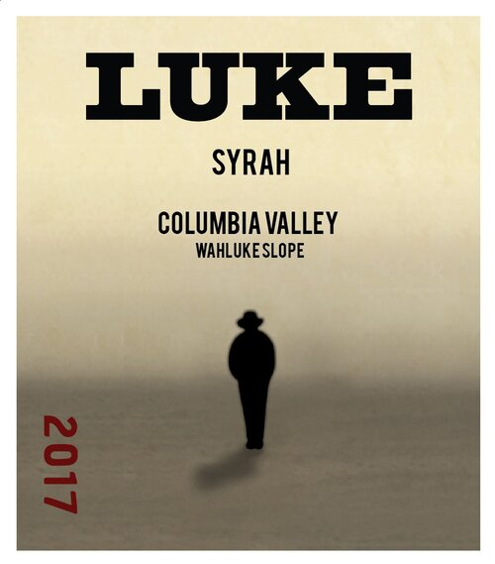
Just before reaching for my keyboard, I speed read today’s Wall Street Journal and what do you know,

there was a pitch for their “Top 12 Wines You Need to Try.”

Not only that, the latest Wine Spectator had their strategies to get the new wine you want. So, I was in good company and in a celebratory mood, as I poured into my e mail messages for the latest blasts from my favorite San Diego (and elsewhere) wine shops. What kept coming up was LUKE.

LUKE, new and an “imitation of no one” is a family of wines

celebrating the vision of a character that “reveals himself slowly

like a freed wind emerging from the shadow of a mountain.”

Located in the gigantic AVA of the Columbia Valley on the Eastern side of Washington at the Wahluke Slope, LUKE makes some of the finest Cabernet Sauvignons and Merlots you would ever want to spend the night with, but the one you’ll want to marry is their Syrah, with the new vintage 2017.($18.) This is a full bodied red, packed with full color and a constellation of flavors with dark chocolate competing with notes of pepper and candied fruits.

Once you unlock the value of this newcomer, you’ll want to try them all

Visit winesbyluke.com.

I love the hunt when it comes to finding a treasure, so here’s what I have

to find your next dream wine. You should taste before you buy so if possible visit some wineries. Wine “flights” at wine shops, restaurants and wine shows are abundant and fun to compare with others. You may be able to quiz the winemakers or reps that show up to promote. Take notes and crosscheck with other sources on-line with its wine websites and an enormous inventory of detailed info. Get on as many emailing lists as you can handle.

Be aware of current vintage years. Was it a great year or a bad year?

How did it do in the various ratings published by wine authorities in the media?

Talk to a wine sommelier (certified wine director) in shops and restaurants and get up to speed on what varietal is in the lead on the current wine scene.

Here’s a few more arrivals to the party that you may want to follow up on:

The Four Graces Pinot Noir, Willamette Valley Oregon, 2017. $25. Delicate and polished like most Pinots. Cinnamon accents the bold richness and refined tannins. Visit thefourgraces.com.

Triumph by 1848 Wine Company, Sonoma CA, 2017. $45. A complex and bold red wine. Plenty of “fruit forward” on the palate, with dark, inky wine revealing flavors of raspberry, blackberry and plum. You’ll be saluting the wine and the U.S. flag resemblance artwork on the label. See 1849 wine.com.

Frescobaldi Tenuta PERANO Chianti Classicco, Tuscany, 2016. $25. This wine holds the highest standard award from the Italian government, a DOCG, for guaranteed highest quality. 2016 was a banner year for crop excellence and perfect ripeness. PERRANO is a debut wine for 2016, with 100% Sangiovese grape power. Visit Frescobaldi.it.

Enjoy the seductive power of a new wine with personality. It may become your new best friend.

David Phinney Inspired Wine Dinners at Ercolano Restaurants

Sal Ercolano called Frank and me up at the end of 2019 when he was putting together his 2020 Wine Dinner venues to share the great and exciting news that he was going to have a The Prisoner Wine Dinner at Seasalt Seafood Bistro back to back to with an Orin Swift Cellars Wine Dinner at his West End Bar & Kitchen restaurant. We loved it!

Both of these terrific wines are the creation of Napa Valley renowned wine maker David Phinney, who in his mid 40s, has already made a huge impact on Napa Valley wines and winemaking. Phinney started his wine career in 1997 at Robert Mondavi. In 1998, he created his Orin Swift Cellars label name after his father’s middle name Orin and his mother's maiden name of Swift.

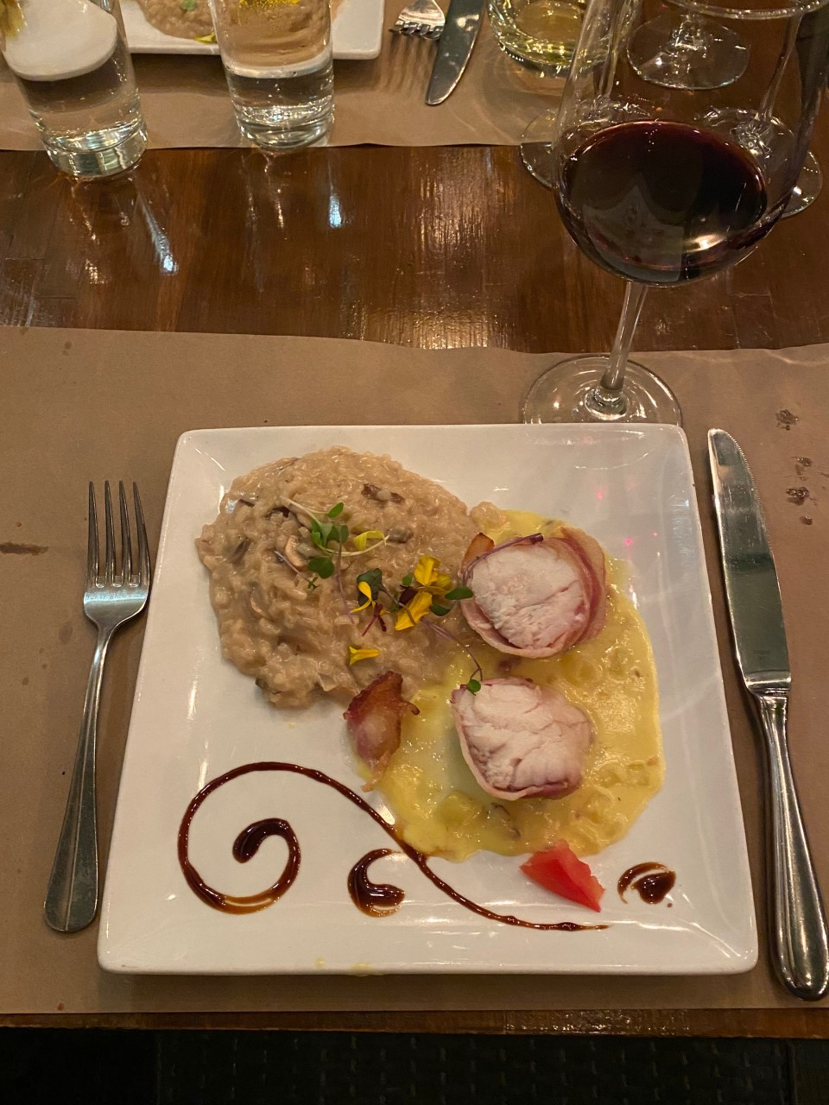
This was also the year that he was able to get access to some exceptional Napa Valley fruit. Perhaps a vision in the middle of the night, but somehow Phinney figured out that he could inject Zinfandel into a blend of Cabernet Sauvignon, Petite Sirah, Syrah, and Charbono to make a killer wine. The Huneeus Family Vintners, owners of Napa’s Quintessa Winery, agreed as well and in 2010 years purchased Orin Swift brands The Prisoner and Saldo as a collaboration project with Phinney, who maintained control over production and winemaking. The Prisoner Wine Company was then purchased from Huneeus Vintners in 2016 by Constellation Brands for $285M within a year

Fresh monkfish wrapped in parma ham on a bed of
fennel, saffron cream sauce and porcino risotto paired
with The Prison Red Blend.

of purchasing Meomi from Joe Wagner. Go Constellation Brand!

If this was not enough, Phinney picked up vineyards in Europe, started a line of spirits, and opened up a tasting room in St Helena building a nice portfolio. In 2016, E. & J. Gallo purchased the Orin Swift brand, inventory, and St. Helena tasting room. Knowing Phinney’s magical winemaking skills, Gallo recruited him as winemaker for the Gallo Orin Swift brand in full circle.

With all of this history it was clear to see why Ercolano was so excited with these two wine dinners. The Prisoner Wine Dinner is in the history books. The five course dinner had a seafood theme and featured a main course of Monkfish wrapped in parma ham served with a rich saffron sauce and porcini mushroom risotto perfectly paired with The Prisoner Red Blend.

Next up for Ercolano is the Orin Swift Wine Dinner on Thu 3/5 and Sat 3/7 6:00PM at West End Bar & Kitchen featuring a 5 course meal paired with 5 Orin Swift wines including Papillion Bordeaux blend and Mercury Head Cabernet Sauvignon complementing a wild boar tenderloin and stuffed chicken breast. The dinner will finish off with chocolate ganache and 8 Years in the Desert Zinfandel blend. Cost is $75 per person plus tax and gratuity. RSVP at 858-259-5878. Story by Tech Director/Writer Rico Cassoni.

Wine Byte
Meritage Wine Market in Encinitas will re-charge its Friday Night Tastings starting the first week in March. A new schedule of events will be revealed plus classes to enjoy on premises. For details call 760-479-2500.

Bazille Restaurant, inside Nordstrom UTC is staging its first wine dinner, with an Italian theme, Thurs. March 5 from 5 to 8pm. The cost is $50. per person for

a 3 course dinner plus “Amuse” and Italian paired wines. To secure a place, call 858-812-3582.

Rancho Valencia in Rancho Santa Fe presents the next in its series of winemaker dinner series, with a DAOU Vineyards event Wed. March 4 from 6:30 to 10pm. Join owner Georges and Daniel Daou as they introduce award-winning Bordeaux style red wines with a stylish, exquisite al fresco five course dinner on the fountain patio. Please call 858-759-6246 or email veldorareserations@ranchovalencia.com. $155. each.

Frank Mangio is a renowned wine connoisseur certified by Wine Spectator. He is one of the leading commentators

on the web. View his columns at tasteofwineandfood.com.

Go to recent columns. Reach him at frank@tasteofwineandfood.com

