
TASTE

OF

WINE
By Frank Mangio

Week of February 2, 2020



With Valentines Day several 24 hours away, we thought we’d be cute and offer you four headlines for you to choose from, to impress your Valentine. You can poetically use them in your Valentine themed card, scratched on your glass of wine or a romantic gift, then break the news about the tasty restaurant you’ve chosen. My favorite? “Love the wine you’re with”! I have it on a waiter’s fancy towel hanging from my floor-to-ceiling wine cooler. They are all wines I love to open and sip. You grey-haired types, if you still have hair, surely remember Crosby Stills and Nash from the 60’s. Stephen Stills sang the lead on “Love the one you’re with.” “Wine” replaced “one” shortly after.

Music and wine have had an intimate relationship in all kinds of music formats: A sample: Red Red Wine: UB 40, Spill the Wine: Eric Burden and War, Cracklin’ Rosie: Neil Diamond, 2 More Bottles of Wine: Emmy Lou Harris, Elderberry Wine: Elton John and the classic Days of Wine & Roses: Andy Williams.

A disturbing shift in Valentine tradition… greeting card companies like Papyrus and American are closing operations. Even Hallmark is slashing stores and increasing their on-line offerings. Millennials and Gen Z’s aren’t sending Valentine cards. Even their parents are moving over to digital substitutes.

Clever restaurants this year are offering the same specials Thursday, Friday, Saturday and Sunday, February 13, 14. 15 and 16. Exhibit A is the Charthouse group and their 3 course “Sweetheart Special Menu.” All 4 nights can include choices of gourmet offerings, and a premium bottle of Golden Eye Pinot Noir or a Patz & Hall Chardonnay wine for a nominal extra cost. In the Encinitas Charthouse, you get the bonus of a gorgeous ocean view. For an RSVP we advise calling 760-436-4044 ASAP.

Wines to embrace for that complete intimate home dinner: Banfi Rosa Regale sparkling wine, Dr. Loosen Blue Slate Riesling, DAOU Reserve Cabernet Sauvignon and a minimum 20 year Tawny Port from Taylor Fladgate. All are Valentine poetry in a bottle.

Sojourn Cellars Wine Release Party at Ruth’s Chris
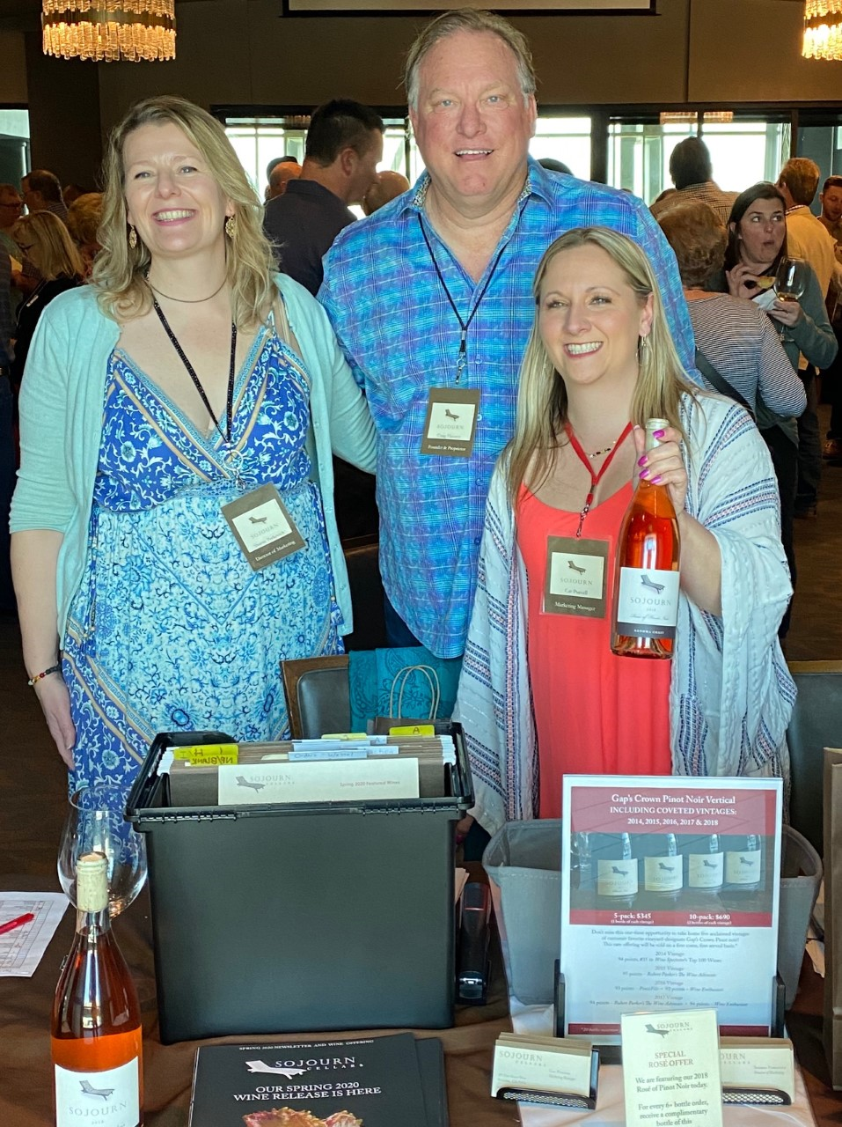

Sojourn Cellars hailing from Sonoma was at Ruth’s Chris Del Mar for their Spring 2020 Wine Release Party. They are calling the 2018 vintage a winemaker and grape grower’s dream across Sonoma and Napa Valley. Moderate temperatures and dry weather created abundant yields of high-quality fruit. Cool evening temperatures and a long, even growing season allowed for complex flavor development while retaining natural acidity.

Sojourn offered guests the first 5 wines to prove the 2018 Dream with 7 wines to enjoy in total.

(Left to right) Sojourn Cellars Sherrie Perkovich, Director of Marketing, Craig Haserot, Founder & Proprietor, and Cat Purcell, Marketing Manager at San Diego 2020 Release Party.

Attendees were greeted with the Sangiacomo Vineyard Chardonnay sporting fruit forward notes of citrus with hints of apple. Next was a Pinot Noir quad starting with Rodgers Creek Vineyard nestled in a ridge in the heart of Petaluma Gap benefitting from cool nights and fog-perfect for Pinot Noir. The Sangiacomo Vineyard was next. This has been Sojourn’s flagship wine since 2004 with good reason. Berry flavors and a creamy mouthful feel made this an outstanding wine. The third was the Walala Vineyard at 1,200 foot elevation with gravely soils and abundant sun at high altitude to ripen the fruit resulting in tropical notes. Fourth was the Gap’s Crown Vineyard at 800 foot elevation with volcanic soil and windy conditions resulting in the most intense qualities of the 4 Pinots with dark berry and cherry on the nose, deep garnet in color, and cherry and baking spice hints on the palate.

In between wine sipping, the Ruth’s Chris team ensured that visitors enjoyed sliders with their signature beef, chicken cakes, and puff pastry inspired delicacies that equally matched the great Sojourn wines. Tech Director Rico and I were able to see our good friends from Ruth’s Chris Del Mar Mark Parsini, Beverage Manager, and Yadira Navarro, Sales & Catering Manager. Yadira was sharing her excitement for events that will be held in the new downstairs patio overlooking the ocean for perfect sunset views. Be on the lookout for upcoming events in forthcoming Wine Bytes. Visit ruthschris.com.

The last two Sojourn tastings were non-2018 Cabernet Sauvignons. The first, 2017 Home Ranch Cuvee, originally planted by Sojourn proprietor Craig Haserot in 2002 in the southwest corner of Sonoma Valley. Warm temperatures with large fluctuations ripened the 2017 with blueberry aroma, balanced tannins, and a long dark fruit lingering finish. Second was the 2016 Oakville with blackberry, cassis, and plum with vanilla hints. This was Tech Director Rico’s favorite of the day. The 2017 Oakville releases in the fall.

Of note with Sojourn Cellars is its iconic lounge chair logo. Sherrie Perkovich, Director of Marketing shared with us, “Sojourn is all about recognizing that Life is a Journey.” Proprietors Craig Haserot and Eric Bradley, also the winemaker, wanted to create amazing wines sourced from the best vineyards of Sonoma and Napa Valley so that their wines could be enjoyed with family and friends when we slow down to enjoy great times on our own life journeys. More info at sojourncellars.com.

Wine Bytes

Firenze Trattoria in Encinitas has a Valentines Day special premium menu with several choices per entrée Fri. Feb. 14. Main entrée choices include Halibut, Risotto, Pollo, Salmon and other choices. $75. each. Call 760-944-9000 for details.

Enjoy a Valentines Sparkling Wine Rose’ Tasting Thurs. Feb. 13 from 5:30 to 7:30pm at Vintage Wine Storage in Carlsbad. Light appetizers available. Cost is $20.

South Coast Winery, Resort and Spa in Temecula offers romantic dining for Valentines Day at the Vineyard Rose Restaurant in a three course gourmet experience, 5:30 to 9pm. Live entertainment from 4:30 to 9:30pm. A sweet surprise awaits at the climax. $150. per couple. RSVP at opentable.com or 951-719-8356.

Celebrate St.Valentine at Il Fornaio in Del Mar Fri. Feb. 14 as well as Feb. 3 to 16! It’s a unique menu inspired by the Italian region of Umbria, the home of St. Valentine. Featured dishes include Risotto Umbro and Fondente ai Tre Cuore, a heart-shaped flourless dark chocolate cake with white chocolate and mixed berry gelee hearts. Celebrate with a reservation at 858-755-8876.

Frank Mangio is a renowned wine connoisseur certified

by Wine Spectator. He is one of the leading commentators

on the web. View his columns at tasteofwineandfood.com.

Go to recent columns. Reach him at frank@tasteofwineandfood.com

