
TASTE OF WINE & FOOD

By Frank Mangio

Week of January 26, 2020

France and Italy Versus the U.S.

Having the wines of these 3 countries to compare and compete against each other is like having the NFL Super Bowl, NBA playoffs and MLB World Series go at it at the same time and in the same space. France and Italy, aka “old world” wines and the U.S. (read California new world wines) are the wine heavyweight champions of the world. These three regions pinpoint and focus on all that is great in the world of wine.
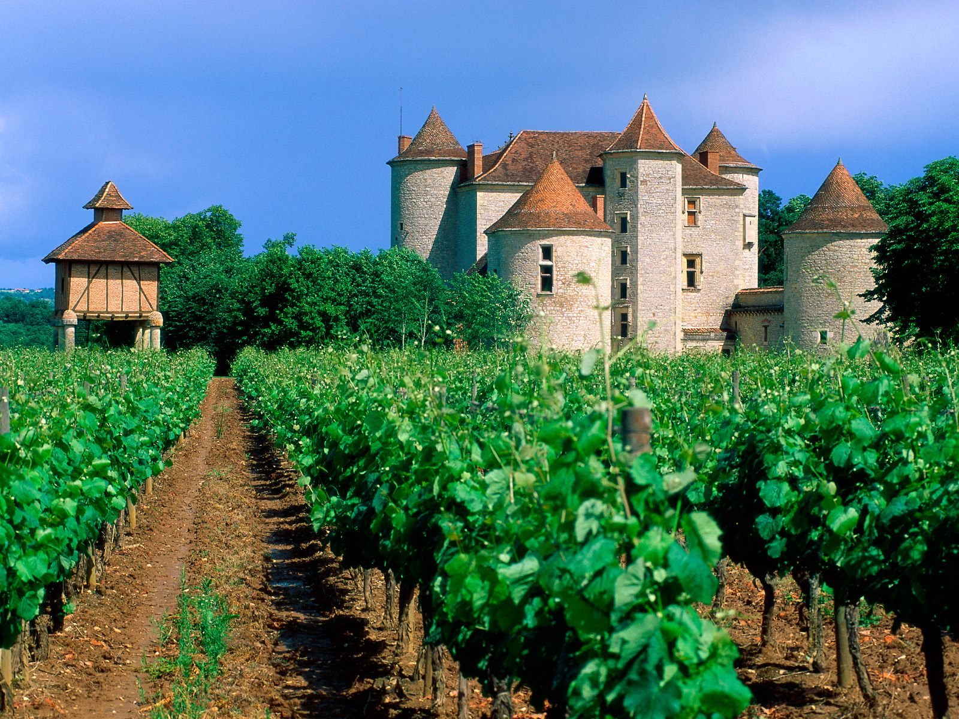

The Italians were the first of the three countries to introduce and develop fine wine to the civilized world. Etruscan tribes based in Central Italy about 800BC emigrated to what is now France. Later, Roman legions, in their thirst for power and territory, found France to be a garden for wine grapes.

Mansions, castles and magnificent gardens cover the showcase district of Bordeaux

in France. The famous Rothschild, Latour and Margaux wines are in this region.

They settled in the Rhone Valley, Bordeaux, Burgundy and the Loire Valley. France now ranks first among wine producing countries worldwide. It brings to the table elegance and a certain snobbery to wine, rewarding wine “royalty” with a system of “first growth” favoritism that lives to this day. In the Bordeaux district, luxury is the standard ingredient in wines, along with Cabernet Sauvignon, Merlot and Petite Verdot.

As for Italy, you have a choice of over 370 varieties of grapes and some 384,000 vineyards, from hundreds of hectares (acres) to your neighbor’s backyard. Italy knew about the link with native foods and local wines long before it was thought of here. Twenty districts are all of distinct character from Trentino in the north to Sicily in the south. The celebrity district is Tuscany, home of Chianti, Brunello and Vino Noble di Montepulciano. The leading grape is Sangiovese, reportedly used in all wine that the Italian government recommends. 2015 and 2016 are the best vintages in decades with all weather fronts aligned to perfection.

When U.S. wines are talked about, the conversation most often is directed to California’s Napa and Sonoma districts. Discovery began with French and Italian wine makers in the eighteen hundreds who took a chance on this upstart region to make wine in the new world, and like a rolling stone, it has never stopped rolling and expanding.

Despite the political volatility of trade tariffs and price scares, there should always be an increased number of brands, supplies and public demand for quality wine at affordable prices. As Wine Spectator’s Editor and Publisher recently proclaimed, “it’s time for wine lovers to stand up and be counted in their support of our greatest beverage!”

Craftsman Tavern Hosts 5 Course Italian Feast

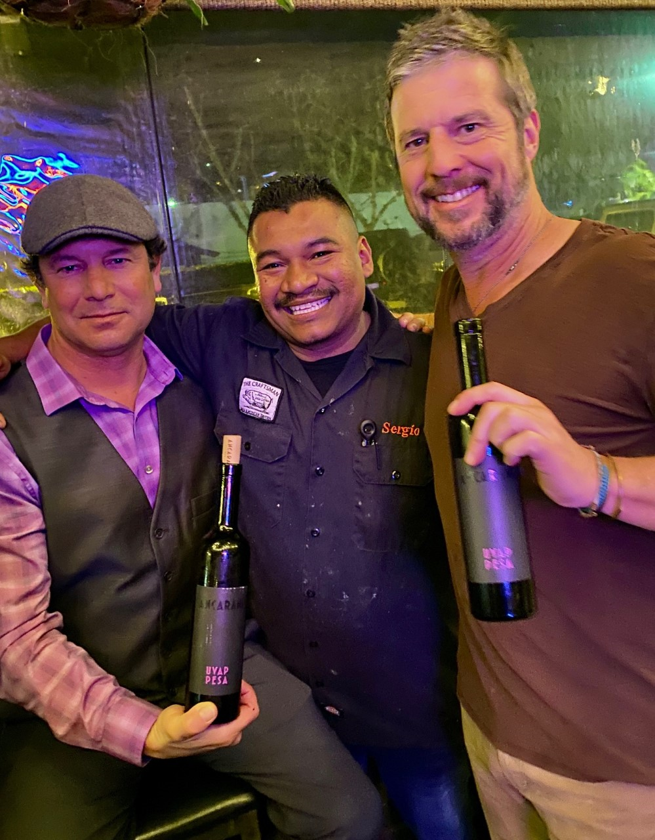
Craftsman Tavern GM Mike Cusey knew exactly what to do when Alluvial Wines, San Diego Account Manager, Bryan Taylor said he had some exceptional Italian Wines. Mike reached out to his Italian Executive Chef Sergio Serrano to create a 5 course Italian Feast.

Taylor, who has a passion for Italian wines, was able to secure select low production high quality wines for the dinner that he called “Royalty Wines”.

First up was a Clara C Brut Prosecco paired with a mini charcuterie plate. The Prosecco

(Left to right) Alluvial Wines San Diego Account Manager, Bryan Taylor and Craftsman Tavern Chef Sergio Serrano and GM Mike Cusey.

from this woman owned and operated winey was pale pink in color with velvety micro bubbles pale pink in color had fruit aromas on the nose and palate of peaches and apricots. The next two wines were from the Baracchi winery hailing from Tuscany. A side note in addition to making great wines, Baracchi’s are famous for their training of hunting birds. The first of the Barachhi wines was the Olillo Red Blend, a baby Super Tuscan, with equal parts of Sangiovese, Cabernet Sauvignon, Merlot and Syrah. Second was the Smeriglio Sangiovese benefitting from small batch production in French Oak barrels vs larger casks. These wines were paired with a simple homemade pasta spaghetti plate with pecorino cheese and black pepper and a mushroom ragout risotto cake. Easily the highlight of the dinner was Chef Serrano’s Braised Short Ribs with creamy polenta, gorgonzola, and fig compote. The marbling of the short ribs with the tartness of the gorgonzola, and sweetness of the fig was perfectly complemented with the 2014 Daniele Conterno Barolo from the Piemonte region with a cherry hint and leathery earthiness on the palate. A perfect sweet and savory combo! The dinner finished out with Papi’s Tiramisu and Ancarani “Uva Pessa” Centisimino Passito from the Emilia Romagna region.

Upcoming Craftsman Tavern dinners include a 4 course Redemption Whiskey Dinner on March 25. Details at 760-452-2000.

Wine Bytes

Oak + Elixir wine bar in downtown Carlsbad Village has a Hill Family Napa Valley Wine Tasting and Food Pairing, Thurs. Feb. 6, 6:30 to 9pm. Ryan Hill, the winemaker, will be at the event. Public cost per person is $40. RSVP at 760-453-7853.

Firenze Trattoria in Encinitas welcomes Beaulieu Vineyard of Napa Valley for a wine pairing dinner, Thurs. Feb. 6 at 6:30pm. The 4 course dinner will feature Georges de Latour Private Reserve Cabernet. $98. each. To reserve a place, call 760-944-9000.

Join award-winning Italian chef Fabio Flagiello on a country style Italian wine dinner at Apotheque lifestyle spa and social lounge at the Bunkershouse on Cleveland Street Oceanside, Thurs. Feb.6 from 6 to 9pm. This is a demonstration cooking class where the Italian food and Tuscan wines are served to those at the event. $69. includes 4 course demonstration cooking class. Call 760-967-7727 for details or visit bunkerhouselounge.com.

Frank Mangio is a renowned wine connoisseur certified

by Wine Spectator. He is one of the leading commentators

on the web. View his columns at tasteofwineandfood.com.

Go to recent columns. Reach him at frank@tasteofwineandfood.com

