
TASTE OF

WINE & FOOD

By Frank Mangio

Week of January 19, 2020

Sal Ercolano Kicks Off 2020 Wine Dinner Series with Argentina’s Catena Zapata

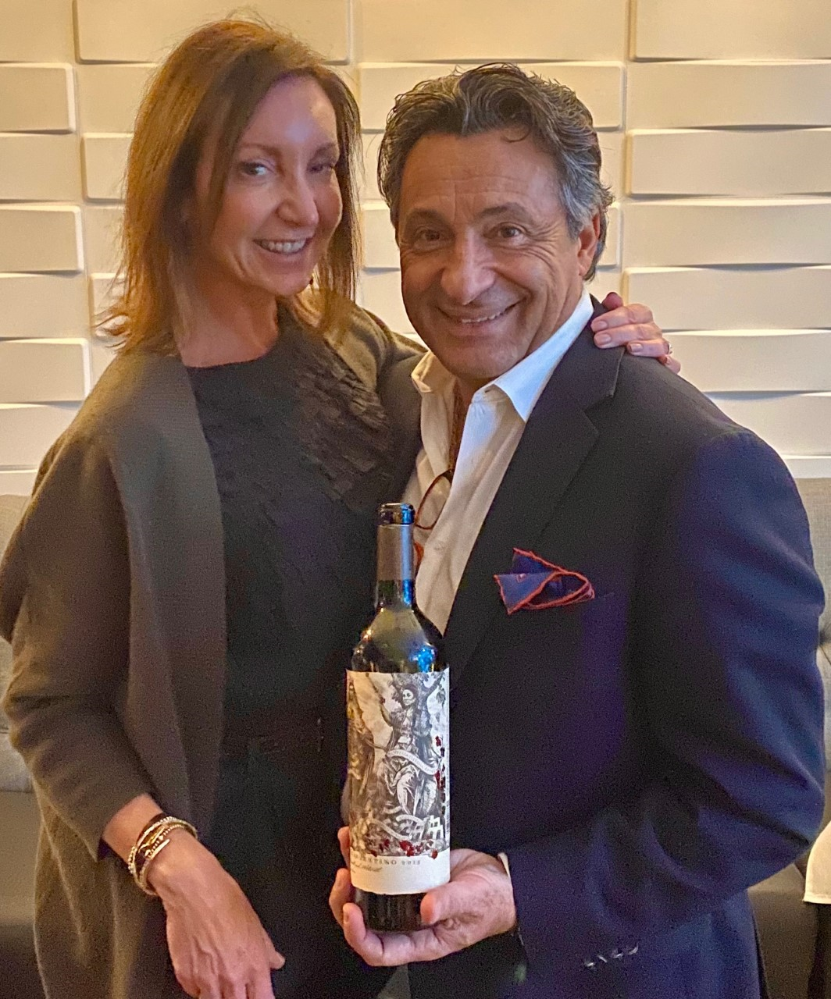
Sal Ercolano proprietor of both Seasalt and West End Bar & Kitchen kicks off his 2020 Wine Dinner Series with international flair hosting Argentina’s Catena Zapata Wines. Andii Ulrich, Winebow Group SoCal Manager narrated the dinner providing the rich history of Catena Zapata wines.

Ulrich noted that, “Today Catena is led by third generation Nicolas Catena Zapata who took over in the 1960’s and revolutionized not only Catena but Argentinian wines in general and is compared in stature to Robert Mondavi’s influence in Napa Valley.”

Winebow Group SoCal Territory
Manager, Andii Ulrich (left) with West
End Bar & Kitchen Proprietor Sal
Ercolano (right)

Guests indulged on 5 Catena Zapata wines that included a Chardonnay, Cabernet Franc, Malbec, Cabernet Sauvignon, and a bonus 2015 Nicolas Catena Zapata Cabernet Sauvignon/Malbec Cuvee blend, a 93pt Robert Parker score, that was the highlight of the evening. “The 4,000 foot Catena Argentinian terroirs create thicker skins with beautiful color, less alcohol, typically only 13.5% vs 15%, and more minerality”, says Ulrich.

These wines were paired with a Chef Noe 5 course dinner highlighted with Patagonia-style lamb served over creamy polenta and grilled skirt steak with pampas chimichurri sauce. Several guests commented that it was one of Chef Zoe’s best dinners!

Sal’s next soirée features a 5 Course Seafood-inspired The Prisoner Wine Company Dinner on Thur/Fri Feb 6 & 7 at Seasalt (Del Mar). See Wine Bytes below for details. Visit at catenawines.com.

Temecula Valley Opens its Doors for Annual Barrel Tasting

The history of wine making in Southern California starts with Temecula Wine Country and its over 50 years of building a major district of some 40 wineries. The major wine publication Wine Enthusiast, called it one of the 10 Best Wine Travel Destinations in 2019.

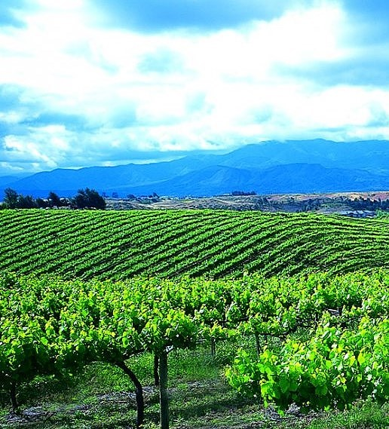
The best time to enjoy all that this beautiful land has to offer is its self-guided annual barrel tasting and tour of up to 19 different wineries per day Sat. Jan. 26 and 19 more, Sun. Jan. 26 from 11 to 4pm. a 2 day ticket is your best value at $138. per person. A Sat. ticket is $88. per person and a Sun. ticket $78.

Wineries reportedly will perfectly pair food samples with table seating providing for a leisurely pace.

Temecula is a frequent visit for formative stories in Taste of Wine.

Rolling hills carpeted by vineyards in Temecula,

reveal some of California’s most popular

grape varietals and a growing amount of

Mediterranean style wine grapes.

I’ll always have a sentimental place in my column for the many owners that gave of their time and expertise, that spoke in glowing terms about their sense of place for small production wine excellence.

Joe Hart of Hart Family Winery made the decision to commit to the Temecula Valley for winemaking in 1970, emphasizing small scale premium wines and opening the present winery in 1980. He was my first video interview and after a nervous introduction, Joe took my first question and for the next 15 minutes, finished his final statement, a win for Taste of Wine. Joe has now turned over much of the successful winemaking to his son Jim Hart who is now the lead wine maker.

You will find many of the winery owners more than willing to spend time so you can have the experience you hoped for at the Barrel Tasting. For the full story, go to temeculawines.org or call 800-801-9463.

Wine Bytes

Seasalt in Del Mar is hosting a 5 Course Seafood-inspired The Prisoner Wine Company Dinner on Thu/Fri Feb 6&7 @6PM. The main dish is fresh monkfish wrapped in parma ham and a saffron cream sauce with porcini risotto paired with The Prisoner Red Blend. Cost is $75 per person and includes tax/gratuity. RSVP at 858-259-5878.

At The WineSellar & Brasserie in Sorrento Valley San Diego, A “Walk-Around” Wine Tasting of staff favorites will happen Sat. Jan. 25 from 3:30 to 5:30pm. Try over 15 wines and discover your style. $35. per person. Call 858-450-9557.

Vittorio’s in Carmel Valley San Diego has a J. Wilkes wine dinner Thurs. Jan. 30 at 6:30pm. This is a 4 course dinner plus dessert with different wines to pair.

$65. each. Make sure of your place by calling 858-538-5884.

Ranch 45 in Solana Beach, Wed. Jan. 29 from 6 to 7:30pm, is celebrating the popular Rose’ wine by offering many styles, from France, Spain, Portugal, Italy and the U.S.A. for $45. Enjoy light appetizers from the culinary team. Contact Ranch 45 at 650-250-1983.

7 Mile Kitchen in Carlsbad is planning a Super Bowl party with a special offer: celebrate with a pitcher of select beer, wings and fries for $19. good from 1 to 11pm on Sun. Feb. 2. Reservations suggested at 760-827-2514.

Frank Mangio is a renowned wine connoisseur certified

by Wine Spectator. He is one of the leading commentators

on the web. View his columns at tasteofwineandfood.com.

Go to recent columns. Reach him at frank@tasteofwineandfood.com

