
TASTE OF

WINE & FOOD

By Frank Mangio

Week of Dec 1, 2019

San Diego Urban Wineries Inaugural Sip By The Sea Sets Sail

San Diego Urban Wineries held their Inaugural Sip By The Sea at Del Mar Plaza overlooking the Pacific from on high. It was a perfect location and venue for local urban wineries to celebrate Harvest 209 and to showcase their wines.

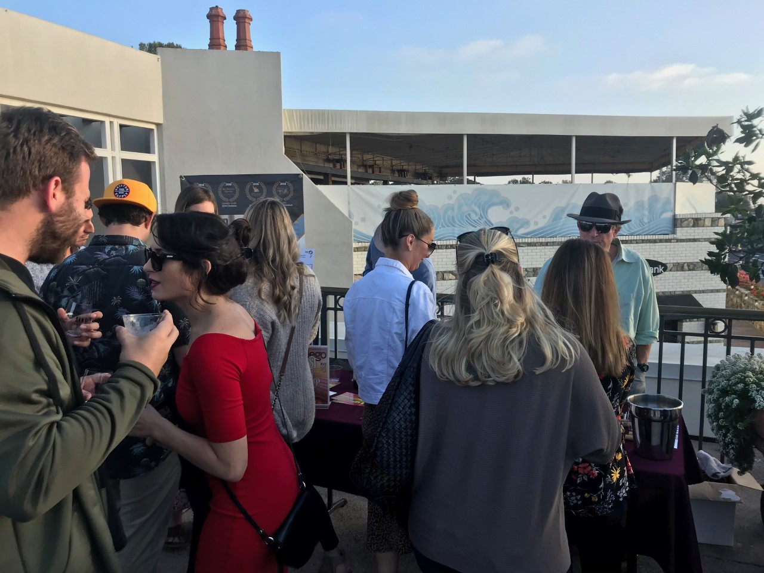
Before we get too far into the story, a few might be wondering what defines an urban winery. These are wineries working closely with suppliers in the county and beyond to source 100% of their exceptional fruit. Once the fruit (grapes) is received, these urban wineries crush, ferment, age in oak, stainless steel, etc., and lay down to complete the aging just as estate wineries would.

Guests enjoying wine from Gianni
Buonomo Best of San Diego Urban Winery
Winner at Sip By The Sea. Photo by Rico
Cassoni

What we find interestingly strategic in today’s competitive world is how much these wineries are cooperative vs. competitive. It is one big family with some wineries sharing equipment and barrel rooms. A great example of this is the La Mesa COOP shared by San Pasqual Winery and Wyatt Oaks winey. “The mission of San Diego Urban Wineries is to increase awareness of locally crafted, artisanal wine while creating a collaborative community for our skilled city winemakers.”

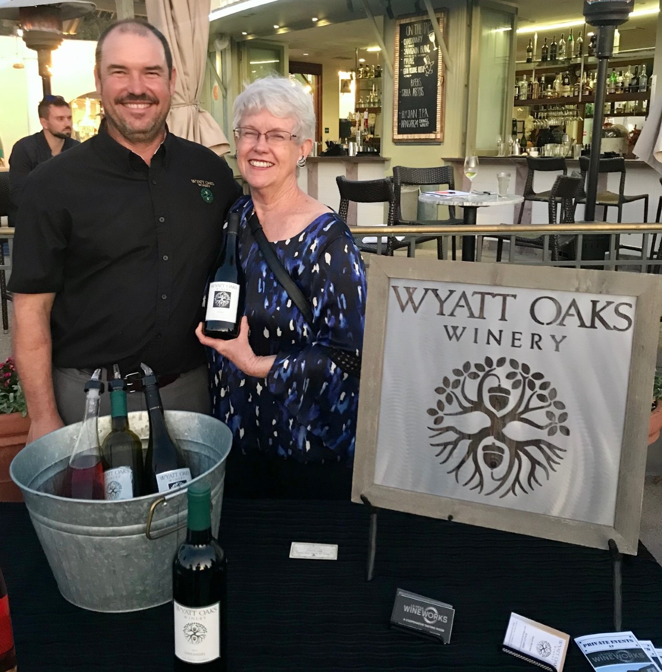
The event showcased 12 wineries throughout the county including larger wineries such as Gianni Buonomo and Carruth Cellars with three locations, along coastal San Diego, to wineries such as BK Cellars and San Pasqual Wineries in North East County.

One of Tech Director Rico Cassoni’s favorite wines at the show was up and comer Wyatt Oaks Winery 2012 Syrah, $30. The Syrah had a nose of strawberry

Wyatt Oaks Winemaker Gavin
McClain and mother, Karen,
holding a bottle of 2012 Syrah

and cherry with a great balance of acid and tannins with light spice on the palate. Details at wyattoakswinery.com.

We look forward to enjoying San Diego Urban Wineries over the next year as well as next year’s Sip By The Sea. Visit sdurbanwineries.com

West End Bar & Kitchen Hosts Huneeus Family

Wine Dinner

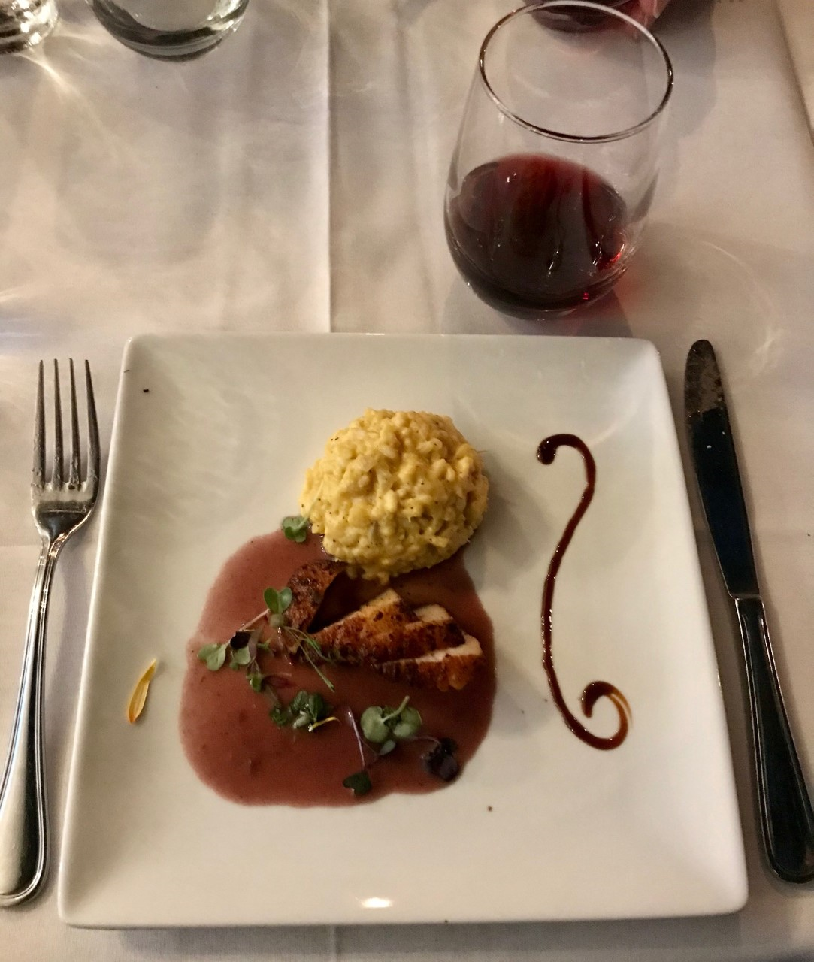
We were fortunate to enjoy the great wines of Huneeus Family at West End Bar & Kitchen. Agustin Huneeus and wife Valerie are proprietors and founders of Quintessa, one of the Napa Valley’s most highly regarded wineries. Their winery benefits from 50 years of Agustin’s experience in the wine industry that started in 1960 in Santiago, Chile.

Agustin and Valerie started Quintessa in Napa Valley’s Rutherford district in 1990. Since then, the Huneeus’ have grown to a total of 6 brands and labels that include Faust (Napa Valley), Illumination, Flowers (Sonoma Coast), Leviathan, and Benton-Lane

Jumbo diver scallop with a beurre rouge
reduction over saffron risotto perfectly
paired with Benton Lane Pinot Noir

(Willamette Valley, OR). All wines except Leviathan were paired throughout the dinner. Highlights included jumbo diver scallop with a beurre rouge reduction over saffron risotto paired with Benton Lane Pinot Noir, Short Ribs with Faust Cabernet Sauvignon, and Quintessa with a dessert cheese platter. Visit huneeuswines.com.

Viewers will want to consider attending the Seasalt Far Niente Wine Dinner, Thu Dec 19th @6:00PM. This 5-course dinner includes a champagne reception to kick off the holidays and features short ribs with root vegetables on a bed of polenta as the main entrée paired with sister Nickel & Nickel wines. $115 per person. RSVP at 858-755-7100.

Wine Bytes

Join Violet Grgich, daughter of Master Winemaker Mike Grgich and President of Grgich Hill Estates, for a Bottle Signing & Wine Tasting at Pavilions (Carmel Valley). Sat Dec 7, 1:00 PM - 3:45 PM

DAOU Wine Tasting at Pavilions (Carmel Valley), Wed Dec 11, from 3pm-6pm at Pavilions in Carmel Valley. DAOU will be pouring the Reserve Chardonnay, Bodyguard, and Soul of a Lion.

DAOU Wine Dinner with Winemaker Daniel Daou at Il FornaioDel Mar Wed Dec 11@6:30pm. This will be an unforgettable evening with DAOU Winemaker & Proprietor, Daniel Daou. Savor DAOU wines paired with the authentic Italian cuisine of Il Fornaio in Del Mar. Enjoy a memorable 5-course menu progression created by Executive Chef Roberto Gerbino with wine curated by Daniel. Cost is $99 per person. RSVP at 858-755-8876.

Frank Mangio is a renowned wine connoisseur certified

by Wine Spectator. He is one of the leading commentators

on the web. View his columns at tasteofwineandfood.com.

Go to recent columns. Reach him at frank@tasteofwineandfood.com

