
TASTE OF

WINE & FOOD

By Frank Mangio

Week of Nov. 10, 2019

Catch Florida Stone Crab Season at Truluck’s

When we think about the ocean, everything from giant whales to tiny algae float through our minds. Within this vast collection is savory seafood from flaky fish to shellfish. And then, there is a category all by itself, Stone Crab from Florida!
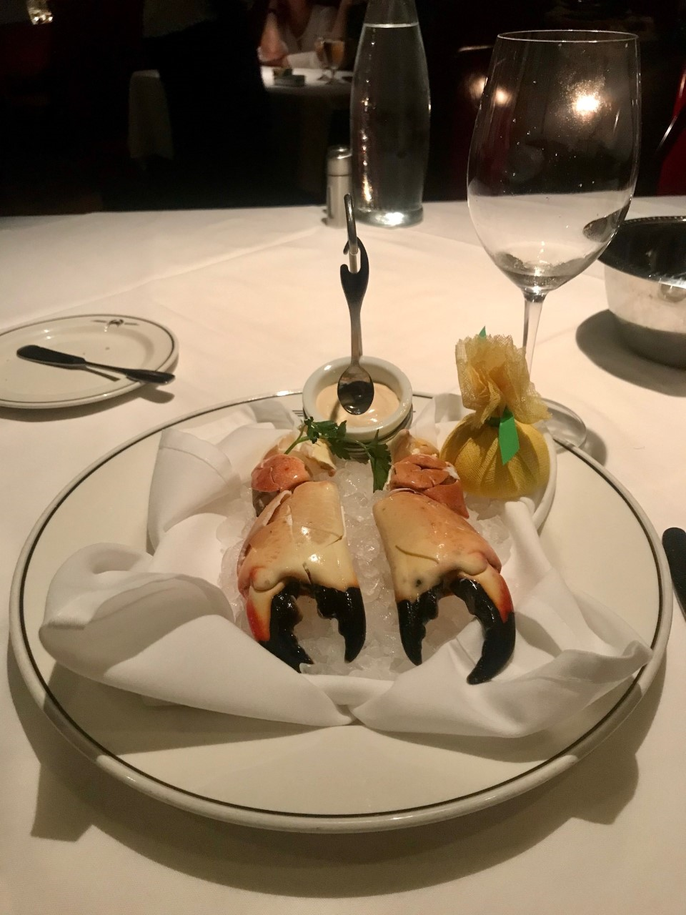

Technical Director Rico and I had the pleasure of visiting the only Truluck‘s in California at San Diego’s Aventine Hyatt Plaza in La Jolla. We were able to enjoy this in season delicacy that is farmed, poached, ice packed, and served fresh the next day in California.

General Manager and Sommelier Lee Carre shared, “What makes the Florida Stone Crab extra flavorful are the warm Gulf waters. The crabs do not have to create a fat layer. Everything under the shell is succulent crab meat.” We also learned that Truluck’s and its suppliers responsibly farm crab legs by only taking one claw at a time. Crabs can generate new claws that are even

Truluck’s FloridaStone Crab served with
Signature Spicy Mustard sauce and lemon
paired with Cakebread Chardonnay

larger than the previous. Additionally, no matter the 3, 5, or 7 ounce claw, each is just as tender as the other, size does not matter. We learned during our visit that Truluck’s is so dedicated to the quality of the meal, they have a Buy Back Meal Program just in case you don’t like it. We figured this is rarely invoked as both Rico and I agreed, this was the best crab either of us had ever had. No wonder Truluck’s was voted by Zagat’s as Best Seafood in San Diego and Best Restaurant Service in San Diego. The live piano music is a great touch.

Following our crab appetizer, which was perfectly paired with Cakebread Chardonnay (Napa) with light citrus and peach nose crispness, we moved onto wedge and chopped salads and Goldeneye Anderson Valley Pinot Noir with strawberry, cherry and hints of leather, spice, and vanilla on the finish. The Goldeneye complemented our Pacific Swordfish steak and Sweet and Spicy Wild Striped Bass served with asparagus. Lee was also kind enough to pour the Spanish 2013 Vega Sicilia, Valbuena, Ribera del Duero,, named after its 5 year aging process (Valbuena) from the Sommelier by the Glass Collection. This was a knockout wine, mostly Tempranillo, with hints of cherry and blueberry.

Key at Truluck’s is saving room for the 4-layer signature Carrot Cake garnished tableside with a butterscotch sauce with a hint of tumaca spice for heat and topped with toasted pecans. A masterpiece! Visit at trulucks.com.

Justin Winery Comes to West End Bar and Kitchen

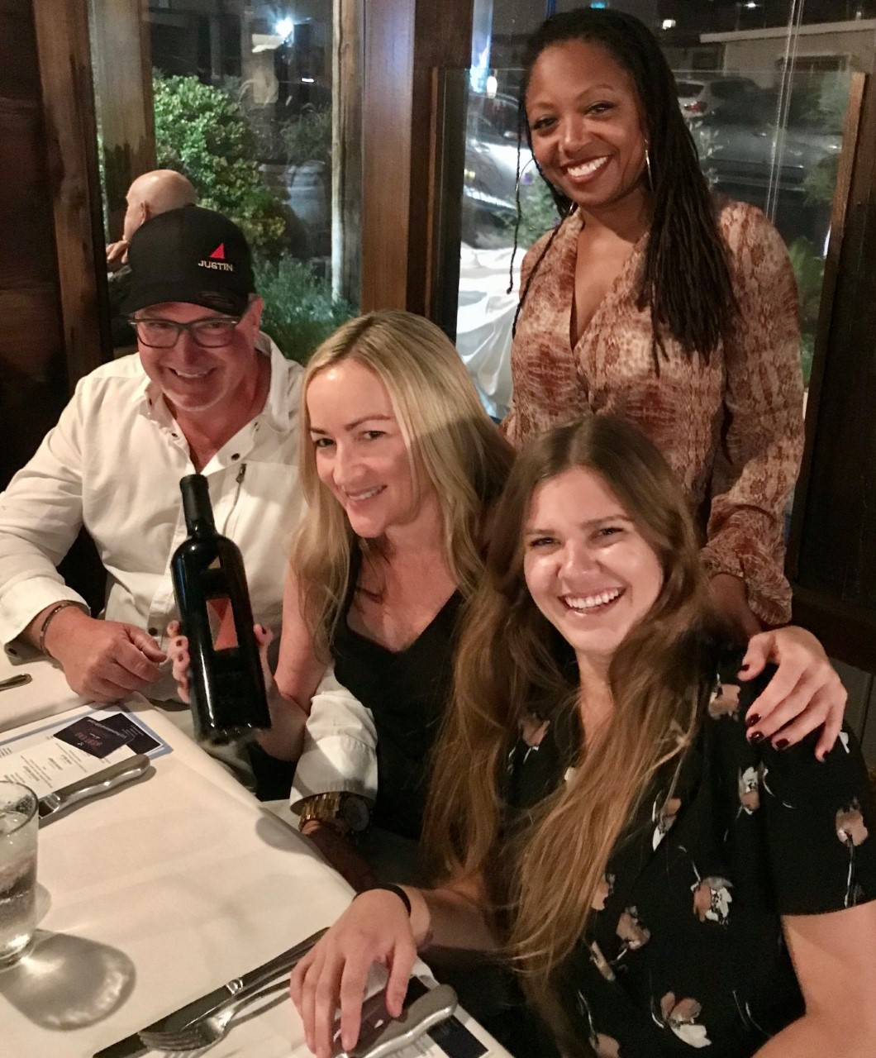
Sal Ercolano, proprietor, West End Bar and Kitchen, Del Mar, teamed up with Paso Roble’s Justin Vineyard for a 5-course dinner featuring Chef Noe starters, a seafood medley with shrimp, scallops, calamari, clams, then pork belly with mango chutney, veal loin with scalloped potatoes, and Gruyere Souffle. Each course was paired respectively with: Sauvignon Blanc, Rose (a crowd favorite for the evening), Cab Sauvignon, signature Isoceles, and hard to find Savant. Justin’s Sinia Shaw provided expert commentary for each of the wines.

Congrats to Isosceles raffle winners Anna
(bottom right), Susan (middle), and Mark
with Justin’s Sinia Shaw (top right)

Justin’s winemaking is based on French Bordeaux techniques using small batches, overseen by winemaker Scott Shirley. The Sauvignon Blanc is aged in stainless steel with no malolactic fermentation for crisp flavors including hints of pink grapefruit. The Rose (Syrah) is whole cluster pressed and fermented like a white wine, with salmon color with a red fruit, apple palate. Isosceles is named after the triangle and is a left bank blend of Cabernet Sauvignon (~84%) and equal parts of Cabernet Franc and Merlot, each ~8%. It is aged for 21 months in French oak and is Justin’s flagship wine. It was a special treat to have Savant as a dessert wine. This hard to find wine is a Syrah and Cabernet Sauvignon blend aged for 19 months in stainless steel with twice daily pump overs.

Of note, Taste of Wine and Food is always impressed with the number of wine dinners that Sal hosts each year. The Justin dinner was the 31st dinner for 2019! Congrats to Sal and his teams at Seasalt and West End. Details at seasaltdelmar.com and westenddelmar.com.

Wine Bytes

Gianni Buonomo Winery, Ocean Beach, is hosting a Harvest Celebration Dinner / 2015 Sangiovese Release Party. With 30 tons of grapes made into wine and aging in barrels, owner Keith Rolle said it’s time to celebrate with a 3-course Wine Dinner featuring Chef Max Farina, Saturday, Nov 21 @6:30PM. $55 per person. RSVP and details at sangio.bpt.me.

With Thanksgiving coming up, there are plenty of great dinners in San Diego. Our initial list includes two events at The Lodge Torrey Pines. For either event, RSVP at opentable.com.

Savor the smoky flavors at The Grill for a prix fixe three-course meal with optional beer or wine pairings for an additional charge, or create your own feast with the a la carte menu. Starting at $60 per person ($35 under 12), Thursday, Nov 28, 10:30 a.m. - 10:00 p.m.

Executive Chef Jeff Jackson invites you to celebrate Thanksgiving in A.R. Valentien's timbered indoor-outdoor dining room with a prix fixe four-course meal featuring the freshest flavors of the season. Starting at $120 per person ($60 under 12), Thursday, Nov 28, 12:00 p.m. - 10:00 p.m.

Frank Mangio is a renowned wine connoisseur certified

by Wine Spectator. He is one of the leading commentators

on the web. View his columns at tasteofwineandfood.com.

Go to recent columns. Reach him at frank@tasteofwineandfood.com

