
TASTE OF

WINE & FOOD
By Frank Mangio

Week of October 20. 2019

Everything You’d Ever Want in a Resort is Yours

At South Coast Resort & Spa Temecula

Can dreams come true? Sure they can! As long as you don’t confine them.

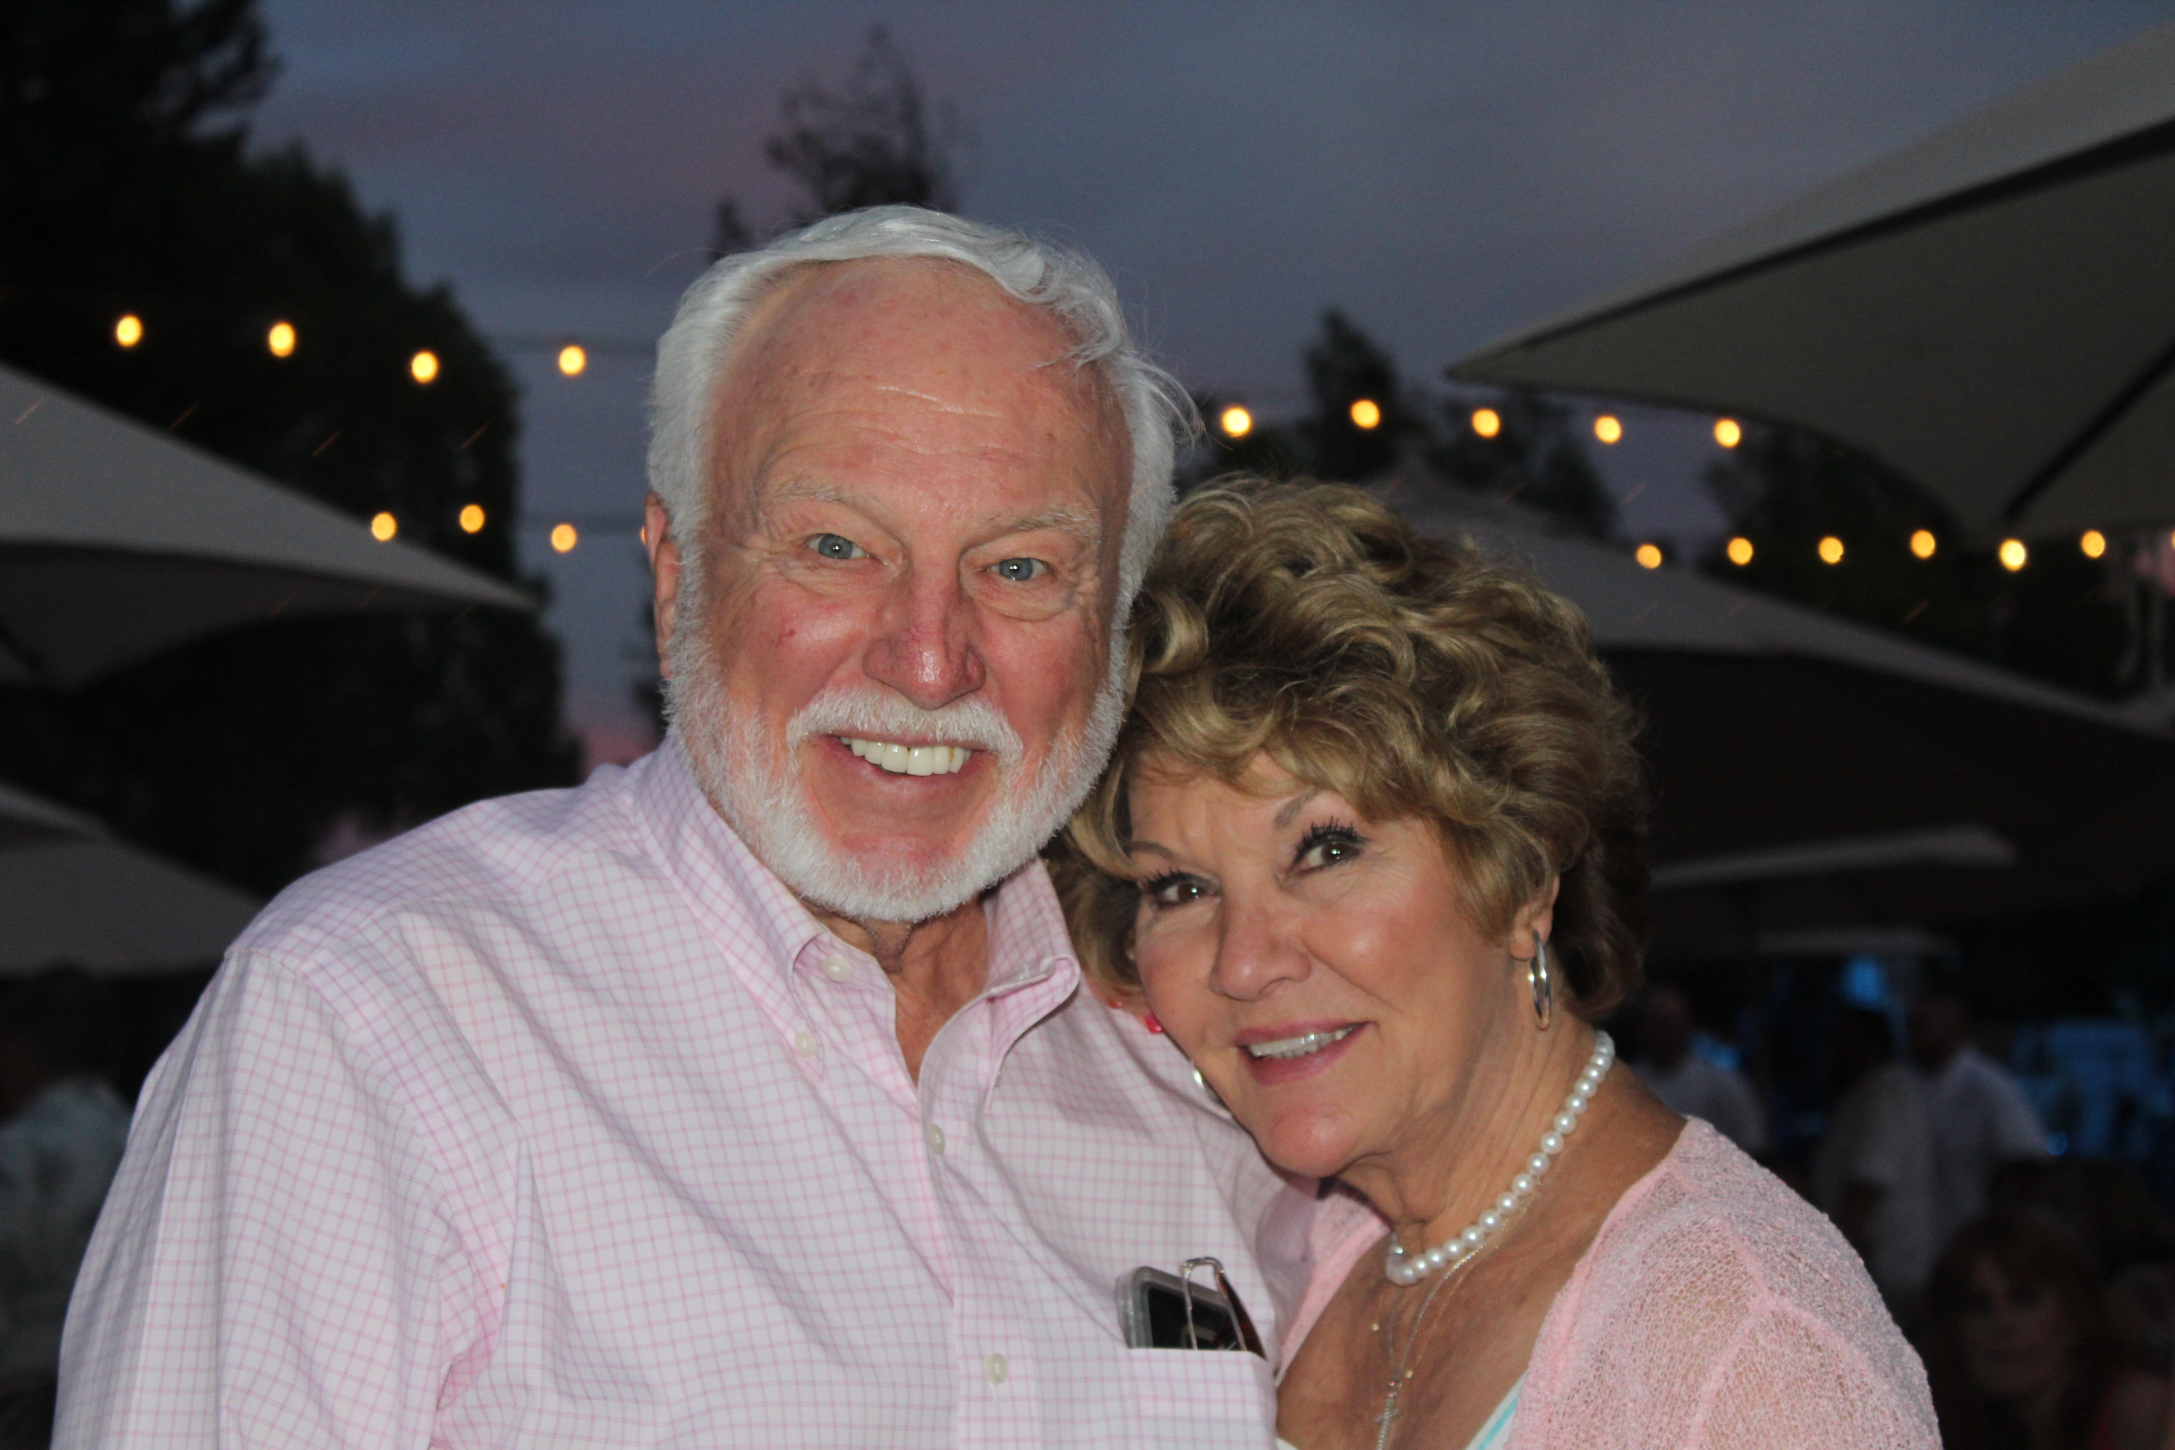
Jim Carter’s dream of a lifetime happened in a movie theatre in the mid 1990’s, when he watched the classic vineyard film, “A Walk in the Clouds.” He owned a 400 acre scenic region of land in Southern California’s Temecula with no plans for the future, and now he had the vision to produce wine grapes on his land close to the top of Palomar

Jim and Dawn Carter have brought world recognition

to Southern California’s Temecula Valley with

South Coast Winery, Resort and Spa and Carter Estates.

Mountain.

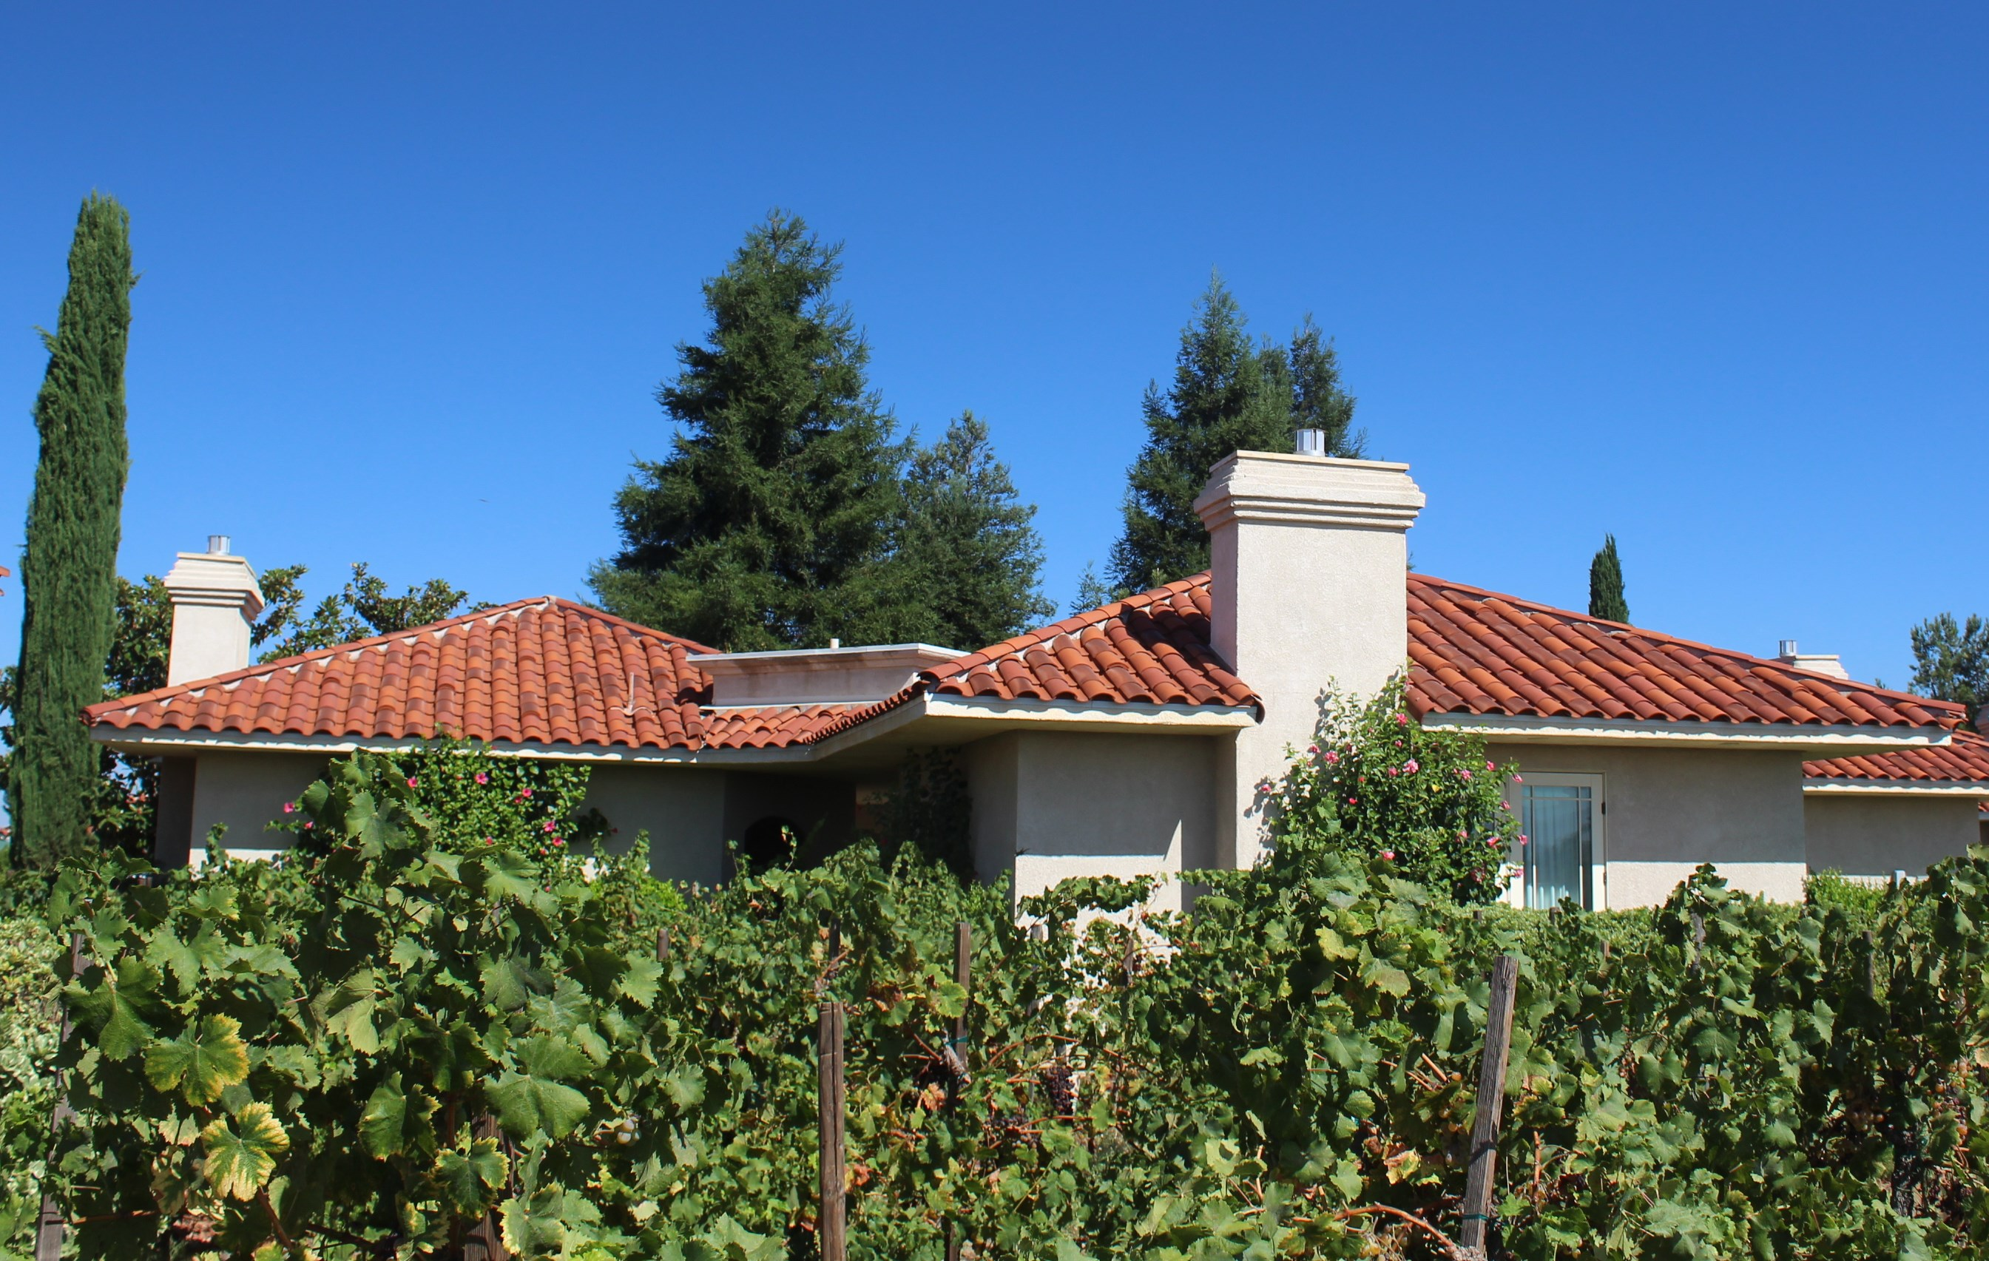
After years of working on research, planting and harvesting, classic award-winning wines now mark his family’s dream come true. In addition to his “walk in the clouds” vineyard, 63 more acres were added in Temecula Valley in 2003, devoted to a state of the art winery, resort restaurant and spa, complete with villas for guests to relax among the vines. As Carter tells it, “I wanted to share the complete wine country experience. Guests not only enjoy the finest wines paired with the finest foods, but they stay in a private villa in a working vineyard.”

It’s an unforgettable lodging experience, a direct path from your patio to the vineyards.

If a suite is more your size, an elegant hotel tower totals 132 spaces with

South Coast Winery Resort & Spa includes

Tuscan inspired single level villas in the

vineyards.

magnificent views of the countryside. Experience also a working winery and tasting room, gift shop, full-service spa and the fine dining Vineyard Rose Restaurant for breakfast, lunch and dinner.

Just 3 years ago, Carter Estate Winery and Resort was added, with its 109 pristine acres, adjacent to the South Coast site. It features 60 newly designed bungalows and suites, a luxurious swimming pool and poolside restaurant, a working winery, private tasting room and in-room spa service.

From Chardonnay to Cabernet Sauvignon and many other varietals, South Coast Winery has earned more than 2,000 awards since its inception, and has set the gold standard for Temecula wine country. It’s the only winery among the state’s top wineries to claim the title of California Winery of the Year 4 times at the California State Fair Wine Competition.

A perfect time to enjoy this “dream come true” would be the final performance of the South Coast Winery Rhythm On The Vine Jazz Concert Series, Sunday November 3rd featuring piano legend David Benoit. He will be featuring his new “David Benoit and Friends” album, produced with a who’s who of other jazz greats. Doors open at 6pm, showtime is at 6:30pm, inside the Estate Vineyard Room. Ticket prices start at $40 for general admission. For ticket details and special room and dining reservations, visit southcoastwinery.com/concerts.

Wine Bytes

The Cabaret of Cabernet is the theme for the next wine tasting
Sat. Oct. 26, 3:30 to 5:30 at Winesellar Brasserie, Sorrento Valley San Diego.

It’s an all-Cabernet day from Bordeaux to Loire Valley and Napa Valley. Over 14 wines. $35. per person and $30. for club members. Visit winesellar@winesellar.com.

A benefit breast cancer “Breast Fest” is planned for Cheval Winery in Escondido

Sun. Oct. 27 from 1 to 5pm. Cost is $5.00 ea. Sip for a cause during Breast Cancer Awareness month. Live music, food, wine. Details at 760-690-6617.

The San Diego Urban Wineries (SDUW) present SIP BY THE SEA, Sun. Nov. 10 from 3 to 6pm at the Del Mar Plaza’s ocean view deck. Unlimited tastings from a dozen local urban wineries and fine Charcuterie provided by Pacifica Del Mar. Tickets are $49. with portion of the proceedings to The Helping Paws Foundation, a veterans support local non-profit. The SDUW is a coalition of wineries throughout San Diego County that take grapes from the country and craft wine in the city. For ticket info, go to SDURBANWINERIES.COM.

A two day private tour of Valle de Guadalupe is being offered for a select number of guests November 9 to 11. Experience the best wineries with daily wine tasting, lunches, dinners and nightly stays in high end accommodations.

Availability is limited, reservations are required. RSVP to Sal at salercolano@hotmail.com or call 858-864-9598.

Frank Mangio is a renowned wine connoisseur certified

by Wine Spectator. He is one of the leading commentators

on the web. View his columns at tasteofwineandfood.com.

Go to recent columns. Reach him at frank@tasteofwineandfood.com

