
TASTE OF

WINE & FOOD
By Frank Mangio

Week of October 13. 2019

Here & There in the Wine & Food World

Every few months or so, my in-basket of wine and food information gets higher than a 5 liter bottle of Cabernet, so let’s dig in, get to it and get it down.


The top drawer wine and food event

in San Diego recently happened when Ruth’s Chris Steak House in Del Mar teamed up with first place wine player DAOU Vineyard and Winery of Paso Robles. It was a match made in wine and food heaven, two of the best in their respective categories. Ruth’s Chris invented the upscale steak format and its 150 locations make it the leader. Managers Mark Parasini and Yadir Navarro stepped up and declared “we love to bring guests together for events like this. Our food pairings match beautifully with the perfect wines from DAOU!”

Ruth’s Chris Steak House in Del Mar hosted a DAOU wine dinner

recently that brought, from left to right, DAOU Sales Manager Dan

Brunner and Social Media Manager Katherine Daou, joining with

Yadira Navarro, Sales and Catering Manager and Mark Parisini,

Beverage Manager from Ruth’s Chris.

Once again, DAOU’s Bodyguard was spotlighted as a new wine champion, one that Daniel Daou himself calls “approachable luxury.” It’s a Petite Verdot with a Petite Sirah blend. ($37)

If you missed this DAOU wine dinner, in December at least 5 more DAOU wine events are planned for the San Diego area. Watch this column for details, including a wine dinner at Seasalt in Del Mar scheduled for the 4th, and a stop at Pavilion’s in Carmel Valley with a full service wine department in a quality super market of the same name, on Tuesday the 11th from 3 to 5pm. Jeff Venier is the Wine Steward at Pavilion’s and offers cellar worthy tastings of a select number of over 2,200 wines worldwide. For the latest tastings, call 858-793-4661.

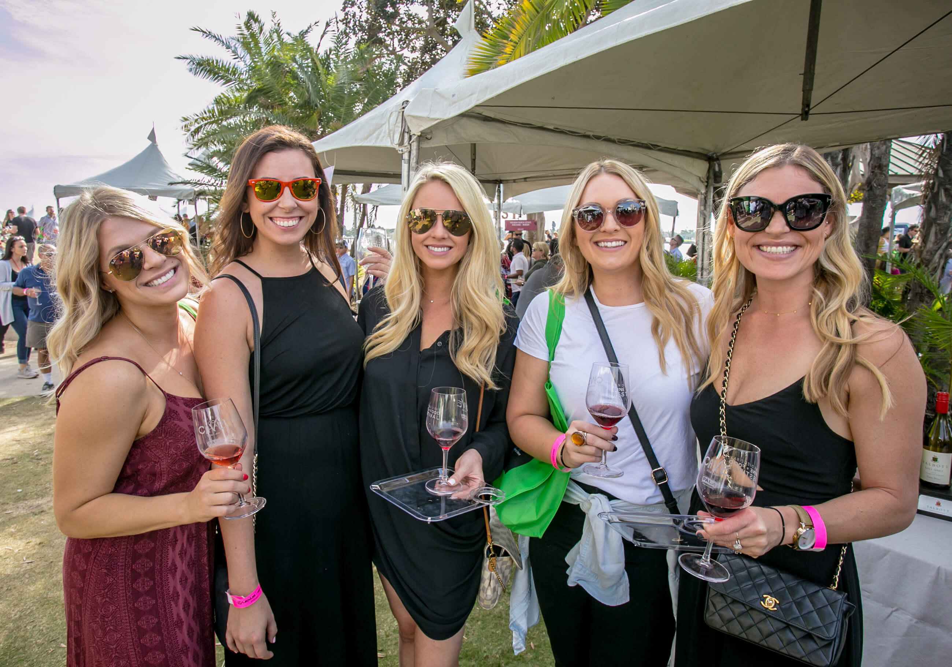
“Arrive at Awesome” is the right slogan for the 16th Annual San Diego Bay Wine & Food Festival, planned for November 10 to 17. It features hundreds of wineries, chefs, restaurants and more than 40 amazing culinary experiences all week, including the Saturday Grand Tasting. Save the dates and check out sandiegowineclassic.com.

October is National Pizza month and time to once again hail the exploits of Mangia e Bevi Oceanside owner, Tore Trupiano. He’s a leading “pizzaioli” (pizza chef) in the country and a recent 2nd place winner for best pizza in the nation representing the United States Pizza Team. Trupiano will be in London in November, representing the U.S. team at the European Pizza and Pasta show.

For more information about the U.S. Team, visit uspizzateam.com.

This column sends our congratulations to San Diego’s Joshua Orr for earning his Master Sommelier diploma, only the second person with this ultimate wine designation in the city. The only other local Master Sommelier is Eddie Osterland who earned his diploma 46 years ago, the first such award given to an American by the Court of Master Sommeliers. Six others from around the country were awarded this honor in a recent ceremony in St. Louis. Fewer than 300 people in the world have earned the Master Sommelier diploma.

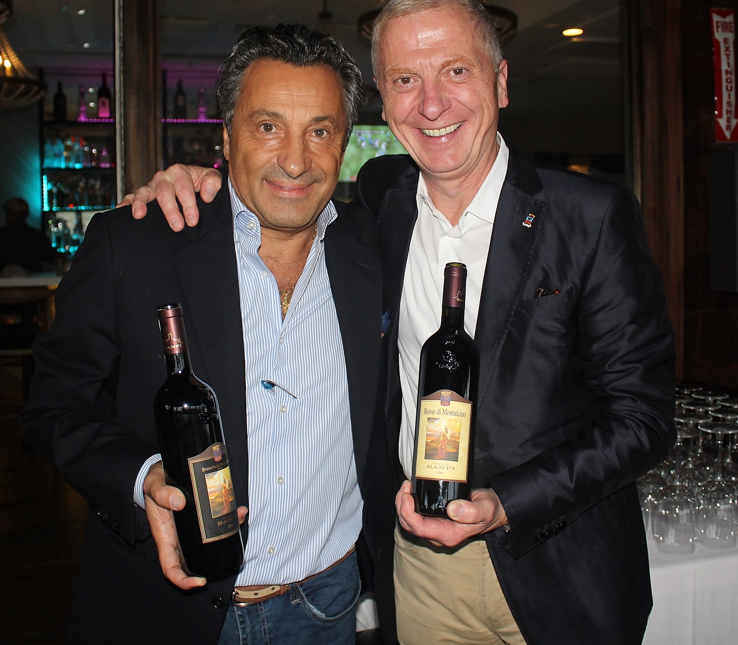
Banfi Winery, the premier wine estate in Tuscany and home to Brunello wine from Montalcino, recently sent its world famous emissary and ambassador Luciano Castiello to West End Bar & Kitchen and owner Sal Ercolano. Ercolano’s “Night in Tuscany” crafted a magnificent menu that

(Sal Ercolano, left, greets Banfi’s Luciano Castiello

before a royal 5 course wine dinner at West End, Del Mar.)

met the Banfi standards for their world-class reds, topped by the aforementioned Brunello with West End’s Lamb Ossobuco. Next West End wine dinner is Justin from Paso Robles Thurs. Oct. 24 and Sat. Oct. 26 at 6pm. The 24th is already sold out. Call today for the 26th.

Wine Bytes

Craftsman Tavern in Encinitas will have a French harvest 5 course wine pairing dinner Wed. Oct. 23 at 6pm. From Halibut to Duck Confit, Chef Sergio Serrano

has paired his cuisine perfectly with 5 French varietals. $70. per person. Call Mike at 760-452-2000.

A Riboli winery 5 course dinner is being planned at North County Wine Company Wed. Oct. 23 at 6pm, prepared by Chef Erin Sealy in the wine company’s patio. Cost is $85. each. Details at 619-823-3541 or chef@winepairsevents.com.

Vigilucci’s Seafood & Steakhouse at the beach in Carlsbad presents a Gaja Wine Dinner with District Manager Joeseph Schlegel, Thurs. Oct. 24 at 6pm. Cost is $175. per guest. Gaja is the single most important winery in the Piedmont district of northern Italy. Five gourmet courses and 5 great wines to match. Call 760-434-2580 for your place.

Cakebread Cellars is the highlight winery at the next wine dinner at Vittorio’s Trattoria Thurs. Oct. 24 at 6:30pm in Carmel Valley, San Diego. Cakebread is an elite Napa Valley winery, including Cabernet, Pinot Noir and Chardonnay. $75. per person. Call 858-538-5884.

Frank Mangio is a renowned wine connoisseur certified

by Wine Spectator. He is one of the leading commentators

on the web. View his columns at tasteofwineandfood.com.

Go to recent columns. Reach him at frank@tasteofwineandfood.com

