
TASTE OF

WINE & FOOD
By Frank Mangio

Week of October 6, 2019

The 130 year Inglenook Tale from Niebaum to Coppola

The Inglenook/Francis Ford Coppola story is one of the wine industry’s most fascinating tales. If you are wondering could this be the same Francis Ford Coppola that created blockbuster movies, “The Godfather Part 1 and 2” along with “Apocalypse Now,” you would be correct.

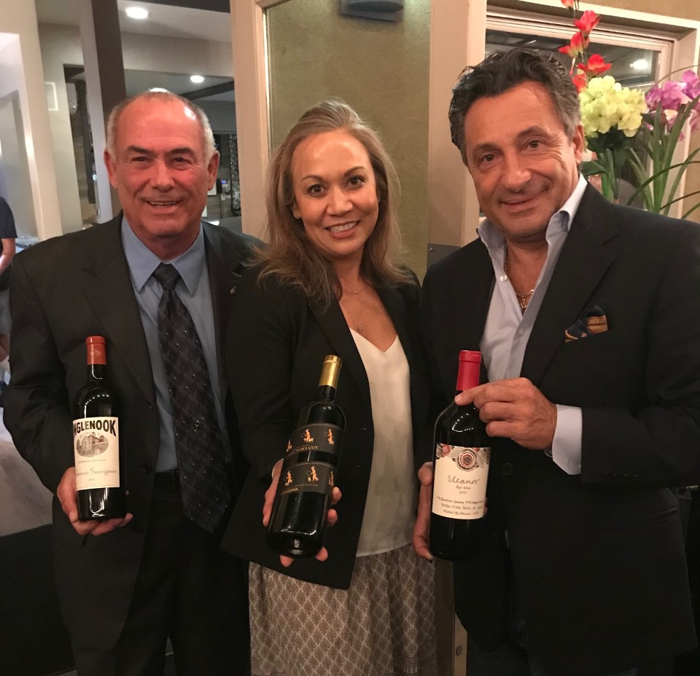
Onto the tale. Gustave Niebaum, a Finnish sea captain, wine connoisseur, and fur trader entrepreneur arrives in San Francisco in 1868. In 1879, Niebaum purchases the 78 acre G. Koni farm west of Rutherford named Inglenook, a Scottish expression meaning “cozy corner,” along with a neighboring 440 acre property for $48,000, with grapes initally planted in 1871. The first vintage of grapes is crushed in 1882 and is also when Niebaum expands another 712 acres from five neighboring farms purchased.

Left to right, Sheridan Dowling, SoCal
Rep, American Wine and Spirits, Tabitha
Arizini, District Manager, SoCal, Francis
Ford Coppola Winery, and Sal Ercolano,
SeaSalt and West End Bar and Kitchen,
Proprietor.

The next 70 years sees the birth of grandnephew John Daniels, the passing of Niebaum resulting in a discontinuation of production which restarted in 1911 until production was again shutdown in 1919 by Prohibition. Prohibition is repealed in 1933 and Inglenook starts back up with John Daniels at the helm. In 1941, Inglenook Cabernet Sauvignon achieves a perfect 100 score by Wine Spectator and celebrates their 75th Diamond Anniversary in 1954. Small harvests and low profits in 1964 forced the sale of Inglenook to United Vintners and another sale in 1969 resulting in the sold Inglenook brand falling from a premier wine to table wine that many us living today remember growing up. With the passing of Daniels in 1970, his wife decides to sell the estate and in 1975 Francis and Eleanor Coppola buys 1,560 acres and the Niebaum mansion with profits from “The Godfather” films. In 1978, Coppola harvests their new flagship Rubicon wine that launches 7 years later in 1985. In 1989, genetic testing proves the Rubicon Estate Cabernet Sauvignon is the original that Niebaum brought back from France in the 1880s, now registered as Rubicon Estate heritage Clone #29. 1990 brings more accolades. Wine Spectator scores the Inglenook 1941 Cabernet Sauvignon a perfect 100 points and names it one of the Top Wines of the Century. In 2011, Coppola’s dream of once again owning the Inglenook brand name was complete . Rumor has it that Coppola paid more to buy back the trademark Inglenook name than all of the land combined. It is an amazing 130 year history! Congrats to Francis Ford Coppola for being awarded the Wine Enthusiast Lifetime Achievement Award.

Sal Ercolano’s SeaSalt Wine Dinner was even that much better knowing all of this history. The 5 Course dinner featured Pipe alla Bolognese and Dunken Lamb over a bed of saffron risotto. Over the course of the dinner, guests enjoyed the Coppola Sofia Rose (Grenache/Sirah), Blancaneaux (Viognier/Rusan/Marsan), and Director’s Cut Cinema Red Blend. From Inglenook, guests experienced Edizione Pennino Zinfandel and Cabernet Sauvignon. Details at inglenook.com and francisfordcoppolawinery.com.

The next Sal Ercolano wine dinner is at West End Bar and Kitchen featuring a 5 Course JUSTIN Wine Dinner on Oct 24th (SOLD OUT) and a second night on Oct 26th. $75 per person. RSVP at 858-259-5878.

September was California Wine Month with Grape Stomps Cab Dinners & Debuts

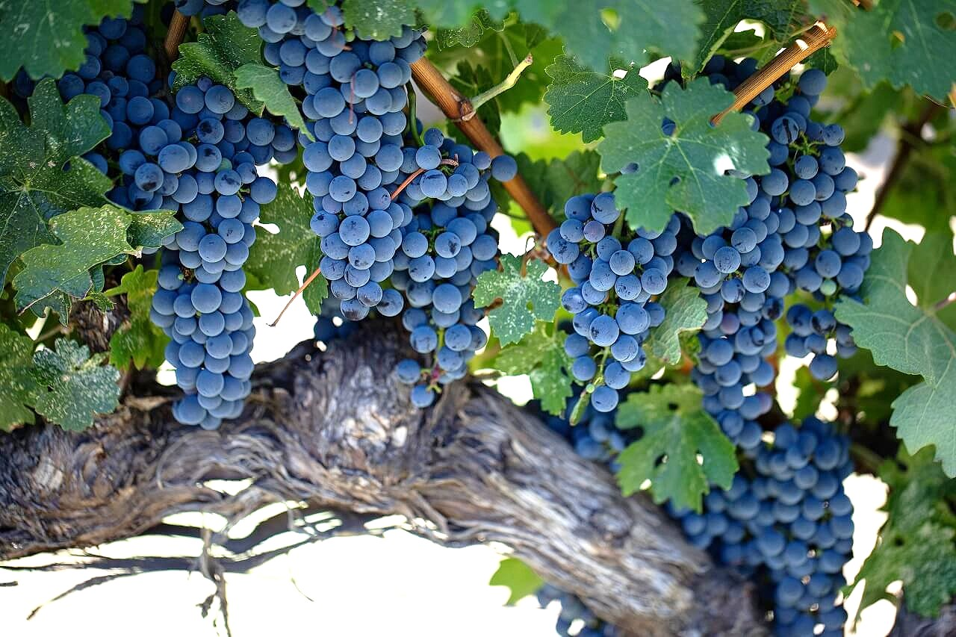
From Sonoma to San Diego, special events abounded in September. Celebrations, historical reminders and wine dinners like the Inglenook testimonial you read about at Seasalt in Del Mar, covered by my collegue Rico Cassoni, underlined California Wine Month.

Cabernet Sauvingon grapes, the most peroduced wine varietal
in Calfornia, are hanging heavily at the highest quality vineyards,
waiting for their harvest whistle to blow, generally October.

Cabernet Sauvignon, the King of wines in California, got the jump on its other rivals, by declaring “National Cabernet Day”the end of August. Cab is famous on a global scale, and the grape has contributed immensely to California’s fame in the wine world. It’s the most widely planted grape in this state. The latest figures have it at 90,782 acres. Even California’s Governor, Gavin Newsom, is part owner in 3 Napa Valley wineries, led by Plumpjack. Their 2014 Reserve Cab goes for $300. at the winery.
New Cab releases to look for include:
2017 Lewis Cabernet Sauvignon, Napa Valley, $100.
Lewis President Dennis Bell reports that his 2017 Cab is “the best since 2013,”
with alluring oak, spice, front palate fruit, and a long, lavish finish. Details at lewiscellars.com.
2015 Frank Family Winston Hill Cabernet, Napa Valley, $ 150.
Crafted entirely from the deepest, darkest fruit available on the estate. Visit frankfamilyvineyards.com.
2014 Long Meadow Ranch Cabernet Sauvignon, Napa Valley, $55.
Mostly Cab, with a touch of Petit Verdot and Petite Sirah for orginality. Deep cherry and blackberry. Already aged 5 years so “drink now” applies here.
See longmeadowranch.com.
2016 Louis Martini Cabernet Sauvignon, Napa Valley, $40. Martini has been producing Cab since the end of prohibition. Spectacular reds in almost all price points are its specialty. This one is a marriage of fruit, spice and cedar. Visit louismartini.com.

Wine Bytes
The Winery at UTC in La Jolla is presenting a Batasiolo Barolo Wine Dinner Thurs. Oct. 17 from 6 to 9pm. Stefano Poggi, Batasiolo Wine Educator, will speak
on understanding Piedmont Italian wines. Six wines poured with this six course dinner. Cost is $95. Phone is 858-230-7404. Visit thewinerylajolla.com/events.

The Lodge at Torrey Pines is offering its annual Celebrate the Craft food festival Sun. Oct. 20, 11:30am to 3pm. This will showcase Southern California’s finest chefs, food artisans, produce, wine and craft beer. General Admission is $145. ea. + $11.24. Details at 858-777-6641. Visit lodgetorreypines.com.

PAON Wine Bar & Bistro in the Carlsbad Village celebrates October Merlot month with a wine tasting of six unique Merlots now through Fri. from 5 to 8pm.
Cost is $25. – no RSVP required. Details at 760-729-7377, or info@paoncarlsbad.com.

Frank Mangio is a renowned wine connoisseur certified

by Wine Spectator. He is one of the leading commentators

on the web. View his columns at tasteofwineandfood.com.

Go to recent columns. Reach him at frank@tasteofwineandfood.com

