
TASTE OF

WINE & FOOD
By Frank Mangio

Week of September 8, 2019

Harvest for Hope Happens September 22

The Emilio Nares Foundation (ENF) of San Diego presents its 16th annual Harvest for Hope Wine & Cuisine fundraising event Sunday September 22 starting at 2pm at Brick, on Historic Decatur Rd., Liberty Station, San Diego.

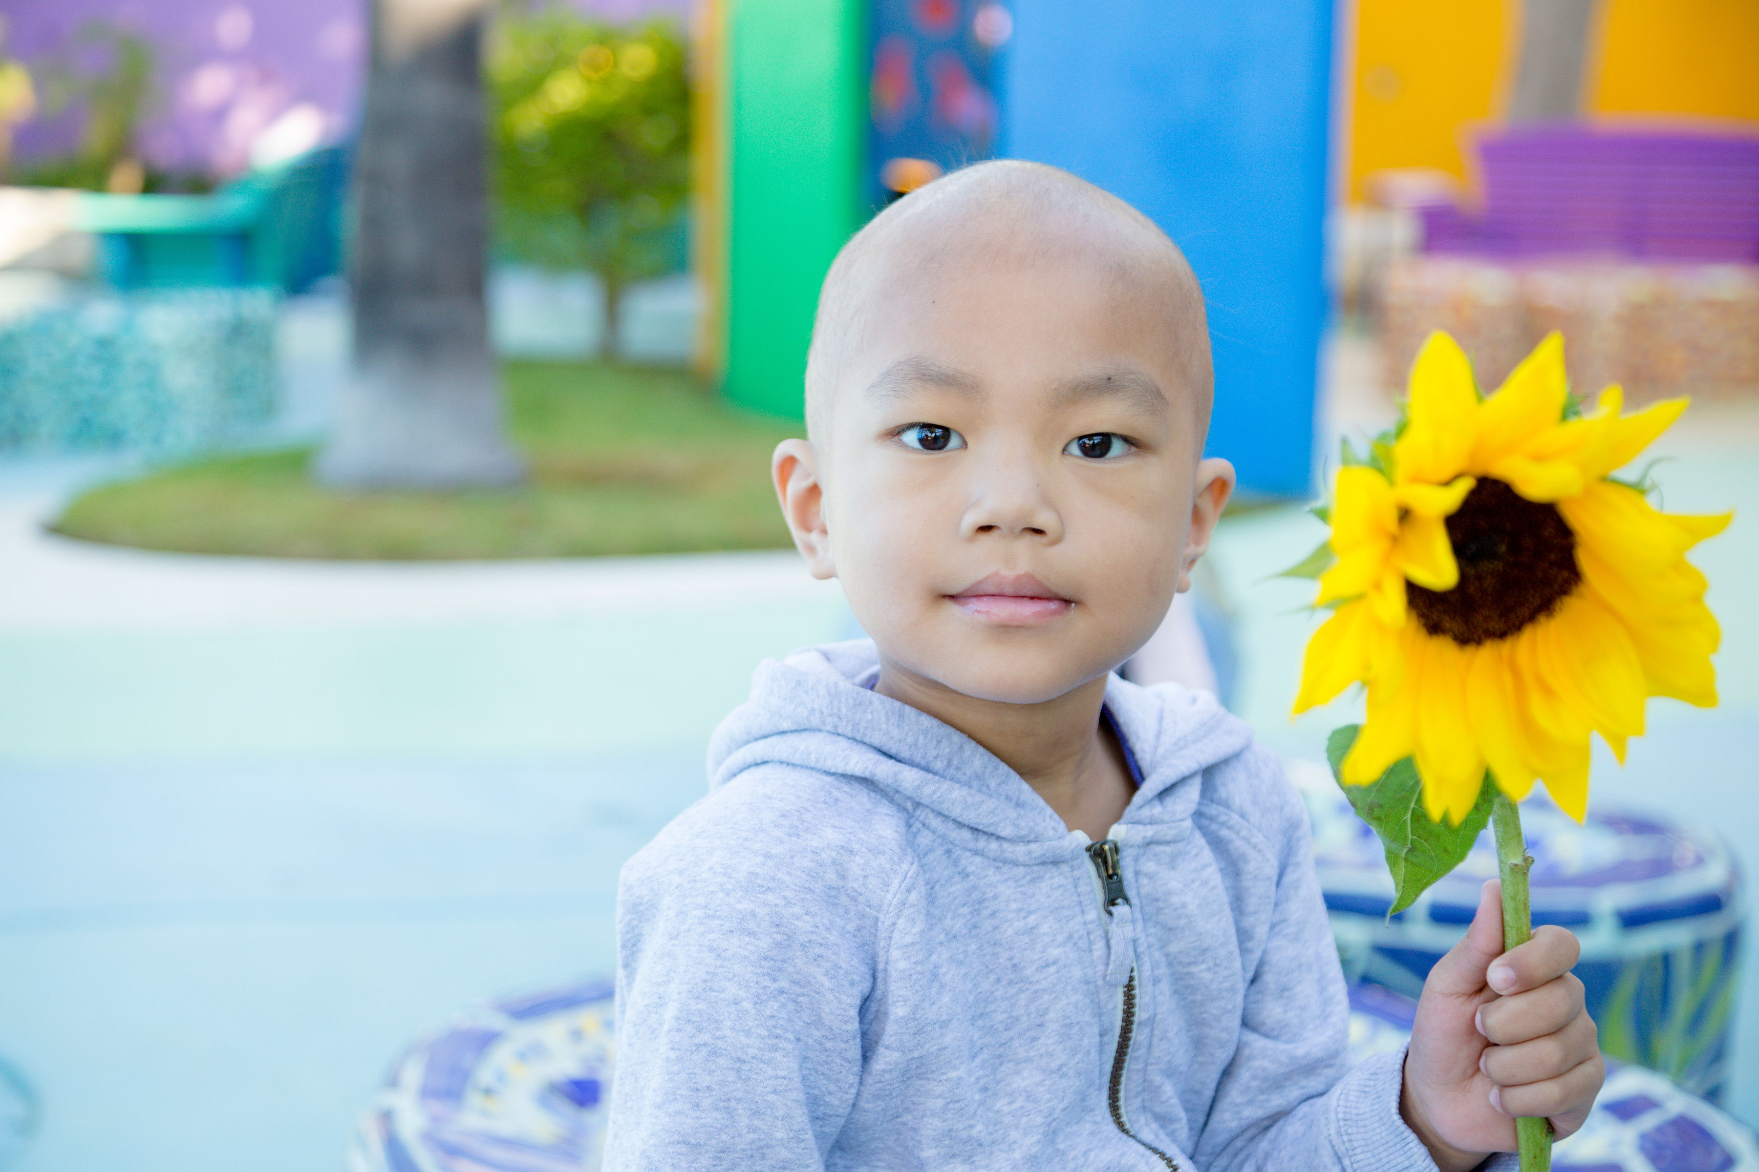

The Emilio Nares Foundation (ENF) San Diego, has its 16th annual Harvest for Hope Sunday

September 22, supporting low income, underprivileged families of children as they battle cancer.

This column has long been an advocate of the wine industry and related services doing as much as they can and then some, for worthy causes that impact the communities they serve. The good that wine has brought to consumers who have embraced the beverage for centuries, also brings to the table an opportunity to turn to wine, to help those in need. It motivated me to devote this column to the Harvest For Hope event, saluting those volunteers and contributors who have undertaken this promise to extend a hand to needy families with children who are cancer victims. I have stepped up with a Partnership donation to Diane Nares, my dear friend and co-founder of ENF in San Diego, from its beginnings in 2003.

I am happy to report that this 16th annual event has some 18 wineries and wine related companies plus some 18 restaurants and a craft beer sponsor, donating their products and services. They include my good friends at Banfi Winery in Montalcino Italy, the Gold Partner for the event.

The Emilio Nares Foundation was created in 2003, as relayed to me by Diane Nares, loving mother of her only child, who, after a nearly 3 year battle, passed away at 5 years old.

“My husband Richard and I were later–in-life parents. Our first 3 years we had a beautiful relationship as parents with a lovely child. One day at pre-school, Emilio caught a cold that developed into several colds, then a fever. He was losing energy and felt lethargic. We took him into a specialist who had blood tests taken. It was then we found out the awful truth. He reportedly had Leukemia. Emilio was brought to Rady Children’s Hospital in San Diego and was given cancer treatments for nearly 3 years. In that period of time, there were 2 remissions and 2 relapses before Emilio passed away, just before his 6th birthday. There followed a difficult journey of grief for Richard and myself.

We started having ‘kitchen table’ conversations about where we should go from here. We brought up adoption, but we were in our 40’s and the complications of that option were many. The over-riding thought we both developed was the knowledge and experience of some 3 years with Emilio’s affliction and what to do with it. We decided we could apply this gift to others badly in need of help as they went through the same experience of navigating their child’s journey with cancer. We launched the Emilo Nares Foundation with that primary mission, in our city of San Diego and across the county of San Diego”

ENF has provided and continues to provide resources and support with their flagship Ride With Emilio transportation program, with free rides to and from the hospital to ensure that no child misses the life-saving cancer treatment due to lack of transportation. As of the first of this year, 986 families have been supported with some 94,924 miles of rides. Other services are provided and more are planned including an End of Life program.

The Harvest of Hope fundraiser on September 22 features new and exciting entertainment for guests to enjoy,” said Karen Terra, Executive Director. “We’re thrilled to unveil a new bidding system for live auction items and our live entertainer, Amy Berkman, a cancer survivor, will be auctioning off her sunflower painting at the end of the event.”

General admission tickets are $160. per person. Partnerships are still available. To learn more about the foundation and to RSVP for tickets to the September 22 event, visit enfhope.org, or contact Katie Khasim at 858-571-3328.

Wine Bytes

The 3rd annual Ramona Grape Stomp is Sat. Sept. 14 from 2 to 7pm at the Ramona Outdoor Community Center. Enjoy grape stomping, wine tasting, children’s activities, music, food and line dancing. Stomp competition Grand Prize is $300. Tickets can be purchased at the door or the website. Adults $10. Kids $5. Under 6 free. Visit ramonagrapestomp.com.

Zaca Mesa Winery from Santa Ynez will serve their new releases at a 5 course wine dinner at North County Wine Company in San Marcos, Sat. Sept. 14 at 6pm. Chef Erin Sealy will be pairing each of the 5 wines with her own dinner courses. Call 619-823-3541 or visit chef@winepairsevents.com for details and pricing.

Il Fornaio in Del Mar presents a Masi wine dinner Thurs. Sept. 19 at 6:30pm. A five course dinner will feature choice of baked wild seabass or whole beef tenderloin with a Masi Amarone Costasera 2013. $80. per person. RSVP at 858-755-8876.

Vittorio’s Trattoria in Carmel Valley San Diego, has a Niner Wine Estates four course wine dinner Thurs. Sept. 26 at 6:30pm. The 2016 Niner Cabernet Sauvignon will be featured with a petite filet mignon. Reserve now at 858-538-5884. Cost is $70. each.

Frank Mangio is a renowned wine connoisseur certified

by Wine Spectator. He is one of the leading commentators

on the web. View his columns at tasteofwineandfood.com.

Go to recent columns. Reach him at frank@tasteofwineandfood.com

