
TASTE OF WINE & FOOD
By Frank Mangio

Week of July 7, 2019

The Ten Best Wine Tastes – First Half of 2019

Cheers to California. Most of our top wines came from this historically great wine country. The upside surprise was the increase in excellence from Paso Robles which rang up 4 winners. The rest of the ten also came from the west coast of the U.S. with 3 from Napa Valley and one each from Sonoma, Walla Walla WA. and Escondido, north San Diego.

Best new restaurants so far in 2019: Del Frisco’s, Cesarina, Mangia e Bevi and West End Bar & Kitchen. Important yet-to-open restaurants include: Brian Malarkey’s Herb & Sea in Encinitas, star chef Michael Mina’s International Smoke in Del Mar, Italian Restaurant Blade in Oceanside and Sere, the new anchor restaurant for the Hotel Del Coronado.

Wine guidelines included: all ten equally “excellent” and listed alphabetically; prices taken at each winery’s web site, and all selections had superior flavor, body and value for the price. Web sites are listed for your further information.

. Cass Reserve, Paso Robles, 2015. $125. A top shelf reserve Bordeaux Blend featuring estate Cabernet Sauvignon (75%), Petit Verdot (11%), Merlot (10%), and Cab Franc (4%). This beauty is aged for 22 months in French Oak, creating silky tannins and focused acidity, with black currant and crème de cassis flavors, accented with cherry crumble, baked boysenberry and pomegranate preserves. Subtle yet sultry, this will pair well with red meat and grilled dishes. More at casswines.com.

. Chateau Montelena Cabernet Sauvignon, Napa Valley, 2016. $65. This wine continues to thrive over the years, sanctified by incredible vineyard sites that have heaped praise on Chateau Montelena over the years. Dried blueberry and ripe plum are immediately front and center for a classy nose. Swirling reveals fresh lavender and cocoa. Your palate will be enriched by dark blueberry jam and lively raspberry. Tannins add depth and breadth to a robust mouthfeel and focused acidity. The 2016 vintage should have the hallmarks of a classic. More to learn at montelena.com.

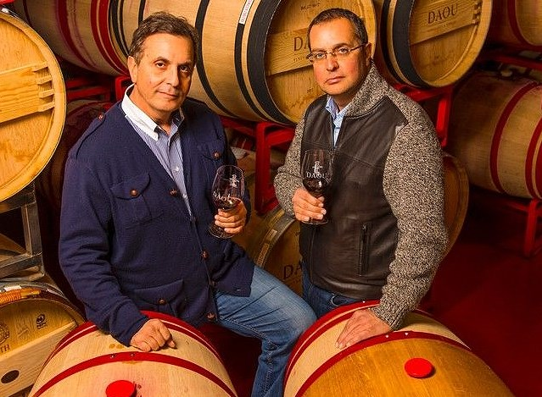
. DAOU Unbound, Paso Robles, 2016. $76. We discovered this new release, Petite Sirah, Tannat and Tempranillo blend, during our recent Paso Robles press tour. Unbound has inky, violet coloring with warm berry notes of blueberry pie, boysenberry jam and mulberries. This unique blend would pair nicely with Ribs, Grilled Hamburgers, Meatloaf and Roasted Pork.

Georges and Daniel Daou lead the charge to elevate

the wines of Paso Robles into a compelling world class

collection to rival any others in California and elsewhere.

Be on the lookout for DAOU’s soon to be released The Bodyguard ($35.) that Daniel Daou describes as “affordable elegance.” Visit at daouvineyards.com.

. Justin Isosceles, Paso Robles, 2016. $76. Named after the triangle with two equal sides, Isosceles has been Justin’s Flagship wine for over 25 vintages. The blend is predominantly Cabernet Sauvignon (85%), Petit Verdot (11%), Merlot (10%) and Cab Franc (4%). This beauty is aged for 22 months in French oak creating silky tannins and focused acidity, with black currant and crème de cassis flavors accented with cherry crumble, baked boysenberry and pomegranate preserves. Subtle yet sultry, this will pair well with red meat and grilled dishes. More at justinwine.com.

. Laird Jillian’s Blend, Napa Valley, 2014. $48. In 1970, the Laird family received a loan and encouragement from none other than Robert Mondavi, then the leading vintner in Napa Valley. Laird later went on to become one of the most prolific suppliers of wine grapes in the region. Jillian’s Blend is its most popular wine on the estate. With a complex and precocious history, the 2014 has a deep ruby red persona with a seductive bouquet of toasted oak, candied plum and ripe strawberries. Expect delicate tannins and acidity. More at lairdfamilyestate.com.

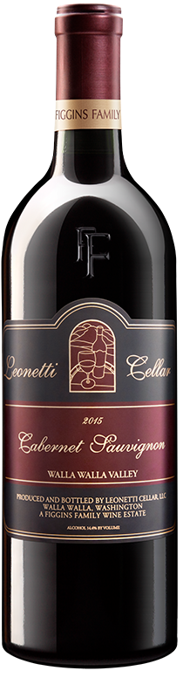
. Leonetti Cellar Cabernet Sauvignon, Walla Walla, WA. 2016. $120. In 1974, the Figgins Family founded this senior Cab, the first in Walla Walla. Leonetti will not be distracted in making this spectacular wine. There is NO: tasting room, tours, appointments or public location. The current wait to join the club is 4 years. Delicious plum and blackberry saturate the palate with a lush finish of soft tannins. Aged 22 months in new and once-filled French oak barrels. Read more at leonetticellar.com.

. Opus One Overture, Napa Valley, 2015. $130. Many wine enthusiasts know of Opus One, a dream product of Philippe de Rothschild and Robert Mondavi. However, few have had a chance to experience this wine. 333 Pacific in Oceanside has Overture by the glass, providing a means to try this Napa Valley Bordeaux estate blend. It features blackberry and cassis from Cabernet Sauvignon, with black cherry, red currant and violet from Merlot, Cab Franc, Petit Verdot and Malbec. Go to opusonewinery.com.

. Orfila Estate Petite Sirah, Escondido North San Diego, 2016. $45. The premier winery in little known San Diego County wine country, Orfila means to change that with French and Italian varietals led by their Petite Sirah. The look and mouthfeel will get you black cherry, licorice, spice and blackberry, with full-bodied flavor concentration and an unusual chocolate/pepper component. See more at Orfila.com.

Leonetti Cellar Cabernet

Sauvignon is the best example

of the over-the-top quality

of Washington wines.

. Turley Ueberroth Vineyard Zinfandel, Paso Robles, 2016. $50. Larry Turley loves to make wine from Old Vine Zinfandel. In fact, he makes 47 wines, mostly Zin and some Petite Sirah, from 50 different vineyards, hand-picked for their excellence. The oldest is the 131 year old Ueberroth Vineyard, high on a hill closest to the ocean in Paso Robles, with very steep limestone slopes. The high pH of the soil makes for a high acid wine, elevating the ripe fruit flavors. All of Turley’s vineyards are certified organic and use all natural yeasts in the fermentations.

Learn more at www.turleywinecellars.com.

. WALT Shea Vineyard Pinot Noir, Willamette Valley Oregon, 2016, $75. If you’re familiar with Burgundy in France, you know it’s a forest floor with more mist than sun. Grapes ripen slowly, very similar to the Willamette Valley, south of Portland Oregon. Matter of fact if you draw a line from Oregon to Burgundy in France, they share the same earthly characteristics. If ever a Pinot Noir displayed these old world-new world flavors, it’s the WALT Shea Vineyard Willamette Valley 2016. These wine grapes are naturally dry-farmed from the seabed soil, with a cool coastal climate, for unusual elegance. See waltwines.com.

Frank Mangio is a renowned wine connoisseur certified

by Wine Spectator. He is one of the leading commentators

on the web. View his columns at tasteofwineandfood.com.

Go to recent columns. Reach him at frank@tasteofwineandfood.com.

