
tASTE OF

WINE & FOOD
By Frank Mangio

Week of June 30, 2019

Like Fine Wine The Butcher’s Cut Steaks are Aged then Served

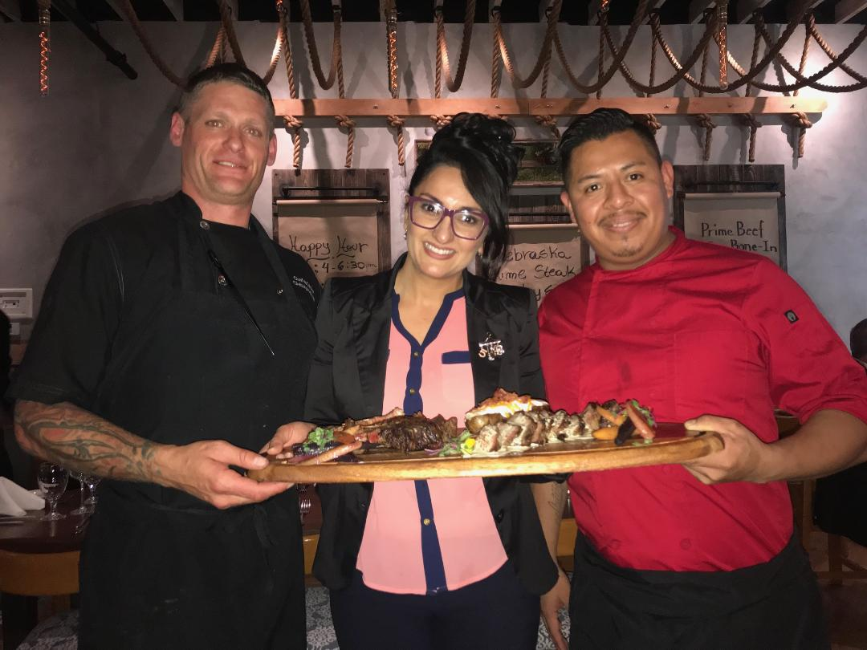
The Butcher’s Cut Steakhouse is setting the Gaslamp District of San Diego abuzz with its aged steak menu experience. It joins sister steakhouse

Greystone, next door, along with other Gaslamp Italian favorites Panevino and

Osetra to create a family of fine dining, all within a couple of blocks of

Sara Arjmand, Director of Operations for The Butcher’s Cut and Greystone Steakhouse, with (left) Chef de Cuisine Christopher Smith, and (right) Executive Chef Gustavinio Lombady, displaying a selection

of aged steaks.

each other on 5th Avenue. I was dialed into the glass floor-to-ceiling steak locker with beautiful cuts of meat, in rows, like models in a meat marbling fashion parade. Classics like Prime Rib Eye Bone-in, T-Bone, Prime Porterhouse and my revered choice, Angus Center Cut New York, locked me into their superior flavor prospects. All were reasonably priced.

But first, a tasting menu of delicious “shareables” was brought in by Sommelier/Server Pietro Chiarello who walked us through the Burratta Bruschetta, Clams and Mussels in a rich tomato broth with Chorizo, and the “Chef’s Surprise”… a bone marrow topped with quail’s egg followed by homemade veal ravioli au jus. Finally, a platter was displayed for our dining pleasure with samples of well-aged steaks including elegantly prepared Bone-In Rib Eye, Filet Mignon and IPA Top Sirloin that was topped in cream sauce. We followed Somm Pietro’s advise and washed our meal down with a Napa Valley Laird Jillian’s Red Blend and an Alexander Valley Sonoma La Storia Cabernet Sauvignon, both magnificent accompaniments to any of the luscious steaks on the menu.

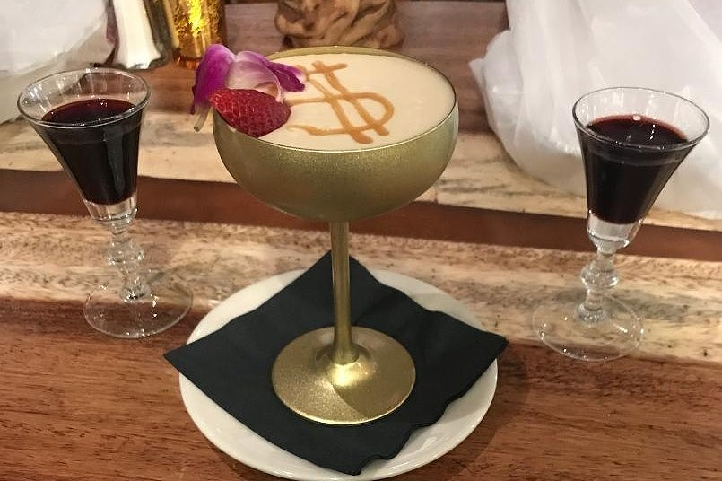
Dessert was remarkable, first for its Cockburn Tawny Port, direct from Porto in Portugal, the source of all great ports. Then came a shared goblet of Butterscotch Budino that left my partner, Tech Director Rico Cassoni, breathless. It was that good.

View more at butcherscutsteakhouse.com.

Two lovely Cockburns Tawny Ports flank a goblet of Butterscotch Budino,

in a perfect dessert matchup at The Butcher’s Cut in San Diego’s Gaslamp District.

All Hail a Cab for the Ages – Stags’ Leap

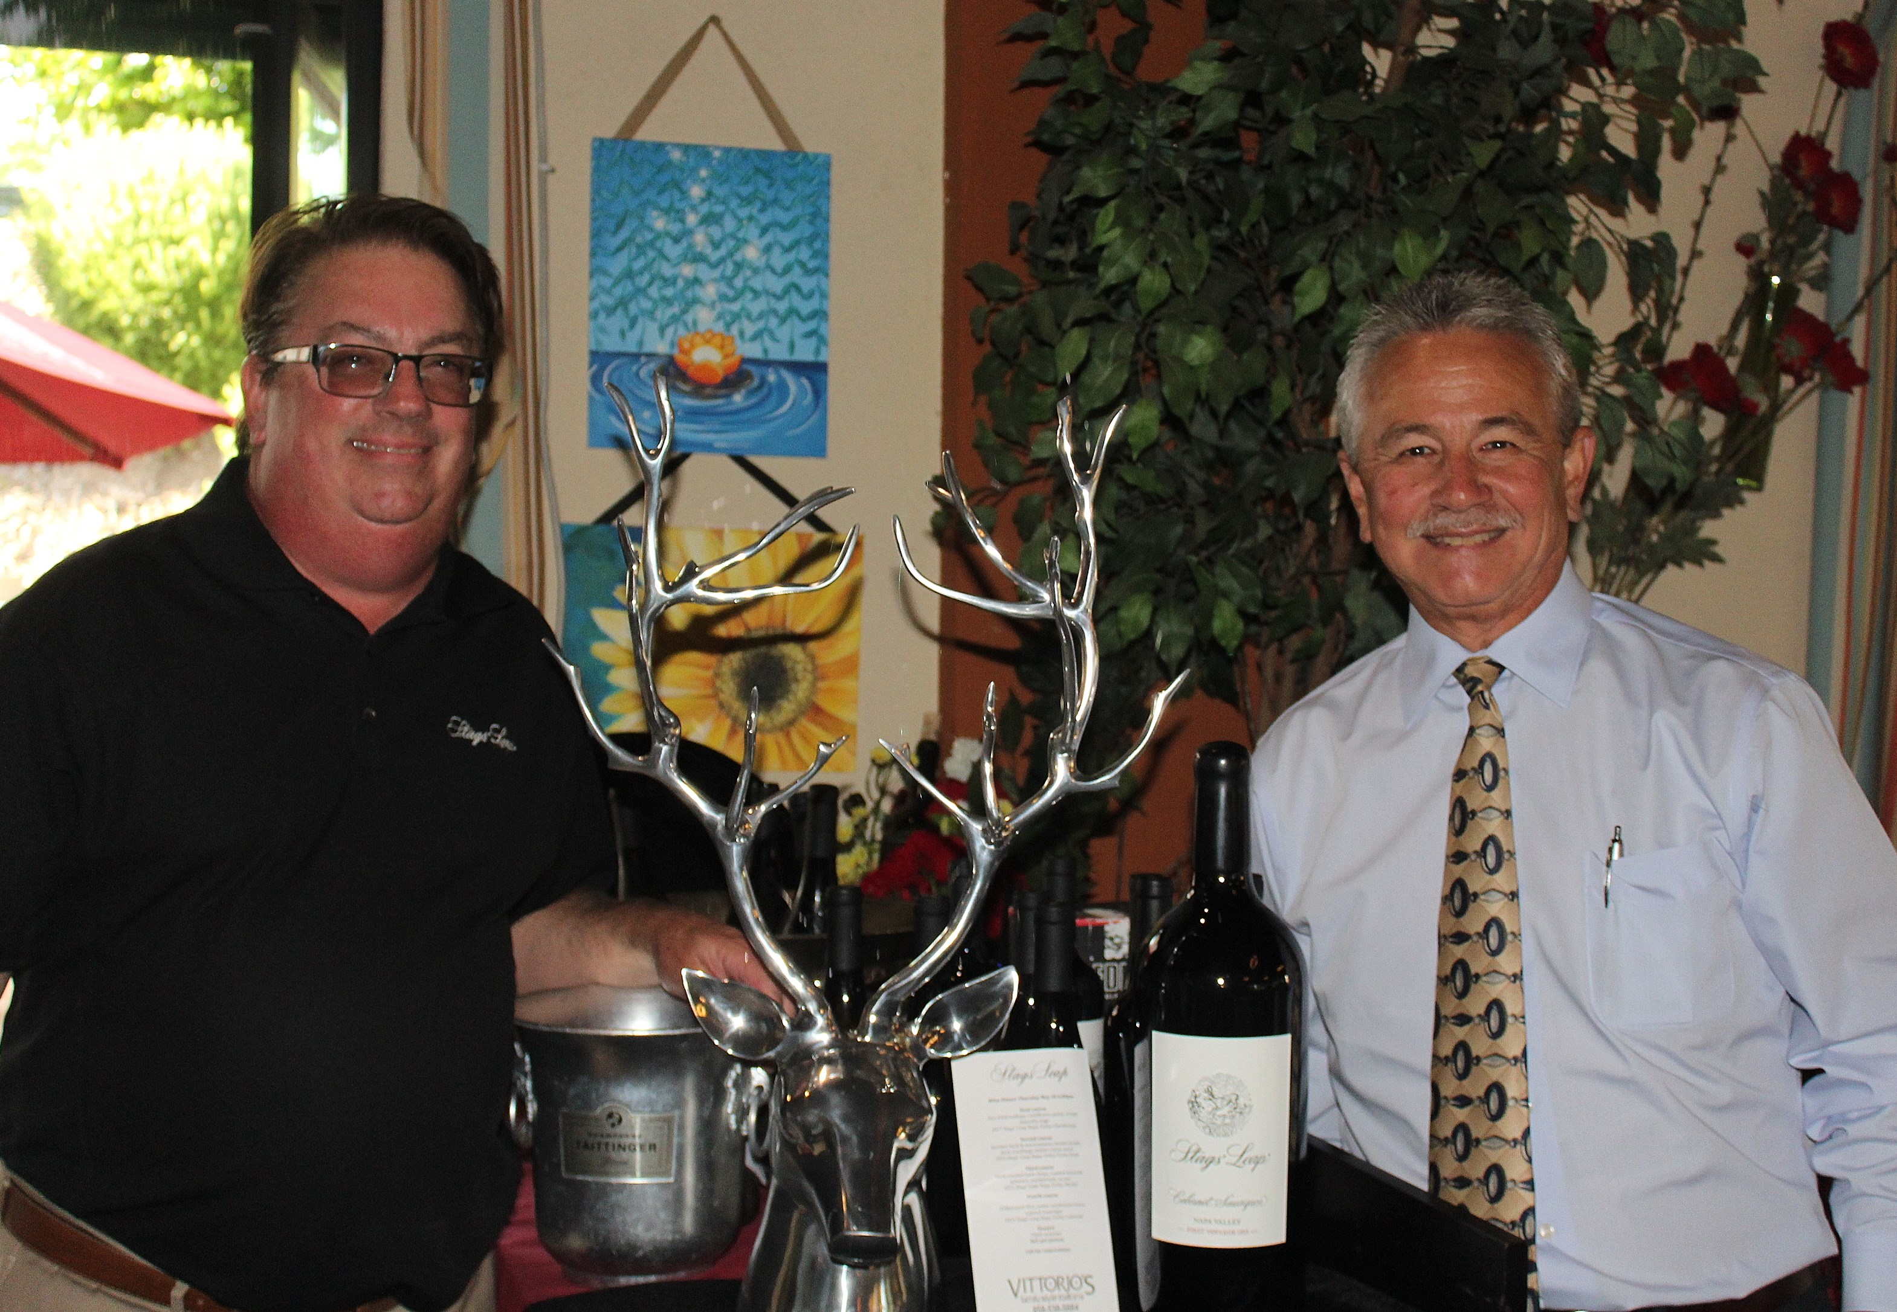
Vittorio’s in San Diego’s Carmel Valley is known for its monthly celebratory wine dinners spotlighting big reds, none bigger than the recent appearance and tasting from Stags’ Leap. This winery is one of the oldest in Napa Valley. In 1893, founder and wealthy businessman Horst Chase stood on the property, puzzled as to what he would call the winery,

Jim Kern of Classic Wines of San Diego (left) and Mike Malcomb of

Treasury Wine Estates (right) salute Stags’ Leap at Vittorio’s in San Diego.

when a large male deer pranced across his line of sight. It would forever be called Stags’ Leap. In 1976, with the great Warren Winiarski as owner-wine maker, the winery’s 1973 Cabernet Sauvignon beat the French versions in the “Judgement of Paris,” a legendary moment in Napa Valley wine history.

Cabernet continues to be the signature wine at Stags’ Leap. The newest release, the 2015 ($60.), shows a rich dark abundance of blueberry, cherry and plum. Seamlessly integrated Oak and refined tannins open a smooth mouth feel with complex layers of flavor. 20 months for aging in French oak, guarantee that this wine is ready to “drink now” when purchased. Review the winery at stagsleap.com.

Wine Bytes

Capri Blu in North San Diego is planning a 5 course wine dinner with some of the best French wines with Italian dishes, Wed. July 10 at 6pm. Top course will be the baked Manicotti with mixed seafood, washed down with the French Chateaux Loudenne, Medoc Bordeaux. Cost is $65. each, with an RSVP at 858-673-5100.

Sal Ercolano’s Seasalt Seafood Bistro in Del Mar brings Chateau E. Guigal in for a memorable French style wine dinner in honor of Bastille Day, Thurs. July 11 at 6pm. Enjoy the great French wine districts like Gigondas, Crozes-Hermitage and Chateanuef-du-Pape. Call 858-755-7100 to reserve your place. Cost is $70. per person.

Thornton Winery in Temecula kicks off its Summer Champagne Concert Series on Sat. July 20 at 7pm with the Brian McKnight 4. General Admission is $95.

The great Jazz trumpeter Chris Botti appears Sat. Aug. 3 at 7pm. General admission is $105. Gourmet Supper package is $190. For details and ticket info, visit events@thorntonwine.com. Or call 951-699-0099.

Frank Mangio is a renowned wine connoisseur certified

by Wine Spectator. He is one of the leading commentators

on the web. View his columns at tasteofwineandfood.com.

Go to recent columns. Reach him at frank@tasteofwineandfood.com.

