
TASTE OF

WINE & FOOD
By Frank Mangio

Week of June 23, 2019

Orfila Leads Wine Quality Upswing in San Diego

Whether you’re aware of it or not, a growing parade of wineries is building up momentum in Southern California and they’re centered right here in the San Diego metro area. Last time an official count was made in the county, 116 wineries made the cut.

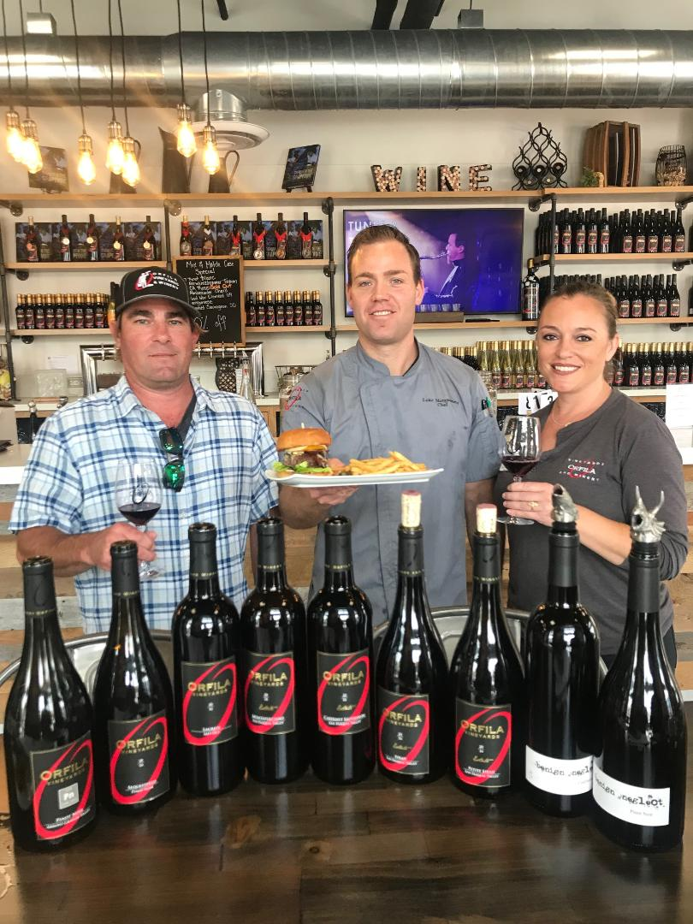
The San Diego County Vintners Association that promotes area wineries, points out that this district was the first to make wine in California with the beginning of the missions way back in the 18th century. Father Junipero Serra established San Diego de Alcala, California’s first mission, several miles from the present Orfila Winery founded in 1994 by former Ambassador to the U.S. from Argentina, Alejandro Orfila, who is still the active owner.

Times have changed since then and the spirit of friendly competition was in the air at the festive annual San Diego County wine show this year in Escondido.

Orfila Vineyards and Winery in Escondido, a familiar name for fine wines

in San Diego County since 1994, expanded to downtown Oceanside to catch

the growing wave of new business, led by winemaker and GM Justin Mund,

Chef Luke Morgenstern and Tasting Room Manager Jessica Englund.

It was a happy group of wineries in a rustic circular setting ranging from BK Cellars to ZXQ Vineyard in Escondido, south to Ocean Beach and the dandy digs at Gianni Buonomo, run by our good friend, Keith Rolle.

A look at the latest winery map will tell you why things are on the upswing for this long-neglected wine country. A distinct wine trail has finally filled in, from Escondido close to the coast, east to Julian up in the hills where some 50 wineries are within a day’s choices…a day tripper’s delight. Then there is the amazing growth of urban wineries along the coastal towns of North County south to the San Diego Metro district, where wine grapes are brought in and the wine is made in a boutique barrel area and offered in a comfortable bar-like setting, with small bites and musical enhancements. Orfila again shows the way with its Tasting Room near the pier in Oceanside, with some 25 Orfila wine varietals, a built in kitchen with a full menu of farm to table offerings with “delicious, simple healthy food” created by Chef Luke Morganstern.

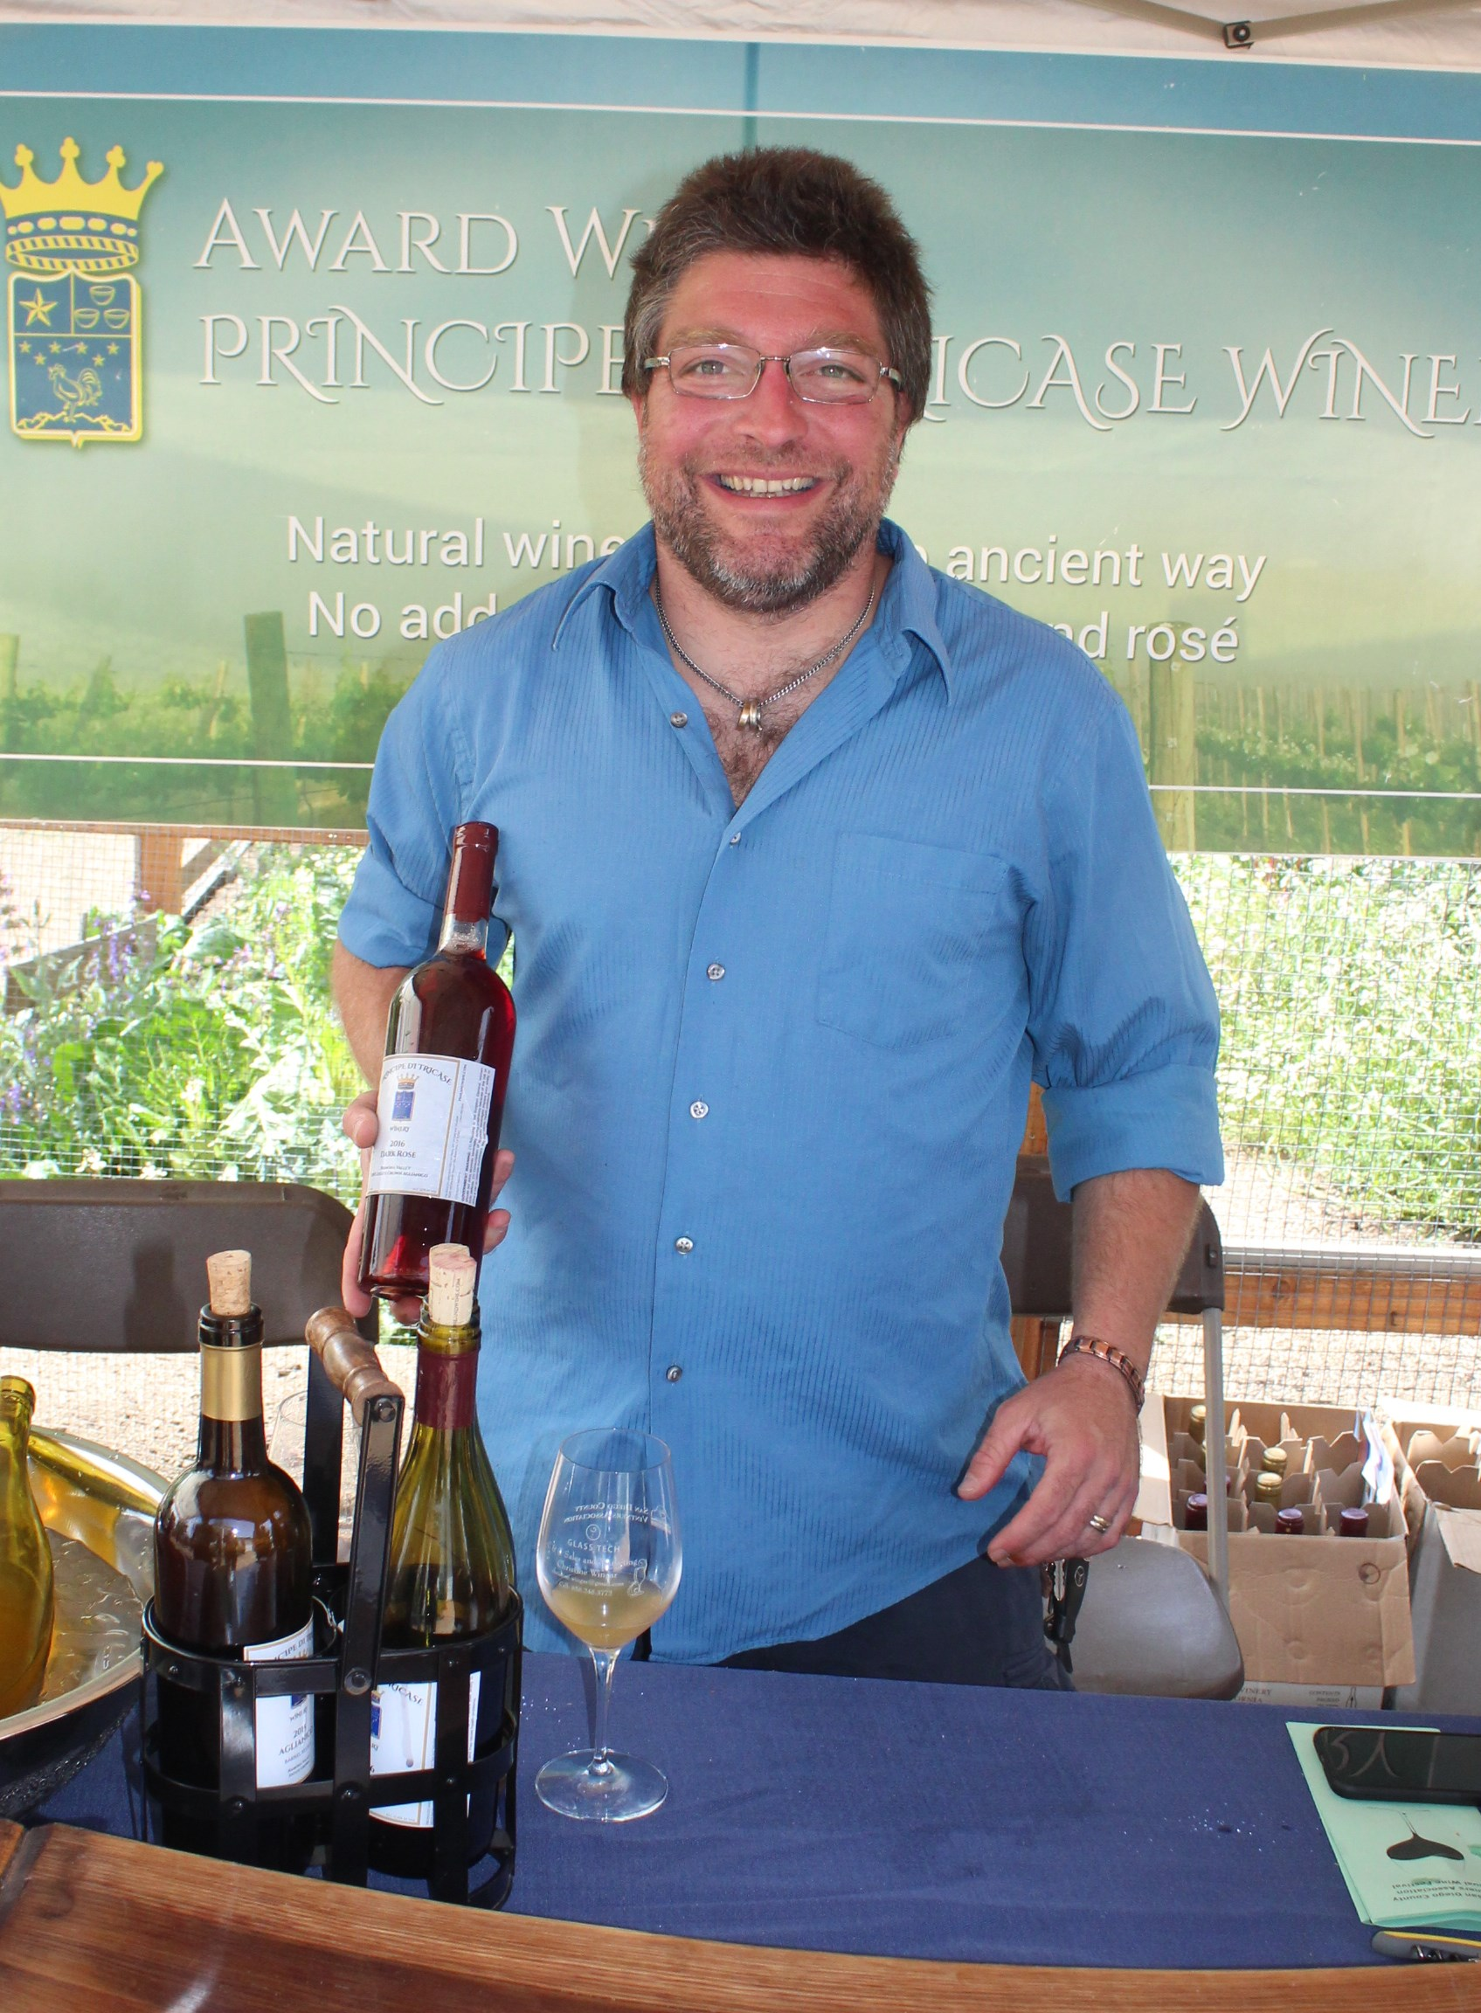
The San Diego district wineries are a diversified group and no better example is Principe Di Tricase, tucked away outside the city of Ramona and run by Alberto Sepe. This winery began in 2007 and from the get-go, it was all Italian, all the time. These were wines you had to acquire a taste for. Sepe likes to say “our Aligianico, native to Campania south of Naples, has a mind of its own and wants you to know, whether you like me or not, I don’t care!” It’s acidic and tannic style makes it ideal for the tomato based food typically found in southern Italy and adopted by many in San Diego County.

Alberto Sepe of Ramona’s Principe Di Tricase is an Italian

wine grower, with its Aglianico, Nebbiolo, Sangiovese and Moscato

sparkling wine.

Visit the Orfila Tasting Room at orfila.com, the San Diego County Vintners at sandiegowineries.org and Principe Di Tricase at pineandwine.com.

New Summertime Selections in the Beverage & Food Menus at 20 / Twenty

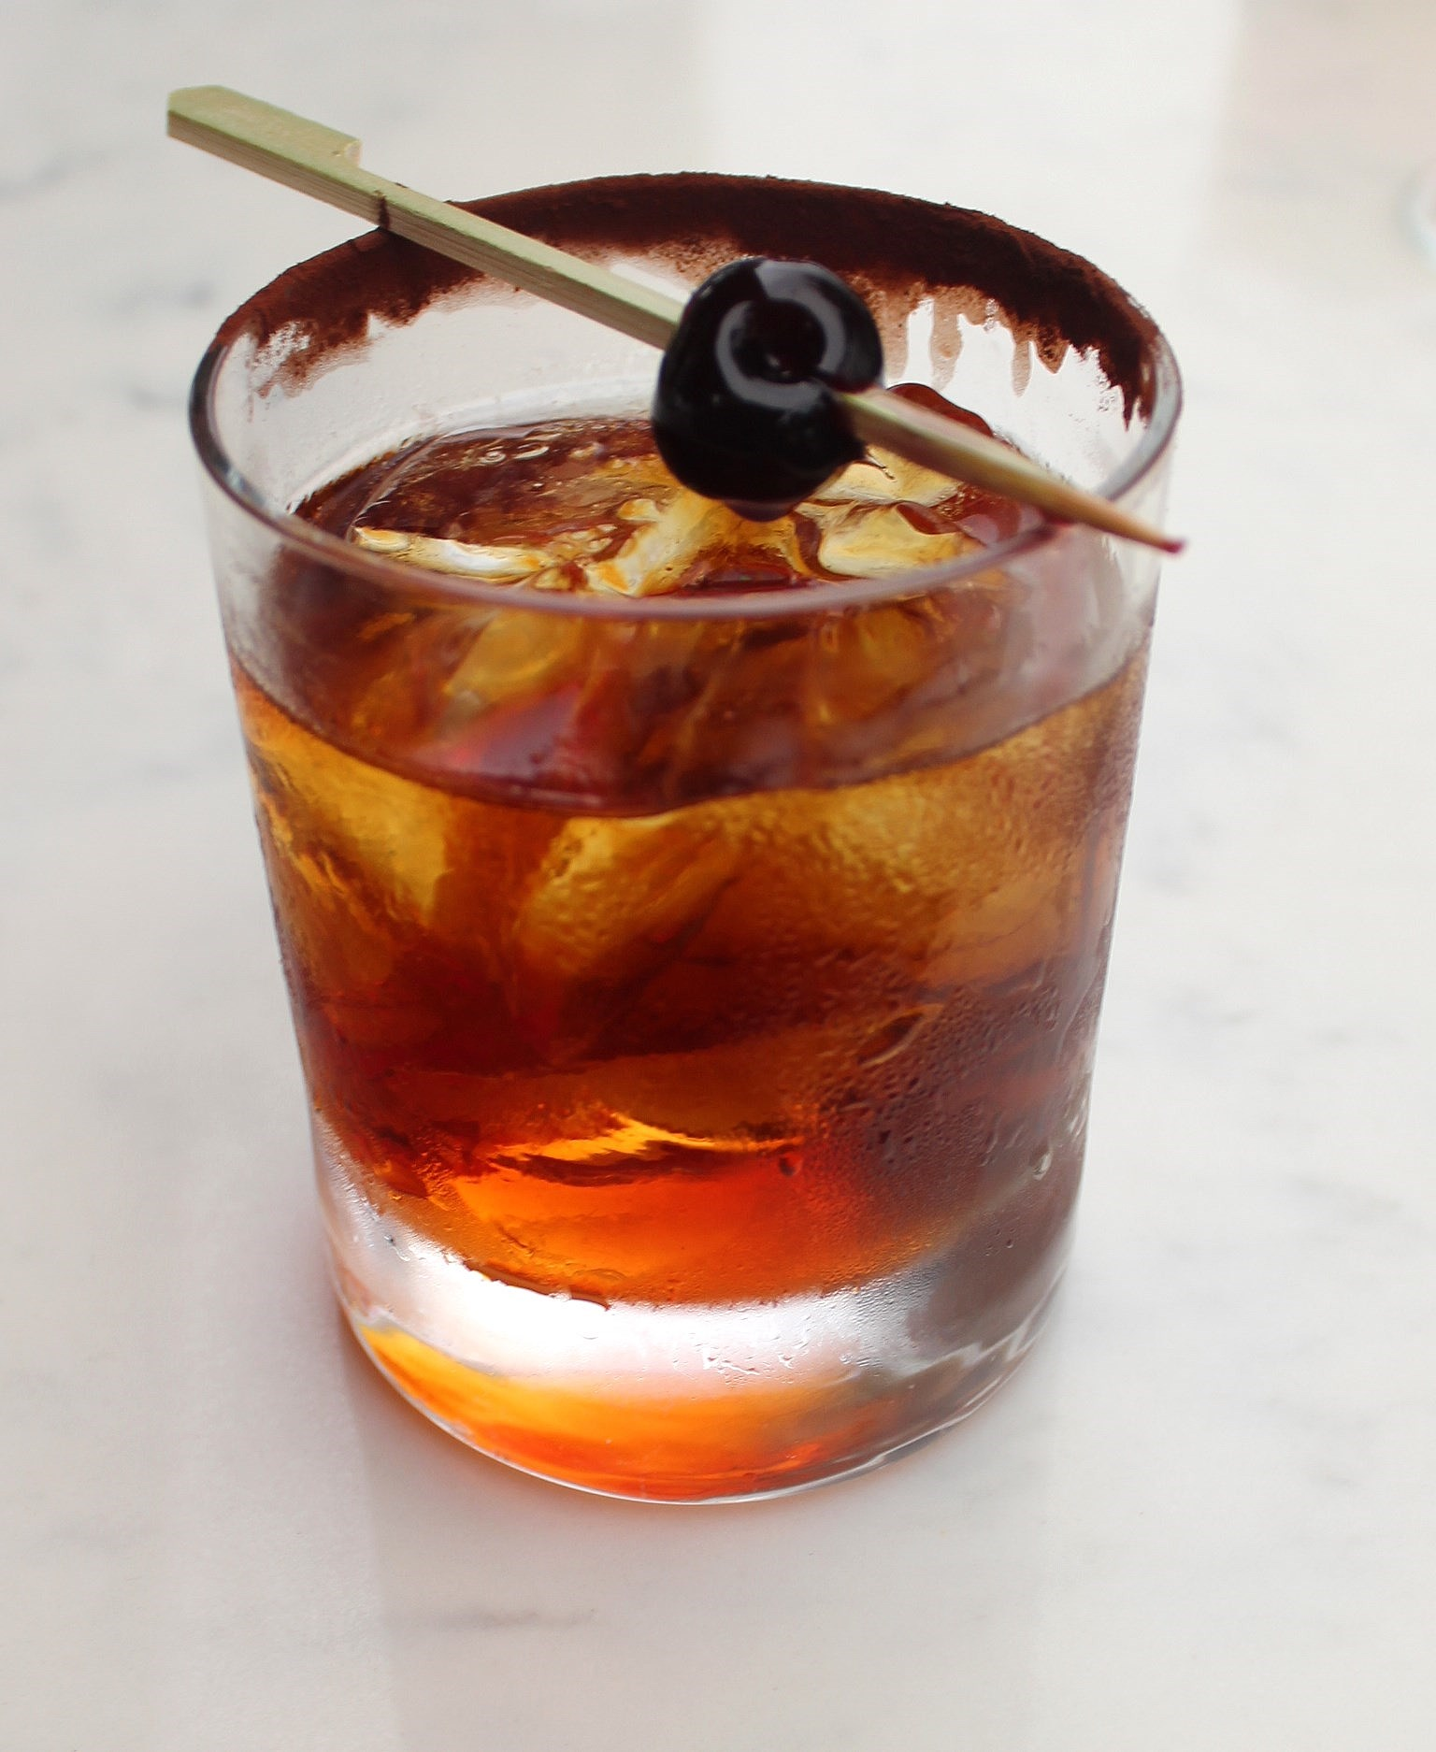
With the 4th of July right around the corner, consider the fun and food at 20 / Twenty’s “Red, White & BBQ” at the Westin Resort in Carlsbad. From 6 to 10pm on the 4th you’ll celebrate with favorites like smoked chicken, cheddar biscuits and strawberry cobbler. I spoke to Augustine, head bartender and he guaranteed me the new drink sensation created by Beverage Manager Steve George, would be plentiful and ready to rock the house! This Black Smoked Manhattan has a Bourbon base with Smoked Maple Syrup, Angostura and Chocolate Bitters.

20 / Twenty, the delightfully creative dining location in the Westin Resort

in Carlsbad, has composed its version of the popular Manhattan, the historic

Cocktail, in an all-new look and taste.

It’s a sensation during their Happy Hour, 7 days a week from 4 to 6pm, when the price is groomed down from $12 to $10. with each order. Executive Chef Julian Quinones has gathered a new and exciting harvest of plant-fed cuisine that is American inspired. Thoughtfully curated items like Farmers Market greens and vegetables, cheeses and walnuts with truffle vinaigrette and South American Verlasso Salmon will have you returning for more. Their one-of-kind-craft cocktails add value to a premium by-the-glass wine list. For details on the 4th of July BBQ event, visit 20twentygrill.com.

Wine Bytes

Falkner Winery in Temecula celebrates its 19th Anniversary with 4 days of celebration starting July 4 to July 7. Most events will happen between Noon and 4pm including live music, yard games, hourly raffles, outdoor BBQ, and sharply reduced prices on selected wines.

A special picnic menu will be posted at the award winning Pinnacle Restaurant.

Check it out at falknerwinery.com or call 951-676-8231 x4.

Ponte Winery in Temecula is having their first-ever Ponte Family Fest, Thurs. July 18 from 5 to 9pm. Get your groove on with live entertainment, lots of kid-friendly games and activities. Enjoy delicious foods from local food trucks. Admission tickets are $4. for club members, $5. for guests. Proceeds from the event will benefit a local non profit for needy children. Visit pontewinery.com or call 851-694-8855.

Frank Mangio is a renowned wine connoisseur certified by Wine Spectator. He is one of the leading commentators on the web. View his columns at tasteofwineandfood.com. Reach him at frank@tasteofwineandfood.com.

