
TASTE OF WINE & FOOD
By Frank Mangio

Week of May 26, 2019

Dining Around for the most Beautiful Views in San Diego

The best coast for dining views is the West Coast, and the best in the West is the view from a few privileged restaurants that have stunning panoramic views of San Diego to add to other over-the-top features inside as well as out.

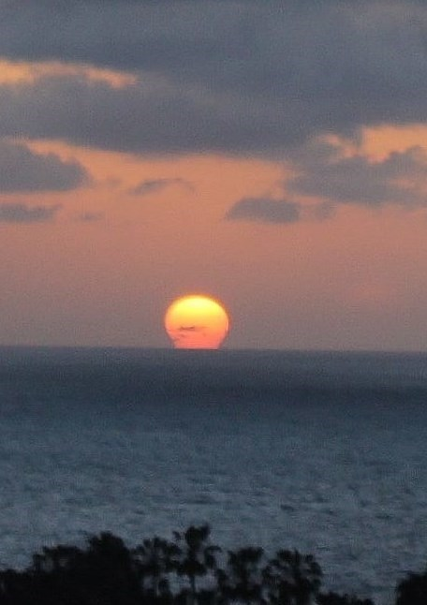
In casting around for candidates for this honor,

I had to ponder such luminaries as Coasterra, Mr. A’s and The Marine Room. All had some of the indulgent reasons for best view, but only two could pass my checklist of a dynamic menu of wine and food, a 180 degree ocean view, outdoor patio, relative quiet while dining, views from the majority of seating spaces, beautiful classy surroundings and a happy group of servers, chefs and managers.

It’s been my experience that the wine and dine experience is so enhanced by all these pluses that leaving is the most difficult of choices.

My congratulations go out to two restaurants that meet these criteria: Cusp and Il Fornaio.

This stunning sunset is a typical window view

while dining at any of the tables at Cusp, at the top

of the Hotel La Jolla.

It was “Bubbly Wednesday” at Cusp and the Veuve Cliquot Champagne was flowing at the lively bar and each of the tables, which are all facing the brilliant sunset, in progress when I arrived. The eye popping promotion has a Happy Hour $4. glass of Veuve starting at 4pm, then going up a dollar every hour for the next few hours.

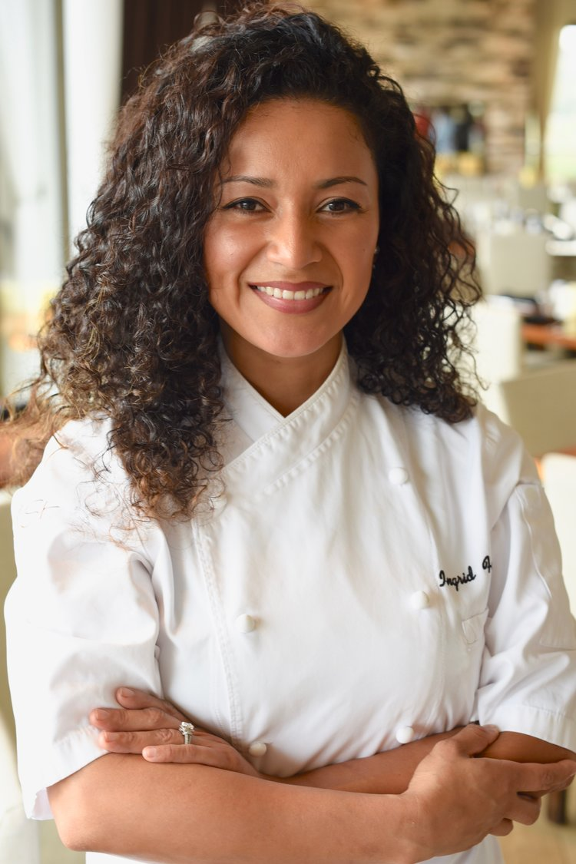
Cusp Executive Chef Ingrid Funes had her fresh coastal cuisine at its inventive best. The lineup included grilled fish, house made pastas, local meats and rustic flatbreads from the imported pizza oven.

The night Food and Beverage Manager, Sergio Bastidas was making sure all the wine and dine guests were taken care of with the best service possible. Chef Funes is from El Salvador and comes from a long line of cooks with pride and passion. After a while at Ironside and L’Auberge Resort, she was named Executive Chef last year. I turned to the “Fresh Catch of the Day” and was I happy about that….a South American Sea Bass with mushrooms, asparagus, yuzu blanc and radish spaetzle.

Ingrid Funes is the Executive Chef at Cusp,

on the top floor of the Hotel La Jolla, with a

panoramic view of the Pacific Ocean.

After sampling the Veuve Clicquot bubbly as an intro to the fine wine list of Cusp, I was in a sparkling mood and continued my quest for more with Batasiolo Moscato di Asti. Many of you know Batasiolo as a family of wines from Asti in the Piedmont Italy area with its bright fruit forward juice delivering juicy peach, citrus and floral notes, is held in high esteem by this column. Both Chardonnay and Pinot Noir are used in the base, similar to Champagne in France. There is now a sparkling wine craze right alongside Rose’ and powered by the Millennial generation.

Cusp Dining and Drinks has a view to drink to. See more at cusprestaurant.com.

Il Fornaio Coronado has Spectacular Bay Views

and Wine Dinners

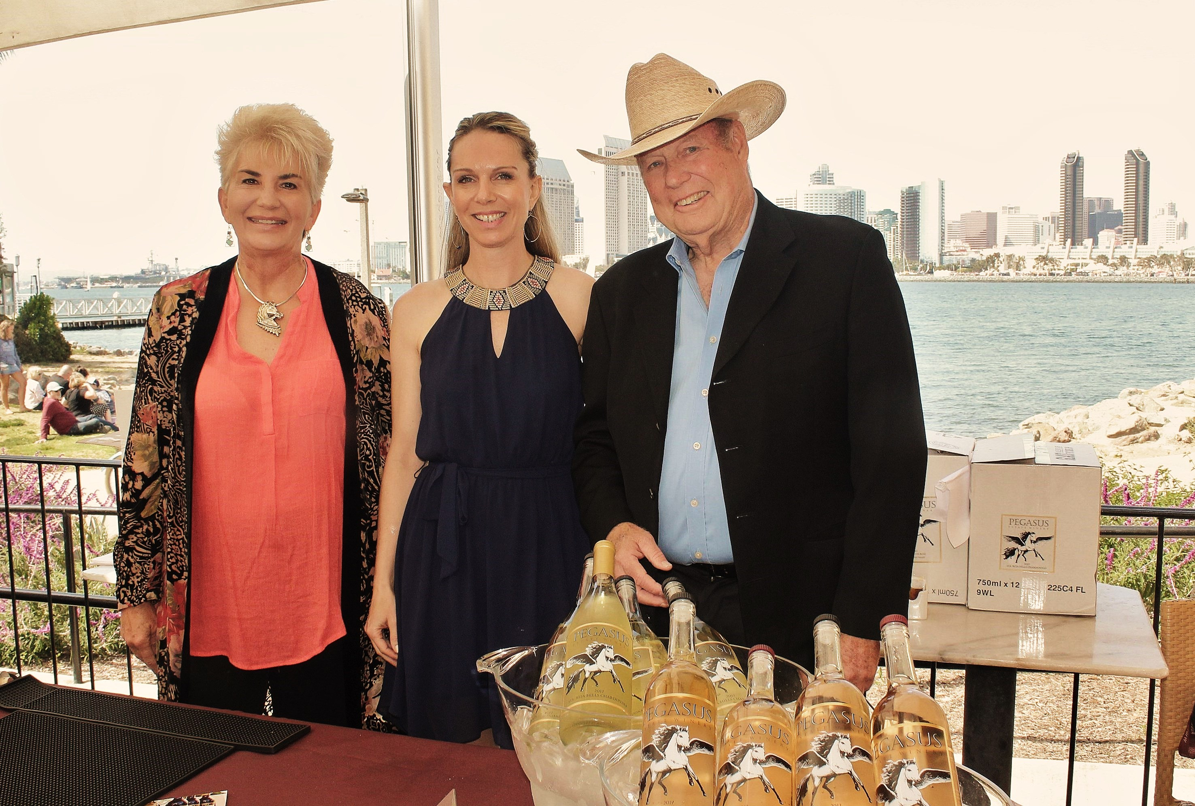
Peggy and Michael Crowley are the creators of Pegasus Estate Winery Santa Ynez, along the Central Coast of California. Skillfully produced in limited quantities with a French flair, they chose Il Fornaio with a front seat to the bay and skyline of San Diego, to publicly present their 5 newest premium wines with perfectly paired small bites.

Il Fornaio with a beach front San Diego Bay view and the

downtown skyline front and center, was the backdrop for a Pegasus

wine dinner with owners Peggy and Michael Crowley on both sides

of Il Fornaio Events Coordinator Lori Dunn.

During a lovely sun-kissed San Diego day, guests enjoyed a Sauvignon Blanc with its bright layers of citrus; Chardonnay with a marriage of citrus and golden Delicious apples and ripe Asian pears; Grenache Rose’ with its tropical fruit; a Quadrille Bordeaux style blend with left bank Cabernet Sauvignon, Merlot and Petite Verdot; and finally the family favorite, a 2014 Cabernet Sauvignon with its deep ruby red bouquet of black plums and other fruit tones of licorice and clove. These wines are a creation of winemaker Ken Brown, a legend along the central coast who founded Byron and Zaca Mesa wineries. In 1990, he attracted Robert Mondavi who brought him to Napa Valley to perfect his Cabernet Sauvignons. Then shortly after, he joined with Pegasus to, as Peggy Crowley says it, “raise the level of winemaking to its peak, where it sits today.” Pegasus is a multi-gold winner at the San Francisco Chronicle competition and many more international shows where the wings of Pegasus have soared. More about Pegasus at pegasusestatewinery.com, and Il Fornaio at ilfornaio.com.

Wine Bytes

Sip the City, an annual salute to the Urban Wineries of San Diego, is returning Fri. May 31 at the Headquarters at Seaport District, from 5:30 to 8pm, at Harbor Dr. Over a dozen urban wineries are pouring their unique and award winning wines. Light snacks and live music add to this event. Cost is as low as $29. with an online purchase. Get tickets at sip2019.brownpapertickets.com.

Parc Bistro Brasserie on 5th Ave. San Diego is presenting the great Paul Hobbs Winery in a dinner setting on Thurs. June 7 from 6:30 to 10pm with Matt Hobbs. 5 course wine pairing dinner costs $125. Contact 619-795-1501 to purchase tickets and reserve.

Il Fornaio in Del Mar honors the Liguria District of Italy June 3 to 16 with a special menu and wines from Liguria. A best buy is the Risotto di Camogli, a shrimp and artichoke Risotto with Rosato wines. On June 6, a Cakebread Napa Valley wine dinner is being planned. Don’t miss either of these events. Call today for an RSVP at 858-755-8876.

A “Tale of Two Pinots” is the next seminar at Meritage Wine Market in Encinitas, Fri. June 7 from 6 to 7:30pm. Find out the differences between California and Oregon Pinots. 6 Pinots will be compared. Cost is $49. Call 760-479-2500.

Frank Mangio is a renowned wine connoisseur certified

by Wine Spectator. He is one of the leading commentators

on the web. View his columns at tasteofwineandfood.com.

Go to recent columns. For comment, reach him at frank@tasteofwineandfood.com.

