
TASTE OF

WINE & FOOD
By Frank Mangio

Week of May 12, 2019

This Month’s Wine May-ry-go-round

Spring wine and food events for 2019 have sprung! I‘ve never seen anything like it in my 14 years as a wine and food writer. The consuming public has finally figured it out. Between the wine tasting, the multi- course special dinners or the vast amount of wine and cuisine offered at special wine trade events, the admission charged is a great bargain when you break it down. And you can’t place a price on the element of fun and friendship.

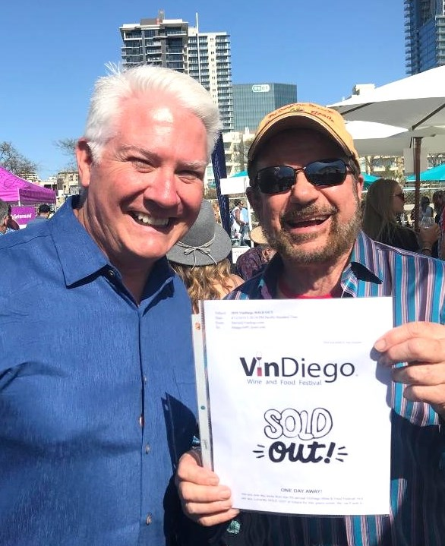
The latest big wine show was the 7th annual VinDiego masterminded by Dave Fraschetti, who gave his many guests a new venue, downtown San Diego’s Waterfront Park. Just to be by the bay with this unforgettable party was enough to sell it out. Wines from all over California descended on the venue under beautiful clear skies.

Several restaurants were invited to offer food samples that identified their menus.

Even gourmet market Gelson’s La Costa location, with manager Kasen Smith, pitched in with a wide variety of cheeses and cheese experts on hand to guide samplers.

Dave Fraschetti, producer of VinDiego and wine columnist

Frank Mangio, celebrate the “sold out” event at Waterfront Park in San Diego.

I wanted to call out some special wines that I hope to see again soon.

Carol Shelton had her award winning Zinfandels from Sonoma, namely Wild Thing, which has been applauded by an array of publications and judges these days. Keith Rolle has been on a roll, taking his Gianni Buonomo winery in San Diego’s Ocean Beach district to new heights. He was awarded Best Winery in San Diego and his Charbono Red was dubbed Double Gold in San Francisco. Opolo, a mountain winery in Paso Robles, is another brilliantly produced Zinfandel entry under the guidance of sales veteran Cary Thrasher and Riboli Family Wines had a wine for everyone with their big name brands like San Simeon, Stella Rosa, Maddelena, San Antonio and more. Keep up with the latest news at VinDiego.com.

Justin Winery Presents their Latest at Vittorio’s

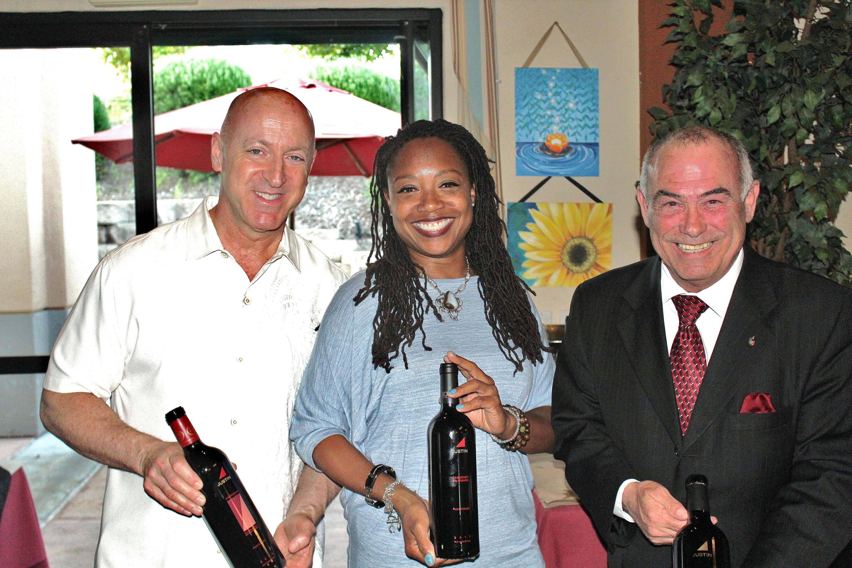
Vittorio’s in the Carmel Valley of San Diego had overflow diners for its Justin Winery wine and dine experience. The Paso Robles winner with famous red blends like Justification ($60.) and favorite Isosceles ($76.) show you why Justin is at the top of its game with great wines.

The quality of Justin wines of Paso Robles was in full bloom at Vittorio’s

in Carmel Valley San Diego. Presenters included: Victor Megalhaes, owner of

Vittorio’s, Sinia Shaw of Justin and Sheridan Dowling of American Wines & Spirits.

Sinia Shaw lit up the room when she told the story of Justin Baldwin, who after visiting the finest chateaus in Bordeaux, created a California winery in 1981 that featured red blends that rivaled the originals. Justin wines have never looked back. Take a look at… JUSTINwine.com.

Il Fornaio Honors Sicilian Food and Wine

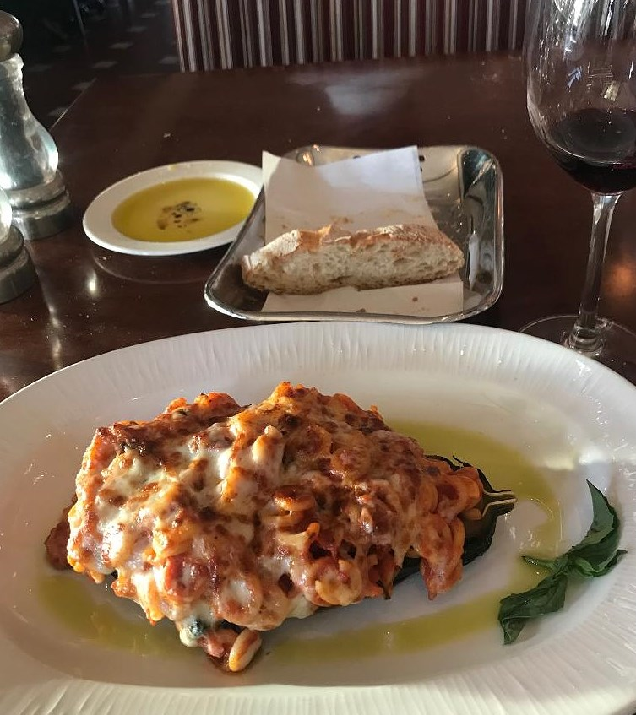
Visit Il Fornaio now through May 19th as the Italian restaurant group celebrates food and wine Sicilian style, during their monthly Festa Regionale. Rico Cassoni and I dined at the Del Mar location when Manager Gianluca Mazzolani hosted menu delicacies that included Analetti al Forno, an inspiring eggplant and pasta dish (eggplant is called Melanzane in Sicily). Analetti pasta, a small circled pasta, was surrounded by baked tomato sauce in a half-globe eggplant, topped with Sicilian Pecorino cheese. Mazzolani revealed that “the eggplant came from the Middle East by way of Arab conquerors who inhabited the island centuries ago. They are grown above ground like a tomato plant and are now considered to be a staple food for Sicilian style restaurants.” The recommended wine was a Nero d’Avola, the 2016 Regaleali ($42. bottle). Complex and supple, it has ripe berry flavors and silky tannins. It made a

Sicily came to Il Fornaio’s restaurants, May 6 to 19.

The Analetti al Forno was our favorite. An eggplant half

globe with lush tomato sauce and the Analetti pasta, is a perfect

compliment. The wine was a 2016 Nero d’Avola Regaleali.

perfect companion for this dish.

The evening would not have been complete without the Spumoni Gelato with cherries, chocolate chips and pistachios for the “Dolce” dessert.

The May-ry-go-round continues with wine events by Hall/Walt, Banfi, Caymus, Pegasus, Keenan and Stags Leap. Stand by!

Wine Bytes

Oak + Elixir Wine, Beer & Eatery in Carlsbad has its 2nd Anniversary party Sat. June 1 from 4 to 11pm. Come dressed in Glam and Jam. Live music by the Shift,

and blind wine tasting, with advance tickets available for $15. Contact carrie.oakandelixir@gmail.com.

Charlie and Echo Restaurant and Wine Bar in San Diego has a Wine & Charcuterie Pairing Wed. May 5 from 6:30 to 7:30pm. 5 paired courses are planned for $29. ea. Wine club members get 20% off. Details at charlieandecho.com.

The San Diego County Vintners is holding their annual Wine Festival Sat. May 18 at Sikes Adobe Historic Farmstead in Escondido, from 1 to 4pm. Dozens of San Diego County’s finest award-winning wines will be poured, and you can connect with the owners and winemakers. Also, a silent auction, live music and a chance to purchase your favorite wines. Tickets are $55. per person for unlimited wine tasting. Buy tickets through brownpapertickets.com.

Frank Mangio is a renowned wine connoisseur certified

by Wine Spectator. He is one of the leading commentators

on the web. View his columns at tasteofwineandfood.com.

Go to recent columns. Reach him at frank@tasteofwineandfood.com to comment or unsubscribe.

