
TASTE OF WINE & FOOD
By Frank Mangio

Week of April 7, 2019

Here and There in the Wine World

The wine world’s a big place, so hop on board as we touch a few bases.

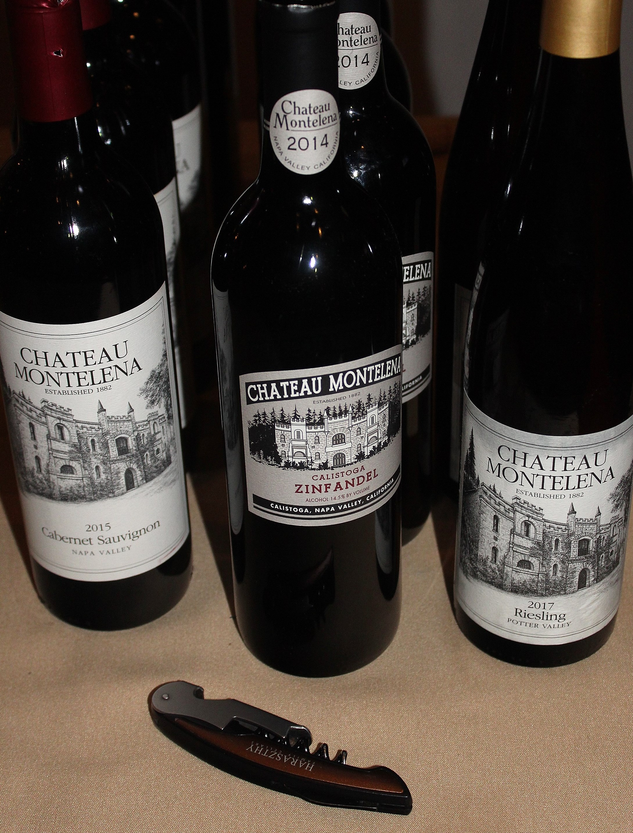
First stop: Chateau Montelena’s arrival in San Diego for a wine dinner at the new West End Bar & Kitchen in Del Mar. The restaurant’s showman-owner Sal Ercolano brought in the Napa Valley Cab favorite with its awesome history of celebrant Chardonnay and Cabernet Sauvignon. True to form, it drew a full house for 2 nights for these estate-driven wines. John Parker of Young’s Market distributors did a totally pro presentation of each varietal including Riesling, Chardonnay, Zinfandel and everyone’s favorite, the 2015 Cabernet. The winery first gained fame when its 1973 Chardonnay beat all French versions in an international battle of the bottles at the 1976 “Paris Tasting.”

History is bottled in every Chateau Montelena Napa

Valley wine shown at a wine dinner at West End Bar

& Kitchen in Del Mar.

Winemaker at the time was Napa Valley’s pioneer Chardonnay king Mike Grgich who went on to make his own wine starting in 1977.

A “Discovery” Napa Valley wine has burst on the scene causing heads to turn.

I had an ACRE 2016 Zinfandel from the Oakville and Yountville districts, at 333 Pacific in Oceanside.($33.) It’s got the famous traits of a great Zinfandel, bold, rich and dark flavors of berry with its 15% alcohol. A plush aroma will lure you in with its black fruit and notes of cedar and licorice.

The 37th Annual Paso Robles Wine Festival in Paso is Thursday May 16 thru Sunday May 19, including a Grand Tasting Saturday the 18th. See pasowine.com for details.

Walla Walla Washington’s world-class wines deserve a lot more attention than they’re getting, not only for their lovely reds at Leonetti Cellars and Le’Cole, but lately the area is showing up in major publications as one of the “50 Best Places to Travel.” With more than 120 wineries and a large number of restaurants, the lover of wine and food should also consider the vineyard-scenic beauty of the city, its surroundings and the “small town” friendliness that fills the air.

The wines turned out in the Walla Walla district enjoy some 12 hours of sun in the Summer and the grapes respond with a depth and power that few areas of the wine world can equal.

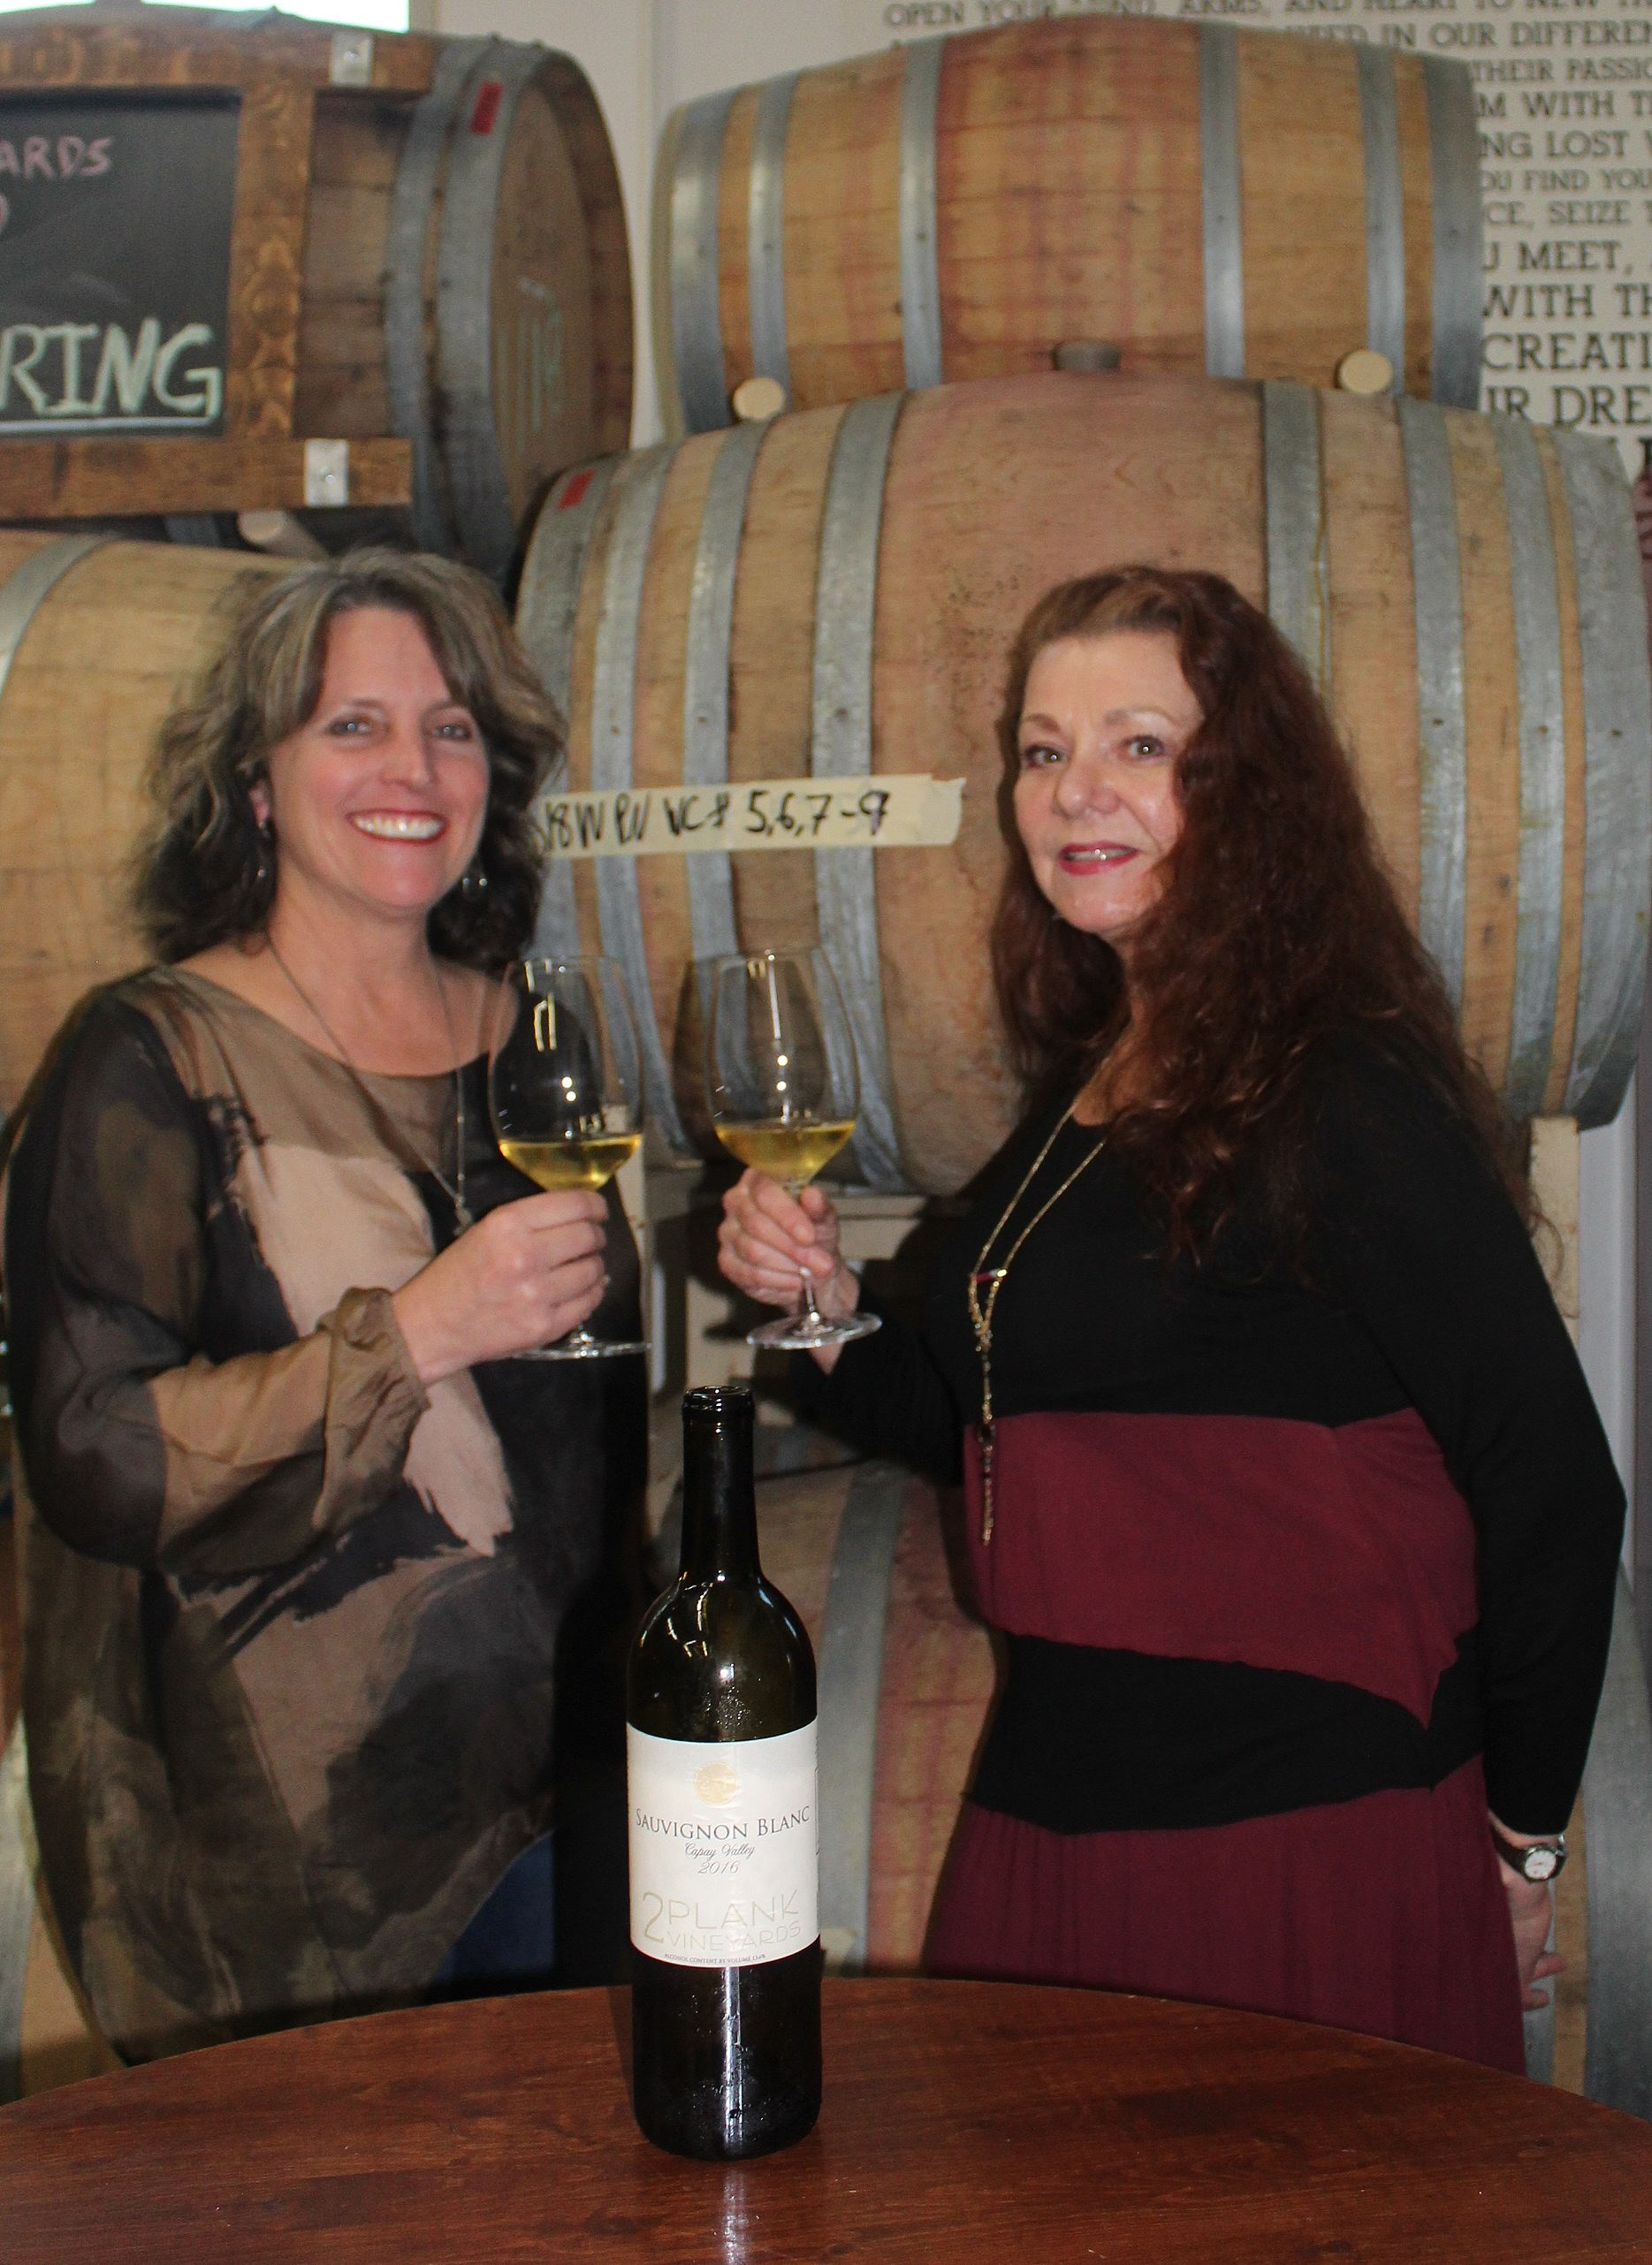
Wine and Cheese are joined at the hip in mutual flavor enhancement at 2Plank Vineyards. Cheese and wine are nature’s link to high quality tasting. Together, they bond and embrace each other in a lifelong romance of taste. At a recent event, 2Plank Vineyards, at its tasting and barrel room in Vista, brought out some of their delicious Rhone Valley French style wines to match up with a craft cheese maker from nearby Ramona for a lovely alliance. Cheese maker Kim Spero owns artisan style Cheese from the Cave, using only fresh local products and expert aging suitable for high quality white and red wines. The old world style of wines is an even better fit. Four cheeses and wines were included in the

Kim Spero, left, of Cheeses from the Cave

in Ramona, presented a cheese and wine event

with 2Plank Vineyards, and Manager Lynette Schultz.

program, highlighted by a Marbier cheese with a 2016 “GSM” (Grenache, Syrah

and Mourvedre. $34.) 2Plank Manager Lynette Schultz praised this wine as perfect for the cheese selected, with its intensely dark color and rich, black fruit aromas. With flavors of caramel, chocolate and tart cranberries, it’s 100% estate wine grown at their vineyard in Fallbrook.

The new Napa Valley Caymus 2015 Special Selection is now available.

This famous brand has been a 2-time winning Wine of the Year in Wine Spectator ($179.95).

Wine Bytes
- The Charthouse in Cardiff has its “Perfect Pairings” chef-inspired 4 course dinner and wine Thurs. April 18 at 6:30pm. The wine will be from the famed Rodney Strong Vineyards of Sonoma. The main entrée aged tenderloin will be paired with the winery’s Reserve Cabernet Sauvignon from Alexander Valley. Cost is $85. per person. Call 760-436-4044 for an RSVP.

- Lorimar Winery in Temecula is planning a Winemaker’s Dinner, Fri. April 19 at 6pm. Enjoy 5 courses paired with award winning Lorimar wines. The highly respected winemaker Marshall Stuart will present. Cost is $76.50 to $85. For details, phone 951-694-6699.

- Europa Village Winery in Temecula presents Festa Europa, Fri. April 19 starting at 5:30pm. A portion of the proceeds to go to the Navy League of the U.S. Inland Empire. Live music by the Classic Rock and Dance Band, Mrs. Jones Revenge. Chef Dean’s gourmet delights and Europa wines available. Free Admission. Chef’s plate $19. from 5:30 to 6:30pm. Purchase in advance: see europavillage.com.

- Gianni Buonomo Vintners in the Ocean Beach district of San Diego has a wine release gala dinner for its new 2015 Maestrale French style red blend, a recent Silver award winner. Date is Sat. April 20 from 6:30 to 9pm. French style cuisine will be featured in this 4 course dinner. Tickets are $55. and are available at releaseparty.bpt.me.

Frank Mangio is a renowned wine connoisseur certified

by Wine Spectator. He is one of the leading commentators

on the web. View his columns at tasteofwineandfood.com.

Go to recent columns. Reach him at frank@tasteofwineandfood.com to comment or unsubscribe.

