
TASTE OF

WINE & FOOD
By Frank Mangio

Week of March 24, 2019

Vin Diego Celebrates Wine at Waterfront Park

If you really enjoy comparing and tasting wines, you have to be at Vin Diego, the one all-wine festival in Southern California, Saturday April 13, at its all-new location at Waterfront Park, Harbor Drive at the Embarcadero in San Diego, starting at 3pm.

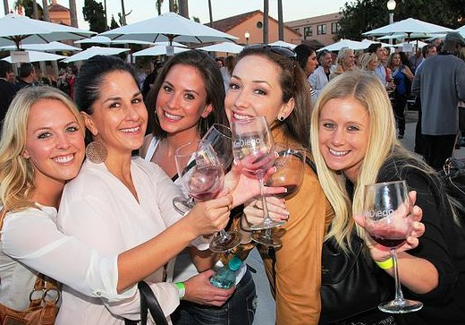
This is the 7th Vin Diego staged by producer Dave Fraschetti, who attracts the best wineries and area name brand chefs, for his magical events with a flair for fun. Enjoy wine tasting, food sampling and lots of dance music with jazz and flamenco guitarists Jimmy and Enrique.

The 7th annual Vin Diego is the exciting all wine, food and music

festival, coming to Waterfront Park at the Embarcadero,

downtown San Diego, Saturday April 13 from 3 to 7pm.

It is an outdoor wine fest so let’s all be thinking sunshine, with reds, whites and everything in between.

Fraschetti had come off his 2nd year of the wine and food-fest in the desert at Rancho Mirage recently and he was breathing easier due to rainy weather there. “Rancho Mirage is our latest venue and I love it out there,” he said. “The rains came but we were ready for it with a 160 foot rented tent. With the wine, food and entertainment, we were very happy and will have it again next year. Rancho Mirage even awarded our event the new business of the year,” he exclaimed. Getting back to Vin Diego, I asked him why the change from the cozy confines of Liberty Station. “I’ve been looking at a chance to go to Waterfront Park for a few years now. The ocean and Star of India historic museum is across the street. From the north you can take the Coaster train, and elsewhere you can take a trolley for a super convenient way to come and go. It’s just a few blocks from Little Italy and all those restaurants, beautiful green belts and awesome fountains. For a lot of reasons, we’re calling it San Diego’s classiest wine festival.”

A convenient feature of this wine event is the ability to purchase wines at the event, some at event-only prices. So mark that date, Saturday afternoon April 13th at Waterfront Park, and mark it in red wine to make sure it’s on your to-do list. Several price ranges and features are optional, but I would really recommend you buy the “Early Admission Ticket” to get the chance to tour and taste with great wineries and restaurants 3 to 7pm, plus your own souvenir crystal wine glass. Only a limited number will be allowed in an hour earlier than most. Cost for this bargain is $105. each. Buy 10 or more as a group and the price discounts to $95. each. Visit vindiego.com and look for the grand tasting event for ticket selections.

Carruth is San Diego’s Largest Urban Winery
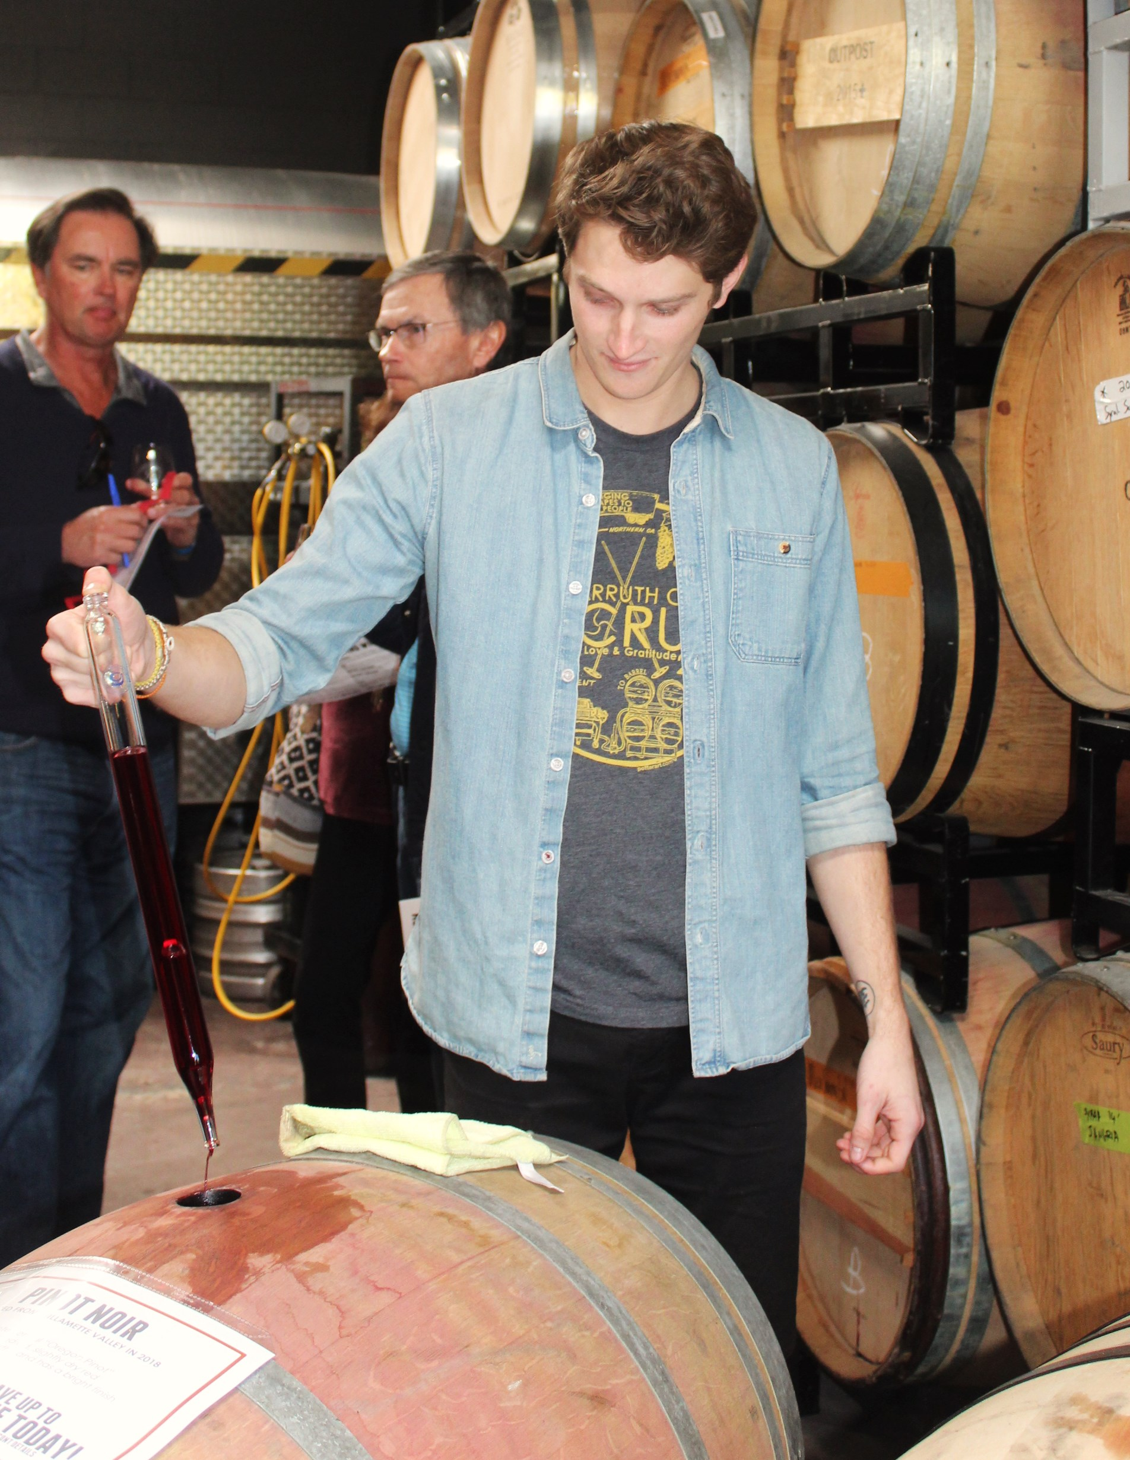

Adam Carruth is taking his Carruth Cellars Urban Winery on the right track, offering a wine experience unlike any other in the San Diego region. In a short time, he now offers Gold Medal award winning wines from the most prestigious and respected competitions.

This year, his 2016 Sonoma Alexander Valley Cabernet Sauvignon and 2016 Napa Knights Valley Malbec, won at the San Francisco Chronicle show. The Cabernet and other equally fine wines were available in a special 9th annual Barrel Tasting Party. This was a rare chance to taste wines direct from the barrels.

Mason Wilfert of Carruth Cellars operates a “wine thief“

to extract wine from a barrel to serve to guests

at Carruth’s 9th annual Barrel Tasting in Solana Beach.

Guests could then purchase “futures,” wines that are not yet bottled, but will be in the Fall of this year. Discounts go from 10% off retail for guests, to 30% for wine club members. Carruth cellars original location is the Solana Beach Design District where they’ve expanded from their first location. Recently, a Tasting Room was built in Carlsbad Village, then most recently Carruth Cellars Wine Garden opened that serves visitors in Little Italy, in downtown San Diego. All locations are open daily.

Wine grapes are sourced from Northern and Central California, then brought in to be produced and bottled in the Solana Beach location.

A release party will be held at Solana Beach on Friday April 29th from 6 to 9pm to celebrate the latest Gold Medal winner, the 2016 Sonoma Cabernet Sauvignon and the 2018 Lake County Sauvignon Blanc, just in time for Summer. Check it out at carruthcellars.com.

Wine Bytes
- Capri Blu in North San Diego brings you a Francis Ford Coppola wine dinner Wed. April 3 at 6pm. Winery favorites served include: Director’s Cut Cabernet and Cinema Red Blend. 4 course dinner included in the cost of $65. ea. Call 858-673-5100.
- THE MED in La Jolla continues its premium wine dinner series on Thurs. April 11 at 6pm, with Domaine Carneros from Napa Valley, hosted by Assistant Winemaker Zak Miller. This multi-course dinner is $165. per person. RSVP at 858-454-0771.
- Il Fornaio Del Mar’s next Festa Carnivale dates are April 1 to 14 when they spotlight the Italian Island of Sardegna. Choose from several selections of an island menu of local flavors, plus a flight of wines or a local favorite. Phone 858-755-8876 for an RSVP.

Frank Mangio is a renowned wine connoisseur certified

by Wine Spectator. He is one of the leading commentators

on the web. View his columns at tasteofwineandfood.com.

Go to recent columns. Reach him at frank@tasteofwineandfood.com to comment or unsubscribe.

