
TASTE

OF

WINE
By Frank Mangio

Week of November 25, 2018

Taste of The Med at La Valencia in La Jolla

Distinguished dining, a team of committed professionals, a new wine preservation system and a prix fixe menu full of value and upscale wines.

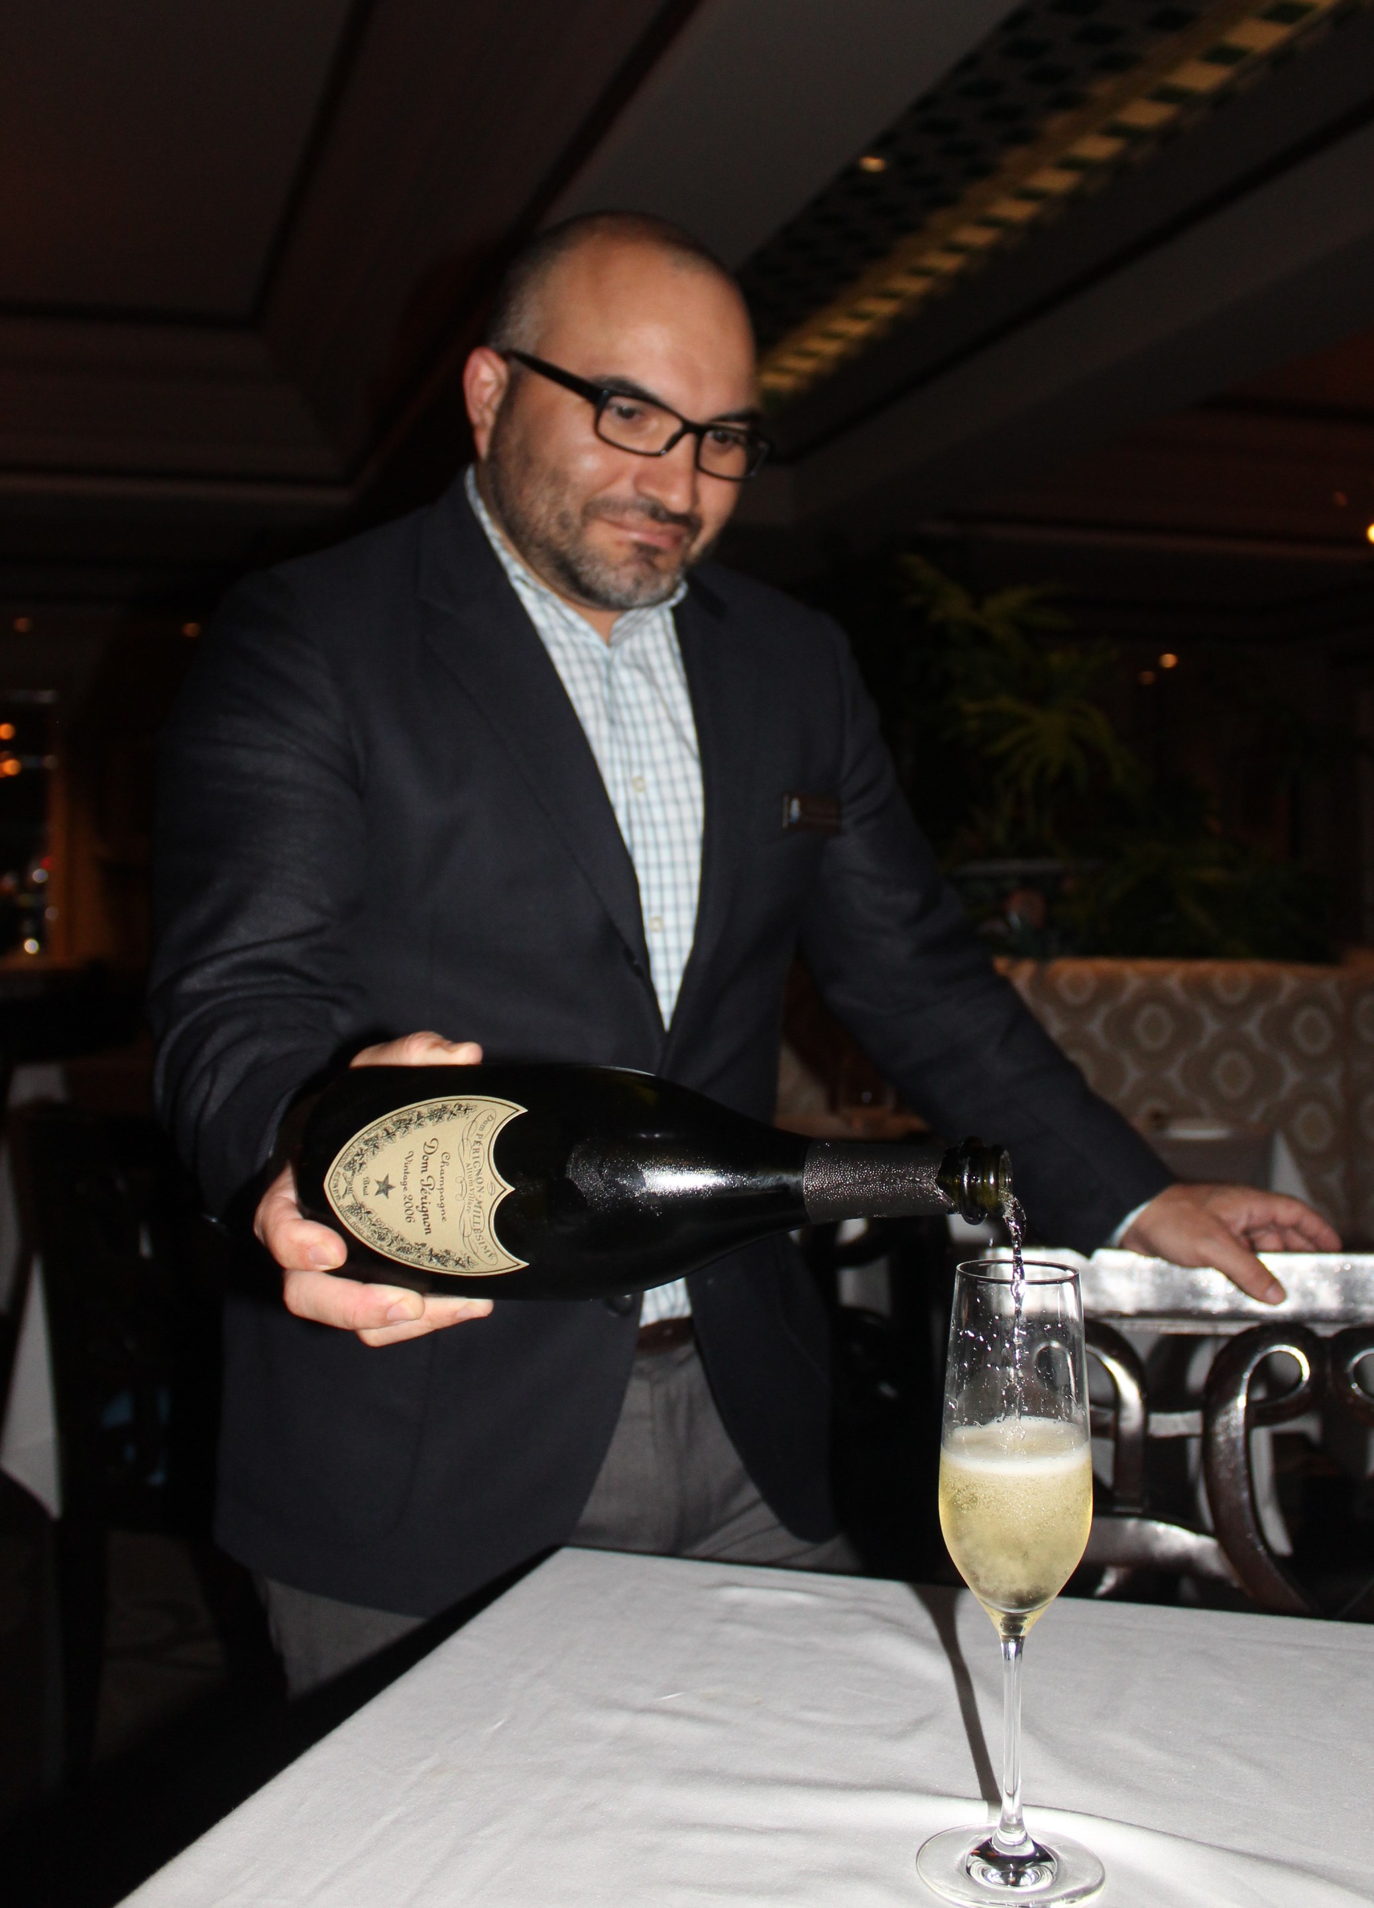
You can expect all that and more, when you dine at The Med, a living room atmosphere with a fine dining experience, just inside the historic La Valencia Resort & Spa in La Jolla’s seaside restaurant row.

The Executive Chef for La Valencia is Alex Emery, who has devoted the last two and a half years toward growing the menu of The Med. “Our current projects include a new Brunch with a multitude of delicious choices. Emery also pointed out that “our banquet business is growing nicely. We put a lot of time into make sure that a banquet meal is equal in quality to an individual meal in the dining room.”

Ashley Luna is the Assistant Food and Beverage Director for the hotel and a passionate lover of French Champagne.

Assistant Food & Beverage Director for

La Valencia Hotel, Ashley Luna, pours

a Moet & Chandon Dom Perignon Champagne.

He began our review of the wines of The Med with a healthy pour of one of the world’s highest rated and most well known Champagnes, the Moet & Chandon Dom Perignon from Champagne France. (current 2008 vintage $180.)

“Dom Perignon was the most well known maker, and the father of modern champagne,” Luna told us. “He was the master of the blending process with only the best grapes of the Chardonnay and Pinot Noir varietal used. There is power and gracefulness in this Champagne,” he concluded. I have to admit that I haven’t given much thought to Champagne. “It gives me a headache,” has been my consistent comment. So it goes without saying that I had not given Dom Perignon a thoughtful review, until this night. I loved it. In a recent article, Wine Spectator pointed out that France’s Champagne region is the world’s premier producer of sparkling wine, with the U.S. a leading buyer. As it turns out, Wine Spectator has just released its Top 100 Wines of the World in its current edition and Dom Perignon has locked up the #5 position in this year’s list. Further into this column, you will get the details on which wine made #1.

I mentioned earlier that a new and more effective wine preservation system is in place at La Valencia. It’s called the Verre de Vin Sytem that sucks oxygen out of the once-opened bottle so that your glass of selected wine will always be dynamic and taste like its just been opened. La Valencia is the first in San Diego to offer this efficient method of keeping the taste of wine always as good as day one. It also locks in CO2 for sparkling wine and Champagne, ensuring that the fizz and bubbly be the best that it can be.

Food and Beverage Director Christopher Reid revealed a list of achievements for the 92 year old hotel in 2019, increasing the level of style and service including more wine dinners starting with an exciting Valentines Day Brunch and wine.

On December 13th at 6pm, La Valencia Hotel will host a “Prisoner” Wine Dinner with the very popular Prisoner blend 2016 and other greats paired with a 5 course master-created dinner. Cost is $125. per person. For details, visit www.lavalencia.com.

Wine Spectator’s Top Wine for 2018 is Sassicaia

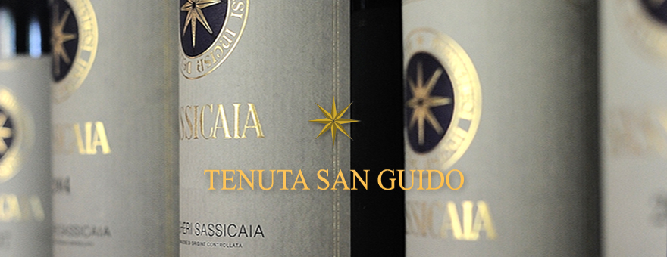
The most distinguished honor roll of wines for 2018, the Top 100 from Wine Spectator, has been revealed and the #1wine in the world is (drum roll) the 2015

TENUTA SAN GUIDO SASSICAIA ($245. at the winery).

This grand blend of Italian grapes from the Bolgheri district of Tuscany was an original “Super Tuscan” Italian blend. It began commercially in 1968 and now can be placed in the same row as a first-growth Bordeaux, grand cru Burgundy or a Napa Valley cult wine. Why was 2015 a #1 year for Sassacaia? It’s in the vintage. Wine Spectator called 2015 “ripe and opulent fruit with purity and elegance.” Europe is anything but consistent with their weather patterns. The year before was a near-disaster due to chill and too much rain that slowed down ripening. The 2015 has 85% Cabernet Sauvignon and 15% Cabernet Franc and enjoyed milder temperatures and a lot more sunny weather that came early and stayed. Occasional heavy rains came at the right time, late spring, to help flowering followed by budding. Manual harvest ended in late September. Grapes were crisp and healthy. 17,200 cases were produced. Piero Antinori is credited with developing Sassacaia into a world class wine, adding to his legacy of making some of the finest wines to come from Italy. Wise aging will bring out the best in this wine. Five years is suggested. For a look at the top 100 wines from Wine Spectator, go to www.winespectator.com.

Wine Bytes

Capri Blu in Rancho Bernardo is hosting a special wine dinner with the Italian wine Tignanello, a Super Tuscan, Wed. Dec. 5 at 6pm. The balance of the wines come from the Antinori winery in Tuscany, paired with 4 course Italian style cuisine. Cost is $110. per person. RSVP at 1-858-673-5100.

Holiday Wine Cellar in Escondido offers a Toast to the Season Sat. Dec. 8 from 3 to 6pm. Toast with reds, whites, Roses, Sparkling wines and craft beers. 3 samples of Scotch tasting, along with delicous treats. Advance tickets $65., week of the event $75. Call 1-888-492-1965 or purchase on line at holidaywinecellar.com.

PAON Restaurant and Wine Bar in Carlsbad has a premier first-ever Warehouse Wine Sale in the restaurant and patio holiday party, Sun. Dec. 9 from 12 noon to 4pm. Only $25. gets you into the party, wine tasting, food station, silent auction and live music. Wines will be priced at amazing discounts, including Riboli, the winery of the year in Wine Enthusiast. Visit www.eventbrite.com

Frank Mangio is a renowned wine connoisseur certified

by Wine Spectator. He is one of the leading commentators

on the web. View his columns at tasteofwineandfood.com

Go to Recent Columns. Reach him at frank@tasteofwineandfood.com to comment or unsubscribe.

