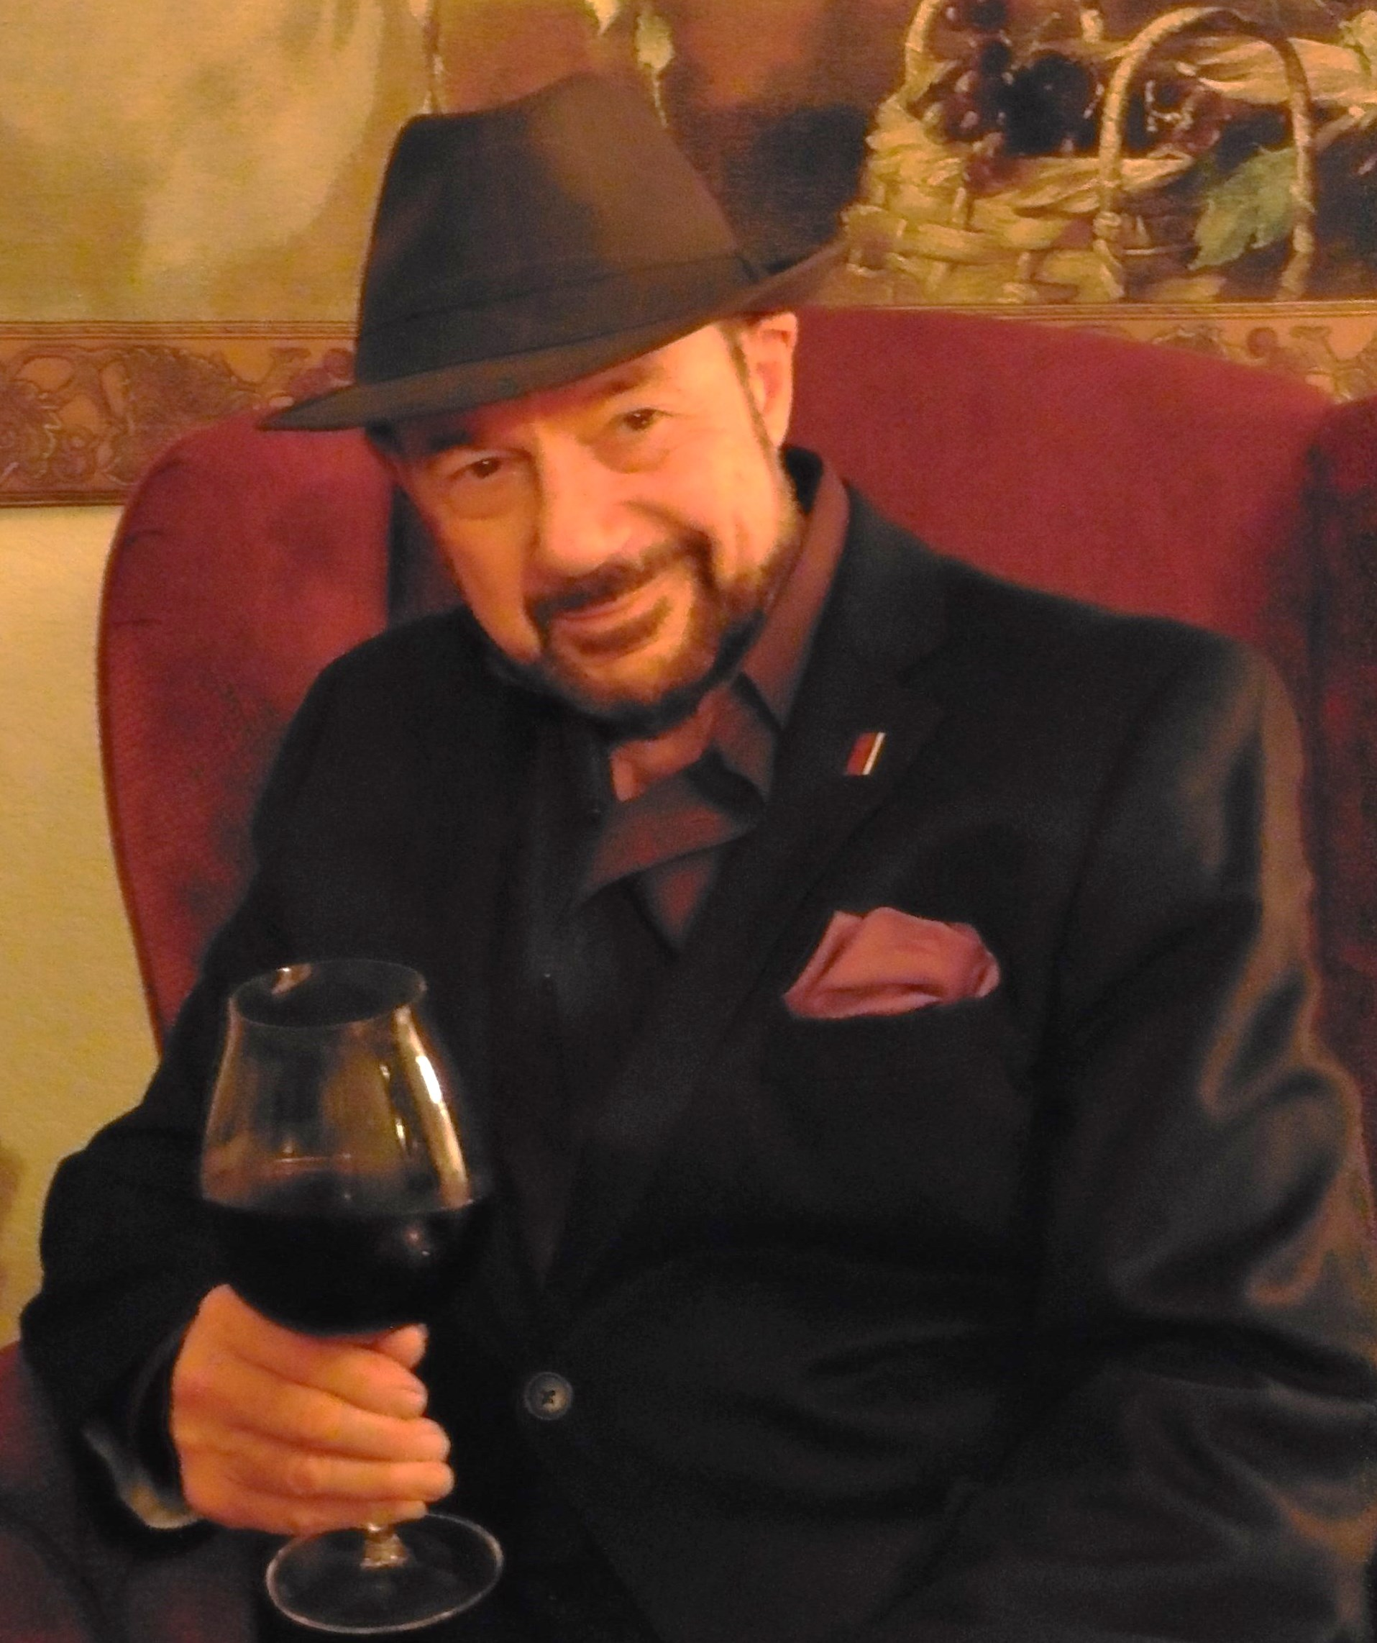TASTE OF

WINE & FOOD
By Frank Mangio

Week November 11, 2018

A Thanksgiving Feast in the Kitchen

With Thanksgiving in the air, my e mail in-box loads up with Thanksgiving

wine and food options to capture the flavor of this feel good holiday.

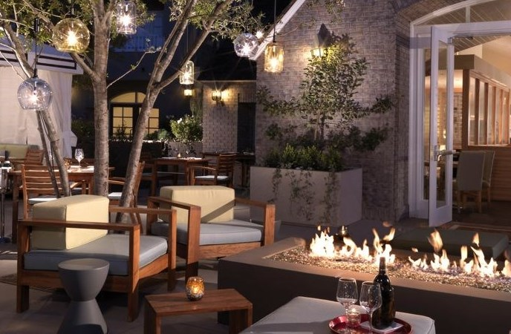There is a special excitement in Kitchen 1540, the cozy, award winning signature restaurant at L’Auberge Del Mar. Besides the panoramic ocean views, garden terrace walks and lively bar, their Thanksgiving dinner will be orchestrated and collaborated by Executive

Kitchen 1540 at L’Auberge Del Mar is planning a stunningly

diverse and delicious Thanksgiving Day experience, November

22nd from 2 to 8pm.

Chef Nathan Lingle and Chef de Cuisine Collin Leaver. Kitchen 1540 speaks volumes of the Southern California dining atmosphere. There is a seamless flow from the bar to the dining room and outdoor patio spaces, a perfect mix of experiences. Many of the food products are sustainable, and eco-friendly. A glance at the Thanksgiving menu tells all. It’s a three-course Prix Fixe dinner with a delightful mix of traditional and unique flavors. The delicious entrees include Heritage Turkey with accompaniments, Beef Tenderloin with roasted root vegetables, whipped potatoes, Arctic Char with parsley root puree and kabocha or Ravioli and heirloom vegetables. Equal amounts of starters and dessert delights await.

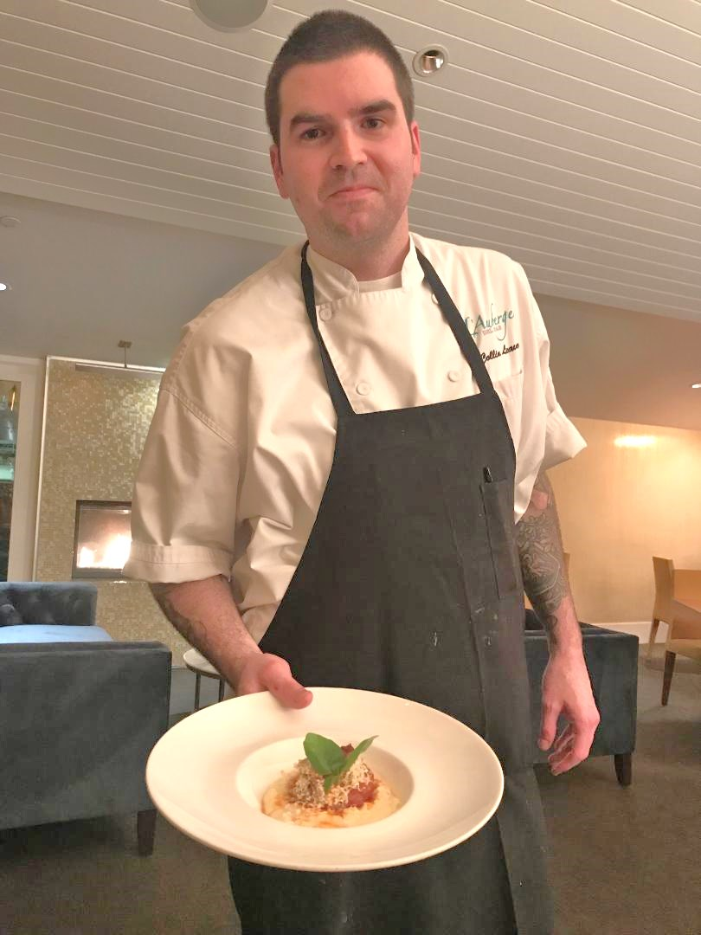Chef de Cuisine Collin Leaver has brought a wealth of top-drawer culinary experiences with him from San Francisco, New York and Naples Italy. His pasta ensemble dishes are artistic triumphs. He served as Executive Sous Chef at Quattro Four Seasons in Palo Alto, Chef de Cuisine at A16 in San Francisco and is a Certified Pizzaiolo by Associazione Verace Pizza Napoletana in Italy.

“I have an extensive background in wood fired ovens and opening these fine dining style operations and we hope to put that to good use in strikingly different approaches to Italian style food preparation,” he said. Four

pastas with a country style focus are already

gracing the menu, led by a beautifully

Kitchen 1540 Chef de Cuisine Collin

Leaver has brought an exciting new

approach to the menu with his ensemble

of metro-style pastas.

styled Mezze Rigatoni seated on a Swordfish base with Caper Lemon and San Marzano tomatoes with bread crumbs and Oregano. Another favorite on the daily dinner menu is the Oregon grilled salmon with Shitake mushrooms. Parsnip puree and mustard greens are added along with Huckleberries.

Now to our wine menu selections. For starters it was the ZD Chardonnay 2016. ($19./glass) I recommend this with starters, salads and fish menu names. A great Chardonnay will always have a zippy complex flavor with refreshing acidity to mate up with these items. Two Pinot Noirs captured the essence of this miracle wine: Eola Hills in the Willamette Valley of Oregon and Row Eleven in the Santa Maria Valley of California. (both $17./glass) Do you want an all-purpose wine that will bring out the best in any dinner entrée you may choose for Thanksgiving? Pinot Noir is it. You will do no better than Pinot Noir. Finally, for those spicy Italian soul dishes I described, the Whitehall Lane Cabernet from Napa Valley 2014 will blend right in with the pastas and a lovely Prime New York Strip Steak. It’s the ideal pairing on the wine menu. ($20./glass)

The pricing on the Thanksgiving Three-Course Prix Fixe Dinner will be $89. per adult; $25 for children 12 and under) . Go to www.laubergedelmar.com.

Wine Bytes

The Grill at the Lodge Torrey Pines has their outdoor rotisserie going for smoky flavors on Thanksgiving Day with a 3-course meal and wine and beer parings. Dinner seating is 1 to 10pm starting at $60. per person, $35. for children under 12. RSVP at 1-858-777-6641. The A.R. Valentien Restaurant at the lodge has a 4 course Prix Fixe dinner with the tastes of the season, with Executive Chef Jeff Jackson. Dinner seating from 4 to 10pm at $115. per person, $60. for children under 12. RSVP at 1-858-777-6635.

The Westgate Hotel, downtown San Diego has a 4 course Thanksgiving Prix Fixe dinner from 11am to 9pm featuring the classic flavors at $69. for adults and $40. for children 4 to 12. RSVP at 1-619-236-8397.

The North County Wine Company in San Marcos has a ”Debate” Tasting Event Wed. Nov. 28 starting at 6pm. The Debate is a 3-bottle set of extreme quality. Cabernet wines from Napa Valley with the same vintage, grape and winemaker. Only the vineyards are different. Vintage is the legendary 2014. The bar will be closed except for the wine lovers who have RSVP’d for this event. Cost for the event is $50. This will be waived if you purchase a 3-bottle set for $550.

To guarantee a spot, call 1-760-653-9032.

Frank Mangio is a renowned wine connoisseur certified

by Wine Spectator. He is one of the leading commentators

on the web. View his columns at tasteofwineandfood.com

Go to Recent Columns. Reach him at frank@tasteofwineandfood.com to comment or unsubscribe.

