
TASTE OF

WINE & FOOD
By Frank Mangio

Week of September 16, 2018

Deluxe Wine and Food on the Water

Cruise lines, whether it be on oceans or rivers, have never been so in demand

by the public. Seems like new ships are being released weekly and the fleets are nearly full as passengers are booking a year in advance to visit their favorite ports of call.

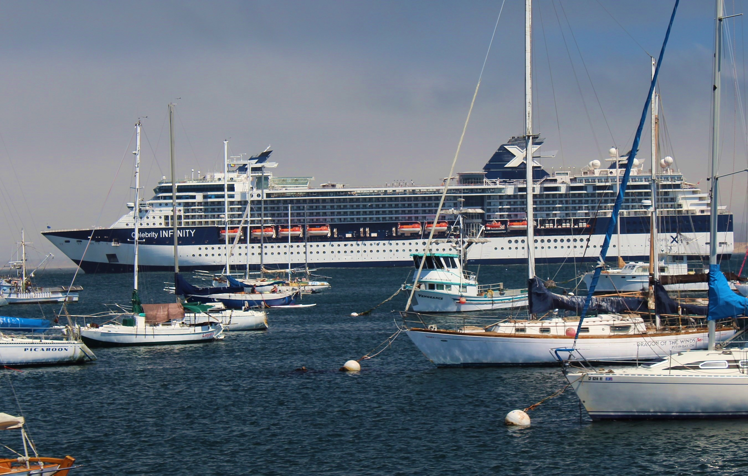
Some newer cruise ships are so large, with over 5,000 passengers, that they are able to fit a replica of Central Park New York in the middle of the ship. Where in the world would you like to go? Venice, Alaska, the Caribbean, Singapore are all accessible by these giant hotels on the water.

Fine wines and food, as well as exciting entertainment and spas

are increasing passenger travel on the seas and rivers of the world.

A Celebrity cruise ship is shown above.

Some travel packages offer as many as 20 ports of call, especially the European and Mediterranean cruises. Many of the restaurants on board the big ocean-going ships are free to passengers, including a buffet restaurant where it’s all you can eat, and then some, with food and drink available nearly 24 hours a day. If you want to dine in your room, and lot of passengers do with a premium balcony, that’s no problem. Just fill out the handy order forms in your cabin and your food and wine choices will be at your room when you want it, at no extra charge. Most ships have 5 or more specialty dining formats.

From sushi to juicy aged prime steaks, you will have many to choose from.

If it’s a village on the Rhone River in France or a vineyard on the Rhine in Germany that you want to immerse yourself in, a river cruise is for you.

With these ships, you go from 5,000 to 500 and many are as low as 100 passengers. These wine country cruises emphasize wine with seminars, guest winemakers, world–wide group tasting and wine lists in restaurants that are plentiful and reasonably priced. Many of the shore stops have vineyards just outside of town, and planned shore excursions at no extra cost.

Celebrity cruises, one of the big cruise lines on the circuit, has recently opened its Cellar Masters wine bars on its fleet. Cool live music, cushy chairs and a bold collection of the familiar and unknown but lovely tasting whites and reds. Six to 8 sommeliers work every ship to sharpen your wine education skills.

One of my frustrations is the pushy way that drink packages are directly marketed to passengers. At Celebrity, a “Taste the Vineyards” package begins at over a hundred dollars a day with limitations on the values of each bottle included. Each package must be pre-paid. Buyer beware.

The better way to go is one of the many wine events on board. For just $30. I signed up for a “World Wine Tour,” tasting 12 generous portions of whites and reds from wine countries like France, Italy, South Africa, Spain, Chile and our own Napa Valley where choices from Beringer and Caymus were poured.

My personal winners were the Gamay red from Joseph Drouhin of France and a Sangiovese Sabazio Rosso from Tuscany, Italy. Two bottles are allowed on board at no cost, but the corkage charge, at least on Celebrity, is $25. One final thought on the nice advantages of being on a cruise ship. If you’ve had a bit too much to drink on one of those 6 course free dinners, there is comfort in knowing that your “designated driver” is the ship’s captain and your cabin is a short walk back. See more on Celebrity at celebritycruises.com.

PAON and Paul Hobbs Wines

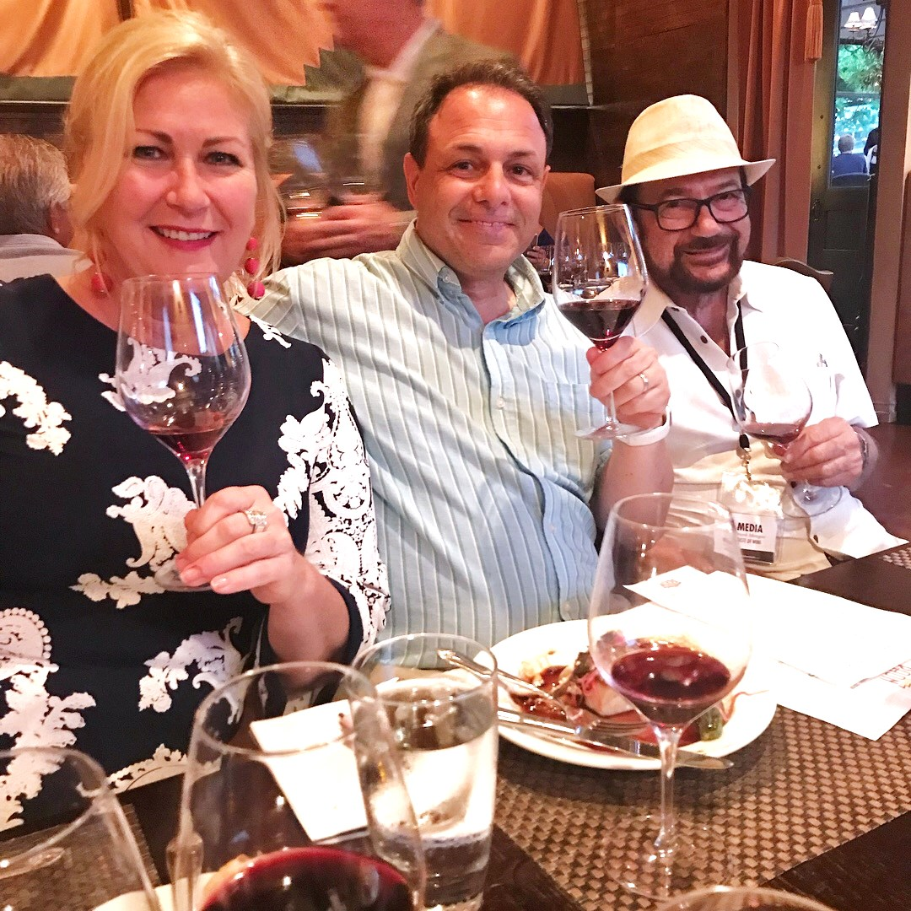
The excitement from the full house at PAON in Carlsbad was at fever pitch

when the fine dining restaurant brought in Paul Hobbs winery from Sonoma and Napa Valley. Hobbs has forged new paths to wine greatness and a sense of place wherever he has harvested wine grapes, that have been applauded for some 30 years. Paul’s brother Matt Hobbs presented diners with Chardonnay, Pinot Noir and Cabernet from various top shelf vineyards in both Sonoma and Napa Valley. These were paired with excellent cuisine

Enjoying a recent Paul Hobbs top drawer wine dinner

at PAON in Carlsbad is the restaurant’s Marketing Director

Barbara Pape, with Taste of Wine and Food’s Tech Director

Rico Cassoni and Senior Editor Frank Mangio.

led by an on-bone New Zealand Venison Rack of Lamb and a pan roasted Pacific Sea Bass. The next big wine dinner event will be the Wait Cellars event at PAON on Wed. Oct. 3rd with 5 courses and a reception that begins at 5:45pm. These are Russian River Sonoma wines and owner Bob Wait will be in attendance. $120. per person. RSVP via email to Kate at info@paoncarlsbad.com.

Wine Bytes

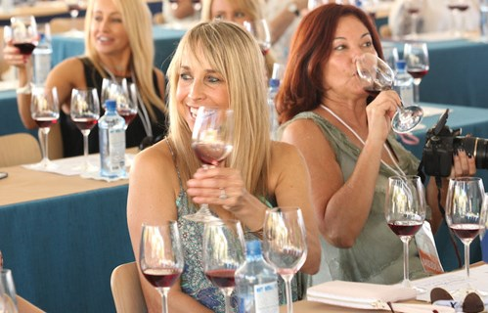
The Newport Beach Wine & Food happens from Oct. 5 to 7 for the 5th year.

This is a lovely, upscale deluxe event with VIP chef dinners, Food Network & Bravo’s top chefs and Grand Tastings on Sat. Oct. 6 and Sun. Oct. 7. from 2:30 to 6:30pm. with a VIP ticket.

$200. each ticket. Access www.NewportBeachWineandFood.com

Wine and food events galore await ticket holders at

The 5th annual Newport Beach Wine & Food Oct. 6 and 7..

#NewbeFest, #NBWFF, #NBWF2018

Vittorio’s in Carmel Valley is presenting a Paul Hobbs Napa Valley wine dinner on Thurs. Sept. 27 at 6pm. This is still another opportunity to mix great wines with the excellent cuisine of Vittorio’s. Call 858-997-7634 for price and a place.

Forgotten Barrel, the historic winery in Escondido is planning a 5 course winemaker’s dinner with master chef Erin Sealy on Fri. Sept. 28 from 7 to 9:30pm. They will be pouring 5 different local wines. John Eppler, winemaker, will be giving insights on his lineup of excellent wines. Cost is $95. ea. Visit www.winepairsevents.com or call 619-233-3541.

Winesellar & Brasserie in San Diego’s Sorrento Valley has a Walk Around Wine Tasting, Sat. Sept. 22 from 3:30 to 5:30PM with Pinot Noir selections. Worldwide Pinots have been chosen for this event. $35. per person, $30. for club members. Call 858-450-9557.

Frank Mangio is a renowned wine connoisseur certified

by Wine Spectator. He is one of the leading commentators

on the web. View his columns at tasteofwineandfood.com

Go to Recent Columns. Reach him at frank@tasteofwineandfood.com to comment or unsubscribe.

