
TASTE OF WINE &

FOOD
By Frank Mangio

Week of August 5, 2018

Here and There with Wine and Food

It’s an endless summer at Coastline al fresco restaurant in L’Auberge Del Mar. This celebrated beach coastal location has always delivered a resort experience over the years and with the new upscale improvements, it is the SoCal stay-place along the coast.

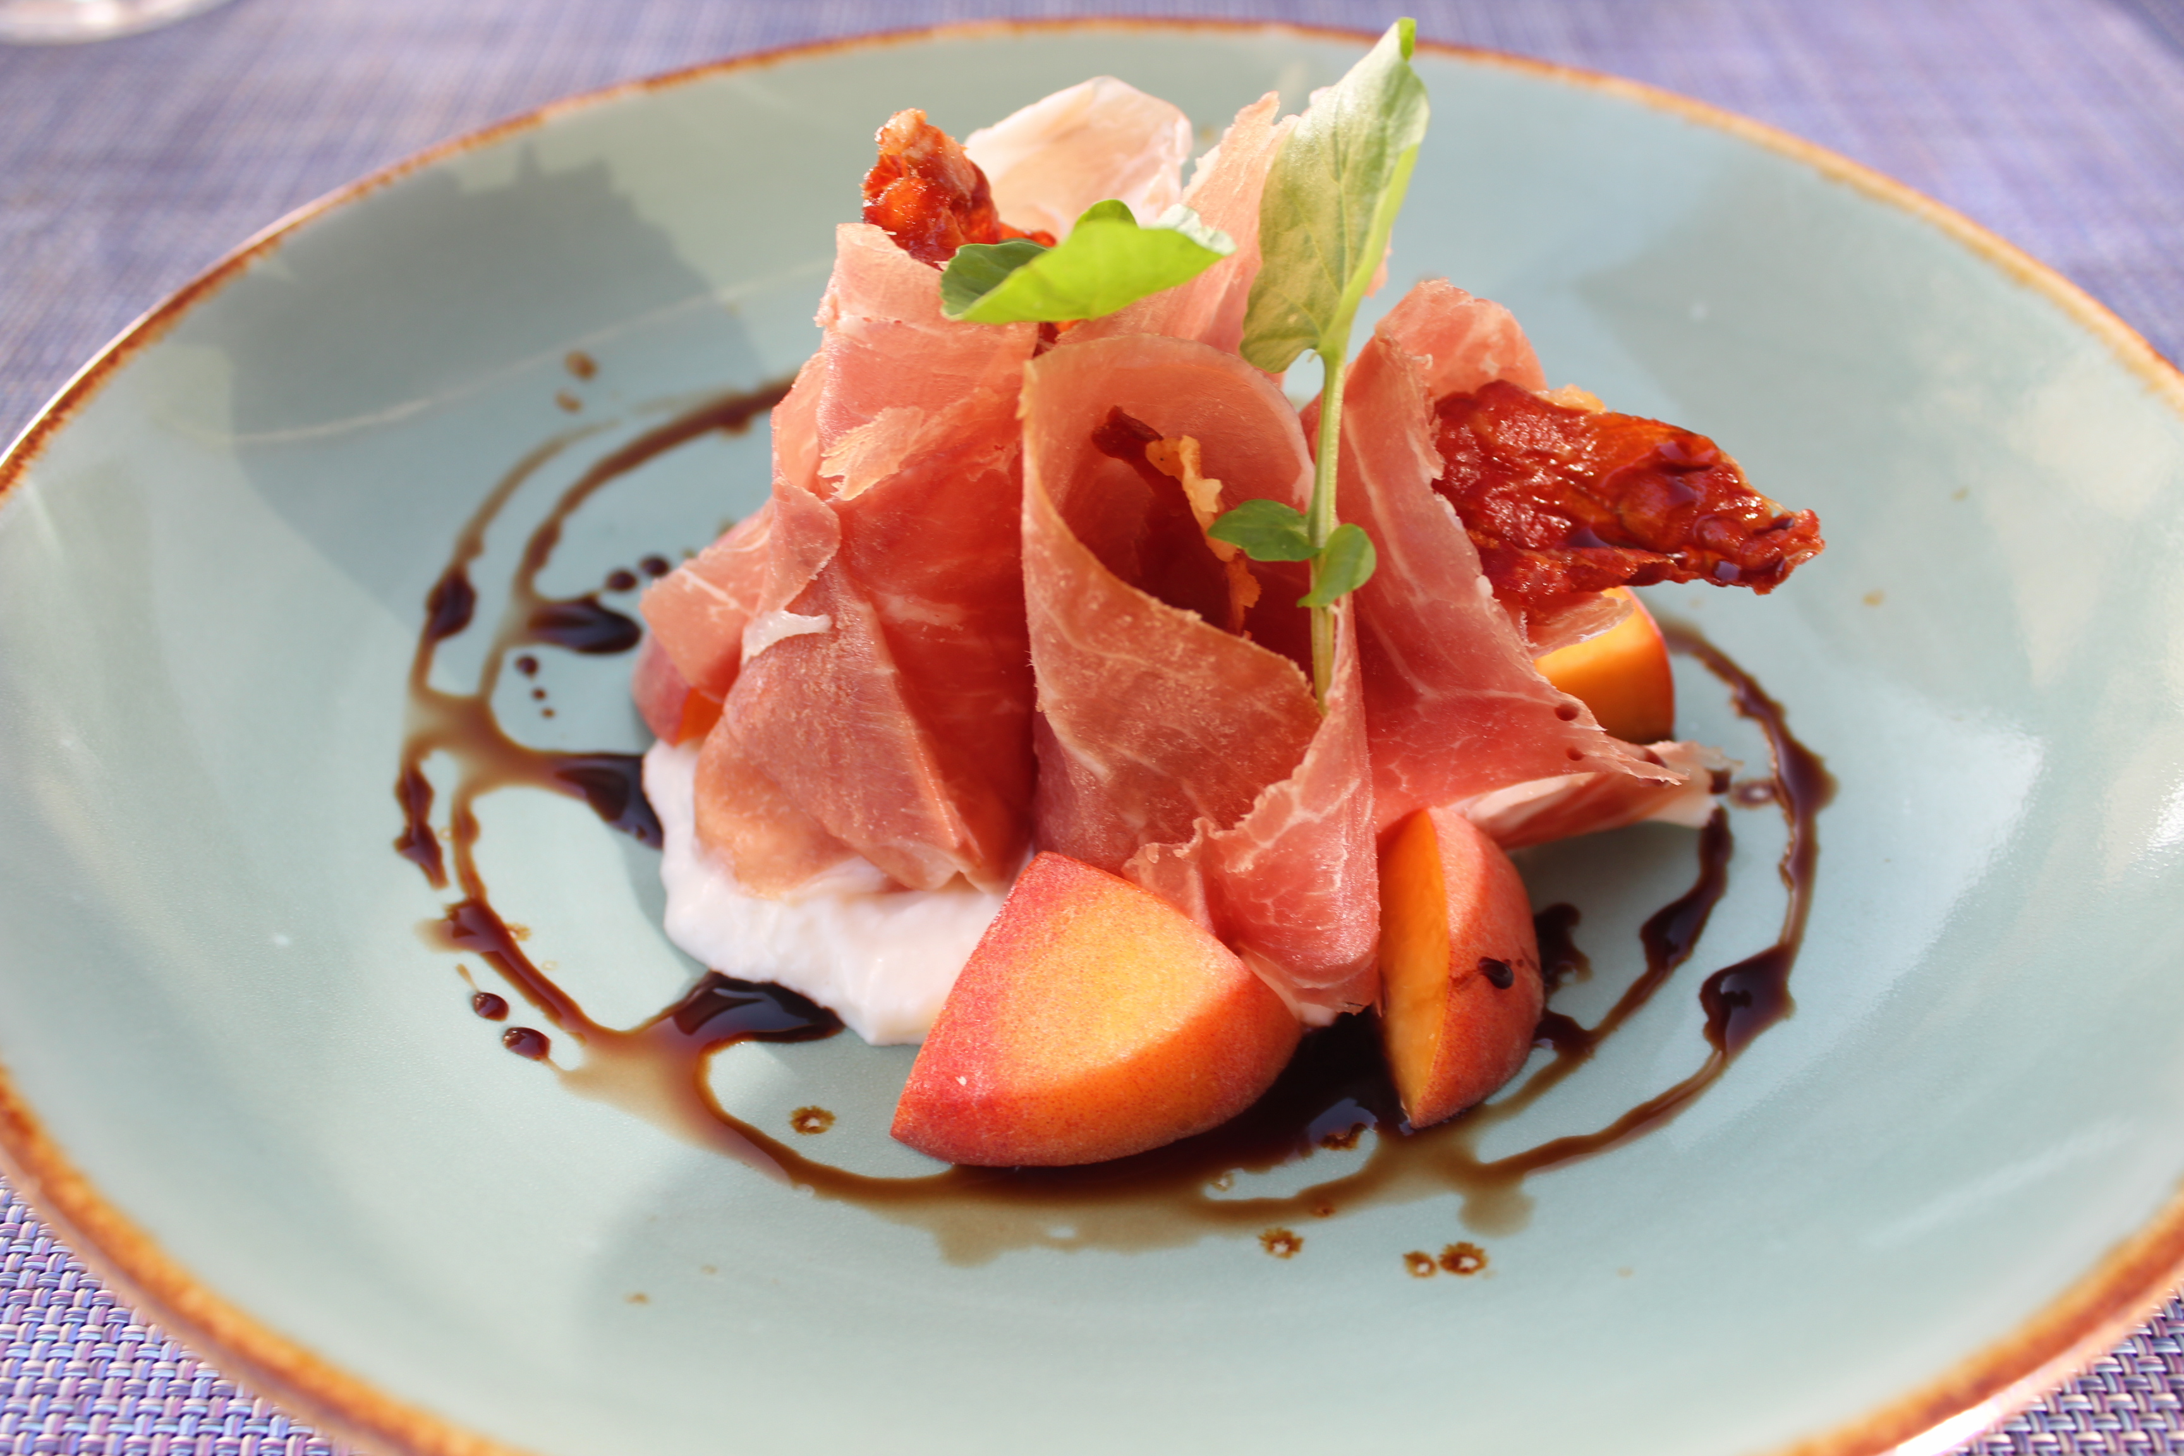
L’Auberge Del Mar has 121 recently refurbished rooms and suites, a large spa and dining options led by the fresh, light and airy Coastline.

I dined in the poolside veranda as sunset was making itself present. The Pacific ocean never looked grander for poolside dining. In scanning the menu, it was clear that Coastline

Coastline is the al fresco fresh food restaurant at L’Auberge

Del Mar, with endless summer dishes developed by new

Chef de cusine Collin Leaver. My favorite is the starter

plate headliner Burrata Cheese, shown above.

was showcasing the Southern California sunny style menu so popular and trendy these days. The food is light, delicious and healthy. The Burrata Cheese is the house choice, with white peaches, Prosciutto speck, Saba balsamic vinegar with Upland cress. Other examples of this trendy menu include: Cured Yellowtail crudo, Arugula salad and the amusing Little Gem salad. Pastas, fish and beef add to the extraordinary choices.

It was announced that Collin Leaver has been appointed chef de cuisine at Coastline. He’ll collaborate with the resort’s executive chef Nathan Lingle on menu development with a plan to increase fresh influences going forward.

I found the wines by the glass menu full of light reds, whites and bubbles. There were lots of familiar established names, and I would recommend a discovery from the Willamette Valley in Oregon, the Patton Valley 2014 Pinot Noir. It was perfect to match up with the breezy, casual tasty menu that Coastline showcases.

See more at LAubergeDelMar.com.

Woman of the Year: Cristina Mariani-May

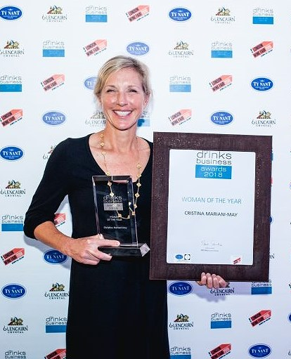
Our congratulations go out to a remarkable Woman of Wine, Cristina Mariani-May, CEO and President of fine wine importer Banfi Vintners worldwide and Castello Banfi of Tuscany Italy, most honored vineyard estate in the country. Readers should be familiar with Mariani-May. She

triumphantly came to San Diego earlier this year to herald the 40th Anniversary of the Castello Banfi brand, known internationally for developing Brunello di Montalcino to world-class stature.

When she is not conquering new markets for her wines, she is an accomplished long distance runner. “The pursuit of excellence,” is the family business model

Cristina Mariani-May of Banfi Wines has

been name Woman of the Year.

and it has played out well over the years. She is also the proud mother of three

and lives in Tuscany close to her Banfi empire. Visit banfi.com.

Two Southern California wineries awarded superior ratings.

San Diego urban winery Gianni Buonomo Vinters recented earned a 94 rating and a Gold Medal in the New York International Wine Competition. The winning wine was their 2014 Maestrale, a Meritage/Bordeaux blend of Petit Verdot, Malbec and Cabernet Sauvignon. Owner Keith Rolle said that “we are a universe away from New York. To think we have won gold is very cool. It’s all about the grapes and these come from Yakima Washington.”

For more information contact GBVinters.com.

Up in Temecula, congratulations go to Robert Renzoni winery and vineyards for their high marks in Wine Enthusiast Magazine. 3 wines did amazingly well: the Robert Renzoni 2014 Sonata Red Blend received 91 points, a 91 point “Editor’s Choice” went to the 2015 Estate Sangiovese, and 90 points went to the 2015 Tempranillo. Visit the winery at robertrenzonivineyards.com.

Wine Bytes
- Seasalt Seafood and Steak in Del Mar has another premiere wine and dinner event Thurs. Aug. 23 and Fri. Aug 24 starting at 6pm. It will be A Night in Baja’s Valle de Guadalupe, the best wine country in Mexico. Learn about El Cielo winery and their Chardonnay, red blends, Merlot and Cabernet, while feasting on an exclusive 6 course menu by Chef Hilario. Cost is $70. per person. RSVP at 858-755-7100.
- It’s Grape Stomp time at Ponte Winery in Temecula, Sun. Aug. 19. Check in at 3pm, food and bar starts at 4pm. Competition at 5pm. Cost is $125. for the public, $112.50 for club members. Check out pontewinery.com.
- The San Diego Spirits Festival happens Sat. Aug. 25 and Sun. Aug. 26 from 2 to 6pm at the Port Pavilion at the Broadway Pier in San Diego. It’s a cocktail, culinary and cultural extravaganza. Lots of entertainment and celebrity chefs. Admission starts at $65. Details at sandiegospiritsfestival.com
- The Carlsbad Brewfest is Sat. Sept. 8 from noon to 4:30pm with some of the finest craft beers in San Diego County as well as music, games and food vendors. All proceeds go to local charities. Managed by the Carlsbad Hi-Noon Rotary Club. Held at Holiday Park, next to I-5 in Carlsbad. Admission starts at $55. Go to carlsbadbrewfest.com.

Frank Mangio is a renowned wine connoisseur certified

by Wine Spectator. He is one of the leading commentators

on the web. View his columns at tasteofwineandfood.com

Go to Recent Columns. Reach him at frank@tasteofwineandfood.com to comment or unsubscribe.

